Chapter 8 – Political Participation

Overview
The popular view that Americans do not vote because of apathy is not quite right. It would be much closer to the truth to state that Americans don’t register to vote—but once registered, Americans vote at about the same rate as citizens in other nations. Many other factors—having nothing to do with apathy—also shape participation rates. These include age, race, party organization, barriers to registration, and popular views about the significance of elections.
The most powerful determinants of participation are schooling and information, and the next most powerful is age. Race makes a difference, but black participation rates approximate white rates when controls are in place for socio-economic status.
Compared with citizens of other nations, Americans vote at lower rates, but more frequently and for many more offices. For these reasons, elections make a bigger difference in the conduct of public affairs in the United States than elsewhere. Americans also engage somewhat more frequently in various nonelectoral forms of participation, such as writing letters to officeholders, attending meetings, and other political activities.

Chapter Outline
I. Introduction
- Political participation refers to the many different ways that people take part in politics and government: voting or trying to influence others to vote, joining a political party or giving money to a candidate for office, keeping informed about government or debating political issues with others, signing a petition, protesting a policy, advocating for a new law, or just writing a letter to an elected leader.
II. A Close Look at Nonvoting
- Two different ways to measure voter turnout yield different perspectives about nonvoting.
- VAP—Voting age population— persons who have reached 18.
- Many persons in this group are not legally eligible to vote including convicted felons and non-citizens.
- In 2008, VAP numbered 231 million including 18 million non-citizens of disenfranchised convicted felons.
- VEP—Voting eligible population only includes those 18 or older who are eligible to vote.
- Measured by VAP— National voter turnout was 56.8 percent in 2008
- Measured by VEP—National voter turnout was 61.7 percent.
- Since 1948 the gap between VAP and VEP has grown.
- When asked, registered voters who did not vote gave three reasons for not voting:
    - About a quarter of registered voters stated they were too busy or had scheduling conflicts.
    - Family chores or obligations (12 percent)
    - They believed their vote would not matter (12 percent).
- Other proposals to the problem of nonvoting include making Election Day a national holiday or holding elections on weekends.
- Voting prior to elections by mail in ballots or no fault absentee voting has also failed to produce significant increases in voter participation.
  - Forty million registered voters failed to vote in recent elections.
  - Forty million voting-age citizens failed to register in either of the two elections.
- GOTV— Get out the Vote drives have had a limited impact on the problem.
  - Door-to-door canvassing and phone calls to voters were the most effective technique.
  - In 2008, these GOTV efforts only stimulated 38 percent of voters to actually vote.
- In Europe, registration is done by the government.
- In the United States, the burden falls on the individual.
- Would reducing the cost of registrations increase the percentage of eligible voters who are actually registered?
  - In 1993, Congress passed the motor voter law, which allows people in all fifty states to register to vote when applying for driver’s licenses and to register through the mail. Many did register but did not vote.
  - Data still show many have not registered.
- Voting is not the only way to participate; by other measures, Americans may participate in politics more than Europeans.
- Important question: How do different kinds of participation affect the government?
III. The Rise of the American Electorate (THEME A: EXPANDING PARTICIPATION IN ELECTIONS)
A. From state to federal control
- Initially, states decided who could vote and for which offices.
- This led to wide variation in federal elections.
- Congress has since reduced state prerogatives through law and constitutional amendment.
- By 1842 law, House members are elected by district.
- Fifteenth Amendment (1870): Seemed to give suffrage to African Americans.
- It opened the door to literacy tests, poll taxes, and grandfather clauses.
- Voting Rights Act of 1965 finally guaranteed blacks the right to vote.
- Women were given the right to vote by the Nineteenth Amendment (1920); participation rose immediately, but no major impact on electoral outcomes.
- Eighteen-year-olds given suffrage by Twenty-sixth Amendment (1971); voter turnout among the newly eligible was low, and has continued to fall.
- In 2008, 52 percent of the eighteen- to twenty-nine-year-old voting population voted.
- This was higher than 2000 (41 percent) and 2004 (48 percent) but lower than 1972 (55 percent) or 1992 (52 percent).
- From 1996 to 2004, under-thirty voters only accounted for 17 percent of the electorate; that figure rose to 18 percent in 2008.
B. Voter turnout
- Debate about declining percentages of eligible adults who vote; two theories:
- Real decline caused by decreasing popular interest and decreasing party mobilization.
- Apparent decline, induced in part by the more honest ballot counts of today
- Parties once printed the ballots.
- Ballots were cast in public.
- Parties controlled the counting.
- Rules regarding voter eligibility were easily circumvented.
- Australian ballot (standard, printed by the government rather than parties; printed and cast in secret) was adopted throughout the country by 1910.
- Most scholars see some real decline, due to several causes:
- Registration is more difficult: Longer residency requirements; educational qualifications; discrimination; and registration have to occur far in advance of elections.
- Florida controversy in 2000 presidential election has provided for some changes to make voting more consistent nationally, but stops short of creating a uniform national voting system.
- Continuing drop after 1960 cannot be easily explained, and may be a function of how turnout is calculated, rather than a substantial phenomenon.
- Some scholars believe that nonvoters mirror voters in their demographic and ideological composition, so their absence has little effect on electoral outcomes.
iv. Who Participates in Politics? (THEME B: REASONS FOR PARTICIPATION)
A. Forms of participation
- Tendency to exaggerate participation
- Voting is the commonest form of political participation, but 8 to 10 percent report having voted regularly when they have not.
- If voting is exaggerated, other forms of participation are also likely to be exaggerated.
- Verba and Nie’s six forms of participation characterize six kinds of U.S. citizens:
- Inactives: Rarely vote, contribute to political organizations, or discuss politics (little education, low income, young, many blacks; 22 percent)
- Voting specialists: Vote but do little else; not much education or income, older
- Campaigners: Vote and get involved in campaign activities; more education, interested in politics, identify with a party, take strong positions
- Communalists: Nonpartisan community activists with a local focus
- Parochial participants: Don’t vote or participate in campaigns or political organizations, but contact politicians about specific problems
- Activists: Participate in all forms of politics (highly educated, high income, middle-aged; 11 percent)
B. Participation: CauseS and Meaning
      - Political participation of any form is greater among people who have gone to college and are employed. It is greater among white and blacks than Hispanics.
  - These differences are descriptive but make generalization problematic. Religion increasing political participation is too sweeping a statement. “Certain types of religious expression” can sometimes increase political participation.
  - Americans participate in nonvoting activities at higher rates than citizens of other democracies.
  - According to a groundbreaking book published in 2008 by Corwin E. Smidt, factors influencing political participation are complicated.
  - Americans vary by religious tradition but also by their level of public religious practice on a scale (high or low).
      - Holding other variables constant (income, race, gender, age, marital status) mainline Protestants are more likely than members of other religious traditions to participate in voluntary associations.
      - Regardless of religious tradition, those whose form of religious expression involves high levels of both public and private practice are more likely to join voluntary associations.
      - What about religion in relation to political engagement? Religion is a significant factor in determining who votes but no more than education or income.
      - One’s form of religious expression has a greater impact in shaping civic rather than political participation.
- The meaning of participation rates:
- Americans elect more officials and have more elections.
- Latinos doubled their participation rates in elections between 1996 (5 percent) and 2008 (9 percent).
- Latino voters gain political information from church membership but also have politically relevant skills and attach quasi-religious meaning to civic engagement.

Chapter 8 Teacher Notes

- A Closer Look at Nonvoting
  - The Problem
    - Misleading data – data computes participation rates by two different measures
      - Voting-age population
      - Registered voters
    - In this country only two-thirds of the voting-age population is registered to vote.
    - Look at Table 8.1 on page 184
  - A Better Explanation of the Problem
    - Apathy isn’t the problem
    - A relatively low percentage of the adult population is registered to vote
  - The Cure?
    - VOTE OR DIE campaigns, do they work? No.
      - They increase the number of registered voters
      - This does not mean that these registered voters are going to go out and vote
    - Lessen the entire burden of voting?
      - The Burden of Voting in America
        - Learn when and where to register
        - Fill out the registration
        - Wait
        - Fill out another registration of one moves
      - In most European nations registration is automatically done for you
    - Motor-Voter Law – a law that requires states to allow people to register to vote when applying for a driver’s license. A few states allow one to register when applying for welfare
  - A Final Point
    - Voting is only one way of participating in politics
    - Americans participate far more than most Europeans – or any other country
    - Low rates of registration could indicate that people are reasonably well satisfied with how the country is governed
    - It is not clear is the lack of participation is a symptom of political disease or political good health
- The Rise of the American Electorate
  - From State to Federal Control
    - The Framers and their intent
      - The Framers, unable to reach a compromise on voter eligibility, left the matter of deciding who is eligible to vote up to the states.
      - The only provision the Framers created in regards to voter eligibility was that “people of the several States” would choose members of the House of Representatives
      - Today, the matter of voter eligibility and the voting process is a state-controlled process, not a process controlled by the national government.
    - Changes Within the Process?
      - Early federal elections, under state management, varied greatly
      - Some states picked their representatives at large rather than by district
      - Some states picked two members per district
      - Some states held elections in odd-numbered years
    - Change of power - Through laws and constitutional amendments, Congress has required that:
      - All members of the House must be elected by district
      - All federal elections must be held in even-numbered years on the Tuesday following the first Monday in November.
  - Major Changes
    - Blacks (15th Amendment – 1870)
      - Originally worked and African Americans began to elect other African Americans into office
      - Ways to Stop Blacks
        - Literacy test – a reading test to determine if one could vote (eliminated by the Voting Rights Act of 1965)
        - Poll tax – one had to pay a tax to register to vote (eliminated by the 24th Amendment in 1964)
        - Grandfather clause – allowed one the ability to vote and eliminated the prior requirements if one had any ancestor who voted before 1867 (ruled unconstitutional in 1915)
        - White primary – only allowing whites to vote in primaries (stopped in 1944)
        - Intimidation, harassment, etc
      - Voting Rights Act of 1965: did this work, yes.
        - In Mississippi, the proportion of voting-age blacks that registered rose from 5% to 70% in just ten years.
        - Gov. George Wallace stopped making prosegregation speeches and started to court the black vote.
    - Women (19th Amendment – 1920)
      - Women were kept away from the polls by laws instead of intimidation.
      - Once allowed to vote, the voting population almost doubled
      - Many thought women would radically change the political spectrum with their vote but this failed to happen as women’s voting actions were similar to men.
    - 18-20 year Olds (26th Amendment – 1971) - The political impact of the youth vote was also less than excepted
  - Voter Turnout
    - Due to the additions to the electorate that have come in the past, one might have expected voter turnout to increase sharply. This is not the case
    - Stats
      - During the elections of the late 1800s, at least 70% of eligible voters went to the polls. At times the percentage of eligible voters who went to the polls was as high as 80% during this era.
      - Today, voter turnout is roughly around 50%-60% of those eligible voters participating
    - The meaning of these figures is a source of debate.
      - One may argue that the popular decline in the interest of elections is due to the weakening of the competitiveness between to the two major political parties
      - During the late 19th century, parties fought bitterly and had great influence on the electorate. Parties worked hard to get as many voters to the polls as possible.
      - Caucuses and conventions provided other motivating opportunities to participate
      - Legal barriers to participate (complex registration procedures) were kept at a low level
      - There was a great excitement around the whole election process.
      - Interest decreased in the early 20th century as Republicans dominated national elections, and politics seemed to lose its relevance to the average voter
    - Voter Fraud
      - Voter fraud often occurred during the late 19th century.
      - The slogan “vote early and often” was more than just a slogan. The political parties controlled the counting of the votes. This led many people to vote numerous times, causing a larger number of votes than the number of actual eligible voters.
      - As safeguards to the validity of voting developed in the 20th century, the number of votes decreased. This may explain the decline in voting.
      - The use of the Australian Ballot was done to eliminate fraud.
    - Strict Registration Procedures
      - Certain procedures were developed to fight voter fraud.
      - The consequence is these procedures caused a lack of new registration voters (usually those with little education)
      - Voter registration is one reason why Americans lag behind other democracies in voter turnout.
    - Voter Apathy (interest)?
      - Most Americans believe low voter turnout reflects voter apathy. This can be very misleading
      - Only two-thirds of the voting age population is registered to vote
      - In most European nations, registration is done automatically, requiring no effort of the individual voter. In the U.S., the process to register is solely on the person. They must learn how, when, and where to register. One must register again if they relocate
      - 1993 Motor-Voter Law – allowed persons to register to vote when applying for their license.
      - States with election-day registration have significantly larger turnout rates without evidence of voter fraud.
    - U.S. versus Other Democracies
      - The U.S. compares more favorably with other democracies when the actual turnout of registered voters is the standard of comparison, not the number of people voting.
      - The real problem: the relative percentage of voters rather than apathy
- Who Participates in Politics?
  - Levels of Participation
    - Inactive – about one-fifth of the population does not participate in any way. They do not vote, and probably do not even discuss politics with others. These people are typically low educated, young, and/or and disadvantaged (poor).
    - Voting specialist – there are people who vote but do not participate in any other substantial way. They tend to have little schooling and tend to be older than the average citizen.
    - Campaigners – these people not only vote, but also enjoy getting involved in campaigns. They are generally better educated than the average citizen. They tend to engage in the conflicts, passions, and struggles of politics. They often have strong identification with a political party, and they have stronger positions on issues
    - Communalists – these have social backgrounds similar to campaigners’ but are far more nonpartisan. They devote their time and energy to community activities and local problems, often contacting local officials about these problems
    - Parochial – These stay away from elections but often-contact local politicians about specific, often personal problems.
    - Activist – Constituting about one-ninth of the population, these are people who are often highly educated, have high incomes, and tend to be middle-aged. They participate in all forms of politics.
  - Forms of Participation
    - Voting – the most common form of political participation
    - Lobbying
    - Becoming a politician
    - Running for a city position
    - You can think of a lot more yourself
  - Voter Profiles – certain profiles are far more likely to produce voters and other forms of political participation
    - Education – College graduates are more likely to participate than those with less education (the more education one has, the more likely he/she is to participate)
    - Age – Aside from the elderly who have a difficulty getting to the polls (due to mobility issues), older people (especially those above the age of 45) tend to vote and participate more than younger people do
    - Faith – Regular churchgoers tend to participate more than non-churchgoers if all other factors are equal
    - Gender – Men and women vote around the same rate
    - Race – A socioeconomic phenomenon?
      - TODAY the average black person has less education and is in a lower socioeconomic class than the average white person.
      - Usually, whites vote more than minorities
      - If two individuals are on the same socioeconomic plane, than the voting tends to be the same
      - Yet, Minorities with the same level of education and income as whites usually tend to vote more than whites
    - Political elites and those with high levels of external efficacy are the group most likely to vote
    - MISTRUST IN THE GOVERNMENT!!!! – There is no correlation
    - Regulations on registration
    - What is left? Several small things:
      - The growing number of minorities and a young population push down the voting rate
      - Political parties are no longer as effective as they once were in mobilizing voters
      - Registration
      - Nonvoting is costless.
      - Do we do something about it? No.
  - The Meaning of Participation Rates
    - Americans participate more (Table 6.3)
    - Americans have to vote for more offices. Europeans do not have to.
    - Americans vote more often
    - American’s usually do not vote on someone who reflects the country
  - Camps of Participation – Americans may be voting less, but there is evidence that they are participating more in campaigning, contacting government officials, and working on community issues
    - Conventional – Widely accepted modes of influencing government such as voting, trying to persuade others, petitioning, giving money to campaigns and even running for office are considered conventional forms of participation.
    - Unconventional – More dramatic activities such as protesting, civil disobedience, and even violence are considered unconventional. The media’s frequent can make protest successful in an effort to change policy. The use of civil disobedience was very successful in the 1950s and 1960s Civil Rights Movements. Although supported by very few people, violence has had a way of pressuring the government to change its policies throughout the nation’s history.
- Other factors – although Americans vote at lower rates than countries abroad, the meaning of voting is different because of federalism.
  - Officials and offices
    - The U.S. has far more officials than other countries
    - One estimate of the number of elected offices in the U.S. is 521,000
    - Citizens vote for numerous positions (president, 2 senators, House of Reps member, governor, state senator, state representative, state attorney general, state auditor, a state treasurer, and other state and local officials as well.
    - In contrast, most Europeans vote for one member of a parliament once every four or five years
  - The responsibility of registration is on the person in the U.S., not automatic like other countries

- The American Electorate
  - The Framers and their intent
    - The Framers, unable to reach a compromise on voter eligibility, left the matter of deciding who is eligible to vote up to the states.
    - The only provision the Framers created in regards to voter eligibility was that “people of the several States” would choose members of the House of Representatives
    - Today, the matter of voter eligibility and the voting process is a state-controlled process, not a process controlled by the national government.
  - Changes Within the Process?
    - Early federal elections, under state management, varied greatly
      - Some states picked their representatives at large rather than by district
      - Some states picked two members per district
      - Some states held elections in odd-numbered years
    - Change of power - Through laws and constitutional amendments, Congress has required that:
      - All members of the House must be elected by district
      - All federal elections must be held in even-numbered years on the Tuesday following the first Monday in November.
    - Biggest Changes
      - African Americans
        - The 15th Amendment (1870) stated that right to vote would not be denied to anyone “on the account of race, color, or previous condition of servitude.
        - Laws/actions created to prohibit African-Americans from voting
          - Literacy tests and poll taxes
          - The Grandfather Clause – allowed poor and illiterate whites to vote (you could vote if your ancestor voted before 1867)
          - White primaries – Prohibited African Americans from voting in primary elections
          - Intimidation, harassment, and threats from government officials
        - Overturning these laws
          - Grandfather Law was declared unconstitutional in 1915
          - White primaries were declared unconstitutional in 1944
          - Voting Rights Act of 1965 – eliminated the use of poll taxes and literacy tests. This Act also allowed federal voting marshals into states and counties where less than 50% of the voting-age public was registered or had voted in the previous presidential election.
          - African American voting rose sharply, particularly in the south
      - Women
        - Several states in the west had given women the right to suffrage by 1915.
        - The 19th Amendment (1920) provided many women their first opportunity to vote.
        - The voting population virtually doubled
        - Women voted “more or less” in the same manner as men, eliminating the idea that dramatic changes would occur due the ratification of this amendment
      - Eighteen Year Olds
        - The 26th Amendment (1971) gave suffrage to eighteen year olds.
        - The impact of this amendment has also been less dramatic than expected
        - Voter turnout for people between the ages of eighteen and twenty-five has been lower than
        - After the ratification of the amendment, many candidates courted the youth vote carefully, but it has since become less of a priority
    - How could one argue that the standard of voter eligibility has recently fallen under control of the federal government?
- Voter Turnout
  - Due to the additions to the electorate that have come in the past, one might have expected voter turnout to increase sharply. This is not the case
  - Stats
    - During the elections of the late 1800s, at least 70% of eligible voters went to the polls. At times the percentage of eligible voters who went to the polls was as high as 80% during this era.
    - Today, voter turnout is roughly around 50%-60% of those eligible voters participating
  - The meaning of these figures is a source of debate.
    - One may argue that the popular decline in the interest of elections is due to the weakening of the competitiveness between to the two major political parties
      - During the late 19th century, parties fought bitterly and had great influence on the electorate. Parties worked hard to get as many voters to the polls as possible.
      - Caucuses and conventions provided other motivating opportunities to participate
      - Legal barriers to participate (complex registration procedures) were kept at a low level
      - There was a great excitement around the whole election process.
      - Interest decreased in the early 20th century as Republicans dominated national elections, and politics seemed to lose its relevance to the average voter
    - Voter Fraud
      - Voter fraud often occurred during the late 19th century.
      - The slogan “vote early and often” was more than just a slogan. The political parties controlled the counting of the votes. This led many people to vote numerous times, causing a larger number of votes than the number of actual eligible voters.
      - As safeguards to the validity of voting developed in the 20th century, the number of votes decreased. This may explain the decline in voting.
    - Strict Registration Procedures
      - Certain procedures were developed to fight voter fraud.
      - The consequence is these procedures caused a lack of new registration voters (usually those with little education)
      - Voter registration is one reason why Americans lag behind other democracies in voter turnout.
    - Voter Apathy (interest)?
      - Most Americans believe low voter turnout reflects voter apathy. This can be very misleading
      - Only two-thirds of the voting age population is registered to vote
      - In most European nations, registration is done automatically, requiring no effort of the individual voter. In the U.S., the process to register is solely on the person. They must learn how, when, and where to register. One must register again if they relocate
      - 1993 Motor-Voter Law – allowed persons to register to vote when applying for their license.
      - States with election-day registration have significantly larger turnout rates without evidence of voter fraud.
    - U.S. versus Other Democracies
      - The U.S. compares more favorably with other democracies when the actual turnout of registered voters is the standard of comparison, not the number of people voting.
      - The real problem: the relative percentage of voters rather than apathy
- Participation – Voting is by far the most common form of political participation, but it is certainly not the only form. Here are the six levels of participation:
  - Inactive – about one-fifth of the population does not participate in any way. They do not vote, and probably do not even discuss politics with others. These people are typically low educated, young, and/or and disadvantaged (poor).
  - Voting specialist – there are people who vote but do not participate in any other substantial way. They tend to have little schooling and tend to be older than the average citizen.
  - Campaigners – these people not only vote, but also enjoy getting involved in campaigns. They are generally better educated than the average citizen. They tend to engage in the conflicts, passions, and struggles of politics. They often have strong identification with a political party, and they have stronger positions on issues
  - Communalists – these have social backgrounds similar to campaigners’ but are far more nonpartisan. They devote their time and energy to community activities and local problems, often contacting local officials about these problems
  - Parochial – These stay away from elections but often contact local politicians about specific, often personal problems.
  - Activist – Constituting about one-ninth of the population, these are people who are often highly educated, have high incomes, and tend to be middle-aged. They participate in all forms of politics.
- Voter Profiles – certain profiles are far more likely to produce voters and other forms of political participation
  - Education – College graduates are more likely to participate than those with less education (the more education one has, the more likely he/she is to participate)
  - Age – Aside from the elderly who have a difficulty getting to the polls (due to mobility issues), older people (especially those above the age of 45) tend to vote and participate more than younger people do
  - Faith – Regular churchgoers tend to participate more than non-churchgoers if all other factors are equal
  - Sex – Men and women vote around the same rate
  - Race – A socioeconomic phenomenon?
    - Usually, whites vote more than minorities
    - Yet, Minorities with the same level of education and income as whites usually tend to vote more than whites
  - Political elites and those with high levels of external efficacy are the group most likely to vote
- Camps of Participation – Americans may be voting less, but there is evidence that they are participating more in campaigning, contacting government officials, and working on community issues
  - Conventional – Widely accepted modes of influencing government such as voting, trying to persuade others, petitioning, giving money to campaigns and even running for office are considered conventional forms of participation.
  - Unconventional – More dramatic activities such as protesting, civil disobedience, and even violence are considered unconventional. The media’s frequent can make protest successful in an effort to change policy. The use of civil disobedience was very successful in the 1950s and 1960s Civil Rights Movements. Although supported by very few people, violence has had a way of pressuring the government to change its policies throughout the nation’s history.
- Other factors – although Americans vote at lower rates than do people abroad, the meaning of voting is different because of federalism.
  - Officials and offices
    - The U.S. has far more officials than other countries
    - One estimate of the number of elected offices in the U.S. is 521,000
    - Citizens vote for numerous positions (president, 2 senators, House of Reps member, governor, state senator, state representative, state attorney general, state auditor, a state treasurer, and other state and local officials as well.
    - In contrast, most Europeans vote for one member of a parliament once every four or five years
  - The responsibility of registration is on the person in the U.S., not automatic like other countries
- Conclusion – Voter turnout rates in the U.S>, when compared with those in other democracies, should probably be considered less of an embarrassment and more of a matter of very different voting systems. While voter turnout is not a source of nationalism, but a result of a unique voting system.

- WHO GOVERNS?
  - Who votes, who doesn’t?
  - Why do some people participate in politics at higher rates than others?
- TO WHAT ENDS?
  - How did the Framers of the Constitution think average citizens should participate in America’s representative democracy?
  - Should today’s college-age citizens participate more in politics?

A Closer Look At Nonvoting
VAP vs. VEP
- Voting-Age Population: All U.S. residents age 18 or older.
- Voting-Eligible Population: Excludes U.S. residents that are not legally permitted to cast a ballot.

- Sources of low voter turnout
  - a relatively low percentage of the voting-age population is registered to vote.
  - approximately one-half of all nonvoters are registered

- Registered nonvoters gave three major reasons why they did not vote:
  - Too busy or had scheduling conflicts
  - Family chores or obligations
  - Believed their vote would not make a difference

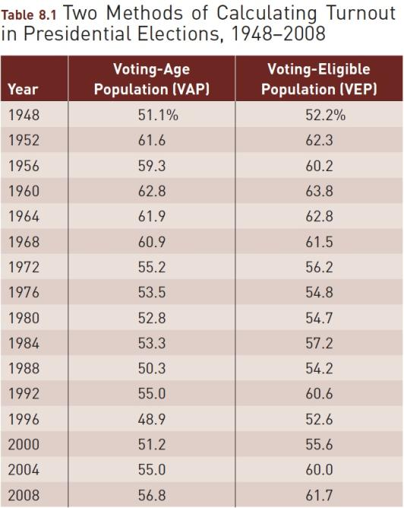
Source: Updated from Michael P. McDonald and Samuel L. Popkin, “The Myth of the Vanishing Voter,” American Political Science Review 95 (December 2001):
table 1, 966. Reprinted with permission of Cambridge University Press; Michael P. McDonald, “2008 General Election Turnout Rates,” updated April 26, 2009, at
http://elections.gmu.edu, accessed May 8, 2009.

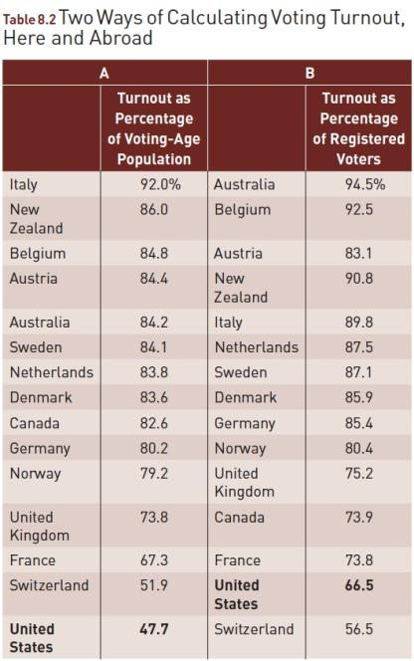
Source: Rafael Lopez Pintor, Maria Gratschew, and Kate Sullivan, “Voter Turnout Rates from a Comparative Perspective,” in Voter Turnout Since 1945: A Global Report (Stockholm, Sweden: International Institute for Democracy and Electoral Assistance, 2002).

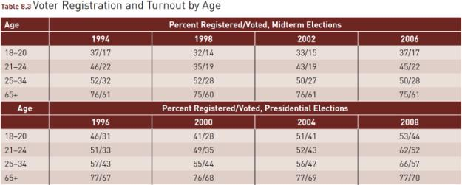
Source: Adapted from U.S. Bureau of the Census, Current Population Reports, June 2008, Table 400.

Figure 8.1 Voting and Registration
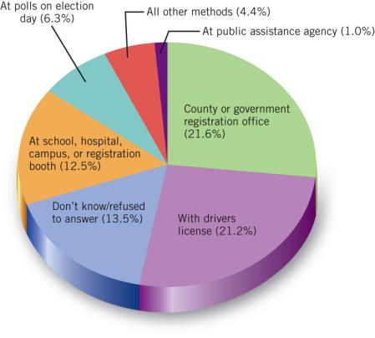
Source: U.S. Bureau of the Census, Current Population Survey,
“Voting and Registration,” June 2008.

The Rise of the American Electorate
- From State to Federal Control
  - Literacy test
  - Poll tax
  - Grandfather clause
  - White primary

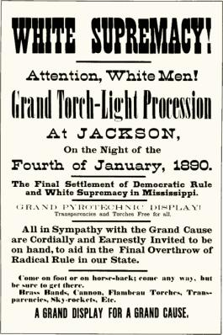
After Reconstruction ended in 1876, black voting shrank under the attacks of white supremacists, p. 188.

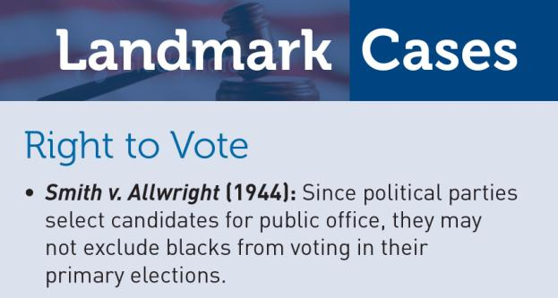
After the Civil Rights Act of 1964
was passed, blacks and whites
voted together in a small Alabama
town.

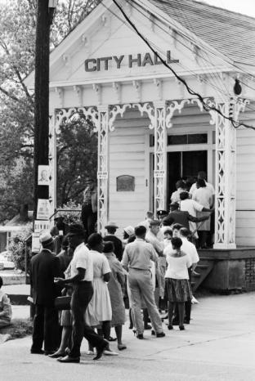
The campaign to win the vote for
women nationwide succeeded with the adoption of the Nineteenth Amendment in 1920.
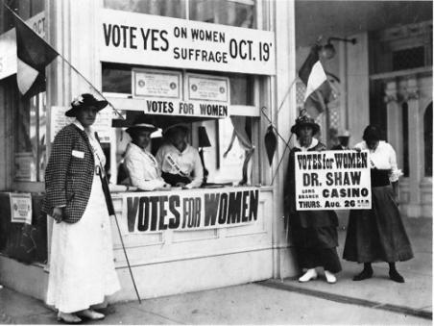

The Rise of the American Electorate
- Voter Turnout: Is the decline real?
  - Yes: There is a decline of popular interest in elections and a weakening of the competitiveness of the two major parties.
  - No: In the 1800’s and early 1900’s voting fraud was commonplace and there were few serious efforts to deter this behavior. Voting percentages were inflated.

Figure 8.2 Voter Participation in Presidential Elections, 1860–2008

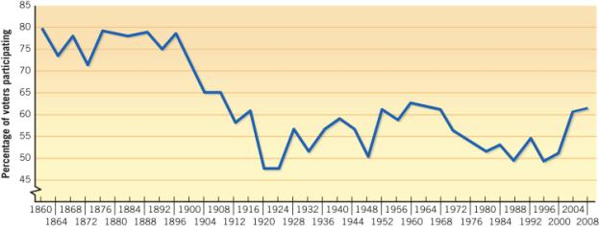
Note: Several southern states did not participate in the 1864 and 1868 elections.
Sources: For 1860–1928: Bureau of the Census, Historical Statistics of the United States, Colonial Times to 1970, part 2, 1071; 1932–1944: Statistical Abstract of the United States, 1992, 517; 1948–2000: Michael P. McDonald and Samuel L. Popkin, “The Myth of the Vanishing Voter,” American Political Science Review 95 (December 2001): table 1, 966; 2004 and 2008 elections, American National Election Studies (ANES).

Who Participates in Politics?
- Forms of Participation
  - Inactive
  - Voting specialists
  - Campaigners
  - Communalists
  - Parochial participants
  - Activists
- Participation: Causes and Meaning

In 2010 supporters of President Obama urged people to vote, but turnout fell and the Democrats suffered major losses.

Young women volunteers work
rebuilding an area in Katrina-damaged
New Orleans, p. 192.

Figure 8.3 Voter Turnout in Presidential Elections
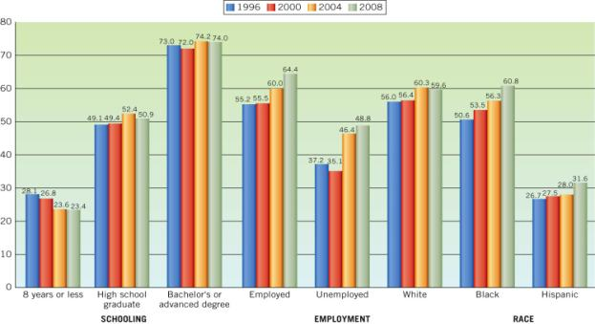
Source: Adapted from U.S. Bureau of the Census, Current Population Reports, June and November 2008.

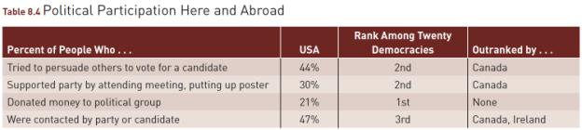
Source: Professor Martin Wattenberg, University of California-Irvine, using data from the Comparative Study of Electoral Systems.

In San Francisco, voting instructions are printed in English, Spanish, and Chinese, p. 194.

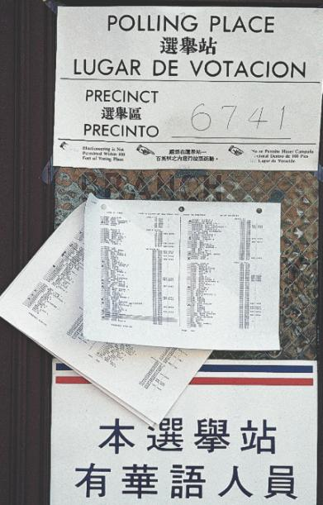

WHAT WOULD YOU DO?

M E M O R A N D U M
To: Senator Henry Gilbert
From: Peter Clark, legislative analyst
Subject: Voting reform legislation
In the 1990s, barely half of the electorate voted for president, and only a third or so cast ballots for congressional elections. In a few recent presidential primaries and statewide special elections, turnout has run 10 percent or below. Studies show that often citizens miss the opportunity to vote because of complications with work or child care. To address this problem, legislators from both parties support celebrating Veterans Day on Election Day, which would create a national holiday for voting. Eligible voters who do not go to the polls would be fined.

Arguments for:
1. This proposal honors veterans by recognizing their service with the fundamental requirement of representative democracy, rule by the people through voting.
2. A voting holiday ensures that people who cannot take off time from work or other responsibilities to vote have the opportunity to exercise their democratic right.
3. Imposing a fine for nonvoting sends a moral message that voting is a civic duty in a democracy. More citizens will feel morally obliged to vote if all citizens are legally obliged to do so.

Arguments against:
1. Just as veterans volunteer their service, so, too, should citizens volunteer to exercise their democratic responsibilities.
2. Voting is a right, but citizens have a civic duty to exercise that right, and the government should not, in effect, exercise that duty on their behalf. Moreover, people can vote by absentee ballot at their convenience.
3. Compulsory voting does not guarantee informed voting. It is both unwise and undemocratic to legally oblige people to vote.

Your decision:
Vote for bill?
Vote against bill?

