Chapter 9 – Political Parties

Overview
A political party exists in three arenas: Among the voters who psychologically identify with it, as a grassroots organization staffed and led by activists, and as a group of elected officials who seek to act on its ideals. This chapter studies the party primarily as an organization that takes on various forms at the local level. These include the political machine, the ideological party, the solidary group, the sponsored party, and the personal following.
National parties are weak coalitions of these local forums. As organizations that influence the political systems, parties are becoming even weaker. Voters no longer strongly identify with one of the major parties. The spread of the direct primary has made it harder for parties to control who is nominated for elective office, thus making it harder for the parties to influence the behavior of officeholders they once elected. Delegate selection rules, especially in the Democratic Party, have contributed to shifting the center of power away from officeholders and party regulars and toward the parties’ more ideological wings.
Minor parties have arisen from time to time, but the only ones that have affected the outcome of presidential elections have been those that began as splinter groups within one of the major parties. An example of such a party is the Bull Moose Progressives. The two-party system is maintained, and minor parties are discouraged, by an election system of winner-take-all, plurality elections. This arrangement makes voters fear that they will “waste” their vote if they vote for a minor party. Meanwhile, the primary system makes it possible for minor parties to wield influence through the major parties.

Chapter Outline
I. Introduction
- American political parties are the oldest in the world, dating back to the first decade of the republic.
- They may be in decline, but they are not dead or dying.
II. Parties—Here and Abroad
- Decentralization
- A political party is a group that seeks to elect candidates to public office by supplying them with a label (party identification) by which they are known to the electorate.
- Arenas of politics in which parties exist:
- The party exists as a label in the minds of the voters;
- as an organization—recruiting and campaigning for candidates; and
- as a set of leaders organizing and trying to control the legislative and executive branches.
- U.S. parties have become weaker in all three arenas.
- As label, they are weaker as evidenced by the fact that there are more independents and more split-ticket voting.
- As organizations, parties have become weaker since 1960s.
- As set of leaders, though, parties are still somewhat strong.
- Reasons American and European parties are different
- European parties are disciplined gatekeepers, to which voters are very loyal, though this has been declining recently.
- Federal system decentralizes power in United States.
- Early in U.S. history, the most important government decisions were made by the state and local governments, and this is where most of the political jobs were.
- National parties in those times were coalitions of local parties.
- As political power became more centralized, parties became even more decentralized and weaker.
- Parties are closely regulated by state and federal laws, which weaken them.
- Candidates are now chosen through primaries, not by party leaders.
- President is elected separately from Congress, and presidential appointees are drawn from many sources.
III. The Rise and Decline of the Political Party
A. The Founding
- Emergence of Republicans, Federalists: Jefferson versus Hamilton
- Loose caucuses of political notables
- Republicans’ success (Jefferson, Madison, Monroe) and Federalists’ demise
- Reflection of the newness of parties is seen in the weakness of this system.
B. The Jacksonians
- Political participation became a mass phenomenon.
- More voters to be reached; by 1832, presidential electors selected by popular vote in most states.
- Party built from the bottom up, rather than top down.
- This transformation is illustrated by the abandonment of presidential caucuses composed of congressional members.
- The caucus system was an effort to unite the legislative and executive branches by giving the former some degree of control over who would have a chance to capture the latter.
C. The Civil War and sectionalism
- Jacksonian system was unable to survive slavery and sectionalism.
- New Republicans became dominant because of:
- Civil War—Republicans relied on Union pride.
- William Jennings Bryan’s alienation of northern Democrats in 1896 deepened sectionalism.
- Most states were dominated by one party.
- Factions emerged within each party.
- Republicans broke into professional politicians (Old Guard) and progressives (mugwumps).
- Progressives initially shifted between parties to gain power, but then began attacking partisanship when the Republicans became dominant.
D. The Era of Reform
- Beginning in the 1900s, but chiefly since the New Deal
- Progressives pushed measures to curtail parties’ power and influence.
- Primary elections favored to replace nominating conventions.
- They also favored nonpartisan elections at city and (sometimes) state level.
- They argued against party-business alliances on the grounds that they were corrupting.
- They wanted stricter voter registration requirements in order to reduce fraud.
- They pressed for civil service reform in order to eliminate patronage.
- They were also able to institute the direct primary and to adopt procedures—called the initiative and referendum—so that citizens could vote directly on proposed legislation
- Effects
- It reduced the worst forms of political corruption.
- It also weakened all political parties—parties became less able to hold officeholders accountable or to coordinate across the branches of government.
E. Party realignments
- Critical or realigning periods: Periods when a sharp, lasting shift occurs in the popular coalition supporting one or both parties.
- The issues that separate the parties change, so the kinds of voters supporting each party change.
- Shift may occur at the time of the election or just after.
- Five realignments so far:
- 1800 (Jeffersonian Republicans defeated Federalists)
- 1828 (Jacksonian Democrats came into power)
- 1860 (Whig party collapsed; Republicans came into power)
- 1896 (Republicans defeated William Jennings Bryan)
- 1932 (Democrats came into office under FDR)
- Two kinds of realignments
- A major party is defeated so badly that it disappears, and a new party emerges.
- Two existing parties continue, but voters shift their loyalty from one to another.
- Clearest cases of realignment: 1860, 1896, 1932
- 1860: Slavery issue fixed new loyalties in the popular mind.
- 1896: Economic issues shifted loyalties to East versus West, city versus farm split.
- 1932: Economic depression triggered new coalition for Democrats.
- 1980: Not a new realignment
- Reagan won in 1980—not because of what he stood for, but because he was not Jimmy Carter.
- Could not have been a traditional realignment, because Congress was left in the hands of the Democrats
- Major shift in presidential voting patterns in the South
- 1972–2004: South has been more Republican than nation as a whole.
- If this continues, it will constitute a major regional realignment.
F. Party decline
- Evidence that parties are declining, not realigning
- Proportion of people identifying with a party declined between 1960 and 1980.
- Proportion of those voting a split ticket increased.
- Was almost unheard of in the nineteenth century, because voters were given ballots by the parties
- Became more common with the adoption of the office-bloc ballot (listing candidates by office instead of party)
IV. The National Party Structure Today (THEME A: PARTY STRUCTURE TODAY)
- Parties similar on paper
- State and local party organizations enjoy a great deal of autonomy from the national party apparatus.
- They control the process of delegate selection to the national nominating conventions by using primaries to select delegates.
- In recent years, there has been a trend where states compete to have their primaries held at the beginning of the delegate-selection process.
- Earlier primaries force presidential candidates to pay particular attention to these states in order to develop momentum by winning earlier primaries.
- This has resulted in a front loading of the delegate-selection process that the national parties are helpless to control.
  - National convention has ultimate power; meets every four years to nominate the presidential candidate.
  - National committee is composed of delegates from states; manages affairs between conventions.
  - Congressional campaign committees support the party’s congressional candidates.
  - National chair manages daily work
- Party structure diverged in late 1960s and early 1970s.
- RNC moved to bureaucratic structure.
- It became a well-financed party devoted to electing its candidates, especially to Congress.
- Beginning in 1980s, RNC used computerized mailing lists to raise money.
- Money was used to provide services to candidates.
- RNC effectively created a national firm of political consultants.
- Democrats moved to factionalized structure and redistributed power.
- Democrats lost five out of six presidential elections between 1968 and 1988.
- By the 1990s, DNC had learned from the RNC: Adopted the same techniques, with some success.
  - DNC and RNC send money to state parties to sidestep federal spending limits (soft money).
  - Campaign fundraising has reached new levels in both Presidential and Congressional campaigns. Significant amounts of money are raised using the Internet.
A. National Conventions
- National committee sets time and place; issues a “call” setting the number of delegates for each state and the rules for their selection.
- Formulas are used to allocate delegates.
- Democrats’ formula shifts delegates away from the South, to the North and West.
- Republicans’ formula shifts delegates away from the East, to the South and Southwest.
- Result: Democrats move left, Republicans move right.
- Democratic formula rewards large states whereas Republican formula rewards loyal states.
- Democrats set new rules.
- In 1970s, rules were changed to weaken local party leaders and increase the proportions of women, youth, blacks, and Native Americans attending the convention; superdelegates.
- Hunt Commission in 1981 increased the influence of elected officials and made the convention more deliberative.
- Consequence of reforms: Parties represent different sets of upper-middle-class voters.
- Republicans represent traditional middle class—more conservative.
- Democrats represent more leftist wing of the liberal middle class.
- To become more competitive, Democrats adopted additional rule changes.
- In 1992, three rules were set:
- Winner-reward system of delegate distribution banned—this had previously given the winner of primaries and caucuses extra delegates.
- Proportional representation was implemented.
- States that violated the rules were penalized with the loss of convention delegates.
- Delegates once selected by party leaders are now chosen by primaries or local caucuses.
- Conventions today only ratify choices made in primary season.
V. State and Local Parties (THEME B: UNITED STATES PARTIES AS BROAD COALITIONS)
- State-level structure
- State central committee
- County committees
- Various local committees
- Distribution of power varies with the state, because different incentives are at work.
A. The machine
- Political Machine: A party organization that recruits members via tangible incentives (money, jobs, political favors).
- High degree of leadership control over member activity
- Abuses were extensive.
- Gradually controlled by reforms—voter registration, civil service, Hatch Act (1939)
- Machines continued until voter demographics and federal programs changed, decreasing the need for the parties’ resources.
- New machine: Uses money to knit together many politicians, though money comes from campaign contributions, not from patronage and contracts.
- New machines are a blend of the old machine (regarding campaign finance) and today’s ideological party traits (regarding issues).
- Money once raised by patronage and contracts is now supplied by wealthy contributors and funds raised through direct mail.
B. Ideological Parties
- Extreme opposite to machine
- Principle is more important than winning election, so ideological parties are contentious and factionalized.
- Usually outside Democratic and Republican parties—“third parties”
- Currently are generally focused social movements, which advance specific demands
- Political machines were once the “farm club” of the national party, but today’s social movements perform that function.
- Factionalism is therefore more intense.
- Party leaders have less freedom.
C. Solidary Groups
- Members are motivated by solidary incentives (enjoying the game; companionship).
- Advantage: Neither corrupt nor inflexible
- Disadvantage: Not very hard working
D. Sponsored parties
- Created or sustained by another organization
- Example: Detroit Democrats were developed and led by the United Auto Workers (UAW) union
- Not very common in United States
E. Personal following
- Requires an appealing personality, an extensive network, name recognition, and money
- Examples: Kennedys (MA), Talmadges (GA), Longs (LA), and Byrds (VA)

Chapter 9 Teacher Notes

Political parties are the main vehicles for nominating candidates and running campaigns. They serve as linkage institutions that help bring the concerns of the electorate to the political arena through elections. Political parties also unite groups of politicians and the electorate by offering an ideological framework with which people can choose to identify themselves. The United States has for the most part always had a two-party system.

- The Meaning of Party
  - Political Party – a group that seeks to elect candidates to public office by supplying them with a label – a party identification – by which they are known to the electorate.
  - The two main political parties in the U.S. are the Democratic Party and the Republican Party.
    - Democrats tend to be more liberal towards issues.
    - Republicans tend to be more conservative towards issues.
    - Both parties usually remain fairly moderate to achieve a majority.
- The Role of the Party in the Electorate
  - Many voters cast their ballots on the basis of party identification. For instance, people who consider themselves Democrats usually vote for Democratic candidates.
  - However, party identification is declining. As of 2000, the plurality (majority) of voters considered themselves Independent rather than Democratic or Republican.
  - Ticket splitting, or voting for members of different parties for different offices in an election, is also on the rise. This practice leads to a divided party government (the President may be a member of a different party than the majority party in Congress).
- Duties of Political Parties
  - Choosing candidates – Originally parties internally nominated their candidates to run in an election. Today, the public can choose candidates in primary elections.
  - Running campaigns – Parties organize political campaigns and try to convince voters to elect their candidate. Today, by directly communicating with the public (mainly through television), candidates can operate more independently from their parties.
  - Providing a political identity – Each party has an image. This offers the public a familiar ideology or platform with which they can choose to identify themselves and identify politicians. The rational-choice theory (proposed by Anthony Downs) provides a model of the relationship between parties and voters, which assumes that individuals weigh the cost and benefits of their choices and choose the party closest to them.
  - Endorsing specific policies – Politicians of a party often support each other, because typically they agree on a general party platform.
  - Coordinating policymaking – Through party identification, politicians in different branches of government are able to work together or support each other.
- The Three Arenas Where Political Parties are Found (And Why They Have Weakened)
  - Labels – Where they stand in the minds of the voters (people see themselves with weaker party identifications than before, far less weaker than the 19th century but not as weak 40 yeas ago)
  - Organization – Recruiting and campaigning for candidates (as time as passed, parties have become weaker in the recruiting and campaigning process).
  - Set of Leaders – those who control the legislative and executive branches of the government (people are losing faith in those who they elect).
- The U.S. versus Europe (stronger in Europe)
  - Because of federalism, political authority is decentralized but with a significant power at the state and local levels (decisions regarding education, land use, business regulation, and public welfare).
  - Also, state and federal laws closely regulate political parties. Even though political authority is increasing becoming centralized, political authority is still decentralized
  - Party leaders do not select people to run for office, voters in primary elections do this. In Europe, there is no such thing as a primary election. The only way one can become a candidate for office is to persuade party leaders to put their name on the ballot.
  - In the American political system, the party that wins control of Congress does not have the power to choose their chief executive of government (unlike most European parliaments). The American President chooses this person. A Congressional member must resign from their position in order to be accepting this position (a cabinet secretary). Therefore, the President cannot use the appointment of such a position to gain a political advantage.
  - Last, the political culture in Europe is different in America.
    - Political parties do not play a major role in the lives of most Americans (other than voting). Our social, business, working, and cultural lives are almost entirely nonpartisan. Parties play a segmental role, not a comprehensive role.
    - This is not the case in Europe:
      - Many Europeans join political parties and pay dues and attend meetings
      - In some European countries (France, Austria, and Italy), political parties sponsor a wide range of activities and dominate a variety of associations to which a person may belong (labor unions, youth groups, educational programs, etc.)
- The Rise and Decline of Political Parties
  - Most democratic nations have multiparty systems that allow many interest to be represented. The United States, however, has always had a two-party system. Political scientists divide American history into party eras in which one party dominated politics for a significant period of time. Party eras change when a critical election reveals new issues and a failure of the traditional coalitions. This usually causes party realignment, when the party redefines itself and attracts a new coalition of voters. Good examples include:
    - Election of 1860 – Republicans become a major party
    - Election of 1932 – begins the era of the New Deal
  - Party Eras in American History
    - The First System (1796-1824)
      - Thomas Jefferson and Alexander Hamilton had a number of policy disagreements even while serving George Washington
      - Hamilton’s short-lived Federalist Party was the first political party.
      - Jefferson’s Democratic-Republicans (Anti-Federalist) maintained control of the White House.
      - This “Republican” party was not the precursors of the Republican Party we know today.
      - Even though the Democratic-Republicans maintained control of the White House for some time, both parties were weak.
    - The Democrats and the Whigs (1828-1856)
      - During the Election of 1832, land requirements that once restricted many poor Americans were lifted, therefore allowing the “common man” the opportunity to vote.
      - Andrew Jackson appealed to this group (the majority) and won the election. He formed a new party that eventually became the Democratic Party
      - The opposition party was known as the Whig Party, which battled the Democrats on issues such as slavery and nativism. The Whig Party had little political success.
    - The Two Republican Eras (1860-1928)
      - The Republican Party was formed out of a coalition of antislavery groups and nominated Abraham Lincoln as its first presidential candidate in 1860.
      - During this era, it was the Democratic Party (especially in the South) that maintained a conservative party identity, reluctant to extend rights to African Americans and women.
      - After the Civil War, Republicans were seen as liberals (Moderates and Radicals) while Democrats were conservative
      - The election of 1896 began another strongly Republican era during which industrialization and capitalism were advanced.
      - Overall the sectionalism led to major trends
        - States became one-sided or one-party states
        - Factions started to form within the political parties (especially within the Republican party)
          - Party regulars (stalwarts) or the Old Guard
          - Mugwumps/Progressives (reformers)
    - The New Deal Coalition (1932-1964)
      - Franklin Roosevelt brought the Democratic Party back into favor by starting scores of federal programs to combat the Great Depression.
      - The new Democratic coalition brought together the poor, southerners, African Americans, city dwellers, Catholics, and Jews.
      - During this era there were many changes in voting behavior
        - Primary elections become more popular than nominating conventions
        - Nonpartisan elections became very common in both state and local elections
        - Party alliances with businesses ceased
        - Strict voter registration requirements became the norm
        - As well as civil service reforms to eliminate patronage (support from politicians)
        - Initiative and referendum measures were started in many states to allow voters to decide directly on proposed legislation
      - John F. Kennedy’s New Frontier (a program designed to boost the economy, provide international aid, provide national defense, and being the space race) and Lyndon B. Johnson Great Society (a program created to create social reforms – eliminate poverty and racial injustice) and War on Poverty continued the Democratic New Deal tradition.
    - The Era of Divided Party Government (1968-Present)
      - In recent years both parties have seem to be decaying and declining.
      - During this era, many voters practice split ticket voting.
      - Johnson’s poor handling of the Vietnam War paved the way for the election of Republican Richard Nixon.
      - Nixon was the first president to be of a different party from the majority in Congress during his era. This has since happened several times, and may continue as voters become more independent. Political scientists call this phenomenon party dealignment.
      - More recently this party dealignment has been characterized by party neutrality, where there is growing indifference (lack of interest) toward political parties.
      - A divided government makes policymaking difficult and leads to gridlock when the president and Congress do not agree
- The Two-Party System and Minority Parties – The United States has a two-party system that dates back to the original parties (the Republics and the Federalist). Several unique features are responsible for the longevity of such a system:
  - Types of Elections – Elections at every level are based on the plurality, winner-take-all method.
    - Plurality System
      - A plurality system means that the winner is the person who gets the most votes, even if he or she does not get a majority of all votes cast.
    - Winner-take-all method
      - The presidential candidate who wins the most popular votes in a state is all of that state’s Electoral College votes. (In all states but Nebraska and Maine)
      - Minority parties cannot compete under this system because they are unable to get enough votes to defeat a major party candidate.
  - The options of the voters – Most voters have been satisfied to let their individual beliefs fall into one of the two broad coalitions that the two parties represent.
  - Criticisms of the two-party system
    - There is little choice for voters because the two parties keep to the middle of the road.
    - There is less opportunity for political change.
    - It is so decentralized that it fails to translate campaign promises into policy because politicians do not have to vote with the party line.
- Minority Parties and Their Impact on American Politics – Though rarely successful at getting candidates elected, minority parties (or third parties) have often come on the American political scene.
  - Reasons Why We Have Minority Parties
    - Arise to challenge the two party parties, but rarely gain enough support to put a candidate in office.
    - Some parties form around a specific cause.
    - Some are splinter parties, formed from smaller factions of the two major parties.
    - Some form around a specific individual.
  - Affects of minority parties
    - Though they rarely win, third-party candidates do force particular issues onto the political agenda and allow Americans to express their discontent with the two major parties.
    - They may also shift the votes of the electorate. Many political scientists think George W. Bush won the 2000 election because Green Party candidate Ralph Nader took votes away from Democrat candidate Al Gore.
  - Categories of minority parties
    - Ideological parties – These tend to be at the edges of the political spectrum. Some examples are the Socialist party, the Communist party, the Green party, and the Libertarian Party.
    - One-issue parties – Minor parties often address a single issue. Examples include the Prohibition Party (to ban alcohol) and the Women’s party (to obtain women’s voting rights).
    - Economic protest parties – These parties, often regional, protest against depressed economic conditions. Examples include the Populist party, the Reform party (under Ross Perot), and the Greenback party.
    - Factional parties – Splits in the major parties can create a factional party, usually over the identity and philosophy of the major party’s presidential candidate. Examples include the “Bull Moose” Progressive party and the States’ Rights party. These types of parties usually have the greatest influence on policy making (the threat of a factional split is significant to either party, and the major parties often go to great lengths to avoid such a split).
- The National Party Structure Today
  - The Similarities of the Political Parties
    - Both hold national conventions every four years to nominate a presidential candidate.
    - Both have a national committee
- Composed of delegates from various states.
- Manage affairs between conventions.
    - Both have congressional campaign committees who support congressional candidates with party money.
    - Both have a national chair that manages daily work.
  - The Different Structural Paths the Parties Have Taken in the 60’s-70’s.
    - Republicans
- Became well financed.
- Created a highly staffed organization devoted to funding and electing “true” Republican candidates, especially in Congress.
- The first to take advantage of computerized mailings, building a huge file of names of people who had given or might give money to the party.
- Eventually the Democrats adopted this system as well
- Both parties began to focus on sending money to state parties, sidestepping federal spending restrictions, a loophole referred to as soft money
    - Democrats – Changed their rules for nominating presidential candidates
      - Altered the distribution of power in the party.
      - Made the Republicans a more efficient bureaucracy (administrative system)
      - Democrats became more factionalized (split).
  - National Convention Differences
    - Delegates – a member of a political party who participates in the convention process
      - Democrats – Shifted voting strength away from the South and into the North and the West
      - Republicans – Shifted voting strength away from the East and into the South and Southwest
    - The McGovern-Fraser Commission – Created by the Democrats to change the rules of their national convention
      - The main purpose was to make representation more diverse
        - Weakened the power of local party leaders
        - The proportion of women, African Americans, youth, and Native Americans increased
      - Later reforms reestablished some of the influence of elected officials by reserving 14% of the delegates for party leaders and elected officials, who would not have to commit themselves in advance to a presidential candidate (superdelegates – party leaders and elected officials who become delegates to the national convention without having to run in primaries or caucuses.)
    - Distribution of Democratic Delegates
      - State delegates are divided among candidates who receive at least 15% of the vote in the primary or caucus
      - This differed from the traditional winner-reward system that gave primary and caucus winners extra delegates.
      - States that violate the rules are now penalized with the loss of 25% of their national convention delegates.
  - Additional Changes in the National Convention (Permanently?)
    - Members are chosen through primary elections and grassroots (ordinary people in the community) caucuses. Party leaders once selected delegates
    - As a result, party conventions are no longer a place where party members meet to bargain over the selection of their presidential candidates.
    - Today, they are a place where delegates come together to ratify choices already made by party activist and primary voters.
- State and Local Parties
  - Every state has a Democrat party and a Republican party. Each have the following
    - State central committee
    - County committees
    - Various local committees (not in all cases)
  - National party structures have changed, but grassroots organizations have withered. As a result, state party systems have sought to redefine their role.
  - Political Machines – a party organization that recruits its members by the use of tangible incentives (money, political jobs, and opportunities to receive favors from the government)
    - Gave control to the party leaders who control the political machines
    - Created a common use of abuses and scandal
    - Things that halted the corruption
      - Voting registration
      - Civil service
      - Hatch Act – makes it illegal for federal civil service employees to take an active part in the political campaign while being employed.
      - The fact that voters stared to become more educated, wealthier, and sophisticated. Voters now need less help and leadership from local party officials.
      - Today voters are drawn to ideological groups
      - Voters also understand the “game” of politics
- Delegates and Voters
  - The Presidential Candidate Must Be:
    - Appealing
    - Moderate
    - Make compromises to satisfy the dissidents
  - Characteristics
    - Democratic candidates are often more liberal
    - Republican candidates are often more conservative
    - Both are issue-oriented
  - At times parties can nominate a candidate that is unacceptable to the party’s rank-and-file voters
    - This is the reason why there are a lower number of Democratic presidential candidates who are elected into office since the 1968 (several liberal candidates who lacked appeal to moderate voters).
    - 1964 – Barry Goldwater for the Republican Party
  - Campaigning
    - Candidates must limit themselves to issues that most of the party agrees on because of the wide range of beliefs within a party.
    - However, by doing this, the candidate can risk losing the vote of the more ideologically extreme voters.

- WHO GOVERNS?
  - How has America’s two-party system changed, and how does it differ from the party systems of other representative democracies?
  - How much do parties affect how Americans vote?
- TO WHAT ENDS?
  - Did the Founding Fathers think political parties were a good idea?
  - How, if at all, should America’s two-party system be reformed?

Parties - Here and Abroad
- Political Party – A group that seeks to elect candidates to public office.
- A political party exists as
  - A label
  - An organization
  - A set of leaders

Figure 9.1 Decline in Party Identification, 1952–2008
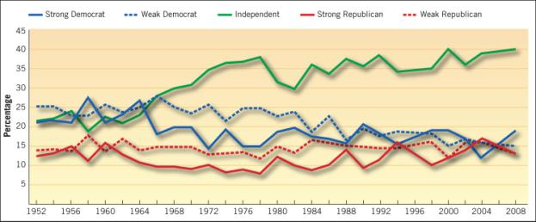
Source: American National Election Studies, Table 2A.1, “Party Identification, 1952–2008.”

The United States Versus Europe

- In Europe, political parties tend to have more influence because:
  - Candidates for elective office are usually nominated by party leaders
  - Campaigns are run by the party and not the candidate
  - Once in office, the elected official is expected to vote and act together with the members of his party

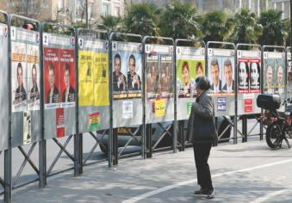

There are so many political parties in France that
in 2007 a woman could study pictures of twelve
candidates to be president.

The Rise and the Decline of the Political Party

- The Jeffersonian Republicans
- The Jacksonians
- The Civil War and Sectionalism
- The Era of Reform
- Party Realignments
- Party Decline

When Andrew Jackson ran for president in 1828, over a million votes were cast for the first time in American history. This poster, from the 1832 election, was part of the emergence of truly mass political participation, p. 207.
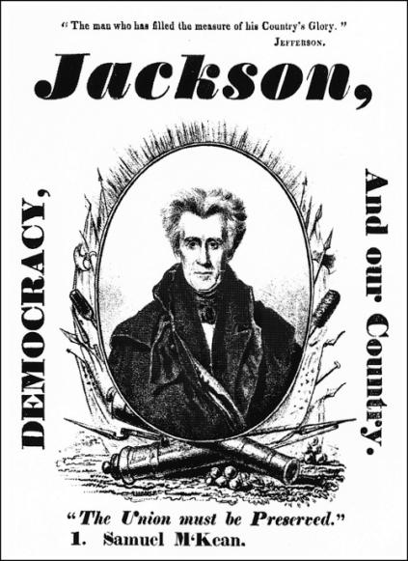

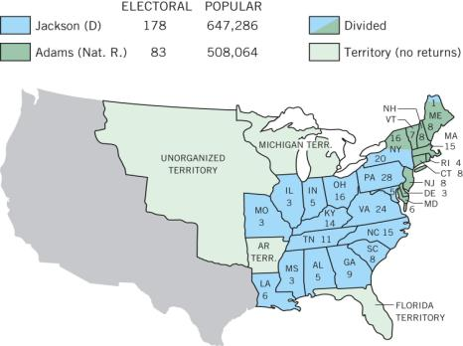
The Election of 1828.

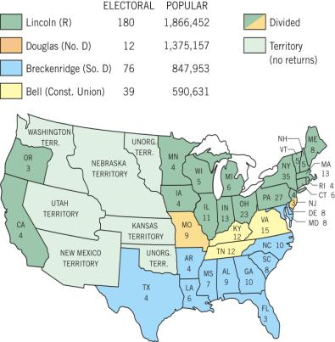

The Election of 1860.

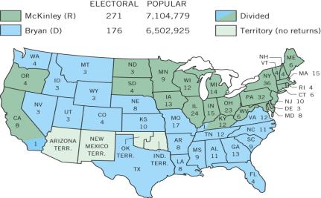
The Election of 1896.
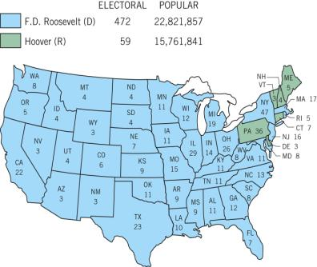
The Election of 1932.

Figure 9.2 Split-Ticket Voting for President/Congress, 1952–2008
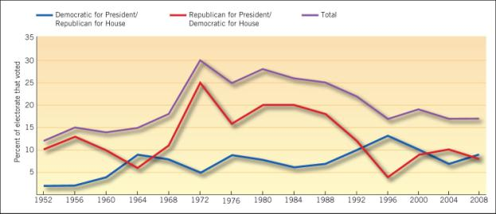

Source: American National Election Studies, Table 9B.2, “Split-Ticket Voting for President/Congress, 1952–2008.”

The National Party Structure Today

- National convention
- National committee
- Congressional campaign committee
- National chairperson

Figure 9.3
Cleavages and Continuity in the Two-Party System

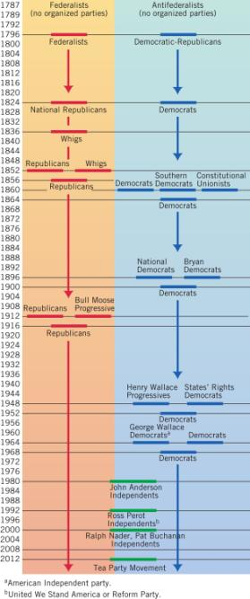

a American Independent party.
b United We Stand American or
Reform Party.

Figure 9.4: Cost of Winning a Congressional Election, 2002–2010

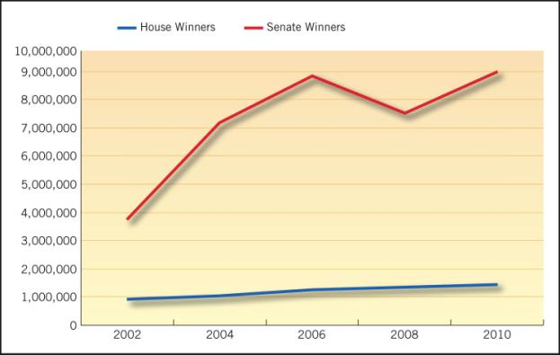

Source: Campaign Finance Institute, updated data from Vital Statistics on Congress, ed. Michael J. Malbin, Norman J. Ornstein, and Thomas E. Mann (Washington, D.C.: Brookings Institution Press, 2008).

President Obama in 2011 used an e-mail and a video to tell his followers that he was going to run for reelection in 2012. Digital communication has become more important for both parties.

Who Are the Party Delegates?
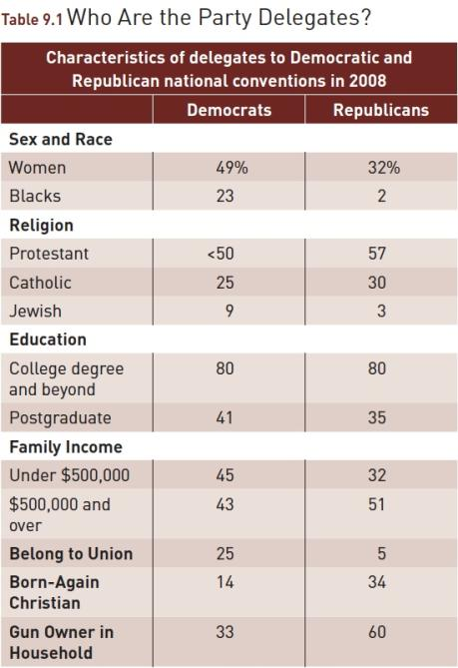
Source: 2008 CBS News/New York Times delegate polls.

State and Local Parties

- The Machine
- Ideological Parties
- Solidarity Groups
- Sponsored Parties
- Personal Following

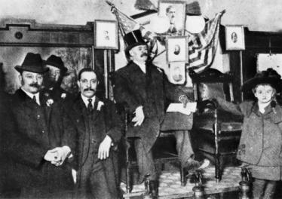
By permission of the Houghton Library/Harvard University

Ex-Senator George Washington Plunkitt of Tammany Hall explains machine politics from atop the bootblack stand in front of the New York County Courthouse around 1905, p. 217.

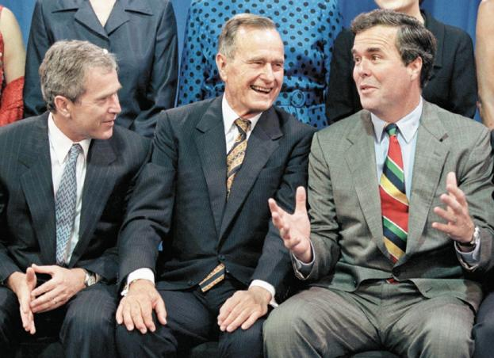
The personal following of former President George Bush was passed on to his sons, George W. (left) and Jeb (right), both of whom became governors of large states, and the former of whom became president, p. 220.

The Two-Party System

WHY HAS THE TWO-PARTY SYSTEM PERSISTED IN THE UNITED STATES?
- Plurality System
- Voter Opinion
- State Laws

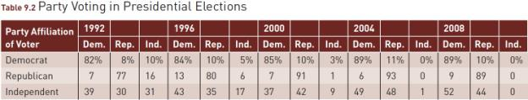
Source: Data from CNN exit polls for each year.

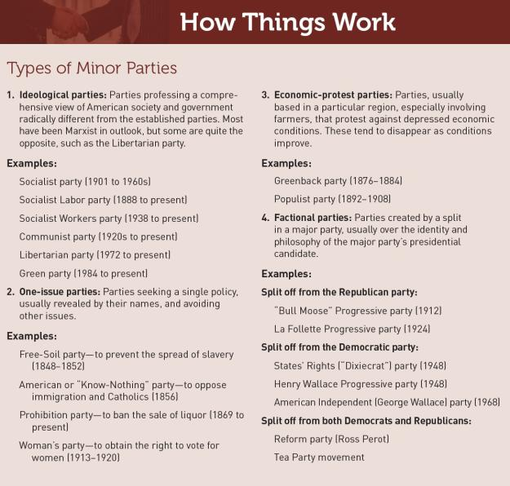

Minor Parties

- Ideological
- One-Issue
- Economic-Protest
- Factional

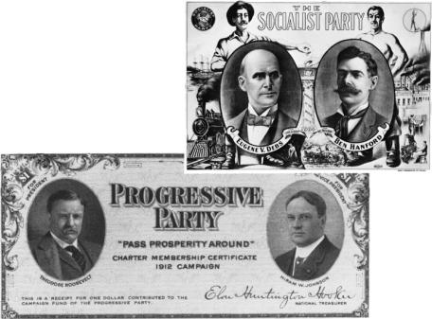

The Socialist party and the Progressive party were both minor parties, but their origins were different. The Socialist party was an ideological party; the “Bull Moose” Progressive party split off from the Republicans to support Theodore Roosevelt.

Nominating a President

- Are the delegates representative of the voters?
- Who votes in primaries?
- Who are the new delegates?

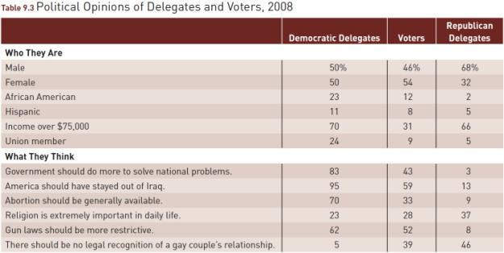
Source: 2008 CBS/New York Times polls.

WHAT WOULD YOU DO?

M E M O R A N D U M
To: Elizabeth Ramos, campaign manager
From: Isaac Marx, political consultant
Subject: Independent voters in the upcoming presidential election
As you prepare for the upcoming presidential campaign, you need to consider how your candidate can build support among the growing number of independent voters. To do so, she must establish a centrist party platform that will appeal to voters beyond the party faithful.

Arguments for:
1. Independent and third-party voters can garner votes for president or tip an election result. In 1992, Ross Perot won nearly a fifth of the votes. In 2000, Green party candidate Ralph Nader got only 3 percent, but that included 100,000 votes in Florida where Republican Bush was credited with only 600 votes more than Democrat Gore.
2. Third-party voters can make a mark on American politics. Third parties have advocated policies later championed by the two main parties: abolishing slavery (Free-Soil party), women’s right to vote (Woman’s party), direct election of U.S. senators (Progressive party), and many others. The candidate can break out of the field of contenders by advocating far-reaching policy change that will appeal to independent voters.

Arguments against:
1. Independent and third-party voters do not direct the national agenda. It is virtually impossible for their candidates to win, thanks to the winner- take-all system of elections. Since the 1850s, over a hundred third parties have come and gone. Better to be attentive to concerns within the major party than to be distracted by issues that are not central to victory. The two major parties have a long history of taking issues that are important to independent voters and making them more palatable to the larger electorate, which is more effective than appealing directly to independent voters.

Arguments against:
2. In the 1930s, the Democrats plucked Social Security from the Socialist party’s far-reaching plan. In the 1980s, the Republicans’ position on taxes only faintly echoed the Libertarian party’s.
3. In a close election, building support among likely and predictable voters is a more effective strategy than reaching out to possible but unpredictable voters.

Your decision:
Create a centrist platform?
Keep the platform focused on core party issues?

