Chapter 10 – Elections and Campaigns

Overview
Political campaigns have become increasingly personalized with little or no connection to formal party organizations. Party influence has decayed as a result of the widespread adoption of the direct primary, the increasing influence of the media, and the workings of campaign finance law. Today, candidates face the problem of creating a temporary organization that can raise money from large numbers of small donors and mobilize enthusiastic supporters; they must win the nomination by appealing to the party faithful while not losing their ability to recruit moderate and independent voters in the general election.
Election outcomes can have important effects on public policy, especially during critical, or realigning, elections. On these occasions, new voters enter the electorate in large numbers, old party loyalties weaken, and/or a crucial issue splits the majority party.

Chapter Outline
I. Introduction
- Many things have changed, but the key changes are related to one another: parties are less important; media (or “media buys”) are more important; polling is ubiquitous; and money—or the nonstop fundraising that keeps it coming—matters more than ever.
II. Campaigns Today
- Political parties have limited control over the nomination process in both Presidential and Congressional races. Candidates must orchestrate a highly structured campaign.
- Campaigns are run by large staff.
- Media consultants create advertisements and buy air time from media outlets.
- Direct-mail firms design and produce promotional materials for fundraising purposes.
- Polling firms survey voters on their attitudes toward issues and candidates and run focus groups.
- Political technology firms supply services such as Web site design, online advertising, online fundraising, and voter-targeting.
- To pay for this help, candidates must raise and spend large sums of money.
  - Candidates for the 435 House races spent $1 billion.
  - Candidates for Senate races spent $400 million.
  - Candidates for president spent $1.75 billion.
  - The amount spent by presidential candidates has exploded since 1976 with most of the money going to fund various forms of media, including TV, radio, newspapers, yard signs, and the Internet.
- Largely based on media advertising
- Large amount of money is spent on media advertising.
- Advertisements appeal largely to emotions, such as fear, patriotism, or community pride.
A. Better or Worse?
- Candidates use polling data to determine voter opinions, positions.
- In 2008, both presidential campaigns made extensive use of micro-targeting software to reach sets of voters.
- Parties emphasize get-out-the-vote activities.
- Candidates rely heavily on advice of political consultants.
- Campaigning has become synonymous with fundraising.
B. HERE AND ABROAD
- Differences in how candidates secure party nominations
- In America, the nomination is determined by individual effort.
- In Europe, the nomination is determined by party leaders.
- Differences in how nominees secure electoral victory
- In America, largest role of parties is to provide individual candidates with label for voters.
- In Europe, elections are largely contests between parties, not between individual candidates.
III. Presidential versus Congressional Campaigns
- Differences
- Most obvious difference is size: More voter participation in presidential campaign so candidates must work harder and spend more.
- Presidential races are more competitive than House races.
- Lower turnout in off years means that candidates must appeal to more motivated and partisan voters.
- Members of Congress can do things for their constituents that the president cannot.
- Members of Congress can run as individuals, distancing themselves from “the mess in Washington”; presidents cannot.
- However, members of Congress may feel voter anger about national affairs, particularly the economy.
- Presidential coattails do not have the value they once had; some scholars argue they do not exist anymore.
- Congressional elections are now substantially independent of the presidential election.
A. Running for president
- Getting mentioned
- David Broder: “The Great Mentioner”
- Let it be known to reporters “off the record” that you are considering running.
- Travel around the country making speeches.
- Have a famous name (John Glenn).
- Be identified with a major piece of legislation.
- Be the governor of a big state.
- Setting aside time to run
- Reagan: Six years; Mondale: Four years
- May have to resign from office first (Dole in 1996), though many campaign while in office.
1. Money
- Individuals can give $2,000; PACs can give $5,000 in each election to each candidate.
- Candidates must raise $5,000 in twenty states in individual contributions of $250 or less to qualify for federal matching grants to pay for primary campaigns.
2. Organization
- A large (paid) staff
- Volunteers
- Advisers on issues: Position papers
3. Strategy and Themes
- Incumbents defend their record; challengers attack incumbents.
- Setting the tone (positive or negative)
- Developing a theme: “trust,” “confidence,” “compassionate conservatism”; in 2008, Barack Obama developed the themes “Change you can believe in” and “Yes, we can”.
- Judging the timing (early momentum versus reserving resources for later)
- Choosing a target voter: Who is the audience? Who will change his or her vote?
B. Getting elected to Congress
- Incumbents with extraordinary advantage—and Congress has no term limits
- Each state has two senators; number of House representatives is based on state population, as determined by the census.
- House members are now elected from single-member districts.
- District boundaries can affect election outcomes; two enduring problems have characterized congressional electoral politics.
- Malapportionment: Districts have very different populations, so the votes in a less-populated district “weigh more” than do those in a more-populated district.
- Gerrymandering: Boundaries are drawn to favor one party rather than the other, resulting in odd-shaped districts.
- Problems associated with House elections:
- Total size of the House, which Congress decided in 1911
- Allocating House seats among the states (states gain and lose seats following the census)
- Determining the size and shapes of congressional districts within the states, which states have decided in keeping with stringent Supreme Court rulings
1. Winning the Primary
- Must gather voter signatures to appear on the ballot for a primary election.
- Win party nomination by winning the primary election; parties have limited influence over these outcomes.
- Run in the general election; incumbents almost always win: “sophomore surge” due to use of office to run a strong personal campaign.
- Personalized campaigns offer members independence from party in Congress.
2. Staying in Office
- How members get elected has two consequences:
- legislators are closely tied to local concerns; and
- party leaders have little influence in Congress because they cannot influence electoral outcomes.
- Affects how policy is made: Members gear their offices to help individual constituents while securing committee assignments that will produce benefits for their districts.
- Members must decide how much to be delegated (do what district wants) versus trustees (use their independent judgment).
IV. Primary versus General Campaigns (THEME A: HOW CAMPAIGNS ARE CONDUCTED)
- Primary and general campaigns
- What works in a primary election may not work in a general election and vice versa.
- Voters, workers, and media attention are different depending on types of elections.
- Must mobilize activists who will give money, volunteer, and attend caucuses.
- Activists are more ideologically stringent than are the voters at large.
- Iowa caucuses
- These are held in February of presidential election year.
- Candidates must do well or be disadvantaged for media attention, contributor interest.
- Winners tend to be most liberal Democrat and most conservative Republican.
- The balancing act
- Candidate must be conservative enough or liberal enough to get nominated.
- Once nominated, move to center to get elected.
- Apparent contradictions can alienate voters from all candidates.
- Even primary voters can be more extreme ideologically than average voters: Kerry took more extreme positions in 2004 primaries, backed away from them after winning Democratic nomination.
A. Two Kinds of Campaign Issues
- Position issues: Issues in which rival candidates have opposing views and voters are divided; a partisan realignment may result.
- Position issues in 2000: Social security, defense, and public school choice systems
- In 2008 McCain favored tax cuts whereas Obama favored increasing taxes for people earning over $200,000.
- Great party realignments (e.g., 1890s, 1960s) have been based on position issues.
- Valence issues: Issues on which nearly everyone agrees (strong economy, low crime rates, and health-care reform)
    - Voters select candidate who seems most closely linked to universally shared view.
    - Increasingly important because television leads to a reliance on popular symbols and admired images
    - The 2008 campaign relied on both valence and position issues. Both Obama and McCain supported “reforming” the health care system to make it “affordable.”
B. Television, Debates, and Direct mail
- Paid advertising (spots)
- Little-known candidates can increase name recognition through the frequent use of spots (example, Carter in 1976).
- Spots have probably less effect on general than primary elections, because most voters rely on many sources for information.
- News broadcasts (“visuals”)
- Cost little
- May have greater credibility with voters
- Rely on having television camera crew around
- May actually be less informative than spots and therefore make less of an impression
- Debates
- Usually an advantage only to the challenger
- Reagan in 1980: Reassured voters by his performance
- 2008 Barack Obama and John McCain: No clear winner; not likely to have affected the election results
- Risk of slips of the tongue on visuals and debates
- Forces candidates to rely on stock speeches that set campaign themes along with their ability to string together proven applause-getting lines
- Sell yourself as much as or more than ideas
- Ross Perot’s campaign depended on television.
- CNN appearances
- Infomercials
- Televised debates with major party contenders
- In 1996, major networks gave free time to “major” candidates, and denied it to minor third-party nominees
- The Internet
- Makes direct-mail campaigns possible
- Allows candidates to address specific voters via direct mail
- Mailing to specific groups so more specific views can be expressed
- Howard Dean’s 2004 campaign was based on Internet appeals.
- The gap between running a campaign and running the government has been growing.
- Party leaders had to worry about their candidates’ reelection, so campaigning and government were linked.
- Today’s consultants work for different people in different elections and do not participate in governing.
V. Money (THEME B: MONEY IN ELECTORAL CAMPAIGNS)
A. The Sources of Campaign Money
- Presidential primaries: part private, part public money
- Federal matching funds for all individuals’ donations of $250 or less
- Gives candidates an incentive to raise money from small donors
- Government also gives lump-sum grants to parties to cover convention costs.
- Presidential general elections: All public money up to a legal limit of major party candidates and part of the costs of minor party candidates if they receive 5 to 25 percent of the vote
- Congressional elections: Mostly private money
- From individuals, political action committees, and political parties
- Most money comes from individual small donors ($100–$200/person)
B. Campaign finance rules
- In 1972, the Watergate scandal and illegal donations from corporations, unions, and individuals catalyzed change.
- Brought about the 1974 Federal Campaign Reform Law and Federal Election Commission (FEC)
- Reform law
- Set limit on individual donations ($1,000 per candidate per election)
- Reaffirmed ban on corporate and union donations . . .
- . . . but allowed them to raise money through PACs
- PAC requirements:
- Must have at least fifty voluntary members
- Must give to at least five federal candidates
- Limited to giving $5,000 per election per candidate, or no more than $15,000 per year to any political party
- Primary and general election counted separately for donations
- Public funding for presidential campaigns:
- Matching funds for presidential primary candidates who meet fundraising stipulations
- Full funding for presidential general campaigns, for major party candidates
- Candidates may decline public funding: In 2004, George W. Bush, John Kerry, and Howard Dean did not accept public funding and ran on money they had raised privately.
- In 2008, John McCain declined public financing for the primaries but accepted it for the general election. Barack Obama relied entirely on his own funds to support his campaign in the primaries and general election.
- Partial funding available for minor party presidential candidates in the general campaign if they won at least 5 percent of the vote in the previous election. (In 2000, the Reform Party and Green Party candidates, Pat Buchanan and Ralph Nader, respectively, each received some funding; neither was eligible in 2004.) No minor party won more than 5 percent in either 2004 or 2008, so no one got public support.
- The 1973 reform produced two problems:
- Independent expenditures: an organization or PAC can spend as much as it wishes on advertising as long as it is not coordinated with a candidate’s campaign.
- Soft money: Unlimited amounts of money may be given to a political party as long as a candidate is not named; this money can then be spent to help candidates with voting drives and so on. (Approximately half a billion dollars in soft money was spent in 2000 and again in 2004.)
C. A second campaign finance law
- Following 2000 election, desire to reform the 1974 law led to the Bipartisan Campaign Finance Reform Act, which enacted three changes:
- banned soft money contributions to national parties from corporations and unions after 2002 election;
- raised the limit on individual donations to $2,000 per candidate per election; and
- sharply restricted independent expenditures.
- Corporations, unions, trade associations, and nonprofit organizations cannot use their own money for an advertisement referring to a candidate by name for thirty days before a primary and sixty days before a general election.
- Immediately challenged in court as restriction of free speech (McConnell v. Federal Election Commission, 2002); the Supreme Court upheld almost the entire law
D. New sources of money
- 527 organizations: A new source of money under the Bipartisan Campaign Reform Act
- Designed to permit the kind of soft-money expenditures once made by political parties
- Can spend their money on politics so long as they do not coordinate with a candidate or lobby directly for that person
- Democratic 527 organizations:
- The Media Fund
- America Coming Together
- America Votes (and many others)
- Republican 527 organizations:
- Progress for America
- The Leadership Forum
- America for Job Security (and many others)
- In 2004, 527 organizations raised and spent over one-third of a billion dollars.
E. Money and winning
- Presidential candidates have similar funds because of federal funding.
- During peacetime, presidential elections are usually based on three factors:
- political party affiliation (the 20 percent of voters who swing between the parties);
- the state of the economy (often called “pocketbook voting”; although not clear whose pocketbook is being voted: the individual’s or that of the country as a whole?); and
- character: personal characteristics or social/religious values.
- Other influential factors on the presidential campaign are usually overstated:
- vice-presidential nominee;
- political reporting;
- religion of the presidential candidate; and
- abortion as a single issue.
- Congressional races—money has a decisive effect.
- Challenger must spend to be recognized.
- Jacobson: Big-spending challengers do better.
- Big-spending incumbents do better than low-spending ones.
- Advantages of incumbency in fundraising:
- can provide services to constituency;
- can use franked mailings; and
- can get free publicity by sponsoring legislation or conducting investigations.
VI. What Decides the Election?
A. Party
- Not so simple as it seems: Most people identify as Democrats, but the Democrats lost six of nine presidential contests between 1968 and 2000.
- Democrats are less wedded to their party than are Republicans.
- Republicans tend to do better among independents. Since 1960, Republicans have won the independent vote seven times; the Democrats won it five times.
- Republicans have higher turnout.
B. Issues, especially the economy
- V. O. Key: Most voters who switch parties do so in their own interests.
- They know what issues affect them personally.
- They have strong principles about certain issues (for example, abortion).
- Prospective Voting
- Relatively few voters vote prospectively.
- Those voters know the issues and vote accordingly.
- Most common among activists and special interest groups
- Retrospective Voting
- Most voters vote retrospectively; decides most elections.
- Voters judge the incumbent’s performance and vote accordingly.
- Have things gotten better or worse, especially economically?
- Examples: presidential campaigns of 1980, 1984, 1988, 1992, 2008
- Usually helps incumbent, unless economy has gotten worse
- Midterm elections: Voters tend to turn against president’s party.
C. The campaign
- Campaigns do make a difference.
- They reawaken voters’ partisan loyalties.
- They let voters see how candidates handle and apply pressure.
- They let voters judge the character and core values of the candidates.
- Campaigns tend to emphasize themes over details.
- True throughout American history
- What has changed is importance of primary elections.
- Emphasis on themes gives more influence to single-issue groups with loyal members who vote as a bloc.
D. Finding a winning coalition
- Ways of looking at various groups
- How loyal are groups to the candidate or party?
- How important are groups to the candidate or party?
- Democratic coalition
- African Americans most loyal
- Jews almost as loyal as African Americans
- Hispanics loyal, though somewhat mixed because of underlying ethnic differences
- Cubans tend to vote Republican.
- Mexicans and Puerto Ricans strongly Democratic
- Turnout among Hispanic voters still quite low
- Catholics, southerners, unionists departing the coalition
- Republican coalition
- Party of business and professional people who are very loyal (exception: 1964)
- Farmers are often Republican, but are quick to change parties.
- When making demands on party leaders or presidential candidates, representatives of different groups within the coalition stress loyalty or numbers but can rarely claim both.
VII. The Effects of Elections on Policy (THEME C: ELECTIONS AND PARTISAN ALIGNMENTS)
- The broad trends in winning and losing
- 1876–1896: Democrats and Republicans hotly competitive
- 1896–1932: Republicans dominant party
- 1932–1952: Democrats dominant party
- 1952–present: Power has changed hands frequently.
- Argument: Public policy remains more or less the same no matter which official or party is in office.
- Depends on the office and the policy
- Voters must elect numerous officeholders.
- Parties have limited ability to build coalitions of officeholders.
- Winning coalitions may change from policy to policy.
- Comparison: Great Britain, with parliamentary system and strong parties, often sees marked changes, as in 1945 and 1951.
- Conclusion: Many American elections do make differences in policy, though constitutional system generally moderates the pace of change.
- Why, then, the perception that elections do not matter?
- Because periods of rapid change alternate with periods of consolidation.
- Most elections are not “critical”; instead, they are retrospective judgments about the incumbent president and the current congressional majority.

- WHO GOVERNS?
  - How do American elections determine the kind of people who govern us?
  - What matters most in deciding who wins presidential and congressional elections?
- TO WHAT ENDS?
  - Do elections make a real difference in what laws get passed?

Campaigns Today

- Campaign tasks performed by
  - Media consultants
  - Direct mail firms
  - Polling firms
  - Political technology firms

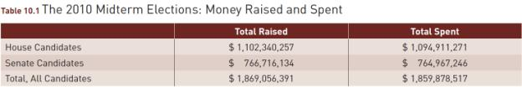
Source: Federal Election Commission, 2010 House and Senate Campaign Finance Summary.

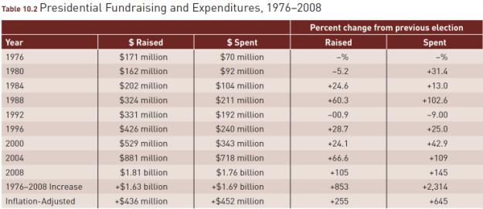
Source: Adapted from Federal Election Commission summary reports, January 2009 and May 2009. Dollar figures rounded. Inflation adjustment keyed to consumer price index 1976–2008, 3.74 (i.e., assumes that what cost $1.00 in 1976 cost $3.74 in 2008).

Figure 10.1 Presidential Campaigns, Spending on Media, 2008

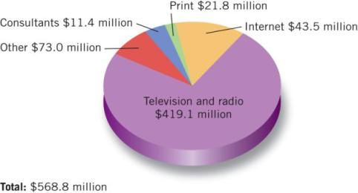

Source: Federal Election Commission, summary reports, May 2009. Figures rounded.

Campaigns Today
- Better or Worse?
  - Extensive Polling
  - “High-Tech Canvassing”
  - Campaign Spending and Fund Raising

- Here And Abroad
  - In the U.S., elections have two crucial phases: getting nominated and getting elected. They both require an individual effort on the part of the candidate.
  - In most of Europe, the political party decides who will be allowed to run and puts the candidate’s name on the ballot.

Presidential Versus Congressional Campaigns

Presidential Race

- More Competitive
  - Winner usually gets less than 55% of the vote
- Larger Voter Turnout
- Must Rely On The Mass Media To Reach Voters
- Incumbent Presidents Are Often Held Responsible For Whatever Has Gone Wrong

Congressional Race

- Less Competitive
  - Winner usually gets over 60 % of the vote
- Smaller Voter Turnout
- Closer Contact With The District’s Voters
- Even Incumbent Congressmen Can “Run Against Washington”

Presidential Campaigns
Running for President
  - Getting “Mentioned”
  - Money
  - Organization
  - Strategy and Themes

Lisa Murkowski, a write-in candidate, won a Senate seat in Alaska, the first person to do this in any state since 1954. She defeated the Republican candidate.

Political campaigns are hard work, even when you get to fly on the vice president’s airplane

Barack Obama campaigned on the slogan “Change We Can Believe In.”

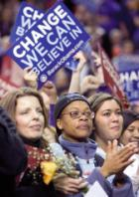

Getting Elected To Congress

- The Problems Of Malapportionment and Gerrymandering
- Winning The Primary
- Staying In Office

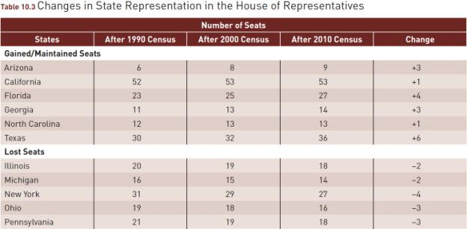
Source: U.S. Bureau of the Census.

Two Kinds Of Campaign Issues
  - Position Issues
  - The rival candidates have opposing views and the issue divides the voters.
  - Valence Issues
  - The voters are not divided on an important issue and examine whether a candidate fully supports their view.

Television and Debates
- Television
  - Paid Advertisements/Commercials
  - Making the Nightly Newscasts
- Debates
  - What effects do they have on elections?
  - What risks are involved in televised debates?

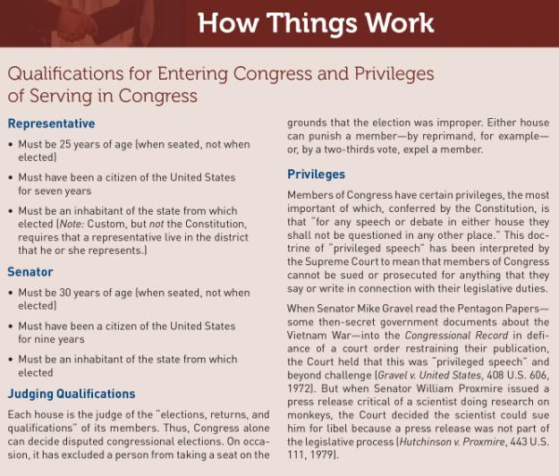

Politically Speaking:
Clothespin Vote
The vote cast by a person who does not like either candidate and so votes for the less objectionable of the two, putting a clothespin over his or her nose to keep out the unpleasant stench.

In the 1888 presidential campaign, supporters of Benjamin Harrison rolled a huge ball covered with campaign slogans across the country. The gimmick, first used in 1840, gave rise to the phrase “keep the ball rolling.”
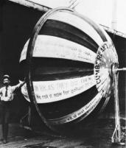

Alaska Governor Sarah Palin debates Senator Joe Biden during the 2008 campaign.

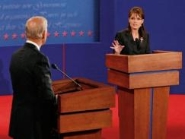

Money

- The Sources of Campaign Money
- Campaign Finance Rules
- A Second Campaign Finance Law
- New Sources of Money
- Money and Winning

Candidates first made phonographic recordings of their speeches in 1908. Warren G. Harding is shown here recording a speech during the 1920 campaign.

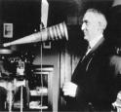

John F. Kennedy and Richard Nixon debate during the 1960 presidential campaign.

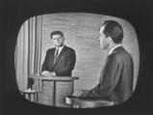

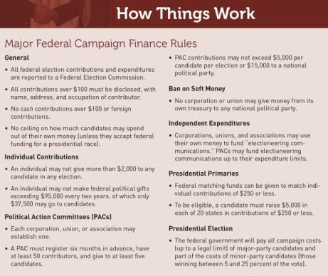

Figure 10.2 Growth of PACs
1979–2010

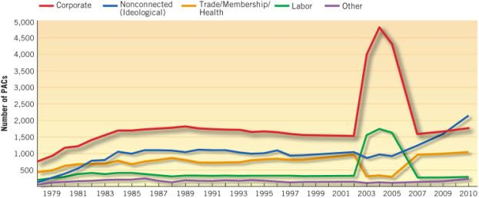

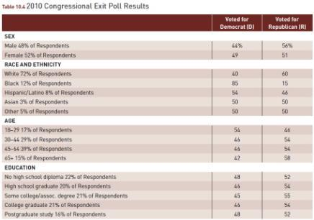

Source: ABC News/Politics 2010 National Exit Poll, November 2, 2010, reporting data on more than 17,000 respondents.

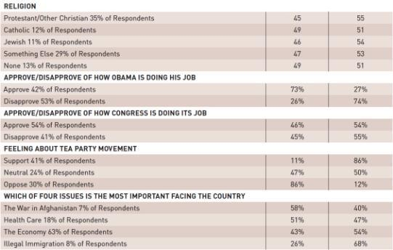

Source: ABC News/Politics 2010 National Exit Poll, November 2, 2010, reporting data on more than 17,000 respondents.

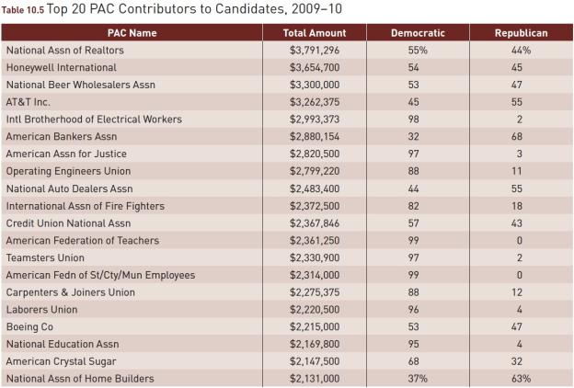
Source: Center for Responsive Politics, based on FEC data.

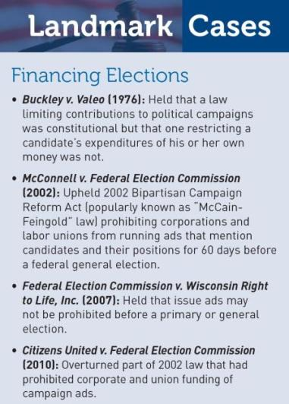
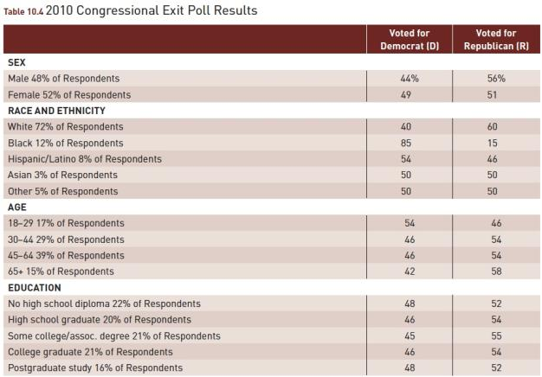

The figures for 1980, 1984, 1988, and 1996 fail to add up to 100 percent because of missing data.

What Decides the Election?
- Party
- Issues, Especially the Economy
  - Prospective voting
  - Retrospective voting
- The Campaign
- Finding a Winning Coalition

Figure 10.3 The Economy and Vote for President, 1948–2008

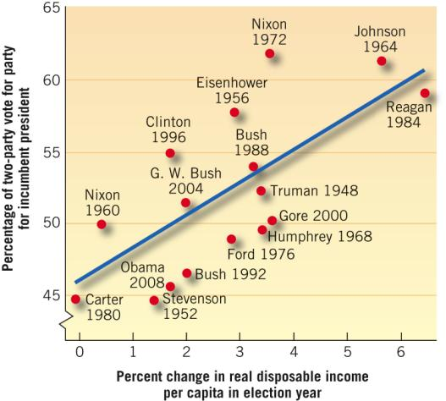

Notes: (1) Each dot represents a presidential election, showing the popular vote received by the incumbent president’s party. (2) 1992 data do not include votes for independent candidate H. Ross Perot. (3) 2004 value on RDI is projection from data available in December 2004.
Source: From American Public Opinion, 5th ed., by Robert S. Erikson and Kent L. Tedin. Copyright © 1995 by Addison-Wesley Educational
Publishers, Inc. Reprinted by permission of Pearson Education, Inc. 2008 update from Bureau of Economic Analysis, U.S. Department
of Commerce.

What Decides the Election?
- Party
- Issues, Especially the Economy
  - Prospective voting
  - Retrospective voting
- The Campaign
- Finding a Winning Coalition

Union members were once heavily Democratic, but since Ronald Reagan began winning white union votes in 1980, these votes have been up for grabs.

At a public meeting, Samuel Joseph Wurzelbacher challenged Barack Obama on his tax plan and quickly became known as “Joe the Plumber.”

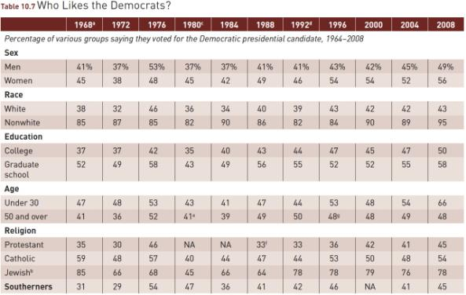
ª1968 election had three major candidates (Humphrey, Nixon, and Wallace).
^{b} Jewish vote estimated from various sources; since the number of Jewish persons interviewed often is less than 100, the error in this figure, as well as that for nonwhites, may be large.
^{c} 1980 election had three major candidates (Carter, Reagan, and Anderson).
^{d} 1992 election had three major candidates (Clinton, Bush, and Perot).
^{e} For 1980–1992, refers to age 60 and over.
^{f} For 1988, white Protestants only.
^{g} For 1996, refers to age 45 and over.

Sources: For 1964–1976: Gallup poll data, as tabulated in Jeane J. Kirkpatrick, “Changing Patterns of Electoral Competition,” in The New American Political System, ed. Anthony King (Washington, D.C.: American Enterprise Institute, 1978), 254–256. For 1980–1992: Data from New York Times/CBS News exit polls. For 1996: Congressional Quarterly Weekly Report, 1997, p. 188. For 2000: Exit polls supplied by ABC News. For 2004 and 2008: CNN exit polls.

Figure 10.4 Partisan Division of the Presidential Vote, 1856–2008

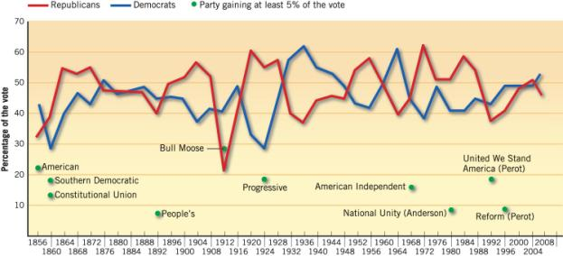

Sources: Information for 1856–1988, updated from Historical Data Archive, Inter-University Consortium for Political Research, as reported in William H. Flanigan and Nancy H. Zingale, Political Behavior of the American Electorate, 3rd ed., 32. For 1992: World Almanac and Book of Facts 1994, 73.

WHAT WOULD YOU DO?
M E M O R A N D U M
To: Arjun Bruno, National Party Chairman
From: Arlene Marcus, State Party Chairwoman
Subject: Supporting a National Primary
In the past few election cycles, our state’s role in the party nomination for president virtually has disappeared with a May primary date. Several states have leapfrogged ahead of us, and party leaders have indicated that they do not want any more states to move up their primary date. The national party needs to find a way to ensure that all states, large and small, have a real voice in nominating a presidential candidate.

Arguments for:
1. A single national primary permits equal participation by all states and presents a fair compromise with the increased number of delegates that larger states send to the national conventions, much like the compromises during the original constitutional debates.
2. The nominating process needs to be less costly, particularly when presidential candidates realistically need to raise $100 million a year before the general election to be competitive for the nomination. Holding all primaries and caucuses on a single day will reduce overall election expenses significantly.
3. If the American electorate knows presidential nominations will be decided by each party on one day, then they will be more likely to vote, a significant factor for elections in which historically, fewer than 20 percent of eligible voters typically participate.

Arguments against:
1. Each state decides in conjunction with the national party when its primary or caucus will take place, and the federal system of government designed by the Framers did not guarantee that all states would be treated equally at all times.
2. A national primary would favor candidates with high name recognition and funding to further that recognition and would severely disadvantage lesser known candidates within the party.
3. Even though the general election takes place on one day, voter turnout in the United States still is lower than in other advanced industrialized democracies, which suggests that other factors influence who participates.

Your decision:
Support a National Primary?
Oppose a National Primary?

