Chapter 11 – Interest Groups

Overview
Interest groups in the United States are more numerous and more fragmented than those in nations such as Great Britain, where the political system is more centralized. The goals and tactics of interest groups reflect not only the interests of their members but also the size of the groups, the incentives with which they attract supporters, and the role of their professional staffs. Because of the difficulty of organizing large numbers of people, any group purporting to speak for mass constituencies will often have to provide material benefits to members or acquire an affluent sponsor. The chief source of interest group influence is information; public support, money, and the ability to create “trouble” are also important. The right to lobby is protected by the Constitution, but tax and campaign-finance laws impose significant restrictions on how interest groups may spend money.

Chapter Outline
I. Introduction
- An interest group is an organization of people sharing a common interest or goal that seeks to influence public policy.
- Factors that promote the establishment of interest groups in the United States:
  - size and diversity of the country;
  - decentralizing effects of Constitution;
  - vast numbers of nonprofit organizations;
  - the increasing weakening of political parties;
- great variety of ethnic groups;
- more than seventy religious organizations;
- sharing of power among three branches of government; and
- recognizing the independence and power of the states by the federal system.
- A Political action committee (PAC) is a committee set up by a corporation, labor union, or interest group that raises and spends campaign money from voluntary donations.
- A lobbyist is a person who tries to influence legislation on behalf of an interest group.
- The First Amendment protects the right of lobbyists to freedom of speech and to petition the government for a redress of grievances.
II. The Birth of Interest Groups (THEME A: HISTORY AND INTEREST-GROUP FORMATION)
- Periods of rapid growth
- Seventy percent of Washington-based groups have established their D.C. offices since the 1960s.
- 1770s: independence groups
- 1830s–1840s: religious associations, antislavery movement
- 1860s: trade unions, Grange, fraternal organizations
- 1880s–1890s: business associations
- 1900–2000: business and professional associations, charitable organizations
- 1960s: environmental, consumer, political reform organization
- 1973: Political action committees were formed by business, labor and ideological groups.
- By mid 1990s there were six times as many PACS as in the 1970s.
- Many of the PACS were ideological.
- 1981–2009: There has been a massive expansion in lobbying activity with over 3.5 billion dollars spent in 2009.
- Factors explaining the rise of interest groups
- Broad economic developments create new interests and redefine old interests.
- Farmers became politically active when their livelihoods became dependent on selling crops in unstable markets or became affected by external forces.
- Mass-production industries were established, thus creating a need for mass-membership unions.
- Government policy itself
- Wars create veterans who demand benefits.
- Encouraged formation of American Farm Bureau Federation and professional associations
- Emergence of strong leaders, usually from a social movement; drawn to need for change and inspired by political and religious doctrine
- Religious revival of 1830s and 1840s, and creation of antislavery organizations
- From 1890 to 1920, college-educated middle class increased in size.
- During the 1960s, college enrollments more than doubled; civil rights and antiwar movements were also influential.
- Expanding role of government—creates policies of concern to groups
- Government made policies affecting trade and labor.
- Public interest lobbies proliferated following expansion of government involvement in social welfare, civil rights, environment, and consumer protection.
- Post 9-11: a massive increase in lobbies focused on security and counter terrorism.
III. Kinds of Organizations (THEME B: BIAS IN THE GROUP PROCESS AND KINDS OF ORGANIZATIONS)
- Interest group: Any organization that seeks to influence public policy; two kinds: institutional and membership interests.
A. Institutional interests
- Institutional Interests: Individuals or organizations representing other organizations
- Types
- Business firms: for example, General Motors
- Trade or governmental associations
- Focus on issues of central concern to their clients
- Other interests include governments, foundations, and universities.
B. Membership interests
- Americans join some groups more frequently than citizens of other nations do.
- Americans just as likely as the British to join social, business, professional, veterans’, or charitable organizations.
- Americans are less likely than the British to join labor unions.
- Americans are more likely than the British to join religious, political, or civic groups.
- Americans have greater sense of political efficacy; civic duty seems to explain tendency to join civic groups.
C. Incentives to join
- Interest groups face the problem of free riders.
  - Free riders are persons in the general public who benefit from the efforts of the organization without actually joining the organization.
  - They do not support the organization through financial aid or join it and contribute membership effort.
- Solidary incentives (pleasure, status, or companionship) are used to recruit members.
- Solidary incentives arise only when national organizations structure themselves as coalitions of small local units.
- Facilitated by the importance of local governments in the United States
- Examples: League of Women Voters (LWV), NAACP, Rotary, Parent Teacher Associations (PTA), American Legion
- Material incentives (include money, things, services) are used to recruit members.
- To increase benefits for members, organization may try to influence how laws are administered.
- Examples: Farm organizations, AARP
- Purposive incentives (appeal based on goals of the organization) are used to recruit members.
- Though an interest group also benefits nonmembers, people join because:
- they are passionate about the goal(s) of the organization;
- they have a strong sense of civic duty; and
- cost of joining is minimal.
- Ideological interest groups: Appeal of coherent and often controversial principles
- Public interest groups: Purpose principally benefits nonmembers (example, Nader groups such as Public Citizen)
- Engage in research and bring lawsuits, with liberal or conservative orientation (public-interest law firms, such as ACLU and the Center for Individual Rights)
- Publicity important because purposive groups are influenced by mood of the times; they may prosper when the government is hostile to their agenda.
D. The Influence of the Staff
- Staff influences the group’s policy agenda if solidarity or material benefits are more important to members than are the purposive goals.
- Staff opinions may be quite different from members’ opinions.

IV. Interest Groups and Social Movements
- Social movement: A widely shared demand for change in the social or political order, either liberal or conservative.
- Tea party: Focus on restraining government growth.
- Triggers of interesting groups
- Scandal—oil spill
- Widely publicized activities of a few leaders
- Paradigm shifts when a new generation of thinkers comes onto the public scene.
A. The environmental movement
- Effect of a social movement is to increase the value some people attach to purposive incentives.
- Environmental movement came into being in three eras:
- 1890s: Emergence of conservation as an issue; founding of Sierra Club
- 1930s: Conservation again popular; Wilderness Society and National Wildlife Federation founded
- 1960s and 1970s: environment important again; Environmental Defense Fund and Environmental Action founded.
- Environmental movement highlights general lessons about social movements:
- Movement may spawn many organizations.
- More extreme organizations will be smaller and more activist.
- More moderate organizations will be larger and less activist.
- Overtime the movement has become fragmented with differing approaches splitting the focus of the movement.
B. The Feminist Movement
- Three kinds of organizations
- Solidary: Examples are LWV, Business and Professional Women’s Federation
- Middle-class educated women
- Avoid issues that might divide membership or limit networks (examples: partisanship, abortion)
- Purposive: Examples are NOW, NARAL
- Highly activist organizations that take strong positions on divisive issues
- Internal controversy is common.
- Local organizations are highly independent from national organization.
- Material: Examples are Women’s Equity Action League (WEAL); National Women’s Political Caucus (NWPC); National Federation of Republican Women.
- Addresses specific issues of material benefit
- Not necessarily tied to satisfying the needs of large rank-and-file membership
C. The Union Movement
- Labor unions continued their activism after their social movement died, but sustaining membership is difficult.
  - Economic changes have not worked to unions’ benefit in member recruitment.
  - Public approval of unions has declined.
  - But unions do offer a mix of benefits and are attracting white-collar employees (such as government workers).
  - Public sector membership in unions is 5 times (36.2%) the membership rate of private sector employees (6.9%).
  - Unions provide a significant source of political campaign contributions.
- Interest groups attempt to fund themselves through some combination of funding.
- Foundation grants
- Government grants
- Direct-mail solicitation
- On-line appeals and donations (blogs and social media)
- After the 2007 recession began, each of the funding sources became more precarious.
D. Upper-Class Bias?
- Reasons for belief in upper-class bias
- Those who are more affluent are more likely to join and be active.
- Business/professional groups are more numerous and better financed than those representing minorities, consumers, or the disadvantage.
- 1981–2006: Ratio of business lobbyists to union/public interest lobbyists who tend to oppose business interest rose from 12 to 1 to 16 to 1.
    - Analysts argue that the 2007– 2010 economic crisis was due in part to the disproportionate influence wielded by business interests.
    - In 1999 corporate lobbyists succeeded in having the Glass-Steagall Act that regulated commercial banking and financial companies repealed. This permitted banks to lend money to poor credit risks and create financial products largely unregulated by government.
    - This lack of regulation fostered the collapse of the real estate market.
- These facts do not decide the issue.
- Describe inputs to the political system but not who eventually wins or loses on particular issues
- Business groups are often divided among themselves.
- Important to ask what the bias is
- Many conflicts are among upper-middle class, politically active elites.
- Resource differentials are clues to, not conclusions about, the outcomes of political conflicts.
V. The Activities of Interest Groups (THEME C: INTEREST GROUPS IN ACTION)
A. Information
- The single most important tactic of interest groups is supplying credible information.
- Detailed, current information at a premium and can build (or destroy) a legislator-lobbyist relationship
- Most effective on narrow, technical issues—links to client politics
- Officials also need political cues regarding what values are at stake and how that fits with their own political beliefs; groups may establish informal coalitions based on their general political ideology.
- Rating systems are intended to generate support or opposition for legislators.
  - Earmarks
- Information can be linked to influence.
  - Members of Congress exchange information with lobbyists about activities in Congress.
  - Lobbyists use this knowledge to convince members of Congress to draft special provisions in legislation to benefit their clients. These are called earmarks.
  - In recent decades, the activities of the federal government have affected more parts of society.
  - Lobbying organizations have determined how to tailor federal legislation to benefit individual clients.
  - The Cassidy firm used this technique to persuade Congress to create a national nutrition center and locate it at a particular university that was a client of Cassidy. This practice has proliferated in recent years.
  - In 2008, OMB estimated that over eleven thousand earmarks had been approved by Congress at a cost of over 16 billion dollars.
  - Despite efforts at reform, the process continues.
C. Public support: the rise of the new politics
- Insider strategy previously most common: Face-to-face contact between lobbyist and member of Hill staff
- Increasing use of outsider strategy: Grassroots mobilization of the issue public (effects of individualistic Congress, modern technology)
- Politicians dislike controversy, so they work with interest groups that agree with them.
- Lobbyists’ key targets: The undecided legislator or bureaucrat
- Some groups attack their likely allies to embarrass them.
- Legislators sometimes buck public opinion, unless the issue is very important and would cost them an election.
- Some groups try for grassroots support.
D. Money and PACs
- A PAC is an organizations created by a business firm, labor union, trade association or ideological group that makes campaign contributions to candidates. Though tightly regulated, PACs have proliferated to over four thousand in 2008. In 2003–2004, they gave over $300 million to Congressional candidates.
- Money is the least effective way to influence politicians.
- Campaign finance reform law of 1973 had two effects:
- restricted amount interests can give to candidates; and
- made it legal for corporations and unions to create PACs that could make donations.
- Rapid growth in PACs has probably not led to vote buying.
- More money is available on all sides of the issues.
- Members of Congress take money but still can decide how to vote.
- Members are establishing their own PACs to advance their political ambitions.
- Almost any organization can create a PAC. Over half of the PACs are sponsored by corporations; one-tenth by unions, the remainder varies.
- In 2003–2004, unions and business/professional organizations gave the most.
- Incumbents get the most PAC money.
- Labor PACs give almost exclusively to Democrats.
- Business PACs split money between Democrats and Republicans.
- Both parties are dependent on PAC money.
- PACs provide only one-third of the money spent by House candidates.
- No systematic evidence that PAC money influences votes in Congress.
- Most members vote their ideology and with their constituents.
- When an issue is of little concern to voters and ideology provides little guidance, there is a slight correlation between PAC contributions and votes, but that may be misleading.
- PAC money may affect politics in other ways, as in gaining access or influencing committee actions.
- PAC money is viewed as most likely to influence “client politics.”
E. The “revolving door”
- Federal government workers leave to take more lucrative positions in private industry (lobbying, consulting, executive positions).
- May give private interests a way to improperly influence government decisions
- Promise of future jobs to officials in exchange for acting in corporate interest
- Person who has left uses personal contacts in Washington for favorable treatment.
- Agencies differ in vulnerability to outside influences.
- FDA: Employees’ judgment about new drugs may be clouded by promise of lucrative positions if drug is approved
- FTC: Employees may have better chance at lucrative position later if they are vigorous at prosecuting antitrust suits.
F. Civil Disobedience
- Disruption has always been part of United States politics and has been used by groups of varying ideologies as well as by others.
- Civil disobedience tactics have been more frequently used since the 1960s, becoming more generally accepted.
- Goals:
- disrupt the institution and force negotiations;
- enlist the support of others who will also press for negotiations; and
- create martyrs to draw public concern and support.
- Often create no-win situations for public officials, who are criticized whether they negotiate or not
VI. Regulating Interest Groups
- Protection by First Amendment
- Federal Regulation of Lobbying Act of 1946 accomplished little in requiring registration and financial reports.
- Supreme Court restricted application to direct contact with members of Congress.
- Grassroots activity not restricted.
- No staff to enforce law by reviewing registration or reports
- 1995 act provided a broader definition of lobbying and tightened reporting requirements.
- Twice a year, all registered lobbyists were required to report the following:
- the names of their clients;
- their income and expenditures; and
- the issues on which they worked.
- Grassroots organizations were still exempted.
- No enforcement agency established, but Justice Department may undertake investigations.
- Tax-exempt, nonprofit organizations cannot receive federal grants if they lobby.
- 2007 reforms enacted by Democrats include:
- no gifts of any value from registered lobbyists or firms that employ them;
- no reimbursement for travel costs from registered lobbyists or firms that employ them; and
- no reimbursement for travel costs from any source if trip is organized or requested by registered lobbyists or firms that employ them.
- Other significant restraints
- Tax code; nonprofits lose tax-exempt status if a “substantial part” of their activities involve lobbying.
- Campaign-finance laws limit donations by individual PACs.

- WHO GOVERNS?
  - Do interest groups dominate government, and is any particular lobby politically unbeatable?
  - Why do people join interest groups?
- TO WHAT ENDS?
  - Is the proliferation of political action committees (PACs) and other groups good or bad for America’s representative democracy?
  - Should interest groups’ political activities be restricted by law?

The Rise of Interest Groups

- An interest group is any organization that seeks to influence public policy.
- The conditions that lead to the rise of interest groups are
  - Broad economic developments
  - Government policy
  - Leadership exercised
  - Increased governmental activities

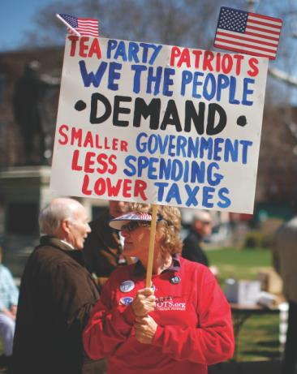

A woman holds a Tea Party sign at a rally in Concord,
New Hampshire.

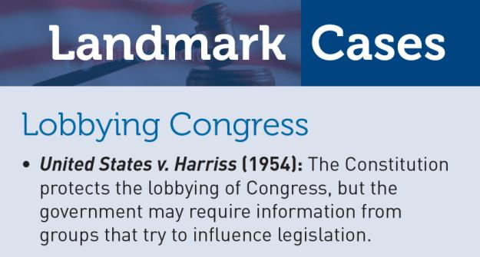
Figure 11.1 What the Top Lobby Spent, 1998–2010
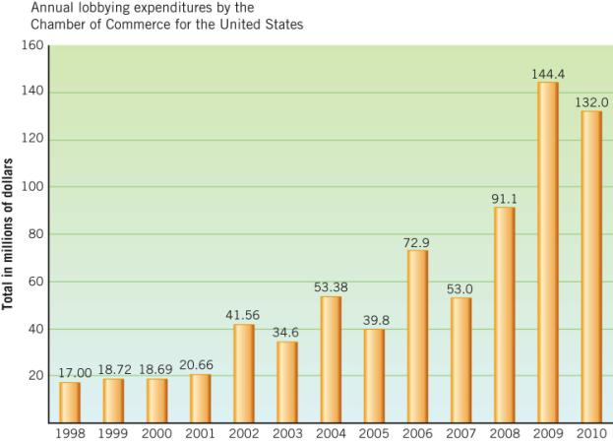
Source: Center for Public Integrity, Georgetown University, Washington, D.C., 2011.

Kinds of Organizations

- Institutional Interests
- Membership Interests

W. E. B. Du Bois, scholar and activist, was one of the founders of the NAACP.

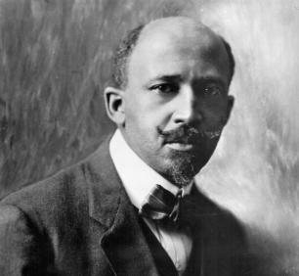

Getting and Keeping Members

- Incentives to Join
  - Solidarity
  - Material
  - Purposive

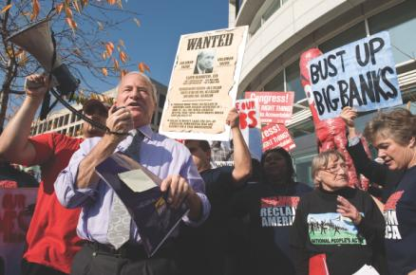

The Service Employees International Union, a large and growing force, listens to Andy Stern, its president until 2010.

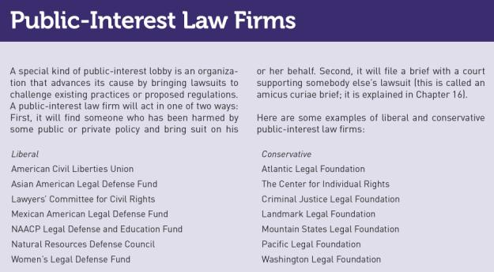

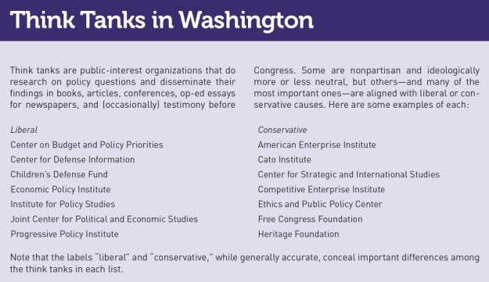

The Influence of the Staff
- Some members of an interest group may not care about many of the issues with which the group gets involved.
- What the interest group does may reflect what the staff wants than what the members believe.

Interest Groups and Social Movements
- The Environmental Movement
- The Feminist Movement
- The Union Movement

The Million Moms March in 2004 demanded a federal ban on assault weapons.

Funds for Interest Groups

- Foundation Grants
- Federal Grants and Contracts
- Direct Mail

Upper Class Bias?

- Do interest groups reflect an upper-class bias?
- Those most likely to belong to a voluntary association have
  - Higher incomes
  - College degrees
  - Professional or technical jobs

- Consider:
  - Do interest groups and lobbyists always get what they want?
  - Are business-oriented groups divided among themselves?
  - Are there profound cleavages of opinion among the upper class?

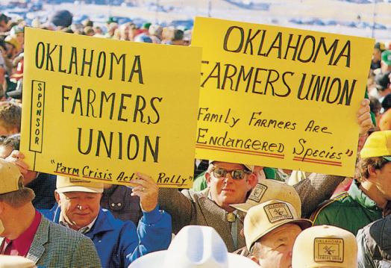

Farmers once had great influence in Congress and could get their way with a few telephone calls. Today, they often must use mass protest methods.

The Activities of Interest Groups

- Information
- Earmarks
- Public Support
- Money and PACs
- The “Revolving Door”
- Civil Disobedience

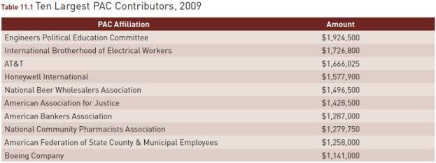
Source: Federal Election Committee, “Top 50 PACs by Contributions to Candidates and Other Committees, January 1, 2009–December 31, 2009,” 2010.

Figure 11.2 Political Action Committees (PACs)

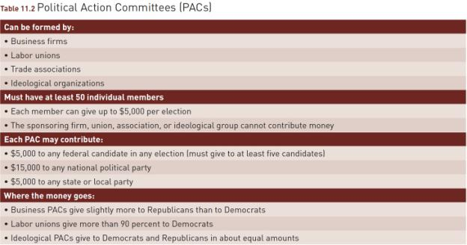

Jack Abramoff, convicted of unethical behavior in handling lobbying claims by certain Indian tribes, is sworn in before a congressional committee investigating this.

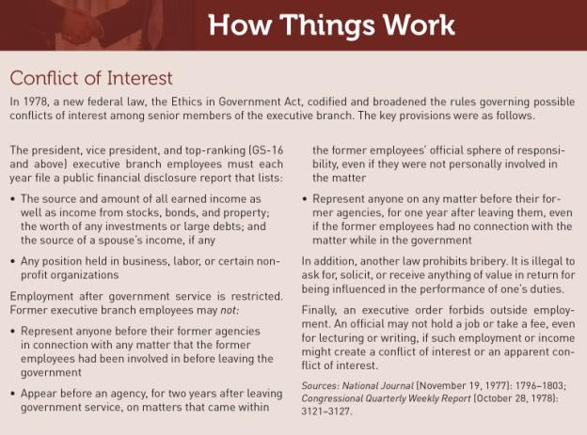

Lawsuits, such as this one against Proposition 8 which banned same sex marriage in California, are often more effective than protest demonstrations in changing policies.

Regulating Interest Groups
- 1946 – Federal Regulation of Lobbying Act
- 1995 – Congress unanimously passed lobbying bill
  - Tightened registration and disclosure requirements
  - Broadened definition of a lobbyist
  - Did not cover grass roots organizations

- 2007 – New regulations took effect
  - No gifts of any value from registered lobbyists or firms that employ lobbyists
  - No reimbursements for travel costs from registered lobbyist or firms that employ lobbyists
  - No reimbursement for travel costs, no matter the source, if the trip is in any part organized or requested by a registered lobbyist or firm that employs lobbyists

WHAT WOULD YOU DO?

M E M O R A N D U M
To: Kathleen Moore, Senate majority leader
From: Christopher Franklin, chief of staff
Subject: Full federal financing of presidential campaigns
Every presidential election since 1976 has been financed in part by federal funds. Now presidential candidates say they will forego public funding for the general election, given the vastly greater resources available through private fund-raising. Congress needs to decide whether elections are a public investment or a political free market for citizens and candidates.

Arguments for:
1. Legal precedents are promising. Federal matching funds already go to presidential primary candidates who have raised at least $5,000, in contributions of $250 or less, in each of twenty states. For the general election, each major party nominee already is eligible for federal funding if he or she agrees to spend no more than that amount.
2. The funding required would be small. Allocating $1 billion out of the public treasury for a presidential election every four years is hardly a fiscal drain on a nearly $2 trillion annual budget.
3. The effects would be pervasive. Candidates and party leaders would stop covertly courting big donors with phone calls, lunches, and personal visits, and would focus instead on the needs of average citizens.

Arguments against:
1. Constitutional precedent for requiring political candidates to accept public funds is weak. In Buckley v. Valeo (1976), the Supreme Court upheld limits on campaign contributions for candidates who accept public money, but it also defined spending money for political purposes as expression protected by the First Amendment, thereby giving individuals the right to raise and spend as much of their own money as they choose, if they forego federal funds.
2. Campaign spending would soon spiral once again. The federal government may not restrict spending by individuals or organizations working independently from the political parties, and federal funds would merely supplement, not supplant, private fund-raising.
3. Less than 10 percent of taxpayers currently supports public financing through voluntary federal income tax checkoffs, and voters likely would view bankrolling elections as serving politicians, not the people.

Your decision:
Support Legislation?
Oppose Legislation?

