Chapter 12 – The Media

Overview
Changes in American politics have been accompanied by—and influenced by—changes in the mass media. The rise of strong national political party organizations was facilitated by the emergence of mass-circulation daily newspapers. Political reform movements depended in part on the development of national magazines catering to middle-class opinion. The weakening of political parties was accelerated by the ability of candidates to speak directly to constituents via radio and television.
The role of journalists in a democratic society poses an inevitable dilemma: If they are to serve well as information gatherers, gatekeepers, scorekeepers, and watchdogs, they must be free of government controls. But to the extent that they are free of such controls, they are also free to act in their own political or economic interests. In the United States, a competitive press largely free of government controls has contributed to a substantial diversity of opinion and a general (though not unanimous) commitment to the goal of fairness in news reporting. The national media are in general more liberal than the local media, but the extent to which a reporter’s beliefs affect reporting varies greatly with the kind of story—routine, feature, or insider.

Chapter Outline
- Introduction
- Television and the Internet are key parts of the New Media; newspapers and magazines are part of the Old Media. And when it comes to politics, the New Media are getting stronger and the Old Media are getting weaker.
- The Media and Politics
- America has had a long tradition of privately owned media
- Although newspapers require no government permission to operate, radio and television do.
  - Licenses must be periodically renewed through the Federal Communication Commission.
- There are two potential limits to the freedom of privately owned newspapers and broadcast stations:
  - they must make a profit and
  - media bias.
III. Journalism in American Political History (THEME A: THE HISTORY AND STRUCTURE OF THE NEWS MEDIA IN THE UNITED STATES)
- Changing media technology
- New Media: television, Internet; Old Media: newspapers, magazines
- The New Media that are challenging the Old Media
- More television viewers than newspaper readers
- More people read Web log (blog) postings than read magazine articles
- Bloggers showed evidence that CBS documents incriminating President George W. Bush were forgeries
- In 2008, 80 percent of those between the ages of eighteen and twenty-nine used the Internet. Fifty percent of that group used it to get news about the election and participate in the process. Internet is the primary source as news. Only one-third of young people read newspapers.
- In Europe, the relationship between government and the media is governed by stricter regulation of the media by government than the same relationships in the United States between government and the media.
- Laws governing libel are stricter in Great Britain than those in the United States.
- Britain also has the Official Secrets Act, which makes it illegal to leak information.
- European governments have imprisoned people for publicizing false information or writing offensive articles.
- Long tradition of private media ownership in United States
- Radio and television stations require FCC licenses.
- Potential limits to freedom of privately owned newspapers and broadcast stations:
- Profit driven: May need to distort the news to build an audience or satisfy advertisers.
- Media bias: Reporters and editors may present only one side of a story
- The effect of the Internet
  - In 2008, one-third of all Americans watched on-line videos related to the campaign.
  - One in ten donated money via the Internet.
  - Challenges to controversial political statements are almost instantaneous.
  - It is noteworthy that one-third of Internet users question its trustworthiness. They believe that it is full of misinformation and is dominated by political extremists.
- The Media and Politics
    - The relationship between politicians and the media remains an adversarial one characterized by mutual mistrust. Both parties in the relationship attempt to manipulate the process for their own ends.
- Politicians want the media to support their positions.
- The media, motivated by controversy, seek to discover problems with the positions of politicians.
- Politicians attempt to use the Internet to appeal directly to the public. Their efforts are balanced by their political opponents, who also use the Internet to reach the public directly.
- The government can exercise very little control over the media.
A. The party press
- Parties created, subsidized, and controlled various newspapers.
- Circulation small, subscriptions expensive
- Newspapers circulated among political and commercial elites.
- Government often subsidized the president’s party press.
B. The popular press
- Changes in society and technology made possible self-supporting, mass readership daily newspapers.
- High-speed press
- Telegraph gave local papers greater access to news.
- Associated Press established 1848; objective reporting and systematic distribution of information
- Urbanization concentrated population to support papers, advertisers.
- Government Printing Office established 1860—end of most printing contracts to Washington newspapers
- Partisanship in mass-readership newspapers reflected the views of publishers and editors.
- Convictions blended political beliefs with economic interest.
- Used sensationalism and exposés to attract large readership
- Publishers’ influence in steering public opinion became powerful political force.
- Established the feasibility of a press independent of government, demonstrating that there was profit to be made in criticizing government policies
C. Magazines of opinion
- Middle class favored new, progressive periodicals.
- Nation, Atlantic Monthly, Harper’s began in 1850s and 1860s.
- McClure’s, Scribner’s, Cosmopolitan arose later.
- Individual writers gained national followings through investigative reporting.
- Number of competing newspapers declined, reducing the need for sensationalism to sell papers
- Readers were also becoming more educated and sophisticated.
- Today, national magazines focused on politics account for a small and declining fraction of magazines.
D. Electronic journalism
- Radio arrives in 1920s, television in the late 1940s.
- Politicians could address voters directly, but people could easily ignore them.
- Fewer politicians could be covered by these media than by newspapers.
- President routinely covered.
- Others must be controversial or have a national reputation or buy time.
- Shorter sound bites on the nightly news make it more difficult for candidates and officeholders to convey their messages.
- Politicians now have more sources—cable, early-morning news, news magazine shows. Many of these new sources feature lengthy interviews.
- Politicians continue to seek the media spotlight even after they are elected.
E. The Internet
- Increasingly important: Fifty percent of American households have access to the Internet.
- Free market in political news: From newspaper/magazine stories to blogs to gossip
- Playing a larger role in politics
- In 2004, most of Howard Dean’s money was raised through Internet appeals.
- Every candidate now has a Web site.
  - Facilitates communication between voters and political activists
      - Some analysts fear the Internet may promote isolation within the public and may contribute to the promotion of extreme opinions.
- Stanford and Carnegie Mellon studies support this conclusion.
- A UCLA study found the opposite effect. Users of the Internet also tend to consult newspapers and magazines and contact others by telephone.
- The Internet has significantly affected politics. It has been used to:
- raise money;
- organize people to attend meetings;
- sample public opinion;
- air criticism of opponents; and
- target likely supporters to work on campaigns.
IV. The Structure of the Media (THEME B: MEDIA SELECTION AND BIAS IN THE NEWS)
A. Degree of Competition
- Newspapers
- Number of daily newspapers has declined significantly.
- Number of cities with multiple papers has declined.
- Sixty percent of cities had competing newspapers in 1900; four percent in 1972.
- In some cities, Joint Operating Agreements (JOAs) merge business operations of two papers, supposedly preserving editorial independence.
- Subscription rates have fallen, however, as most people get their news from television.
- Young people have turned away from political news altogether.
- Radio and television are intensely competitive and becoming more so.
- U.S. press is composed mostly of locally owned and managed enterprises, unlike in Europe.
- Oriented to local market
- FCC regulations dispersed ownership
B. The national media
- Existence somewhat offsets local orientation
- Consists of:
- wire services (AP, UPI);
- national magazines;
- television network evening news broadcasts;
- CNN, FOX News, MSNBC; and
- newspapers with national readerships (New York Times, Wall Street Journal, USA Today, Washington Post).
- Significance of a national press
- Newspapers have a large readership.
- Political elites follow them closely.
- Radio and television stations often decide what to broadcast by looking at the national press.
- National reporters and editors are distinctive from those in the local press.
- Better paid
- From more prestigious universities
- More liberal outlook
- Do investigative or interpretive stories
- Roles played by the national press:
    - Gatekeeper
- Gatekeeper: Influences what subjects become national political issues and for how long.
    - Scorekeeper
- Scorekeeper: Tracks political reputations and candidacies.
- Elections are covered like horse races rather than as choices among policy alternatives.
- Media momentum during the presidential primary season is crucial.
    - Watchdog
- Watchdog: Investigate personalities and expose scandals.
V. Rules Governing the Media (THEME C: GOVERNMENT INFLUENCE ON THE MEDIA)
- Protections for print media
- Newspapers are almost entirely free from government regulation.
- Prosecutions only after the fact—no prior restraint
- After publication, plaintiffs can sue only for libel, obscenity, incitement to illegal act.
- Each of these conditions has been defined narrowly by the courts to enhance the freedom of the press.
A. Confidentiality of sources
- Reporters want right to keep sources confidential.
- Most states and federal government disagree.
- Supreme Court allows the government to compel reporters to divulge information in court if it bears on a crime.
B. Regulating broadcasting
- FCC licensing
- Seven years for radio license renewal
- Five years for television license renewal
- Stations must serve “community needs.”
- Recent movement to deregulate
- License renewal by postcard
- No hearing unless opposed
- Relaxation of some rule enforcement
- Radio has been the most deregulated regarding both ownership and content.
- Other radio and television regulations
- Fairness doctrine abolished; has permitted the rise of controversial talk shows.
- Equal time rule still in effect; stations that sell advertising time to one candidate must sell equal time to opponent.
C. Campaigning
- Equal-time rule applies.
- Equal access for all candidates
- Rates no higher than the cheapest commercial rate
- Debates formerly had to include all candidates.
- Therefore, Reagan-Carter debate had to be sponsored by LWV.
- Now stations and networks can sponsor debates limited to major candidates.
- Not all candidates use TV because its efficiency in reaching voters varies.
- It works well only when the market and the district overlap.
- More Senate than House candidates buy television time.
    - Scholars are concerned about horse-race journalism.
- Focus is on which candidate is leading in the campaign rather than on a discussion of issues within the campaign.
- In 2008, the media focus was on the narrow nomination fight between Hillary Clinton and Barack Obama rather than on the varying positions of the respective candidates on issues.
VI. Are the National Media Biased?
A. A Liberal Majority
- What are the views of members of the national media?
- Great majority is more liberal than the average citizen.
- Majority is also more secular.
- Conservative media outlets have become more visible in recent years.
- Desire for big audience ratings; more self-described conservatives than liberals
- Conservative listeners do not think their views are reflected in big-city media.
- Liberal audience is divided into distinctive racial and ethnic groups that have their own outlets (e.g., Hispanics listen to Spanish broadcasts).
B. Neutral and Objective?
- Do the beliefs of the national media affect how they report the news?
- Journalistic philosophy is that the news should be neutral and objective.
- Does not apply to editorials
- Does not apply to talk radio
- Hard to measure whether commitment to objectivity is actually achieved.
- News stories differ in opportunity for bias.
- Routine stories cover major political events; involve relatively simple matters with little room for bias.
- Feature stories cover public events that are not routinely covered by the press; easier to reflect journalistic or editorial biases.
- Insider stories cover things that are often secret; also easier to reflect journalistic or editorial biases.
- Feature and insider stories became more important to newspapers when radio and television began to cover routine stories.
- Studies that look at bias
    - New York Times and Washington Post are more likely to call conservatives “conservative” than to call liberals “liberal.”
    - Time and Newsweek tended to avoid quoting nuclear scientists and engineers because they favored nuclear power and the magazines opposed it.
    - Economic headlines tend to have a more positive spin when a Democratic president is in office.
    - Public editor of New York Times admits the paper is liberal.
  - Ideology of owners (of newspapers) doesn’t correlate with the political slant of newspaper coverage. Bias tends to reflect the political views of the paper’s readers.
C. Media’s Influence
- Does what the media write or say influence how their readers and viewers think?
- Selective attention: People remember or believe only what they want to.
- Results of studies examining influence of politics on voting behavior:
- newspapers that endorsed incumbents gave them more positive coverage, and voters had more positive feelings about endorsed incumbents than ones that were not endorsed;
- FOX News coverage linked to 3–8 percent increase in Republican vote for George W. Bush;
- Washington Post readership linked to increased Democratic support for Virginia governor; and
- public’s view of policy questions influenced by media coverage.
- Personal knowledge or experience about a topic mitigates media influence.
- Candidates believe the media are important.
- Estes Kefauver made strong bid for presidential nomination in 1952 after chairing televised organized-crime hearings.
- Sometimes bid for media presence backfires: Howard Dean in 2004.
- LBJ decided Vietnam was a lost cause after Walter Cronkite turned against the war.
VII. Government and the News
A. Prominence of the president
- Theodore Roosevelt: Systematic cultivation of the press became an art form.
- Franklin Roosevelt: Press secretary cultivated, managed, and informed the press.
- Press secretary today: Large staff, performing many functions focused on White House press corps
B. Coverage of Congress
- Never equal to that of president; members resentful
- House quite restrictive in the past
- No cameras on the floor until 1978
- Gavel-to-gavel coverage of proceedings since 1979 (C-SPAN)
- Senate more open
- Hearings since Kefauver (1950) have frequently been broadcast.
- TV coverage of sessions initiated by C-SPAN in 1986.
- Senatorial use of televised committee hearings has turned the Senate into a presidential candidate incubator.
C. Why DO WE HAVE so many news leaks?
- Constitution: Separation of powers
- Power is decentralized.
- Branches of government compete; press is a weapon in the competition.
- Not illegal to print most secrets
- Adversarial press since Vietnam War, Watergate and Iran-contra scandals
- Press and politicians distrust each other.
- A more suspicious, cynical, and adversarial press
- Attack journalism: seizing on any bit of information or rumor that might call into question the qualifications or character of a public official
- Most people do not like this kind of news; cynicism about government mirrors public’s increasing cynicism about media.
D. Sensationalism in the media
- Intense competition among many media outlets means that each has a small share of the audience.
- Sensationalism draws an audience and is cheaper than investigative reporting.
- Reporters, meanwhile, may not be checking sources carefully because of pressure to break news stories first.
- Public trust of news media increased somewhat after attacks of 9/11, but now public distrust in accuracy of news media has reached record highs.
E. Government constraints on journalists
- Reporters must strike a balance between two competing factors:
- expressing critical views, which may alienate sources; and
- retaining sources, and becoming their mouthpiece.
- Abundance of congressional staffers makes it easier, because sources are more numerous.
- Governmental tools to fight back
- Numerous press officers in legislative and executive branches
- Press releases—canned news
- Leaks and background stories to favorite reporters
- On the record: Reporter can quote official by name.
- Off the record: What the official says cannot be used.
- On background: Information can be used, but not attributed to source by name.
- On deep background: Information can be used, but not attributed to anybody, including an anonymous source.
- Bypass national press in favor of local press
- Presidential rewards and punishments for reporters on basis of their stories

- WHO GOVERNS?
  - How much power do the media have?
  - Can we trust the media to be fair?
- TO WHAT ENDS?
  - What public policies will the media support?

The Media and Politics
- Freedom of the Press
- The United States versus Europe
- Freedom of Information Act
- Privately Held Media:
  - Newspapers
  - Radio and Television
- Federal Communication Commission (FCC)

powerlineblog.com.

As appeared on www.dailykos.com.

Blogs, both conservative and liberal, have become an important form of political advertising.

Journalism in American Political History
- The Party Press
- The Popular Press
- Magazines of Opinion
- Electronic Journalism
- The Internet

News used to come by radio, but today many people read newspapers on iPads and other electronic devices.

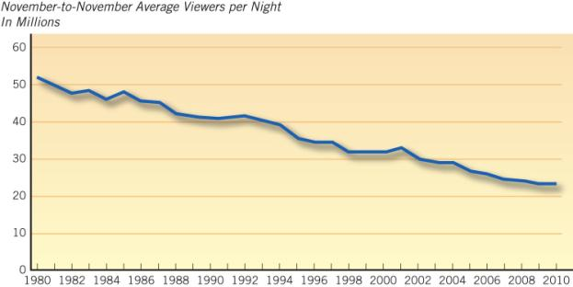
Source: Nielsen Media Research, used under license. Pew Research Center’s Project for Excellence in Journalism, 2011 State of the News Media, http://stateofthemedia.org/2011/network-essay/.

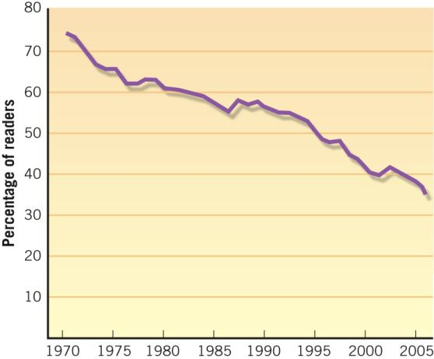
Note: 18–34 readership represents the average of 18–24 readership
and 25–34 readership. 2006 data is through September

Source: The Wall Street Journal (February 15, 2007). Copyright © 2007 Dow Jones & Company, Inc. Reprinted with the permission of Dow Jones & Company, Inc., via Copyright Clearance Center.

The Internet and Politics
It is now easier to:
- raise money in small donations
- organize people to attend meetings
- take instant (unreliable?) opinion polls
- instantly criticize your opponent
- mobilize local followers
- target campaigners with the names of people they should contact

The Structure of the Media
- Degree of Competition
- The National Media
  - Gatekeeper
  - Scorekeeper
  - Watchdog

Rules Governing the Media
- Newspapers – least governmental regulation
- Radio and TV – most governmental regulation
- Confidentiality of Sources
- Regulating Broadcasting
- Campaigning

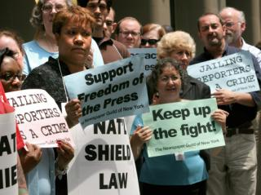
Activists urge Congress to pass a law shielding reporters from being required to testify about their sources.

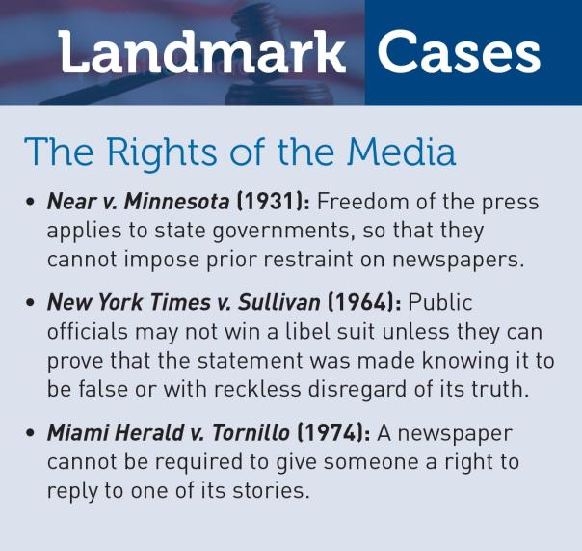

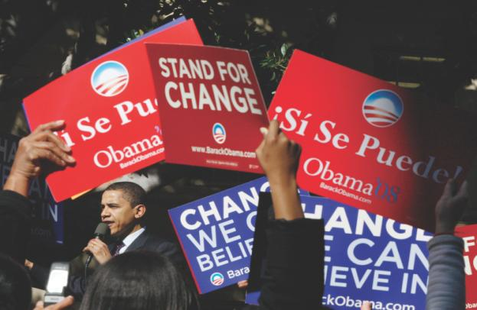
Senator Barack Obama campaigning for president in Los Angeles.

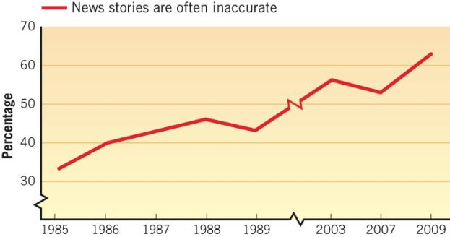

Pew Research Center for the People Source: Pew Research Center for the People & the Press, “Press Accuracy Rating Hits Two-Decade Low: Public Evaluations of the News Media: 1985–2009,” September 2009, http://pewresearch.org/pubs/1341/press-accuracy-rating-hits-two-decade-low.

Are the National Media Biased?

- Do members of the media have a distinctive political attitude?
- Does that attitude affect what they write or say?
- Does what they write or say affect what citizens believe?

Are the National Media Biased?
- A liberal majority
- Neutral and objective?
  - Routine stories
  - Feature stories
  - Insider stories
- Media’s influence
  - Selective attention

Government and the News
- Prominence of the President
- Coverage of Congress
- Why do we have so many news leaks?
- Sensationalism in the media
- Government constraints on journalists

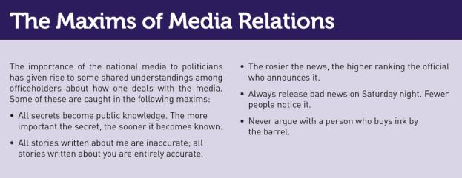

When President Theodore Roosevelt cultivated the media,
reporters usually were unknown and poorly paid.

In 1933, White House press conferences were informal affairs, as when reporters gathered around Franklin Roosevelt’s desk in the Oval Office.

Today, there are huge gatherings held in a special conference room, as on the right.

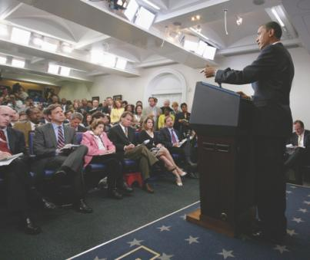

WHAT WOULD YOU DO?

M E M O R A N D U M
To: Matthew Wilson, senator
From: Margaret Drinker, legislative assistant
Subject: Protecting journalists
The Supreme Court has held that forcing a reporter
to testify does not violate the First Amendment to the
Constitution. But Congress could pass a law, similar
to that in many states, banning such testimony if it
reveals a confidential source.

Arguments for:
1. Thirty-four states now have shield laws similar to the one proposed by Congress.
2. Effective journalism requires protecting sources from being identified; without protection, a lot of important stories would not be written.

Arguments against:
1. Every person accused in a criminal trial has a right to know all of the evidence against him or her and to confront witnesses. A shield law would deprive people of this right.
2. A shield law would allow any government official to leak secret information with no fear of being detected.

Your decision:
Support Bill?
Oppose Bill?

