Chapter 13 - Congress

Overview
Over the last fifty years or so, Congress, especially the House, has evolved through three stages. The Congress is presently an uneasy combination of stages two and three.
During the first stage, which lasted from the end of World War I until the early 1960s, the House was dominated by powerful committee chairs who controlled the agenda, decided which members would get what services for their constituents, and tended to follow the leadership of the Speaker. Newer members were expected to be seen but not heard; power and prominence came only after a long apprenticeship. Congressional staffs were small, and members dealt with each other face to face. In dealing with other members, it helped to have a southern accent: Half of all committee chairs, in both the House and the Senate, were from the South. Not many laws were passed over their objections.
The second stage emerged in the early 1970s, in part as the result of trends already underway and in part as the result of changes in procedures and organization brought about by younger, especially northern, members. (As an example of continuing trends, consider the steady growth in the number of staffers assigned to each member.) Dissatisfied with southern resistance to civil rights bills and emboldened by a sharp increase in the number of liberals who had been elected in the Johnson landslide of 1964, the House Democratic caucus adopted rules that allowed the caucus to do the following:
- select committee chairs without regard to seniority;
- increase the number and staffs of subcommittees;
- authorize individual committee members (instead of just the committee chair) to choose the subcommittee chairs;
- end the ability of chairs to refuse to call meetings; and
- make it much harder to close meetings to the public.
Also, the installation of electronic voting made it easier to require recorded votes, so there was a sharp rise in the number of times each member had to go on record. The Rules Committee was instructed to issue more rules that would allow floor amendments.
At the same time, the number of southern Democrats in leadership positions began to decline, while the conservativism of the remaining ones began to decrease. Moreover, northern and southern Democrats began to vote together a bit more frequently, though the conservative “boll weevils” remained a significant—and often swing—group.
These changes created a House ideally suited to serve the reelection needs of its members. Each representative could be an individual political entrepreneur seeking publicity, claiming credit, introducing bills, holding subcommittee hearings, and assigning staffers to work on constituents’ problems. There was no need to defer to powerful party leaders or committee chairs. But because representatives in each party were becoming more ideologically similar, there was a rise in party voting. Congress became an attractive career option for people skilled in these techniques. Their skills as members were manifest in the growth of the sophomore surge, the increase in their winning percentage during their first reelection campaign.
Even junior members could now make their mark on legislation. In the House, more floor amendments were offered and passed; in the Senate, filibusters became more commonplace. Owing to multiple referrals and overlapping subcommittee jurisdictions, more members could participate in writing bills and overseeing government agencies.
Lurking within the changes that defined the second stage were others, less noticed at the time, that created the beginnings of a new phase. This third stage was an effort in the House to strengthen and centralize party leadership. The Speaker acquired the power to appoint a majority of the Rules Committee members. That body, worried by the flood of floor amendments, began issuing more restrictive rules. By the mid-1980s, this had reached the point where Republicans were complaining that they were being gagged. The Speaker also got control of the Democratic Steering and Policy Committee (which assigns new members to committees) and was given the power to refer bills to several committees simultaneously.
These opportunities for becoming a powerful Speaker were not noticed while Tip O’Neill (D-MA) held that post. However, Jim Wright (D-TX), O’Neill’s successor, began to make full use of these powers shortly after he entered office. Perhaps if he had not stumbled over ethical problems, Wright might have succeeded in becoming the policy leader of the House, setting the agenda and getting much of it adopted. The replacement of Wright by Tom Foley (D-WA) signaled a return to a more accomodationist leadership style.
The pendulum continued to swing between different leadership styles during the latter half of the 1990s. Foley’s replacement, the Republican Newt Gingrich (GA), was a more assertive policy leader. The first incumbent Speaker to be reprimanded by the House for ethics violations, Gingrich resigned from office after the 1998 elections. He was succeeded by a more moderate speaker, J. Dennis Hastert (R-IL), who, in turn, was succeeded by Nancy Pelosi (D-CA) after the Democrats regained majority-party status in fall 2006. The evolution of the House remains an incomplete story. It is not yet clear whether it will remain in stage two or find some way of moving decisively into stage three. For now, it has elements of both. Meanwhile, the Senate remains as individualistic and as decentralized as ever—a place where exercising strong leadership has always been difficult.
Congress is a collection of individual representatives from states and districts who play no role in choosing the president. They are therefore free to serve the interests of their constituents, their personal political views, and (to a limited extent) the demands of congressional leaders. In serving those interests, members—out of necessity—rely on investigating, negotiating, and compromising, all of which may annoy voters who want Congress to be decisive. The unpopularity of Congress is made worse by the recent tendency of its members to become ideologically more polarized.
One of the most important changes in the profile of congressional members is the increased ability of incumbents to get reelected. Highly gerrymandered districts; an increase in earmarks; and continuing advantages associated with incumbency, such as name recognition and the franking privilege, have contributed to the very high reelection rates among House members. Although Senate incumbents face more competitive elections, they, too, were successful in nearly 91 percent of their attempts in the last decade.
Though its members may complain that Congress is collectively weak, to any visitor from abroad it seems extraordinarily powerful. Congress has always been jealous of its constitutional authority and independence. Three compelling events led Congress to reassert its authority. These were the war in Vietnam, which became progressively more unpopular; the Watergate scandals, which revealed a White House illegally influencing the electoral process; and the continuance of divided government, with one party in control of the presidency and another in control of Congress.
In 1973, Congress passed the War Powers Act over a presidential veto, giving it a greater voice in the use of American forces abroad. The following year, it passed the Congressional Budget and Impoundment Control Act, which denied the president the right to refuse to spend money appropriated by Congress. This act gave Congress a greater role in the budget process. Congress also passed laws to provide a legislative veto over presidential actions, especially with respect to the sale of arms abroad. Not all these steps have withstood the tests of time or of Supreme Court review, but taken together they indicate a resurgence of congressional authority. They also helped set the stage for sharper conflicts between Congress and the presidency.

Chapter Outline
I. Introduction
- During the 1970s party polarization was very much the exception to the rule.
- Some scholars insist that the “disappearing center” in Congress reflects partisan and ideological divisions among average Americans, while other scholars seem equally sure that we are instead witnessing a “disconnect” between a still nonideological and politically centrist mass public and its representatives on Capitol Hill.
II. Congress versus Parliament
- Comparison with British Parliament
- Parliamentary candidates are selected by their parties.
- Become a candidate by persuading party to place name on the ballot
- Voters choose between national parties, not between multiple candidates within a single party.
- Members of Parliament select prime minister and other leaders.
- Party members vote together on most issues.
- Renomination depends on remaining loyal to party.
- Principal work is debate over national issues.
- Members have very little actual power, very low pay, and few staff resources.
- Congressional candidates run in a primary election, with little party control over their nomination.
- Vote is for the candidate, not the party.
- Result is a body of independent representatives of districts or states.
- Members do not choose the chief executive; voters (indirectly) elect president.
- Power is decentralized, and members are independent.
- Party discipline is limited, not enduring.
- Members’ principal work is representation and action.
- Members have a great deal of power, high pay, and significant staff resources.
III. The Evolution of Congress
- Intent of the Framers
- To oppose the concentration of power in a single institution
- To balance large and small states: Bicameralism
- Expected Congress to be the dominant institution
- Competing values shape congressional action: Centralization versus decentralization.
- Centralization
- Allows Congress to act quickly and decisively
- Requires strong central leadership, restrictions on debate, little committee interference
- Decentralization
- Allows for the protection of individual members and their constituencies
- Requires weak leadership, rules allowing for delay, and much committee activity
- General trend has been toward decentralization, especially since mid-twentieth century.
- Trend may not have been inevitable; decentralization has not occurred in state legislatures.
- Changing organization of the House may have facilitated decentralization.
- House wants the institution and its members to be powerful.
- Large size (435 members) makes it difficult for House to be powerful without investing authority in small leadership group, but . . .
. . . if leadership group has too much power, then individual members will not have power.
- The evolution of the Senate
- Escaped many of the tensions encountered by the House
- Smaller chamber
- In 1800s, balanced between slave and free states
- Size precluded need for a Rules Committee
- Previous to 1913, senators were elected by the state legislature, which caused them to focus on jobs and contributions for their states.
- Major struggle in the Senate about how its members should be chosen; resolved with Seventeenth Amendment (1913)
- Filibuster another major issue: Restricted by Rule 22 (1917), which allows a vote of cloture
IV. Who Is in Congress? (THEME A: WHO GETS TO CONGRESS)
- The beliefs and interests of individual members of Congress can affect policy.
A. Gender and race
- The House has become less male and less white.
- Senate has been slower to change.
- Members of color—who often come from safe districts and have higher rates of reelection—may advance to leadership positions more quickly than women due to their greater seniority.
- Members of color became chairpersons of several important committees when Democrats regained majority party status in 2006.
B. Incumbency
- Membership in Congress became a career: Low turnover by 1950s.
- Elections of 1992 and 1994 brought many new members to the House.
- Redistricting after 1990 census put incumbents in new districts they couldn’t carry.
- Anti-incumbency attitude of voters
- Republican victory in 1994, partially due to the South’s shift to the Republican Party.
- Incumbents still have great electoral advantage.
- Most House districts safe, not marginal
- Senators are less secure as incumbents. However, over half of Senate incumbents won with over 60 percent or more of the vote in over half the elections since 1980; in 2008, nearly two-thirds of Senate incumbents won with 60 percent or more of the vote.
- Voters may support incumbents for several reasons.
- More media coverage of incumbents
- Incumbents have greater name recognition owing to franking, travel to the district, news coverage.
- Members secure policies and programs for voters.
C. Party
- Democrats were beneficiaries of incumbency, 1933–2007: Controlled both houses in twenty-six Congresses, at least one house in twenty-nine congresses.
- Gap between votes and seats: Republican vote is higher than number of seats won.
- Argument that Democratic state legislatures redraw district lines to favor Democratic candidates, although evidence has failed to corroborate this relationship.
- Republicans run best in high-turnout districts, Democrats in low-turnout ones.
- Incumbent advantage increasing (now benefiting both parties)
- Electoral convulsions do periodically alter membership, as in 1994.
    - Voters opposed incumbents due to budget deficits, various policies, legislative-executive bickering, scandal.
    - Other factors were 1990 redistricting and southern shift to voting Republican.
    - In 2006, Democrats regained control of both houses of Congress. Voters were reacting to an unpopular president, blaming Republican leadership in Congress for leading the nation in the wrong direction.
- Conservative coalition of southern Democrats and Republicans now has less influence.
- Many southern Democrats have now been replaced by Republicans.
- Remaining Southern Democrats are as liberal as other Democrats.
- Result: Greater partisanship (especially in the House) and greater party unity in voting, no matter which party is in charge
V. Representation and Polarization (THEME B: DOES CONGRESS REPRESENT CONSTITUENTS’ OPINIONS?)
- Member behavior is not obvious.
- Members may be devoted to their constituents, or act in accordance with their own beliefs, pressure groups, or congressional leaders.
A. Representational view
- Representational View: Members vote to please their constituents in order to secure re-election.
- Applies when constituents have a clear view and the legislator’s vote is likely to attract attention
- Correlations found in roll-call votes and constituency opinion for civil rights and social welfare legislation, but not foreign policy
- Cannot predict that members from marginal districts will adhere to this philosophy or that members from safe districts will not be independent
- Even if a member votes against constituent preferences, he or she can win reelection in other ways.
B. Organizational View
- Organizational view: When constituency interests are not vitally at stake, members primarily respond to cues from colleagues.
- Party is the principal cue, with shared ideological ties causing each member to look to specific members for guidance.
- Party members of the committee sponsoring the legislation are especially influential.
C. Attitudinal View
- Attitudinal view: The member’s ideology determines his or her vote.
- House members are ideologically more similar to the “average voter” than are senators.
- Senate is less in tune with public opinion, more likely to represent different bases of support in each state.
- 1950s–early1960s: Conservative institution dominated by southern senators
- Mid-1960s–late 1970s: Rise of liberal senators and increasing decentralization
- 1980–present: Rise of ideologically based conservative Republicans
- A polarized Congress
- Members are increasingly divided by political ideology.
- A generation ago, the “liberal” faction included Republicans, and the “conservative” faction included Democrats.
- Since 1998, Congress has been polarized along ideological and partisan lines.
- Attitudinal explanations of how Congress votes have increased in importance.
- Organizational explanation is of decreasing importance.
- Polarization among members on the basis of political beliefs greater than that of voters
- More likely to challenge, investigate, or denounce each other
- Less likely to negotiate over legislation or to reach compromise settlements
VI. The Organization of Congress: Parties and Interest (THEME C: CONGRESSIONAL ORGANIZATION AND PROCEDURES)
A. Party Organizations
- The Democrats and Republicans in the House and the Senate are organized by party leaders, who in turn are elected by the full party membership within the House and Senate.
- The Senate
- Party organization of the Senate
- President pro tempore presides; this is the member with most seniority in majority party (a largely honorific office).
- Leaders are the majority leader and the minority leader, elected by their respective party members.
- Majority leader schedules Senate business, usually in consultation with minority leader.
- Majority leader who is skilled at political bargaining may acquire substantial influence over the substance of Senate business as well.
- Party whips: Keep leaders informed, round up votes, count noses
- Each party has a policy committee: Schedules Senate business, sets priorities for bills
- Committee assignments are handled by a group of senators, each for their own party.
- Democratic Steering Committee
- Republican Committee on Committees
- Assignments are especially important for freshmen.
- Assignments emphasize ideological and regional balance.
- Other factors: Popularity, effectiveness on television, favors owed
- The HOUSE OF REPRESENTATIVES
- Party structure in the House: House rules give leadership more power.
- Speaker of the House is leader of majority party and presides over House.
- Decides who to recognize to speak on the floor
- Rules on germaneness of motions
- Assigns bills to committees, subject to some rules
- Influences which bills are brought up for a vote
- Appoints members of special and select committees
- Has some informal powers
- Majority leader and minority leader: Leaders on the floor
- Party whip organizations
- Committee assignments and legislative schedule are set by each party
- Democrats: Steering and policy committees
- Republicans divide tasks:
- Committee for committee assignments
- Policy Committee to schedule legislation
- Democratic and Republican congressional campaign committees
- The strength of party structures
- Loose measure of the strength of party structure is the ability of leaders to get members to vote together to determine party rules and organization.
- Tested in 104th Congress, when Gingrich with party support for reforms and controversial committee assignments
- Senate contrasts with the House
- Senate has changed through changes in norms, rather than change in rules.
- Senate now less party centered and less leader oriented; more hospitable to freshmen, more heavily staffed, and more subcommittee oriented.
B. Party Voting
- Measure party polarization in voting by votes in which a majority of Democrats and Republicans oppose each other
- Party voting and cohesion was more evident in 1990s than from 1960s through 1980s.
- Today, splits often reflect deep ideological differences between parties or party leaders.
- In the past, splits were a product of party discipline.
- Focus was then on winning elections, dispensing patronage, keeping power.
- If voters are usually in the center on political issues, why is there a deep division between the two parties?
- Congressional districts are drawn to give an advantage to one party or another.
- General elections are no longer competitive; favored party usually wins.
- Primary election to pick candidate is the only election that counts; the people who vote in primaries are usually more ideologically motivated.
- As voters follow positions of congressional leaders, voters may also now be more partisan.
- The old seniority rule whereby committee chairs went to senior committee members has been altered. Since the 107th Congress (2001–2002), chair selection reflects members’ support of key party positions on issues.
- Cues are given by and taken from fellow party members. It is important to note that in the 110th Congress (2007–2008), the chair of every committee with one exception went to the senior committee member.
C. Caucuses
- Associations of members of Congress created to advocate a political ideology or a regional or economic interest
- Gained leadership role in the 1970s when congressional power became more decentralized
- Although Republicans were reportedly going to abolish caucuses when they assumed control of the House in 1995, there were 290 caucuses in 2006.
- Influence of caucuses is debatable.
VII. The Organization of Congress: Committees
- Legislative committees are most important organizational feature of Congress.
- Consider bills or legislative proposals
- Maintain oversight of executive agencies
- Conduct investigations
- Types of committees
- Standing committees: Basically permanent bodies with specified legislative responsibilities.
- Select committees: Groups appointed for a limited purpose and limited duration.
- Joint committees: Those on which both representatives and senators serve.
- Conference committee: A joint committee appointed to resolve differences in Senate and House versions of the same piece of legislation before final passage.
- Committee practices
- Majority party has majority of seats on the committees and names the chair.
- Assignments
- House members usually serve on two standing committees or one exclusive committee.
- Senators serve on two “major” committees and one “minor” committee.
- Chairs are elected.
- Usually the most senior member of the committee is elected by the majority party.
- Seniority has been under attack in recent decades in both parties.
- Subcommittee “bill of rights” of 1970s changed several traditions.
- House committee chairs are elected by secret ballot in party caucus.
- No House member or Senator may chair more than one committee.
- All House committees with more than twenty members are to have at least four subcommittees.
- Committees in both houses gained larger staffs; also House members gained more personal staffers.
- House and Senate committee meetings were to be open to the public, unless members voted to close them.
- Decentralizing reforms made the House more inefficient, and committee chairs consequently utilized controversial practices to gain control (for example, proxy votes).
- In 1995, House Republicans implemented changes, such as giving chairmen the ability to select staff members, banning proxy voting, and imposing term limits on leadership positions.
- In 1995, Senate Republicans also imposed term limits on all committee chairmen and required committee members to select chairmen by secret ballot.
- Certain committees tend to attract particular types of legislators.
- Policy-oriented members are attracted to finance or foreign policy committees.
- Constituency-oriented members are attracted to small business or veterans’ affairs committees.
VIII. The Organization of Congress: Staffs and Specialized Offices
A. Tasks of staff members
- Constituency service is a major task of members’ staff.
- Approximately one-third of the members’ staff work in the district.
- Almost all members have at least one full-time district office.
- Legislative functions of staff include devising proposals, negotiating agreements, organizing hearings, meeting with lobbyists and administrators.
- Members’ staff consider themselves advocates of their employers—entrepreneurial function (sometimes very independent).
- Members of Congress can no longer keep up with increased legislative work and so must rely on staff.
- Results of a larger member staff:
- more legislative work in the chamber; and
- more individualistic Congress—less collegial, less deliberative because members interact through their staffs, who become their negotiators.
B. Staff agencies
- Work for Congress as a whole, providing specialized knowledge equivalent to the president’s.
- Major staff agencies
- Congressional Research Service (CRS)
- General Accounting Office (GAO)
- Office of Technology Assessment (OTA), abolished in 1995
- Congressional Budget Office (CBO)
IX. How a Bill Becomes Law
- Bills travel through Congress at different speeds.
- Bills to spend money or to tax or regulate businesses move slowly.
- Bills with a clear, appealing idea move fast, especially if they do not require large expenditures.
- Complexity of legislative process helps a bill’s opponents.
A. Introducing a bill
- Bill must be introduced by a member of Congress.
- Public bill pertains to public affairs generally.
- Private bill pertains to a particular individual; now rare and usually delegated to administrative agencies or courts.
- Pending legislation does not carry over from one Congress to another; it must be reintroduced.
- Congress initiates most legislation.
- Resolutions
- Simple resolution: Passed by one house and affects that house, not signed by the president; does not have the force of law
- Concurrent resolution: Passed by both houses and affects both, not signed by the president; does not have the force of law
- Joint resolution
- Essentially a law: Passed by both houses, signed by president
- If used to propose constitutional amendment, two-thirds vote is required in both houses, but the president’s signature is unnecessary.
B. Study by committees
- Bill is referred to a committee for consideration by either Speaker or presiding officer of the Senate.
- Chamber rules define each committee’s jurisdiction, but sometimes the Speaker has to make a choice.
- Speaker’s decisions can be appealed to the full House.
- Revenue bills must originate in the House.
- Most bills die in committee.
- Multiple referrals permitted until 1995; new rule allows only sequential referrals.
- After hearings and mark-up sessions, the committee reports a bill out to the full House or Senate.
- If bill is not reported out, the House can use the “discharge petition.”
- If bill is not reported out, the Senate can pass a discharge motion (rarely used).
- These are routinely unsuccessful.
- Bill must be placed on a calendar to come for a vote before either house.
- House Rules Committee sets the rules for consideration.
- Closed rule: Sets time limit on debate and restricts amendments.
- Open rule: Permits amendments from the floor.
- Restrictive rule: Permits only some amendments.
- Use of closed and restrictive rules increased from the 1970s to the 1990s.
- Rules can be bypassed in the House: Move to suspend rules; discharge petition; Calendar Wednesday (rarely done)
- In the Senate, the majority leader must negotiate the interests of individual senators.
C. FLOOR DEBATE
- Floor debate—the House
- Committee of the Whole: Procedural device for expediting House consideration of bills; it cannot pass bills.
- Committee sponsor of bill organizes the discussion.
- No riders (nongermane amendments) allowed.
- House usually passes the sponsoring committee’s version of the bill.
- Floor debate—the Senate
- No rule limiting germaneness of amendments, so riders are common.
- Committee hearing process can be bypassed by a senator with a rider, or if bill already passed in House.
- Debate can be limited only by a cloture vote.
- Three-fifths of Senate must vote in favor of ending filibuster.
- Both filibusters and successful cloture votes becoming more common.
- Easier now to stage filibuster
- Roll calls are replacing long speeches.
- Filibuster can be curtailed by double-tracking: disputed bill is shelved temporarily, so Senate can continue other business.
- Effectively, neither party controls the Senate unless it has at least sixty votes; otherwise, the Senate must act as a bipartisan majority.
D. Methods of voting
- To investigate voting behavior, one must know how a legislator voted on key amendments as well as on the bill itself.
- Procedures for voting in the House:
- voice vote;
- division (standing) vote;
- teller vote; and
- roll-call vote (now electronic).
- Senate voting is the same except no teller vote and no electronic counters.
- Differences in Senate and House versions of a bill
- If minor, last house to act merely sends bill to the other house, which accepts the changes.
- If major, a conference committee is appointed.
- Decisions are approved by a majority of each delegation.
- Conference report often slightly favors the Senate version of the bill.
- Conference reports back to each house.
- Report can only be accepted or rejected, not amended.
- Report accepted, usually, as the alternative is often to have no bill.
- Bill, in final form, goes to the president.
- President may sign it.
- If president vetoes it, it returns to house of origin.
- Both houses must support the bill with a two-thirds vote in order to override the president’s veto.
E. LEGISLATIVE PRODUCTIVITY
  - Recent studies of Congressional productivity following 9/11 have yielded some interesting results:
- Congress legislative output over the past two decades has declined. How do you measure legislative productivity? Comparisons were made to legislative output in the 1930s, when Congress funded many programs to combat the Great Depression. A similar period of heightened legislative productivity occurred during the 1960’s when Congress attempted to address the problems of low incomes with the War on Poverty.
- How do you evaluate legislation output or a decline in overall legislative activity? Scholars debate the meaning of this reduced activity, with some taking the position that Congress is in decline. Others argue that Congress is a broken branch of government.
- Does reduced legislative activity reflect the fact that during much of the 1980s and 1990s America had a divided government? Most scholars tend to believe that divided government only reduces the passage of far-reaching and costly legislation.
- A fourth area of concern involves earmarks, which are expenditures for specific projects or tax exemptions to specific groups. Earmarks have tripled since 1994; in 2006, thirteen thousand earmarks cost $64 billion. This form of congressional activity has come under broad attack following the scandals involving the lobbyist Jack Abramoff and Congressman Randy “Duke” Cunningham. Earmarks persist because constituents demand such support from each member of Congress.
- The fifth area of concern reflects a post 9/11 report that expressed concern over the potential impact of a terrorist attack on Congress. Such an attack would cause chaos in the legislature, because it would take months to hold special elections to replace members of the House. Senate members could be rapidly replaced by temporary appointments by governors.
F. reforming congress (THEME D: ETHICS AND CONGRESS)
- Regulate franking
- Place Congress under the law
- Congressional Accountability Act of 1995—Congress obliged itself to obey eleven major employment laws.
- Created the independent Office of Compliance to deal with implementation, avoiding excessive executive power over Congress
- Trim pork
- Bills containing money to provide for local projects such as bridges, dams, and so on
- May be misallocation of tax dollars for trivial benefits
- However, the main cause of the deficit is entitlement programs, not pork.
- Most categories of pork have had decreased funding in the past ten to fifteen years.
- Identifying pork is a judgment call, as some district funding is necessary.
- Pork facilitates compromise among members, who are also supposed to be district advocates.

- WHO GOVERNS?
  - Are members of Congress representative of the American people?
  - Does Congress normally do what most citizens want it to do?
- TO WHAT ENDS?
  - Should Congress run under strong leadership?
  - Should Congress act more quickly?

Congress Versus Parliament
- Congress
  - Independent representatives of their districts or states
  - Principal work is representation and action
- Parliament
  - Loyal to national party leadership
  - Principal work is debate

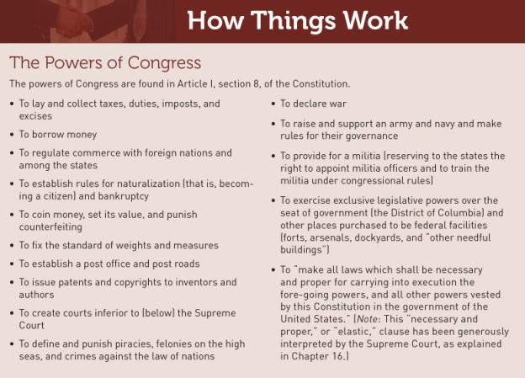

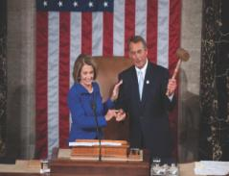

In January 2011, Democratic Speaker Nancy Pelosi turned over her gavel to Republican John Boehner who became speaker after the large Republican victory in the 2010 election.

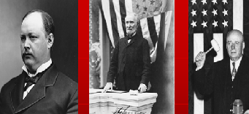

Three powerful Speakers of the House: Thomas B. Reed (1889–1891, 1895–1899) (left), Joseph G. Cannon (1903–1911) (center), and Sam Rayburn (1941–1947, 1949–1953, 1955–1961) (right). Reed put an end to a filibuster in the House by refusing to allow dilatory motions and by counting as “present”—for purposes of a quorum—members in the House even though they were not voting. Cannon further enlarged the Speaker’s power by refusing to recognize members who wished to speak without Cannon’s approval and by increasing the power of the Rules Committee, over which he presided. Cannon was stripped of much of his power in 1910. Rayburn’s influence rested more on his ability to persuade than on his formal powers.
The Evolution of Congress
- Bicameral (two chamber) legislature
- House of Representatives
- Senate
- Centralization vs. decentralization

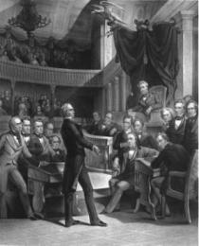

One of the most powerful Speakers of the House, Henry Clay, is shown here addressing the U. S. Senate around 1850.

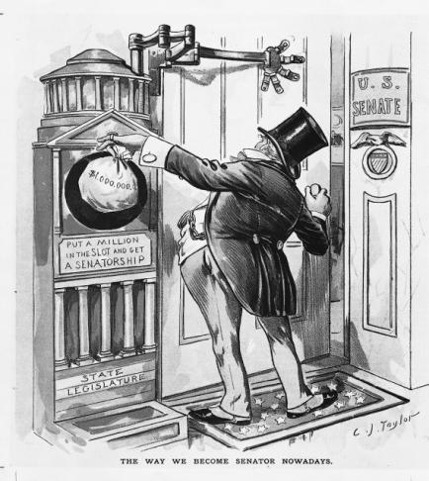
A cartoon from Puck in 1890 expressed popular resentment
over the “Millionaires Club,” as the Senate had become known.

Who is in Congress?

- Sex and Race
- Incumbency
  - Marginal districts
  - Safe districts
- Party

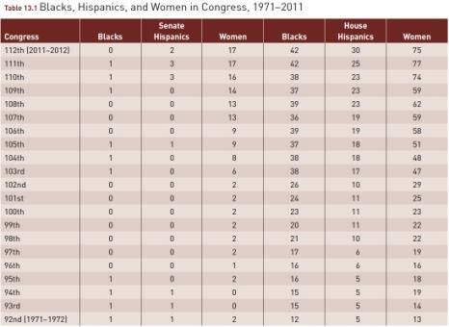

Rep. Paul Ryan (R-WI) in 2011 became the new chair
of the House Budget Committee where he oversaw
the preparation of a response to Pres. Obama’s
budget plan.

Rep. Gabrielle Giffords (D-AZ) recovering from
being shot in the head by a homicidal maniac.

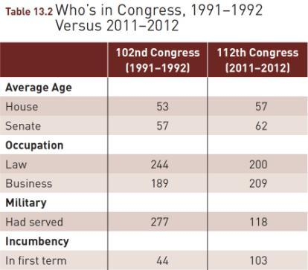Source: Adapted from chart based on Congressional Research Service and Military Officers Association data in John Harwood, “For New Congress, Data Shows Why Polarization Abounds,” New York Times, March 6, 2011.

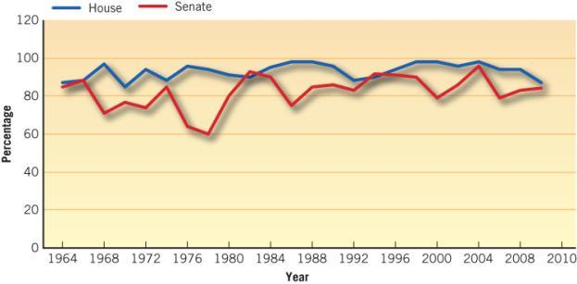
Source: For 1964-2008 data, The Center For Responsive Politics; 2010 data compiled by the author.

Do Members Represent Their Voters?
- Representational View–members vote to please their constituents
- Organizational View–members vote to please fellow members of Congress
- Attitudinal View–members vote on the basis of their own beliefs

Keith Ellison (D., MN), the first Muslim elected to Congress.

A Polarized Congress

- A more ideological perspective has been brought to Congress.
- Congress’ most liberal members are Democrats.
- Congress’ most conservative members are Republicans.
- Are voters closer to the center of the political spectrum?

The Organization of Congress: Parties and Caucuses
- Party Organization of the Senate
- Party Structure in the House
- The Strength of Party Structures
- Party Unity
- Caucuses

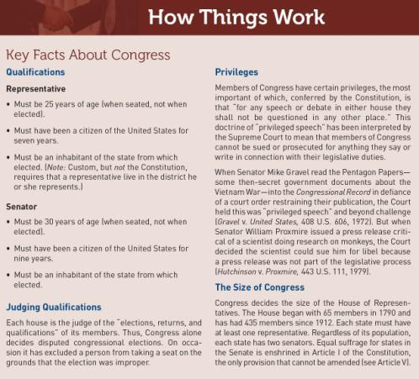

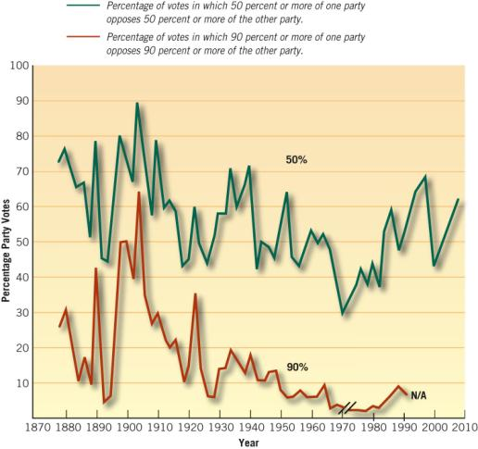
Note: A party vote occurs when the specified percentage (or more) of one party votes against the specified percentage (or more) of the other party.

Sources: Updated through 2008 by Zach Courser; NES data as reported in 2001–2002; Harold W.
Stanley and Richard G. Niemi, Vital Statistics on American Politics (CQ Press, 2001), 211. Reprinted by
permission of Congressional Quarterly, Inc.

The Organization of Congress: Committees
- Standing Committees
- Select Committees
- Joint Committees
- Conference Committees
- House
- Senate

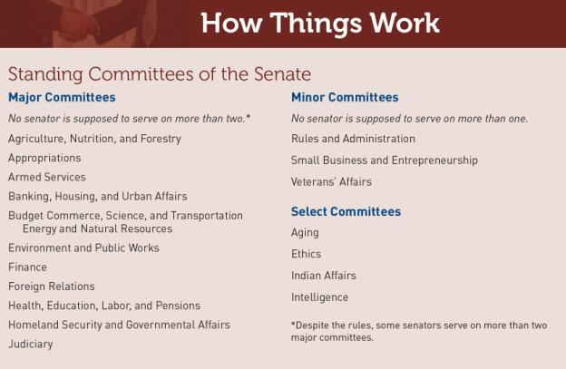
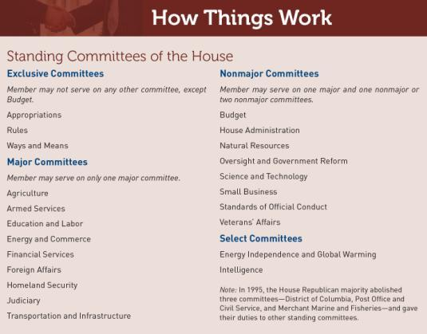

Rep. Steve Scalise, R-La., holds a photo of an oil covered
pelican as he questions BP CEO Tony Hayward on Capitol Hill in Washington, June 17, 2010, during the House Oversight and Investigations subcommittee hearing on the role of BP in the Deepwater Horizon explosion and oil spill.

The Organization of Congress: Staff and Specialized Offices
- Tasks of Staff Members
- Staff Agencies
  - Congressional Research Service (CRS)
  - General Accounting Office (GAO)
  - Office of Technology Assessment (OTA)
  - Congressional Budget Office (CBO)

How a Bill Becomes a Law
- Introducing a Bill
- Legislative Productivity
- Study by Committee
- Floor Debate – The House
- Floor Debate – The Senate
- Methods of Voting

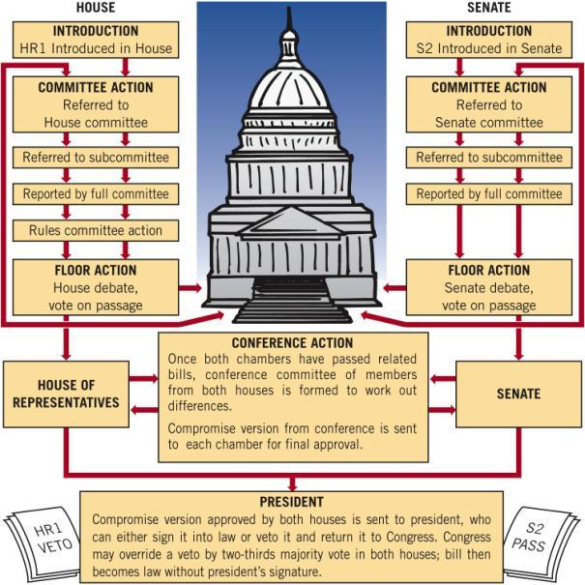

How a Bill Becomes a Law

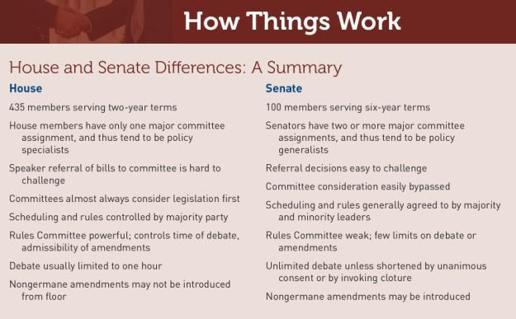

Reducing Power and Perks
- Term Limits?
- New Ethics Laws
- Organizational Changes
- Pork-Barrel Legislation
- Franking Privilege

Photo courtesy of the Office of the Clerk of the House

The electronic voting system in the House of Representatives displays each member’s name on the wall of the chamber. By inserting a plastic card in a box fastened to the chairs, a member can vote “Yea,” “Nay,” or “Present,” and the result is shown opposite his or her name.

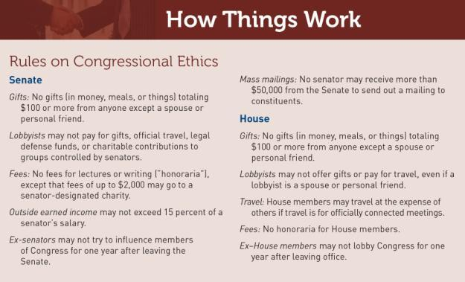

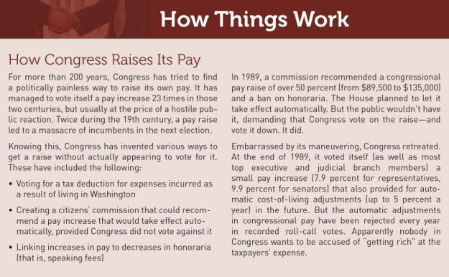
WHAT WOULD YOU DO?
M E M O R A N D U M
To: Representative Peter Skerry
From: Martha Bayles, legislative aide
Subject: The size of the House of Representatives
The House can decide how big it wishes to be. When it was created, there was one representative for every 30,000 people. Now there is one for every 600,000. In most other democracies, each member of parliament represents far fewer than 600,000 people. Doubling the size of the House may be a way of avoiding term limits.

Arguments for:
1. Doubling the size of the House would reduce the huge demand for constituent services each member now faces.
2. A bigger House would represent more shades of opinion more fairly.
3. Each member could raise less campaign money because his or her campaign would be smaller.

Arguments against:
1. A bigger House would be twice as hard to manage, and it would take even longer to pass legislation.
2. Campaigns in districts of 300,000 people would cost as much as ones in districts with 600,000 people.
3. Interest groups do a better job of representing public opinion than would a House with more members.

Your decision:
Increase size of House?
Do not increase size of House?

