Chapter 14 – The Presidency

Overview
The presidency has evolved from 1787 to present. The framers in the Committee on Postponed Matters developed the idea of creating an Electoral College. The framers approved the plan but thought that most elections would ultimately be decided by the House of Representatives. However, more than 200 years later the Electoral College endures and the House has not chosen a president since 1824.
A president, chosen (indirectly) by the people and with powers derived from a written constitution, has less power than does a prime minister, even though the latter depends on the support of her or his party in parliament. The separation of powers between the executive and legislative branches, the distinguishing feature of the political system in the United States, means that the president must compete with Congress in setting policy and even in managing executive agencies.
Presidential power, though still sharply limited, has grown from its constitutional origins as a result of congressional delegation, the increased importance of foreign affairs, and public expectations. Nevertheless, although the presidential office has more power today, the president also faces higher expectations. As a result, presidential effectiveness depends not on any general grant of authority but on the nature of the issues to be confronted and the support gained from informal sources of power. Public opinion and congressional support are extremely important. As a political scientist noted so many years ago, the president’s primary power is often the power to persuade.
Though the president seemingly controls a vast executive-branch apparatus, only a small proportion of executive-branch personnel are presidential appointees or nominees. Even these may not be under presidential control. Moreover, public support, high at the beginning of any new presidency, usually declines as the term proceeds. Consequently, each president must conserve power (and energy and time), concentrating these scarce resources to deal with a few matters of major importance. Virtually every president since Franklin Roosevelt has tried to gain better control of the executive branch—by reorganizing, by appointing White House aides, by creating specialized staff agencies—but no president has been satisfied with the results.
In dealing with Congress, the president may be able to rely somewhat on party loyalty. Presidents whose party controls Congress tend to have more of their proposals approved. However, such loyalty is insufficient. Every president must also cajole, award favors, and threaten vetoes to influence legislation. Few presidents can count on a honeymoon period. Most discover that their plans are at the mercy of unexpected crises.

Chapter Outline
- Introduction
- The American presidency is a unique office, with elements of great strength and profound weakness built into it by its constitutional origins.
II. Presidents and Prime Ministers (THEME A: THE POWER OF THE PRESIDENCY VERSUS OTHER INSTITUTIONS)
- Characteristics of parliaments
- Chief executive is the prime minister, chosen by the legislature.
- Parliamentary system, with a prime minister as the chief executive, is more common than is a federal system with elected president as chief executive.
- Prime minister chooses the cabinet ministers from among the members of parliament.
- Prime minister remains in power as long as his or her party or coalition maintains a majority in the legislature.
- Differences between the chief executives in presidential and parliamentary systems
- Presidents Are Often Outsiders
- Presidents may be outsiders; prime ministers are always insiders, chosen by the members of the majority party in parliament.
- Presidents Choose Cabinet Members from Outside Congress
- Incumbent members of Congress cannot simultaneously serve in a president’s cabinet; members of parliament are eligible to serve in the prime minister’s cabinet, and ministers are almost always chosen from their ranks.
- PRESIDENTS HAVE NO GUARANTEED MAJORITY IN THE LEGISLATURE
- Presidents have no guaranteed majority in the legislature; prime ministers always have a majority.
- Presidents and the Congress often work at cross purposes:
- Even when one party controls both branches
- A consequence of separation of powers, which fosters conflict between the branches
- Only Franklin Roosevelt and Johnson had (briefly) constructive relations with Congress
- PRESIDENTS AND Prime Ministers at War
- Presidents and prime ministers at war highlight differences in political position.
- George W. Bush’s decision to fight invited debate in Congress even though his party controlled both houses; however, no meaningful resistance in the British Parliament when Tony Blair announced his decision to fight.
- Bush’s decision to fight was undeterred by low opinion ratings, but when public opinion turned against Blair, he announced he would resign from office.
III. Divided Government
- Occurs when one party controls the White House and another controls one or both houses of Congress
- Has occurred in nineteen of the last 29 elections
- When Barack Obama became president in 2009, it was only the fourth time since 1969 that the same party controlled the White House and Congress to create a unified government. In 2011, things changed to create a partially divided government.
- A recurring phenomenon in American government
- Many people think divided government produces gridlock.
A. Does gridlock matter?
- Divided government does about as well as unified government in passing laws, conducting investigations, and ratifying treaties.
- Parties themselves are ideologically diverse, leading to policy disagreements.
- Unified government actually requires the same ideological wing of the party to control both branches of government.
B. Is policy gridlock bad?
- Everybody has an interest in some degree of policy gridlock.
- Divided government may result from intentional split-ticket voting practices.
- Necessary consequence of representative democracy
How We Compare
  - Most modern democracies feature one of the three systems:
- Parliamentary systems. Prime ministers are selected by legislative majority and can be removed by same.
- Presidential systems. President and legislators are separately elected and serve fixed terms.
- Semipresidential systems. Prime ministers are selected and subject to removal by parliamentary majority as well as a president who is separately elected.
- In 1950 about 60% of democratic nations had parliamentary systems and 30% had semipresidential systems, and 10% had presidential systems. Today two-thirds have either semipresidential or presidential systems.
- The rate at which a party in power pursues the policies it offered to voters in its platform is generally lower in presidential systems and the incidence of policy-switching is more than four times as common in presidential systems as it is in parliamentary systems.
IV. The Powers of the President
- Formal powers found in Article II
- President can exercise some powers unilaterally, whereas others require formal legislative approval.
- Potential for power found in ambiguous clauses of the Constitution: for example, power as commander in chief, duty to “take care that laws be faithfully executed” (executive power)
- Greatest source of presidential power lies in politics and public opinion.
- Increase in congressional grants of broad statutory authority, especially since the 1930s
- Expectation of presidential leadership from the public
- Powers of the President Alone
- Serve as commander in chief of the armed forces
- Commission officers of the armed forces
- Grant reprieves and pardons for federal offenses
- (except impeachment)
- Convene Congress in special sessions
- Receive ambassadors
- Take care that the laws be faithfully executed
- Wield the “executive power”
- Appoint officials to lesser offices
- Powers the president shares with the senate
- Make treaties
- Appoint ambassadors, judges, and high officials
- Powers the president shares with CONGRESS AS A WHOLE
- Approve legislation
V. The Evolution of the Presidency
A. Concerns of the Founders
- Delegates feared both anarchy and monarchy.
- Fear of the military power of the president, who could overpower states
- Fear of presidential corruption by Senate because Senate and president shared treaty-making power
- Fear of presidential bribery to ensure reelection
- Principal concern was to balance power of legislative and executive branches.
B. The Electoral College
- Each state to devise its own method of selecting electors.
- Electors would meet in their state capital to vote for president and vice president.
- If no candidate won a majority, the House would decide the election.
- Electoral College ultimately worked differently than expected, because Founders did not anticipate the role of political parties.
C. The president’s term of office
- Precedent of George Washington and the historical tradition of two terms
- Twenty-second Amendment in 1951 limited presidents to two terms.
- Another problem was establishing the legitimacy of the office.
- Founders also provided for the orderly transfer of power.
D. The first presidents
- Office was legitimated by men active in independence and Founding politics.
- Minimal activism of early government mitigated the fear of the presidency.
- Appointed people of stature in the community (rule of “fitness”)
- Relations with Congress were reserved: Few vetoes; no advice from Congress to president.
E. The Jacksonians
- Jackson believed in a strong and independent president.
- Vigorous use of veto for constitutional and policy reasons; none of the vetoes were overridden
- Demonstrated what a popular president could do
F. The reemergence of Congress
- With brief exceptions, the next century was a period of congressional dominance.
- Intensely divided public opinion—partisanship, slavery, sectionalism
- Only Lincoln expanded presidential power.
- Asserted “implied powers” and the express authorization of the commander in chief
- Justified actions by emergency conditions created by Civil War
- Following Lincoln, Congress again became the dominant branch until the New Deal, except for the T. Roosevelt and Wilson administrations.
- Even today, the popular perception of the president as the center of government contradicts the reality: Congress is often the policy leader.
VI. The Power to Persuade
- The president can use the office’s national constituency and ceremonial duties to enlarge powers.
- The Three Audiences
- Three audiences for president’s persuasive powers:
- Fellow politicians and leaders in Washington, D.C.; his reputation is very important
- Party activists and officials outside Washington
- Various public audiences with divergent views and interests
- On campaign trail, president speaks boldly about what he will accomplish.
- In office, president speaks quietly about problems that he will overcome.
- Presidents make fewer impromptu remarks and rely more on prepared speeches (taking advantage of the bully pulpit).
B. Popularity and influence
- Presidents try to transform popularity into congressional support for their programs.
- Presidential coattails have had a declining effect for years and are minimal in their influence today.
- Congressional elections are relatively insulated from presidential elections.
- Weak party loyalty and organization
- Congressional members’ own strong relations with their constituents
- Still, to avoid the political risks of opposing a popular president, Congress will pass more of that individual’s legislative proposals.
- Popularity is affected by factors beyond anyone’s control; for example, consider Bush’s approval ratings following the 9/11 attacks.
C. The decline in popularity
- Popularity highest immediately after an election (honeymoon period)
- Declines by midterm, with president’s party usually losing congressional seats in the midterm elections
VII. The Power to Say No
A. Veto
- Veto message sent within ten days of the bill’s passage
- Pocket veto (only before Congress adjourns at the end of its second session)
- Congress rarely overrides vetoes.
- President does not hold line-item veto power.
- 1996 reform permitted enhanced rescissions.
- Supreme Court ruled this procedure was unconstitutional.
B. Executive privilege
- Confidential communications between president and advisers need not be disclosed.
- Justification:
- Separation of powers
- Need for candid advice
- United States v. Nixon (1974) rejected claim of absolute executive privilege.
- Bill Clinton–Paula Jones episode greatly reduced number of officials with whom president can speak in confidence.
C. Impoundment of funds
- Impoundment of Funds: presidential refusal to spend funds appropriated by Congress.
- Nixon impoundments countered by Budget Reform Act of 1974.
- Requires president to notify Congress of funds he does not intend to spend
- Congress must agree in forty-five days to delete item.
- Requires president to notify Congress of delays in spending
- Congress may pass a resolution refusing the delay and requiring the immediate release of funds.
D. Signing statements
- Presidential statement issued at the time the president signs a bill.
- Purposes include:
- To express presidential attitudes about the law
- To communicate to executive branch how law should be enforced
- To declare his belief that a portion of the law is unconstitutional
- Became common in twentieth century
- Viewed by Congress as a type of unconstitutional line-item veto that blocks enforcement of the law.
- Currently allowed by Supreme Court, but Court has not ruled directly on the practice.

VIII. Presidential Character
- Presidential personality shapes the way the White House is organized.
- Eisenhower: Orderly, military style; delegation of authority to trained specialists
- Kennedy: Bold, articulate, amusing leader; improviser who bypassed traditional lines of authority
- Johnson: Master legislative strategist; tended to micromanage
- Nixon: Expert in foreign policy; disliked personal confrontation; tried to centralize power in the White House
- Ford: Discussion oriented and genial; decision structures not always coherent or organized
- Carter: Washington outsider; tended to micromanage
- Reagan: Set policy priorities and then gave staff wide latitude; leader of public opinion
- George H. W. Bush: Hands-on manager, with considerable Washington experience
- Clinton: Good communicator; pursued liberal/centrist policies
- George W. Bush: Tightly run White House; agenda became dominated by foreign affairs following the 9/11 attacks
- Barack Obama: Superb communicator; first African-American elected to the presidency; came to office amid a global economic crisis; has proposed the largest federal budget in history, designed to forestall an economic depression; has proposed a comprehensive health insurance program
IX. The Office of the President (THEME B: THE INSTITUTIONALIZATION OF THE PRESIDENCY)
- President did not have any real staff until 1857.
- White House staff has grown enormously.
  - President now has large bureaucracy of assistants he has difficulty controlling.
  - Rule of propinquity: Power is wielded by people who are in the room when a decision is made.
- Presidential appointments can be classified in terms of their physical and political proximity to the president.
A. The White House Office
- President’s closest assistants
- Three types of structure, often used in combination to compensate for their weaknesses and to capitalize on their strengths
- Pyramidal structure: Eisenhower, Nixon, Reagan, George H.W. Bush, Clinton (late in his administration); most assistants report through hierarchy to chief of staff, who then reports to president.
- Circular structure: Carter (early in his administration); cabinet secretaries and assistants report directly to president
- Ad hoc structure: Clinton (early in his administration); task forces, committees, and informal groups deal directly with president
- Common to mix organizational methods
- Staff members typically have worked on the campaign; a few are experts.
- Always a great deal of jockeying for physical proximity (office closer to the Oval Office) and access to the president.
B. THE Executive Office of the President
- Composed of agencies that report directly to the president
- Appointments must receive Senate confirmation, unlike those of White House staff.
- Principal agencies in the Executive Office include:
- Office of Management and Budget (OMB)
- Director of National Intelligence (DNI)
- Council of Economic Advisors (CEA)
- Office of Personnel Management (OPM)
- Office of the U.S. Trade Representative
- Office of Management and Budget is perhaps the most important agency in the EOP.
- Assembles the budget
- Develops reorganization plans
- Reviews legislative proposals of agencies
- Has recently become more of a policy advocate
C. The cabinet
- The cabinet: Chief executives (secretaries) of the executive branch departments
- Not explicitly mentioned in Constitution
- Presidents have many more appointments to make than do prime ministers, due to competition created by the separation of powers.
- Presidential control over departments remains uncertain—secretaries become advocates for their departments.
D. Independent agencies, commissions, and judgeships
- President appoints members of agencies that have a quasi-independent status.
- “Acting” appointments cause increased legislative-executive tensions.
- In general, independent agency heads can be removed only “for cause” and serve fixed terms.
- Executive agency heads serve at the president’s pleasure, though their appointments must be confirmed by the Senate.
- Judges can be removed only by impeachment.
X. Who Gets Appointed
- President knows few appointees personally.
- Most appointees to the cabinet and subcabinet have had federal experience.
- “In-and-outers” alternate federal government and private-sector jobs.
- Modern tendency is to place experts, rather than those with political followings, in the cabinet.
- Need to consider politically important groups, regions, and organizations when making appointments
- Rivalry often develops between department heads (who represent expert knowledge) and White House staff (who are extensions of presidential priorities).

XI. The President’s Program
A. Putting together a program
- Resources in developing a program include interest groups, aides and campaign advisers, federal departments and agencies, and various specialists.
- Alternative approaches to policy formulation:
- Carter and Clinton: Tried to have a policy on everything
- Reagan: Concentrated on a small number of initiatives and left everything else to subordinates
- Constraints on a president’s program
- Public and congressional reactions
- Limited time and attention span of the president
- Unexpected crises, such as the 9/11 attacks
- Programs can be changed only marginally, because most resources are already committed.
- Public-opinion polls
- Presidential approach may be influenced by opinion polling.
- Trustee model: Do what the public good requires, regardless of popular opinion
- Delegate model: Do what your constituents want you to do.
B. Attempts to reorganize
- Almost every president since 1928 has proposed reorganization.
- Reorganization: Changing the structure of the staff, departments, and agencies that are subordinate to the executive.
- Bush’s reorganization to accommodate the new Department of Homeland Security is an example of long-standing practice.
- Reasons for reorganizing
- Large number of agencies
- Easier to change policy through reorganization than by abolishing an old program or agency
- Reorganization outside the White House staff must be congressionally approved.
XII. Presidential Transition (THEME C: PRESIDENTIAL SUCCESSION)
- Only fourteen of forty-one presidents have served two full terms.
A. The vice president
- Eight vice presidents have succeeded to office on president’s death.
- Prior to 2000, only five vice presidents won the presidency in an election without having first entered the office as a result of the president’s death.
- “A rather empty job”
- Vice president presides over Senate and votes in case of tie.
- Leadership powers in Senate are weak, especially in times of divided government.
B. Problems of succession
- What if president falls ill?
- Examples: Garfield, Wilson, Eisenhower, Reagan
- If vice president steps up, who becomes new vice president?
- Earliest answer was in the Succession Act (1886), amended in 1947.
- Today, Twenty-fifth Amendment (1967) establishes procedures.
- Allows vice president to serve as acting president if president is disabled
- Illness is decided by president, by vice president and cabinet, or by two-thirds vote of Congress.
- Requires a vice president who ascends to office on death or resignation of president to name a vice president
- New vice president must be confirmed by a majority vote of both houses.
- Examples: Vacancies produced by resignations of Agnew (vice president) and Nixon (president)
C. Impeachment
- Judges, not presidents, are the most frequent subjects of impeachment.
- Indictment by the House, conviction by the Senate
- Presidential examples: Andrew Johnson, Richard Nixon (preempted by resignation), Bill Clinton
- Neither Johnson nor Clinton was convicted by the Senate.
- Office of the Independent Counsel was not renewed in 1999 and is generally considered a casualty of the Clinton impeachment.
- Interpretation of constitutional language (“high crime or misdemeanor”) is unclear.
XIII. How Powerful Is the President?
- Both the president and the Congress are more constrained today.
- Reasons for constraint:
- Complexity of issues
- Scrutiny of the media
- Greater number and power of interest groups
- Presidential responses to constraints include:
- Acting early in the first term (honeymoon period)
- Establishing a few top priorities
- Giving power to the White House staff and supervising them carefully

President of the United States | Prime Minister (Great Britain)
Chief executive is the President, chosen by the Electoral College  Federal system with elected president as chief executive  The President is limited to two terms in office; can serve with/without his or her party in power  Incumbent members of Congress cannot simultaneously serve in a president’s cabinet  Presidents have no guaranteed majority in the legislature | Chief executive is the prime minister, chosen by the legislature (Parliament)  Parliamentary system, with a prime minister as the chief executive (more common around the world)  Prime minister remains in power as long as his or her party or coalition maintains a majority in the legislature  Members of parliament are eligible to serve in the prime minister’s cabinet, and ministers are almost always chosen from their ranks  Prime ministers always have a majority

The Electoral College

- There are 538 votes altogether; to win a candidate must receive 270 votes.
- Each state has electors equal to the number of members it has in the House and the Senate.
- Each state devises its own method of selecting electors.
  - The winning states of electors meet in the state capitals about six weeks after the election to cast their ballots.
  - In all but two states (Maine & Nebraska), the candidate who wins the most popular votes gets all of the electoral votes.
- The ballots are opened and counted before a joint session of Congress during the first week of January.
- If no candidate won a majority, the House of Representatives would decide the election.
- Electoral College ultimately worked differently than expected, because Founders did not anticipate the role of political parties.

III. Divided Government
- Occurs when one party controls the White House and another controls one or both houses of Congress
- Has occurred in nineteen of the last 29 elections
- When Barack Obama became president in 2009, it was only the fourth time since 1969 that the same party controlled the White House and Congress to create a unified government. In 2011, things changed to create a partially divided government.
- A recurring phenomenon in American government
- Many people think divided government produces gridlock.
A. Does gridlock matter?
- Divided government does about as well as unified government in passing laws, conducting investigations, and ratifying treaties.
- Parties themselves are ideologically diverse, leading to policy disagreements.
- Unified government actually requires the same ideological wing of the party to control both branches of government.
B. Is policy gridlock bad?
- Everybody has an interest in some degree of policy gridlock.
- Divided government may result from intentional split-ticket voting practices.
- Necessary consequence of representative democracy
How We Compare
  - Most modern democracies feature one of the three systems:
- Parliamentary systems. Prime ministers are selected by legislative majority and can be removed by same.
- Presidential systems. President and legislators are separately elected and serve fixed terms.
- Semipresidential systems. Prime ministers are selected and subject to removal by parliamentary majority as well as a president who is separately elected.
- In 1950 about 60% of democratic nations had parliamentary systems and 30% had semipresidential systems, and 10% had presidential systems. Today two-thirds have either semipresidential or presidential systems.
- The rate at which a party in power pursues the policies it offered to voters in its platform is generally lower in presidential systems and the incidence of policy-switching is more than four times as common in presidential systems as it is in parliamentary systems.

IV. The Powers of the President
- Formal powers found in Article II
- President can exercise some powers unilaterally, whereas others require formal legislative approval.
- Potential for power found in ambiguous clauses of the Constitution: for example, power as commander in chief, duty to “take care that laws be faithfully executed” (executive power)
- Greatest source of presidential power lies in politics and public opinion.
- Increase in congressional grants of broad statutory authority, especially since the 1930s
- Expectation of presidential leadership from the public
- Powers of the President Alone
- Serve as commander in chief of the armed forces
- Commission officers of the armed forces
- Grant reprieves and pardons for federal offenses (except impeachment)
- Convene Congress in special sessions
- Receive ambassadors
- Take care that the laws be faithfully executed
- Wield the “executive power”
- Appoint officials to lesser offices
- Powers the president shares with the senate
- Make treaties
- Appoint ambassadors, judges, and high officials
- Powers the president shares with CONGRESS AS A WHOLE
- Approve legislation
V. The Evolution of the Presidency
A. Concerns of the Founders
- Delegates feared both anarchy and monarchy.
- Fear of the military power of the president, who could overpower states
- Fear of presidential corruption by Senate because Senate and president shared treaty-making power
- Fear of presidential bribery to ensure reelection
- Principal concern was to balance power of legislative and executive branches.
B. The Electoral College
- Each state to devise its own method of selecting electors.
- Electors would meet in their state capital to vote for president and vice president.
- If no candidate won a majority, the House would decide the election.
- Electoral College ultimately worked differently than expected, because Founders did not anticipate the role of political parties.
C. The president’s term of office
- Precedent of George Washington and the historical tradition of two terms
- Twenty-second Amendment in 1951 limited presidents to two terms.
- Another problem was establishing the legitimacy of the office.
- Founders also provided for the orderly transfer of power.
D. The first presidents
- Office was legitimated by men active in independence and Founding politics.
- Minimal activism of early government mitigated the fear of the presidency.
- Appointed people of stature in the community (rule of “fitness”)
- Relations with Congress were reserved: Few vetoes; no advice from Congress to president.
E. The Jacksonians
- Jackson believed in a strong and independent president.
- Vigorous use of veto for constitutional and policy reasons; none of the vetoes were overridden
- Demonstrated what a popular president could do
F. The reemergence of Congress
- With brief exceptions, the next century was a period of congressional dominance.
- Intensely divided public opinion—partisanship, slavery, sectionalism
- Only Lincoln expanded presidential power.
- Asserted “implied powers” and the express authorization of the commander in chief
- Justified actions by emergency conditions created by Civil War
- Following Lincoln, Congress again became the dominant branch until the New Deal, except for the T. Roosevelt and Wilson administrations.
- Even today, the popular perception of the president as the center of government contradicts the reality: Congress is often the policy leader.
VI. The Power to Persuade
- The president can use the office’s national constituency and ceremonial duties to enlarge powers.
- The Three Audiences
- Three audiences for president’s persuasive powers:
- Fellow politicians and leaders in Washington, D.C.; his reputation is very important
- Party activists and officials outside Washington
- Various public audiences with divergent views and interests
- On campaign trail, president speaks boldly about what he will accomplish.
- In office, president speaks quietly about problems that he will overcome.
- Presidents make fewer impromptu remarks and rely more on prepared speeches (taking advantage of the bully pulpit).
B. Popularity and influence
- Presidents try to transform popularity into congressional support for their programs.
- Presidential coattails have had a declining effect for years and are minimal in their influence today.
- Congressional elections are relatively insulated from presidential elections.
- Weak party loyalty and organization
- Congressional members’ own strong relations with their constituents
- Still, to avoid the political risks of opposing a popular president, Congress will pass more of that individual’s legislative proposals.
- Popularity is affected by factors beyond anyone’s control; for example, consider Bush’s approval ratings following the 9/11 attacks.
C. The decline in popularity
- Popularity highest immediately after an election (honeymoon period)
- Declines by midterm, with president’s party usually losing congressional seats in the midterm elections
VII. The Power to Say No
A. Veto
- Veto message sent within ten days of the bill’s passage
- Pocket veto (only before Congress adjourns at the end of its second session)
- Congress rarely overrides vetoes.
- President does not hold line-item veto power.
- 1996 reform permitted enhanced rescissions.
- Supreme Court ruled this procedure was unconstitutional.
B. Executive privilege
- Confidential communications between president and advisers need not be disclosed.
- Justification:
- Separation of powers
- Need for candid advice
- United States v. Nixon (1974) rejected claim of absolute executive privilege.
- Bill Clinton–Paula Jones episode greatly reduced number of officials with whom president can speak in confidence.
C. Impoundment of funds
- Impoundment of Funds: presidential refusal to spend funds appropriated by Congress.
- Nixon impoundments countered by Budget Reform Act of 1974.
- Requires president to notify Congress of funds he does not intend to spend
- Congress must agree in forty-five days to delete item.
- Requires president to notify Congress of delays in spending
- Congress may pass a resolution refusing the delay and requiring the immediate release of funds.
D. Signing statements
- Presidential statement issued at the time the president signs a bill.
- Purposes include:
- To express presidential attitudes about the law
- To communicate to executive branch how law should be enforced
- To declare his belief that a portion of the law is unconstitutional
- Became common in twentieth century
- Viewed by Congress as a type of unconstitutional line-item veto that blocks enforcement of the law.
- Currently allowed by Supreme Court, but Court has not ruled directly on the practice.

VIII. Presidential Character
- Presidential personality shapes the way the White House is organized.
- Eisenhower: Orderly, military style; delegation of authority to trained specialists
- Kennedy: Bold, articulate, amusing leader; improviser who bypassed traditional lines of authority
- Johnson: Master legislative strategist; tended to micromanage
- Nixon: Expert in foreign policy; disliked personal confrontation; tried to centralize power in the White House
- Ford: Discussion oriented and genial; decision structures not always coherent or organized
- Carter: Washington outsider; tended to micromanage
- Reagan: Set policy priorities and then gave staff wide latitude; leader of public opinion
- George H. W. Bush: Hands-on manager, with considerable Washington experience
- Clinton: Good communicator; pursued liberal/centrist policies
- George W. Bush: Tightly run White House; agenda became dominated by foreign affairs following the 9/11 attacks
- Barack Obama: Superb communicator; first African-American elected to the presidency; came to office amid a global economic crisis; has proposed the largest federal budget in history, designed to forestall an economic depression; has proposed a comprehensive health insurance program
IX. The Office of the President (THEME B: THE INSTITUTIONALIZATION OF THE PRESIDENCY)
- President did not have any real staff until 1857.
- White House staff has grown enormously.
  - President now has large bureaucracy of assistants he has difficulty controlling.
  - Rule of propinquity: Power is wielded by people who are in the room when a decision is made.
- Presidential appointments can be classified in terms of their physical and political proximity to the president.
A. The White House Office
- President’s closest assistants
- Three types of structure, often used in combination to compensate for their weaknesses and to capitalize on their strengths
- Pyramidal structure: Eisenhower, Nixon, Reagan, George H.W. Bush, Clinton (late in his administration); most assistants report through hierarchy to chief of staff, who then reports to president.
- Circular structure: Carter (early in his administration); cabinet secretaries and assistants report directly to president
- Ad hoc structure: Clinton (early in his administration); task forces, committees, and informal groups deal directly with president
- Common to mix organizational methods
- Staff members typically have worked on the campaign; a few are experts.
- Always a great deal of jockeying for physical proximity (office closer to the Oval Office) and access to the president.
B. THE Executive Office of the President
- Composed of agencies that report directly to the president
- Appointments must receive Senate confirmation, unlike those of White House staff.
- Principal agencies in the Executive Office include:
- Office of Management and Budget (OMB)
- Director of National Intelligence (DNI)
- Council of Economic Advisors (CEA)
- Office of Personnel Management (OPM)
- Office of the U.S. Trade Representative
- Office of Management and Budget is perhaps the most important agency in the EOP.
- Assembles the budget
- Develops reorganization plans
- Reviews legislative proposals of agencies
- Has recently become more of a policy advocate
C. The cabinet
- The cabinet: Chief executives (secretaries) of the executive branch departments
- Not explicitly mentioned in Constitution
- Presidents have many more appointments to make than do prime ministers, due to competition created by the separation of powers.
- Presidential control over departments remains uncertain—secretaries become advocates for their departments.
D. Independent agencies, commissions, and judgeships
- President appoints members of agencies that have a quasi-independent status.
- “Acting” appointments cause increased legislative-executive tensions.
- In general, independent agency heads can be removed only “for cause” and serve fixed terms.
- Executive agency heads serve at the president’s pleasure, though their appointments must be confirmed by the Senate.
- Judges can be removed only by impeachment.
X. Who Gets Appointed
- President knows few appointees personally.
- Most appointees to the cabinet and subcabinet have had federal experience.
- “In-and-outers” alternate federal government and private-sector jobs.
- Modern tendency is to place experts, rather than those with political followings, in the cabinet.
- Need to consider politically important groups, regions, and organizations when making appointments
- Rivalry often develops between department heads (who represent expert knowledge) and White House staff (who are extensions of presidential priorities).

XI. The President’s Program
A. Putting together a program
- Resources in developing a program include interest groups, aides and campaign advisers, federal departments and agencies, and various specialists.
- Alternative approaches to policy formulation:
- Carter and Clinton: Tried to have a policy on everything
- Reagan: Concentrated on a small number of initiatives and left everything else to subordinates
- Constraints on a president’s program
- Public and congressional reactions
- Limited time and attention span of the president
- Unexpected crises, such as the 9/11 attacks
- Programs can be changed only marginally, because most resources are already committed.
- Public-opinion polls
- Presidential approach may be influenced by opinion polling.
- Trustee model: Do what the public good requires, regardless of popular opinion
- Delegate model: Do what your constituents want you to do.
B. Attempts to reorganize
- Almost every president since 1928 has proposed reorganization.
- Reorganization: Changing the structure of the staff, departments, and agencies that are subordinate to the executive.
- Bush’s reorganization to accommodate the new Department of Homeland Security is an example of long-standing practice.
- Reasons for reorganizing
- Large number of agencies
- Easier to change policy through reorganization than by abolishing an old program or agency
- Reorganization outside the White House staff must be congressionally approved.
XII. Presidential Transition (THEME C: PRESIDENTIAL SUCCESSION)
- Only fourteen of forty-one presidents have served two full terms.
A. The vice president
- Eight vice presidents have succeeded to office on president’s death.
- Prior to 2000, only five vice presidents won the presidency in an election without having first entered the office as a result of the president’s death.
- “A rather empty job”
- Vice president presides over Senate and votes in case of tie.
- Leadership powers in Senate are weak, especially in times of divided government.
B. Problems of succession
- What if president falls ill?
- Examples: Garfield, Wilson, Eisenhower, Reagan
- If vice president steps up, who becomes new vice president?
- Earliest answer was in the Succession Act (1886), amended in 1947.
- Today, Twenty-fifth Amendment (1967) establishes procedures.
- Allows vice president to serve as acting president if president is disabled
- Illness is decided by president, by vice president and cabinet, or by two-thirds vote of Congress.
- Requires a vice president who ascends to office on death or resignation of president to name a vice president
- New vice president must be confirmed by a majority vote of both houses.
- Examples: Vacancies produced by resignations of Agnew (vice president) and Nixon (president)
C. Impeachment
- Judges, not presidents, are the most frequent subjects of impeachment.
- Indictment by the House, conviction by the Senate
- Presidential examples: Andrew Johnson, Richard Nixon (preempted by resignation), Bill Clinton
- Neither Johnson nor Clinton was convicted by the Senate.
- Office of the Independent Counsel was not renewed in 1999 and is generally considered a casualty of the Clinton impeachment.
- Interpretation of constitutional language (“high crime or misdemeanor”) is unclear.
XIII. How Powerful Is the President?
- Both the president and the Congress are more constrained today.
- Reasons for constraint:
- Complexity of issues
- Scrutiny of the media
- Greater number and power of interest groups
- Presidential responses to constraints include:
- Acting early in the first term (honeymoon period)
- Establishing a few top priorities
- Giving power to the White House staff and supervising them carefully

 | Pyramid | Circular | Ad Hoc (done for a particular purpose)
Definition | Most assistants report through hierarchy to chief of staff, who then reports to president | Cabinet secretaries and assistants report directly to president | Task forces, committees, and informal groups deal directly with president
Presidents | Eisenhower, Nixon, Reagan, George H.W. Bush, Clinton (late in his administration) | Carter (early in his administration) | Clinton (early in his administration)
Pros/Cons | Provides for an orderly flow of information and decisions, risks isolating or misinforming the president | Provides the president with a wealth of information, but increases the chance of confusion and conflict. | Allows for great flexibility, minimizes bureaucratic inertia, and generates ideas and information from disparate channels, risks cutting the president off from the government officials who are ultimately responsible for translating presidential decisions into policy proposals and administrative action

- WHO GOVERNS?
  - Did the Founders expect the presidency to be the most important political institution?
  - How important is the president’s character in determining how he governs?
- TO WHAT ENDS?
  - Should we abolish the electoral college?
  - Is it harder to govern when the presidency and the Congress are controlled by different political parties?

Presidents and Prime Ministers
- Presidents are Often Outsiders
- Presidents Choose Cabinet Members from Outside Congress
- Presidents Have No Guaranteed Majority in Congress
- Presidents and Prime Ministers at War

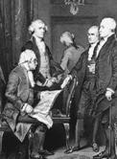

The first cabinet: left to right, Secretary of War Henry Knox, Secretary of State Thomas Jefferson, Attorney General Edmund Randolph, Secretary of the Treasury Alexander Hamilton, and President George Washington.

Divided Government

- Divided government – One party controls the White House and another party controls one or both houses of Congress
- Unified government – The same party controls the White House and both houses of Congress
- Does gridlock matter?
- Is policy gridlock bad?

The Powers of the President
- Powers of the President alone
- Powers the President shares with the Senate
- Powers the President shares with Congress as a whole

A military officer carrying “the football” – the briefcase containing the secret codes the president can use to launch a nuclear attack.

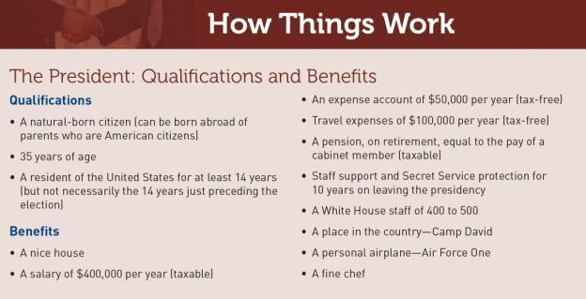

America witnessed peaceful transfers of power not only between leaders of different parties (such as Woodrow Wilson and William Howard Taft in 1913), but also after a popular leader was assassinated (Lyndon Johnson is sworn in after John F. Kennedy’s death), p. 374.

The Evolution of the Presidency
- Concerns of the Founders
- The Electoral College
- The President’s Term of Office
- The First Presidents
- The Jacksonians
- The Re-emergence of Congress

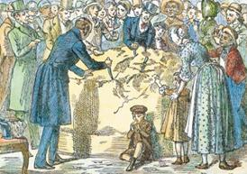

President Andrew Jackson thought of himself as the “Tribune of the People,” and he symbolized this
by throwing a White House party that anyone could attend. Hundreds of people showed up and ate or
carried away most of a 1,400-pound block of cheese.

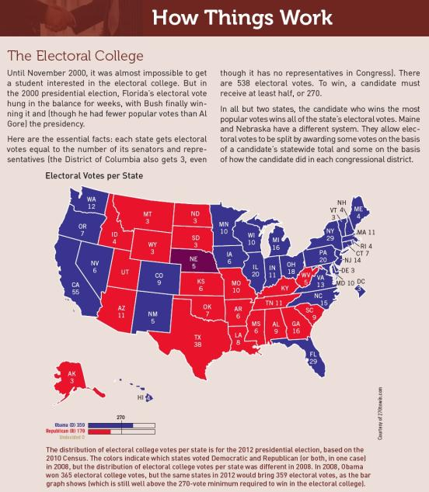

The Power to Persuade

- The Three Audiences
  - Fellow politicians and leaders
  - Partisan grassroots
  - The public
- Popularity and Influence
- The Decline in Popularity

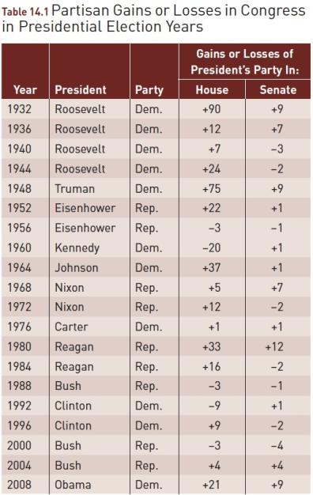
- Sources: Updated from Congressional Quarterly, Guide to U.S. Elections, 928; and Congress and the Nation, vol. 4 (1973–1976), 28.

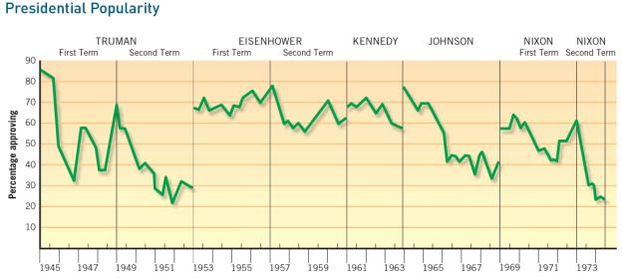

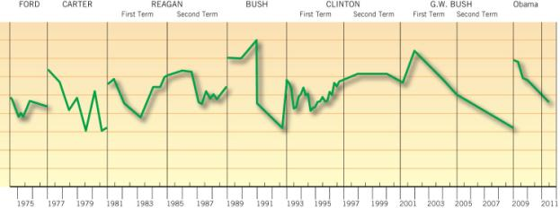

Source: Thomas E. Cronin, The State of the Presidency (Boston: Little, Brown, 1975), 110–111. Copyright © 1975 by Little, Brown and Company, Inc. Reprinted by permission. Updated with Gallup poll data, 1976–2011. Reprinted by permission of the Gallup Poll News Service.

Note: Popularity was measured by asking every few months, “Do you approve of the way _________ is handling his job as president?”

Figure 14.2 Presidential Victories on Votes in Congress, 1953–2010
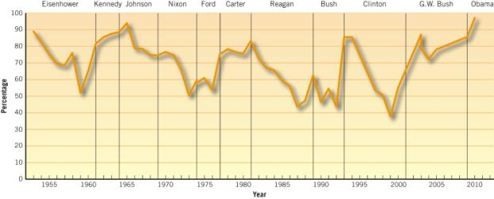
Note: Percentages indicate number of congressional votes supporting the president divided by the total number of votes on which the
president has taken a position.

Source: Congressional Quarterly Weekly Report, various years. Data for 2010 from http://library.cqpress.com/cqweekly/fi le.php?path=/files/ wr20110103-01prezsupport-cht2.pdf; Schatz, Joseph J., “2010 Vote Studies: Presidential Support,” CQ Weekly (January 3, 2011): 18–24.

The Power to Say No
- Veto
  - Veto message
  - Pocket veto
  - Line-item veto
- Executive Privilege
- Impoundment of Funds
- Signing Statements

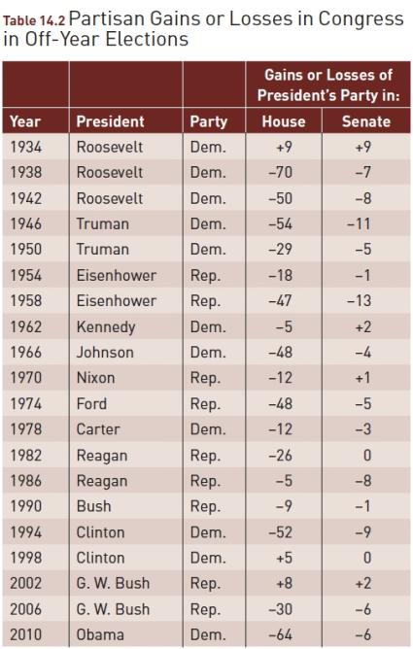
Sources: Norman J. Ornstein, Thomas E. Mann, and Michael J. Malbin, Vital Statistics on Congress, 2001–2002 (Washington, D.C.: Congressional Quarterly Press, 2001), 207; Web sites of U.S. House of Representatives and U.S. Senate. Note: See the Web links on the
front inside cover to visit the House and Senate Web sites.

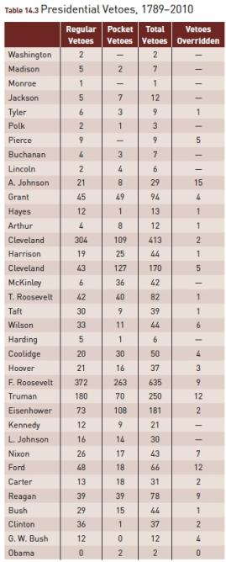
Sources: Norman J. Ornstein, Thomas E. Mann, and Michael
J. Malbin, Vital Statistics on Congress, 2002–2003 (Washington,
D.C.: Congressional Quarterly Press, 2003), 207; The American
Presidency Project of the University of California at Santa
Barbara.

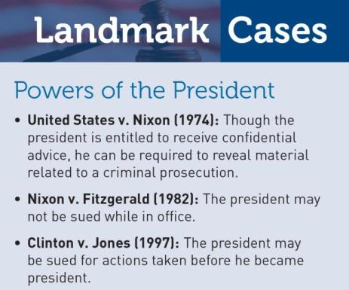

Presidential Character
- Dwight Eisenhower
- John Kennedy
- Lyndon Johnson
- Richard Nixon
- Gerald Ford
- Jimmy Carter

- Ronald Reagan
- George H. W. Bush
- Bill Clinton
- George W. Bush
- Barack Obama

The Office of the President
- The White House Office
  - Pyramid structure
  - Circular structure
  - Ad hoc structure
- The Executive Office of the President
- The Cabinet
- Independent Agencies, Commissions, and Judgeships

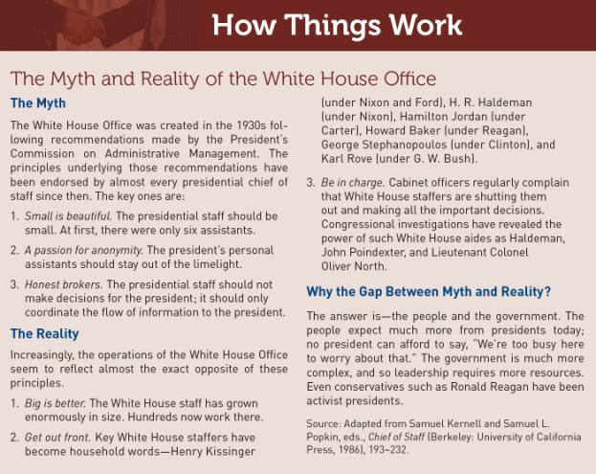
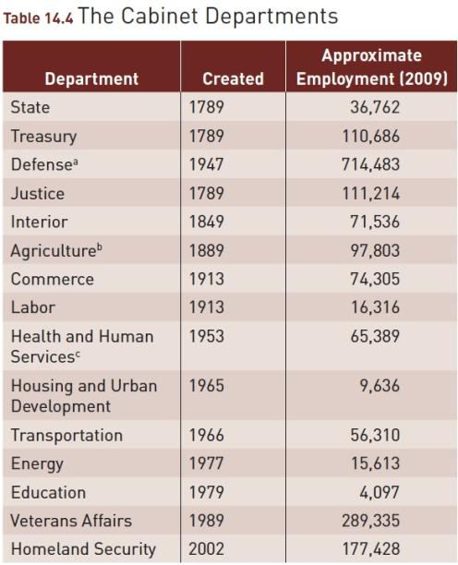
ªFormerly the War Department, created in 1789. Figures are for
civilians only.
^{b}Agriculture Department created in 1862; made part of cabinet in 1889.
^{c}Originally Health, Education and Welfare; reorganized in 1979.
Source: Statistical Abstract of the United States, 2011, table 497.

Who Gets Appointed
- Prior federal experience
- “In-and-outers”
- Political following
- Expertise/ administrative experience

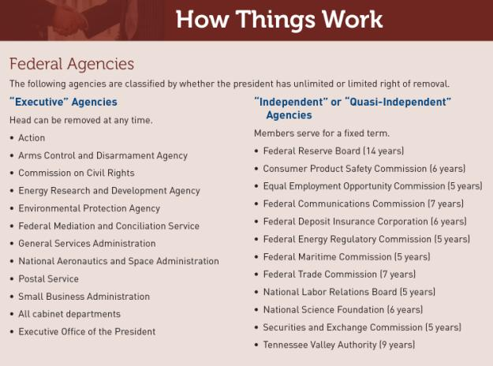

Secretary of Labor Frances Perkins (left), appointed by President Franklin Roosevelt, was the first woman cabinet member.

When Condoleezza Rice was selected by President George W. Bush to be National Security Advisor, she became the first woman to hold that position (and later the first African American woman to be Secretary of State).

The President’s Program
- Putting Together a Program
  - Interest groups
  - Aides and campaign advisers
  - Federal bureaus and agencies
  - Outside, academic, other specialists and experts
- Attempts to Reorganize

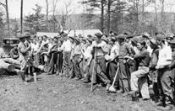
A group of Civilian Conservation
Corps workers hired by the government
during the Great Depression.

Presidential Transition

- The Vice President
- Problems of Succession
- Impeachment
- Lame duck

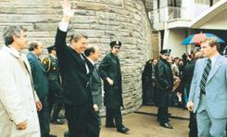

President Reagan, moments before he was shot on March 30, 1981, by a would-be assassin. The Twenty-fifth Amendment solves the problem of presidential disability by providing for an orderly transfer of power to the vice president.

How Powerful is the President?
Presidential rules of thumb for dealing with political problems:
  - Move it or lose it.
  - Avoid details.
  - Cabinets don’t get much accomplished; people do.

WHAT WOULD YOU DO?
M E M O R A N D U M
To: White House Chief of Staff Ann Martin
From: Office of Legislative Affairs Director Sean Rivera
Subject: Passing budget bills under divided government
With the opposition party in control of Congress, media pundits and other commentators are calling for the president to accept the other party’s agenda for the next round of budget bills.

Arguments for:
1. With a re-election battle around the corner, the president cannot afford to get caught up in a budget battle with Congress.
2. The president’s ability to gain public support for his agenda is limited, and even increased public support will not improve leverage with Congress.
3. The president should defer to Congress as the primary representative of the people in American politics.

Arguments against:
1. American politics is guided too often by campaigns, and the president will build support for re-election by acting presidential—that is, by setting the agenda for the budget and not backing down.
2. The president can build public support through speeches and other forms of communication, and this support can be used as political capital to negotiate with Congress.
3. The president is the only nationally elected official in American politics (other than the vice-president), and therefore is responsible for identifying and promoting public priorities, even if this means legislative battles with Congress.

Your decision:
Favor plan?
Oppose plan?

