Chapter 15 – The Bureaucracy

Overview
Bureaucracy is characteristic of almost all aspects of modern life, not just the government. Government bureaucracies, however, pose special problems. Four factors are particularly influential in the United States. Government bureaucracies: (1) must answer to competing sources of political authority; (2) must function in a constitutional system that fragments power; (3) are asked to achieve vague and competing goals; and (4) lack incentive systems that value efficiency.
The power of a bureaucracy should be measured by its discretionary authority, not by the number of its employees or the size of its budget.
War and economic depression have been the principal sources of bureaucratic growth. These were aided, in the 1930s, by important changes in constitutional interpretation that permitted Congress to delegate broad grants of authority to administrative agencies. With only partial success, Congress seeks to check or recover that grant of power by controlling budgets, personnel, and policy decisions, and through the exercise of legislative vetoes. The uses to which bureaucrats put their authority can be explained in part by their recruitment and security, their personal political views, and the nature of the tasks that their agencies perform.
Many of the popular solutions for bureaucratic problems—red tape, duplication, conflict, agency imperialism, and waste—fail to take into account that these difficulties are, to a degree, inherent in any organization that serves competing goals and is supervised by competing officials. Nevertheless, some reform efforts have succeeded in making government work better and cost less to operate.

Chapter Outline
- Introduction
- A bureaucracy is a large, complex organization composed of appointed officials.
- By complex, we mean that authority is divided among several managers; no one person is able to make all the decisions.
II. Distinctiveness of the American Bureaucracy (THEME A: SIZE AND POWER OF THE BUREAUCRACY)
- Distinctiveness of the American bureaucracy
- President and Congress share political authority over the bureaucracy.
- Federal agencies share functions with related state and local government agencies.
- Adversary culture leads to closer scrutiny and makes court challenges more likely.
- Scope of bureaucracy
- Little public ownership of industry in the United States
- High degree of regulation of private industries in the United States
III Proxy Government
- Proxy government: Federally funded programs that are staffed and administered by state and local governments and private groups.
- Government by proxy affects large federal programs, including Social Security and Medicare.
- Military support and emergency response programs are also supplemented by federal partners.
- Disadvantages of government by proxy
- No accountability about how funds are used
- No incentive for Congress to increase oversight
- Advantages of government by proxy:
    - Increased flexibility
    - Greater utilization of skills found in private and nonprofit sectors
    - Defends constitutional principle of federalism
    - Many average citizens receive costly federal government services without ever directly interacting with civil servants.
IV. The Growth of the Bureaucracy
- Constitution made little provision for administrative system, so it provides little guidance.
- Early debate in the Senate over whether the president should have sole removal power over cabinet appointments; president won that challenge
- Congress retained right to appropriate money, investigate the administration, and shape laws that the president would execute during his administration.
A. The appointment of officials
- Officials affect how laws are interpreted, the tone and effectiveness of the administration, party strength.
- Patronage in nineteenth and early twentieth centuries rewarded supporters, induced congressional support, built party organizations.
- Civil War—a watershed in bureaucratic growth; it showed the administrative weakness of federal government and increased demands for civil service reform.
- Post–Civil War period saw industrialization and the emergence of a national economy; power of national government to regulate interstate commerce was necessary, even though it was controversial.
B. A service role
- 1861–1901: Role of new agencies was to serve, not regulate.
- Constitutional values of limited government, states’ rights, and fragmented power
- Laissez-faire philosophy
- Supreme Court held that, under the Constitution, an executive agency could not make rules on its own; it could only apply standards enacted by Congress.
- Wars led to reduced restrictions on administrators and an enduring increase in executive-branch personnel.
C. A Change in Role
- A change in role: Role of agencies was to deal with economic and social problems.
- Depression and World War II led to government activism.
- Supreme Court upheld laws that granted discretion to administrative agencies.
- Heavy use of income taxes supported war effort and a large bureaucracy.
- Public believes in continuing military preparedness and various social programs.
- 9/11 attacks could also affect bureaucracy as profoundly as World War II and the Depression.
    - New cabinet agency (Department of Homeland Security) was created.
    - Centralization of intelligence-gathering activities under single director
    - General Accounting Office issued a report that was critical of DHS for continuing management problems in controlling this diverse array of counterterrorism agencies.
V. The Federal Bureaucracy Today (THEME B: CONTROL OF THE BUREAUCRACY)
- Direct and indirect growth
- Modest increase in number of government employees
- Significant indirect increase in number of employees through use of private contractors and state and local government employees
- Other indicators of size:
- Number of federal civilian employees decreased between 1990 and 2007; drop across all agencies except Department of Justice which grew by over a third
- The Federal Bureau of Prisons (BOP) grew by 90 percent between 1990 and 2009 but the prisoner populations grew by 355 percent.
- Growth in discretionary authority—the ability to choose courses of action and to make policies not set out in the statutory law
- Delegation of undefined authority by Congress greatly increased.
- Primary areas of delegation:
- paying subsidies to groups and organizations;
- transferring money from national to state and local governments (grant-in-aid programs); and
- devising and enforcing regulations, especially for the economy.
- Factors explaining the behavior of officials
- Recruitment and reward systems
- Personal and political attributes
- Nature of work
- Constraints imposed on agencies by various outside actors
A. Recruitment and retention
- Competitive service: Bureaucrats compete for jobs through Office of Personnel Management (OPM).
- Appointment by merit based on written exam or through selection criteria
- Competitive service system has become more decentralized, less reliant on OPM referral.
- OPM system is cumbersome and not geared to department needs.
- Agencies need professionals who cannot be evaluated by examination.
- Agencies face pressure to diversify federal bureaucracy personnel.
- Excepted service: Bureaucrats are appointed by agencies, typically in a nonpartisan fashion.
- About 3 percent of excepted employees are appointed by the president on grounds other than merit.
- Presidential appointments authorized by statute
- “Schedule C” jobs involve a “confidential or policy-determining character”
- Noncareer executive assignments involved in advocacy or policymaking
- Pendleton Act (1883) changed the basis of government jobs from patronage to merit.
- Merit system protects president from pressure and protects patronage appointees from removal by new presidents.
1. The Buddy System
- Name-request job: Filled by a person whom an agency has already identified for middle- and upper-level jobs
- Job description may be tailored to person.
- Circumvents the usual search process
- Encourages issue networks based on shared policy views
2. Firing a bureaucrat
- Most bureaucrats cannot be easily fired, although there are informal methods of discipline.
- Senior Executive Service (SES) was established in 1978 to provide the president and cabinet with more control in personnel decisions but was not very effective.
3. The agency’s point of view
- Agencies are dominated by lifetime bureaucrats who have worked for no other agency.
- Long-term service assures continuity and expertise.
- Long-term service also gives subordinates power over new bosses: they can work behind their boss’s back through sabotage, withholding information, and so on.
B. Personal attributes
- Includes social class, education, political beliefs
- Beliefs about politics and government may differ from those of the public, because political appointees and career bureaucrats are unrepresentative of the average American and because they have a supposed occupational self-interest.
- Surveys of bureaucrats
- Career bureaucrats more likely to hold liberal views, trust government, and vote for Democrats.
- Political appointees usually reflect same political beliefs as president appointing them.
- Bureaucrats do not take extreme positions.
- Correlation was found between the type of agency and the attitudes of the employees.
- Activist agency bureaucrats tend to be more liberal (FTC, EPA, and FDA).
- Traditional agency bureaucrats tend to be less liberal (Agriculture, Commerce, and Treasury).
- Bureaucrats’ policy views reflect the type of work that they do.
C. Do bureaucrats sabotage their political bosses?
- Most bureaucrats try to carry out policies, even those they disagree with.
- But bureaucrats do have obstructive powers; Whistleblower Protection Act (1989) was enacted to protect bureaucrats from retaliation for reporting waste, fraud, or abuse.
- Most civil servants have highly structured jobs that make their personal attitudes irrelevant.
- Professionals’ loosely structured roles may cause their work to be more influenced by personal attitudes.
- Professional values help explain how power is used.
- Example: lawyers versus economists at the Federal Trade Commission
D Culture and careers
- Each agency has its own culture, an informal understanding among employees about how they are supposed to act.
- Strong agency culture motivates employees but makes agencies resistant to change.
E. Constraints
- Much greater on government agencies than on private bureaucracies
- Hiring, firing, pay, and other procedures are established by law, not by the market.
- General constraints
- Administrative Procedure Act (1946)
- Freedom of Information Act (1966)
- National Environmental Policy Act (1969)
- Privacy Act (1974)
- Open Meeting Law (1976)
- Several agencies are often assigned to a single policy.
- Effects of constraints
- Government moves slowly.
- Government sometimes acts inconsistently.
- Easier to block action than take action
- Reluctant decision making by lower-ranking employees.
- Red tape
VI. Why So Many Constraints
- Constraints come from citizens: Agencies try to respond to citizen demands for openness, honesty, fairness, and so on.
A. Agency allies
- Agencies often seek alliances with congressional committees and interest groups.
- Iron triangle: A tight, mutually advantageous alliance.
- Can be politically powerful (for example, Small Business Administration)

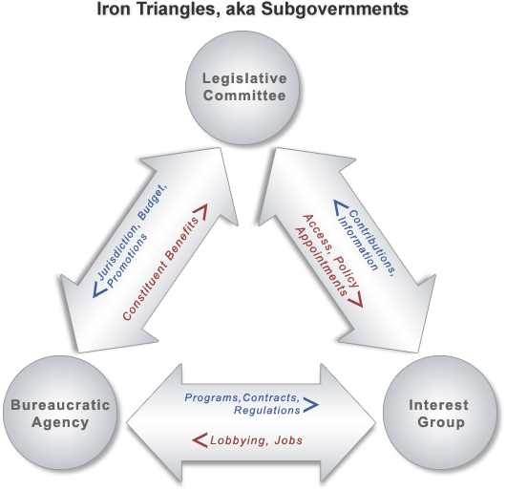

- Far less common today; politics has become too complicated
- More interest groups, more congressional subcommittees, and more competing forces
- Courts have also granted more access.
- Issue networks: Groups that regularly debate government policy on certain issues.
- Contentious—split along partisan, ideological, economic lines
- New presidents often recruit from networks.
VII. Congressional Oversight
- Forms of congressional supervision
  - Congress creates agencies; statutory design can influence agency behavior.
  - Congress authorizes funds for programs.
  - Congressional appropriations provide funds for agencies to spend on their programs.
  - Control of the bureaucracy creates an “invitation to struggle” between the legislative and executive branches.
- The legislature lacks capacity to legislate on all matters— delegates this function to agencies who exercise “rule making” function.
- Executive seeks to control agency actions as an extension of its functional need to faithfully execute the law.
A. The Appropriations Committee and legislative committees
- Appropriations Committee may be the most powerful of all the congressional committees.
- Most expenditure recommendations are approved by House.
- Tends to recommend an amount lower than the agency requested
- Has power to influence an agency’s policies by “marking up” an agency’s budget
- It is, however, becoming less powerful
- Trust funds operate outside the regular government budget and are not controlled by the appropriations committees.
- Annual authorizations allow the legislative committees greater oversight.
- Budget deficits have necessitated cuts.
- Informal congressional controls over agencies
- Individual members of Congress can seek privileges for constituents.
- Congressional committees may seek committee clearance, which is the right to pass on certain agency decisions.
B. The legislative veto
- Legislative Veto: a requirement that an executive decision must lie before Congress for a specified period before it takes effect.
- Declared unconstitutional by Supreme Court in Chadha (1983)
- Debate about the legislative veto continues.
C. Congressional investigations
- Power inferred from the congressional power to legislate
- Means for checking agency discretion and also for authorizing agency actions independent of presidential preferences
VIII. Bureaucratic “Pathologies” (THEME C: BUREAUCRATIC “PATHOLOGIES”)
- Five major complaints about the bureaucracy:
- red tape—complex and sometimes conflicting rules (see the “Politically Speaking” box “Red Tape”);
- conflict—agencies work at cross purposes;
- duplication—two or more agencies seem to do the same thing;
- imperialism—tendency of agencies to grow, irrespective of programs’ benefits and costs; and
- waste—spending more than is necessary to buy some product or service.
- Each complaint has logical origins in the constitutional order and policymaking process.
- Also, some exaggerations and unusual circumstances generate difficulties.
- Wide majorities have somewhat favorable impressions of diverse federal government agencies.
  - For decades surveys have found that despite complaints about “the bureaucracy,” most Americans have judged each federal agency to be fair and useful.
  - Explains why government agencies are rarely reduced in size or budget. Any given agency, even the much criticized Federal Emergency Management Agency (FEMA) in the wake of its failed response to Hurricanes Katrina and Rita, still has many supporters.
IX. Reforming the Bureaucracy
- Numerous attempts to make the bureaucracy work better for less money
  - Eleven reform attempts in the 1900s
  - Prior reforms stressed increasing centralized control on behalf of efficiency, accountability, and consistency.
  - National Performance Review (NPR) in 1993 was designed to reinvent government, calling for a new kind of organizational culture.
    - Less centralized management
    - More employee initiatives
    - Fewer detailed rules, more customer satisfaction
  - President George W. Bush built on to the Government Performance Results Act using the Performance Assessment Activity Tool (PART); its goal was to link management reform to the budget process.
- President Obama echoed a similar theme harkening back to Clinton-Gore NPR, though not given priority in the President’s program.
- Bureaucratic reform is always difficult to accomplish.
- Most rules and red tape are due to struggles between president and Congress or to agencies’ efforts to avoid alienating influential voters.
- Periods of divided government worsen matters, especially in implementing policy.
- Presidents of one party seek to increase political control (executive micromanagement).
- Congresses of another party respond by increasing investigations and rules (legislative micromanagement).

- WHO GOVERNS?
  - What happened to make the bureaucracy a “fourth branch” of American national government?
  - What are the actual size and scope of the federal bureaucracy?
- TO WHAT ENDS?
  - What should be done to improve bureaucratic performance?
  - Is “red tape” all bad?

Distinctiveness of the American Bureaucracy
- Political authority is shared among several institutions.
- Federal government agencies share functions with state and local governments.
- “Adversary culture” leads to close public scrutiny.

Proxy Government
- Social Security
- Medicare
- Environmental protection
- Income tax collection
- Many military duties

People taken by boat away from their New Orleans homes that were struck by Hurricane Katrina in 2008.

The Growth of the Bureaucracy
- The Beginning
- The Appointment of Officials
- A Service Role
- A Change in Role
  - Great Depression
  - World War II
  - Effects of 9/11

The Federal Bureaucracy Today
- Has the size of the Federal bureaucracy increased since 1960?
  - The number of Federal employees (excluding the Post Office) is roughly the same.
  - However, an estimated 13 million people now work indirectly for the Federal government as employees of private firms and state/local agencies largely supported by federal funds.

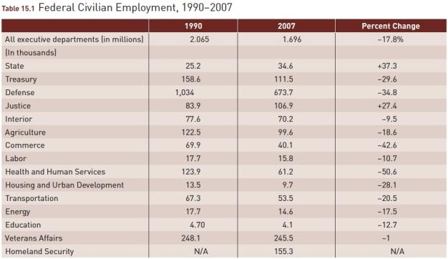
Sources: Statistical Abstract of the United States 2009, Table 481. Federal Bureau of Prisons Weekly Population Report and Quick Facts (available at http://www.bop.gov/locations/weekly_report.jsp; and http://www.bop.gov/news/quick.jsp#5).

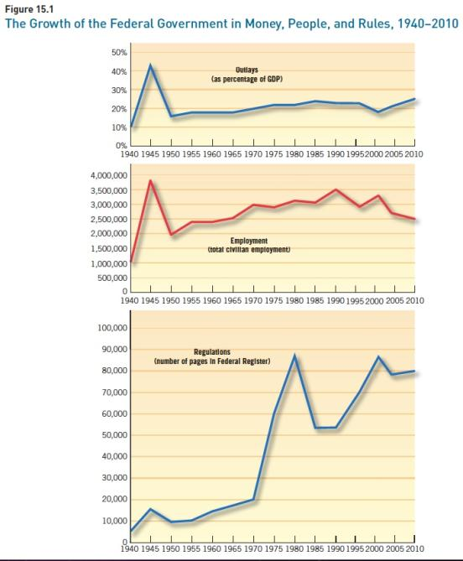
Source: Outlays: Statistical Abstract of the United States, 2004-2005, Table 461, and Historical Statistics of the United States, Series F-32 and Y-340, Civilian employment and pages in the Federal Register: Harold W. Stanley and Richard G. Niemi, Vital Statistics on American Politics (Washington, D.C.: Congressional Quarterly Press, 2010), 255.

The Federal Bureaucracy Today
- Recruitment and Retention
  - Federal Civil Service System
    - Office of Personnel Management
    - The competitive service
    - The excepted service
      - Not hired by the OPM
      - Some are nonpartisan in nature
      - Some are patronage jobs available to the President

- Recruitment and Retention
  - The Buddy System
  - Firing a Bureaucrat
  - The Agencies’ Point of View

Fire erupting from the offshore oil rig operated by BP in the Gulf of Mexico near American land.
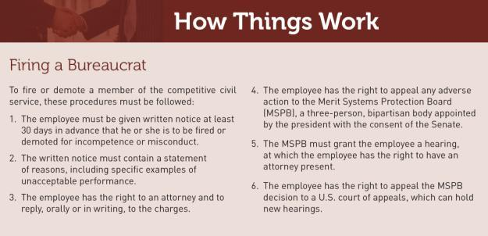
The Federal Bureaucracy Today
- Personal Attributes
  - Social Class
  - Education
  - Personal Beliefs
  - Comparing political appointees and career bureaucrats to the average American citizen

Figure 15.2 Characteristics of Federal Civilian Employees, 1960 and 2005
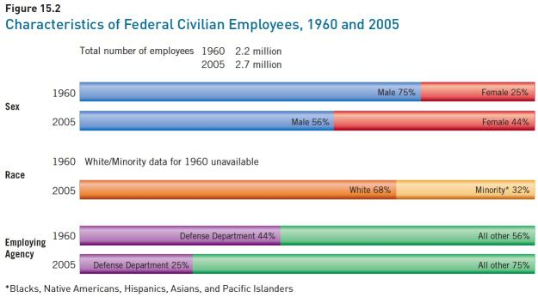
*Blacks, Native Americans, Hispanics, Asians, and Pacific Islanders

Sources: Statistical Abstract of the United States, 1961, 392–394; Statistical Abstract of the United States, 2009, Table 482.

The Federal Bureaucracy Today
- Do Bureaucrats Sabotage Their Political Bosses?
  - To block or to carry out?
  - Whistle Blower Protection Act-1989
  - How common is bureaucratic sabotage?

An Amtrak train speeding along its tracks. Amtrak service costs the federal government much more
than the train earns in fares.

A letter carrier picks up mail; his employer, the U.S. Postal Service, is running a huge deficit.

- Culture and Careers
  - The informal understanding among fellow employees as to “how” they are supposed to act.
  - Agency “career-enhancing” jobs

- Constraints – Why so many?
  - Those imposed by legislation
  - Split responsibilities with other agencies
  - The overall effects of the Constitution on agency behavior

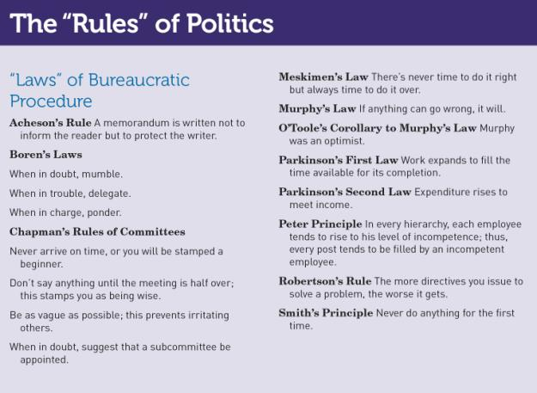
- Agency Allies
  - Iron Triangles
    - Government Agency
    - Committee in Congress
    - Interest Group
  - Issue Networks
    - Interest Groups
    - Congressional Staffs
    - Universities and Think Tanks
    - Mass Media

The F-35 Joint Strike Fighter made by Lockheed Martin for the American military and some of its allies.

Congressional Oversight
- Congressional Oversight of Executive Branch Agencies
- The Appropriations Committee and Legislative Committees
- The Legislative Veto
- Congressional Investigations

Bureaucratic Pathologies
- Red Tape
- Conflict
- Duplication
- Imperialism
- Waste

At the world’s busiest border crossing, cars line up to enter the United States in Tijuana, Mexico, p. 428.

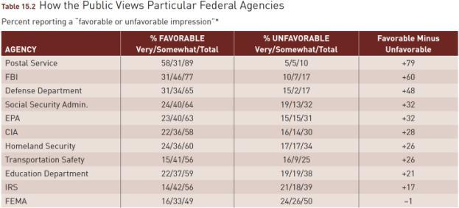
*Other response categories were “never heard of” and “can’t rate,” and only the newest agency, the Transportation Safety Administration,
drew significant numbers in each category (9 percent for each).

Source: Adapted from results of a nationally representative Associated Press/IPSOS Public Agenda poll conducted December 17–19, 2007.

Reforming the Bureaucracy
- The Brownlow Commission
- The First Hoover Commission
- The Ash Council
- National Performance Review
- Government Performance and Results Act
- Performance Assessment Rating Tool

Mayor Villaraigosa goes through a full-body scanner at Los Angeles International Airport.

An airline passenger is questioned by Transportation
Security Administration inspector at Newark airport.

WHAT WOULD YOU DO?
New Administration Struggling to Fill Top Posts—Cabinet Secretaries Say “The President Needs Help!”
Four months into the new administration, hundreds of assistant secretary and deputy assistant secretary positions remain unfilled. In 1960 the total number of presidential political appointees was just 450. Today the total is over 2,400, but sheer growth is not the whole story. Rather, say experts on federal bureaucracy, plum public service posts go unfilled because the jobs have become so unrewarding, even punishing.

MEMORANDUM
To: Dr. Robert Smith, president of Cybersystems Engineering
From: James Logan, Secretary of Defense
Subject: Becoming an assistant secretary of defense
As both secretary and a dear old college buddy of yours, I write again to express my hope that you will accept the president’s call to service. We all desperately want you aboard. Yes, conflict-of-interest laws will require you to sell your stock in your present company and drop out of its generous pension plan. No, the government won’t even pay moving costs. And once you leave office, you will be barred for life from lobbying the executive branch on matters in which you were directly involved while in office, and you will be barred for two years from lobbying on matters that were under your general official authority. Your other concerns have teeth, too, but let me help you weigh your options.

Arguments for:
1. I hate to preach, but it is one’s duty to serve one’s country when called. Your sacrifice would honor your family and benefit your fellow Americans for years to come.
2. As an accomplished professional and the head of a company that has done business with the government, you could help the president succeed in reforming the department so that it works better and costs less.
3. Despite the restrictions, you could resume your career once your public service was complete.

Arguments against:
1. Since you will have to be confirmed by the Senate, your life will be put under a microscope, and everything (even some of our old college mischief together) will be fair game for congressional staffers and reporters.
2. You will face hundreds of rules telling you what you can’t do and scores of congressmen telling you what you should do. Old friends will get mad at you for not doing them favors. The president will demand loyalty. The press will pounce on your every mistake, real or imagined.
3. Given the federal limits on whom in the government you can deal with after you leave office, your job at Cybersystems may well suffer.

Your decision:
Accept position?
Reject position?

