Chapter 16 – The Judiciary

Overview
An independent judiciary with the power of judicial review—the power to decide the constitutionality of acts of Congress, the executive branch, and state governments—can be a potent political force. The judicial branch of the United States government has developed its power from the earliest days of the nation, when Marshall and Taney put the Supreme Court at the center of the most important issues of the time.
From 1787 to 1865, the Supreme Court focused on the establishment of national supremacy. From 1865 to 1937, it struggled with defining the scope of the government’s power over the economy. In the present era, it has deliberated about personal liberties.
It became easier for citizens and groups to gain access to the federal courts in the mid- to late 20th century. This is the result of judges’ willingness to consider class-action suits and amicus curiae briefs and to allow fee shifting. The lobbying efforts of interest groups also had a powerful effect. At the same time, the scope of the courts’ political influence has increasingly widened as various groups and interests have acquired access to the courts, as the judges have developed a more activist stance, and as Congress has passed more laws containing vague or equivocal language. Still, the Supreme Court controls its own workload and grants certiorari to a very small percentage of appellate cases. As a result, although the Supreme Court is the pinnacle of the federal judiciary, most decisions are made by the twelve circuit courts of appeals and the ninety-four federal district courts.

Chapter Outline
I. Introduction
- Alexander Hamilton saw the courts as being “the least dangerous” branch of government because it could not “command the sword” as the president, nor “command the purse strings” like Congress.
- By the middle of the 19th century, the Supreme Court had begun to declare many federal and scores of state laws to be unconstitutional.
- Necessary and proper clause, elastic clause, abortion laws and so on.
- Courts have become not the least dangerous, but the most powerful.
II. Judicial Review
- Only in the United States do judges play so large a role in policy making
- Judicial review: the right of the federal courts to rule on the constitutionality of laws and executive actions
- Chief judicial weapon in the checks and balances system
- Since 1789, the Supreme Court has declared over 160 federal laws unconstitutional
- Few other countries have such a power
- In Britain, Parliament is supreme.
- Judicial review is effective in only a few other countries with stable federal systems that have history of judicial independence (for example, Australia, Canada, Germany, India).
- Debate is over how the Constitution should be interpreted.
- Judicial restraint approach (strict-constructionist): judges are bound by wording of Constitution
- Activist approach: judges should look to underlying principles of Constitution
- Not a matter of liberal versus conservative
- A judge can be both conservative and activist, or liberal and strict constructionist.
- Today, most activists tend to be liberal; most strict constructionists tend to be conservative.
III. The Development of the Federal Courts (THEME A: THE HISTORY OF THE FEDERAL JUDICIARY)
- Founders’ view
- Most Founders probably expected judicial review but did not expect federal court to play such a large role in policy making.
- Traditional view: judges find and apply existing law
- Activist judges would later respond that judges also make law.
- Traditional view made it easy for Founders to predict courts would be neutral and passive in public affairs.
- Hamilton: Courts are the least dangerous branch; their authority only limits the legislature.
- But federal judiciary evolved toward judicial activism, shaped by political, economic, ideological forces of three historical eras.
A. National supremacy and slavery: 1789 to 1861
- Marbury v. Madison (1803) and McCulloch v. Maryland (1819)
- Supreme Court could declare a congressional act unconstitutional.
- Power granted to federal government should be construed broadly
- Federal law is supreme over state law.
- Other cases: interstate commerce clause is placed under the authority of federal law; state law conflicting with federal law was declared void
- Dred Scott v. Sandford (1857): blacks were not, and could not become, free citizens of the United States; federal law (Missouri Compromise) prohibiting slavery in northern territories was unconstitutional.
B. Government and the economy: 1865 to 1936
- Dominant issues of the period
- Under what circumstances could the state governments regulate the economy?
- When could the federal government do so?
- Private property held to be protected by the Fourteenth Amendment
- Judicial activism was born as the Supreme Court began to assess the constitutionality of governmental regulation of business or labor.
- Supreme Court was supportive of private property, but could not develop a principle distinguishing between reasonable and unreasonable regulation of business.
- The Court interpreted the Fourteenth and Fifteenth Amendments narrowly as applied to blacks; it upheld segregation and permitted blacks to be excluded from voting in many states.
C. Government and political liberty: 1936 to the present
- Court establishes tradition of deferring to the legislature in economic regulation cases.
- Court shifts attention to personal liberties and is active in defining rights.
- Failed court-packing plan (FDR); “the switch in time that saved nine”
- Warren Court provided a liberal protection of rights and liberties against government trespass.
D. The revival of state sovereignty
  - Beginning in 1992, the Supreme Court began to rule that the states have the right to resist some federal action.
  - Reassertion of limits to federal supremacy in cases involving gun control, Indian tribe lawsuits.
- President Obama’s health plan challenged on the grounds that the requirement that all citizens purchase health insurance is an excessive use of the commerce clause and therefore unconstitutional.
IV. The Structure of the Federal Courts
- Two kinds of federal courts were created by Congress to handle cases that the Supreme Court does not need to decide.
- Constitutional courts exercise judicial powers found in Article III
- Judges serve during good behavior
- Salaries not reduced while in office
- Examples: district courts (94), courts of appeals (12)
- Legislative courts
- Created by Congress for specialized purposes
- Judges have fixed terms
- Judges can be removed
- No salary protection
- Example: Court of Military Appeals
A. Selecting judges
- Judicial behavior
- Party background has a strong effect on judicial behavior.
- Other factors also shape court decisions: facts of the case, prior rulings, and legal arguments.
1. Senatorial courtesy
- Appointees for federal courts are reviewed by senators from that state, if the senators are of the president’s party (particularly for U.S. district courts).
- Gives heavy weight to preferences of senators from state in which judge will serve
2. The “litmus test”
- Litmus test: a test of ideological purity
- Presidents seek judicial appointees who share their political ideologies.
- Has caused different circuits to come to different rulings about similar cases.
- Raises concerns that ideological tests are too dominant; has led to sharp drop in the percentage of nominees to federal appeals courts who are confirmed
- A judicial nominee’s view on abortion is the chief reason for use of a litmus test.
- The threat of a filibuster aimed at blocking Senate confirmation has led to a situation where the nominee must have the support of at least sixty senators to guarantee that a cloture vote would stop a threatened filibuster. This has led to a great deal of legislative maneuvering with controversial nominees.
- In recent years nominees almost always have been judges in lower courts.
V. The Jurisdiction of the Federal Courts
- Dual court system
- State court systems, federal court system
- Federal cases listed in Article III and Eleventh Amendment of Constitution
- Federal question cases: involving U.S. Constitution, federal law, treaties
- Diversity cases: involving different states, or citizens of different states
- Some cases can be tried in either federal or state court
- Example: if both federal and state laws have been broken (dual sovereignty; the Rodney King case)
- Jurisdiction: each government has right to enact laws and neither can block prosecution out of sympathy for the accused.
- Some cases that begin in state courts can be appealed to Supreme Court.
- Controversies between two state governments can be heard only by Supreme Court.
- Route to the Supreme Court
- Most federal cases begin in district courts
- Most are straightforward and do not lead to new public policy
- Volume is huge: About 650 district court judges received over 300,000 cases.
- Supreme Court picks the cases it wants to hear on appeal.
- Requires agreement of four justices (or a writ of certiorari) to hear case
- Supreme Court generally only agrees to review certain types of cases, involving:
- A significant federal or constitutional question
- Conflicting decisions by circuit courts
- Constitutional interpretation by one of the highest state courts, about state or federal law
- Court may consider seven thousand petitions each year, but only about one hundred are granted.
- Limited number of cases heard results in diversity of constitutional interpretation among appeals courts.
- Increased workload has led to greater influence of law clerks.
- Help to decide which cases should be heard under a writ of certiorari
- May draft initial opinions for the justices
VI. Getting to Court
- Deterrents to the courts acting as democratic institutions
- Supreme Court rejects all but a few of the applications for certiorari.
- Costs of appeal are high.
- Financial costs, including filing, record, and attorney fees, are high, but may be lowered for some.
- In forma pauperis: plaintiff indigent, with costs paid by government
- Indigent defendant in a criminal trial: legal counsel provided by government at no charge
- Payment by interest groups (for example, American Civil Liberties Union)
- Cost in terms of time is also high and cannot be mitigated.
A. Fee shifting
- Usually each party must pay its own legal expenses.
- The losing defendant pays the plaintiff’s expenses (fee shifting) in certain cases.
B. Standing
- Guidelines regarding who is entitled to bring a case
- There must be a real controversy between adversaries.
- Personal harm must be demonstrated.
- Being a taxpayer does not ordinarily constitute entitlement to challenge federal government action; this requirement is relaxed when the First Amendment is involved.
- Sovereign immunity
- Government must consent to being sued.
- By statute, government has given its consent to be sued in cases involving contract disputes and negligence.
C. Class-action suits
- Brought on behalf of all similarly situated persons
- Number of class-action suits increased, because there were financial incentives to bringing suit and because Congress was not meeting new concerns.
- In 1974, Supreme Court tightened rules on these suits for federal courts, though many state courts remain accessible.
- Big class-action suits affect how courts make public policy (such as asbestos, silicone breast implants).
VII. The Supreme Court in Action (THEME B: THE SUPREME COURT IN ACTION)
- Most cases arrive at the Court through a writ of certiorari.
- Lawyers then submit briefs: documents that set forth the facts of the case, summarize the lower court decision, give the argument of that side of the case, and discuss other issues.
- Oral arguments by lawyers after briefs submitted
- Each side has one half-hour.
- Justices can interrupt with questions.
- Since federal government is a party to almost half the cases, the solicitor general frequently appears before the courts.
- Solicitor general: federal government’s top trial lawyer
- Decides what cases the government will appeal from lower courts
- Approves every case presented to the Supreme Court
- A. Justices may also consider other opinions.
- Amicus curiae briefs submitted if both parties agree or Supreme Court grants permission.
- Other influences on the justices include legal periodicals.
- Conference procedures
- Role of chief justice: speaking first, voting last
- Senior judge on winning side selects opinion writer
- Four kinds of court opinions
- Per curiam: brief and unsigned
- Opinion of the court: majority opinion
- Concurring opinion: agree with the ruling of the majority opinion, but modify the supportive reasoning
- Dissenting opinion: minority opinion
- About two-fifths of decisions are unanimous. In this case the law is clear and no difficult questions of interpretation exist.
- The other three-fifths appear to be two main blocs and one swing vote on today’s court:
  - Conservative bloc: Alito, Roberts, Scalia, and Thomas
  - Liberal bloc: Breyer, Ginsburg, Stevens, and probably Sotomayor
  - Swing vote: Kennedy
VIII. The Power of the Federal Courts (THEME C: THE POWER OF THE FEDERAL JUDICIARY)
A. The power to make policy
- The courts make policy:
- by interpretation of the Constitution or law;
- by extending the reach of existing law; and
- by designing remedies that involve judges acting in administrative or legal ways
- Measures of power
- Number of laws declared unconstitutional (over 160)
- Number of prior cases overturned; not following stare decisis (over 260 cases since 1810)
- Extent to which judges will handle cases once left to the legislature (political questions)
- Most significant indicator is kinds of remedies imposed; judges often impose remedies that affect large populations
- Basis for sweeping orders can come either from the Constitution or from court interpretation of federal laws.
B. Views of judicial activism
- Supporters
- Courts should correct injustices when other branches or state governments refuse to do so.
- Courts are the last resort for those without the power or influence to gain new laws.
- Critics
- Judges lack expertise in designing and managing complex institutions.
- Initiatives require balancing policy priorities and allocating public revenues.
- Courts are not accountable, because judges are not elected.
- Possible reasons for activism
- Adversary culture, emphasizing individual rights and suspicion of government power.
- Easier to get standing in courts
C. Legislation and the courts
- Laws and the Constitution are filled with vague language, which increase courts’ opportunities to design remedies.
- Federal government is increasingly on the defensive in court cases; laws induce court challenges.
- Attitudes of federal judges affect their decisions when the law gives them latitude.
IX. Checks on Judicial Power
- Basic restraints on judicial power
- Judges have no enforcement mechanisms (police force or army); thus, their decisions can be resisted or ignored (for instance, Bible reading in schools, segregation in schools).
- Resistance depends on visibility of disobedience.
- Congress and the Courts
- Confirmation and impeachment proceedings gradually alter composition of courts, though impeachment is an extraordinary and unusual event.
- Changing the number of judges gives president more or fewer appointment opportunities.
- Supreme Court decisions can be undone by:
- Revising legislation
- Amending the Constitution
- Altering jurisdiction of the Court
- Restricting Court remedies
B. Public opinion and the courts
- Defying public opinion—especially the opinion of the elites—may destroy the legitimacy of the institution.
- Opinion in realigning eras may energize Court.
- Public confidence in the Supreme Court since 1966 has varied with popular support for the government, generally.
- No overt attempts to curb judicial activism
- Activism has increased because government does more, and courts must interpret the laws.
- Activist ethos of judges is now more widely accepted.

Chapter 16 – The Judicial Branch

Created by the Constitution in 1789 (Article III)

THE FEDERAL COURT SYSTEM (11 Circuits)

United States District Courts (94) –
Federal crimes
Civil suits under federal law
Civil suits between citizens of different states where the amount exceeds $50K
Admiralty and maritime disputes (on the water)
Bankruptcy
Review of actions of certain administrative agencies
Other matters assigned by the federal government (Article III)

United States Court of Appeals or Circuit Courts (11 circuits, one for the District of Columbia, and one for federal courts) –
This is where your appealed case will be heard (appellate jurisdiction)

United States Supreme Court (1)
This is where your appealed case will be heard (appellate jurisdiction)
Original jurisdiction for the following
- Two or more states
- The United States and a state
- Foreign ambassadors and other diplomats
- A state and a citizen of a different state (if begun by a state)

Know the two types of jurisdiction (the official power to make legal decisions and judgments)
Original Jurisdiction – The court that has the power to hear a case for the first time
Appellate Jurisdiction – The court that has the power to review a lower court's decision (a case that has been appealed from a lower court).

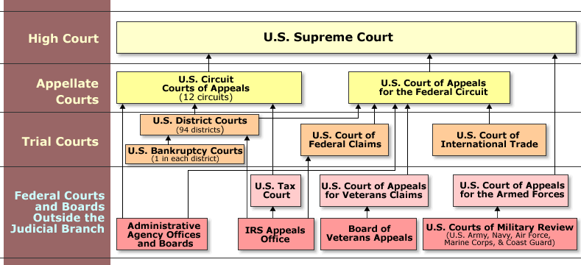
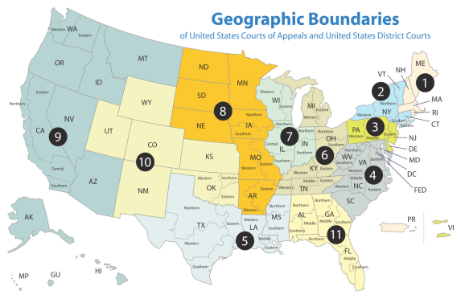

SUPREME COURT JUSTICES
(There are nine justices in total. There is one CHIEF JUSTICE and eight ASSOCIATE JUSTICES)
Name | Age (Appt) | President Appointed By | Senate Confirmation | Length of Term
John G. Roberts (Chief Justice) | 58 (50) | George W. Bush (R) in 2005 | 78-22 | 9 years
Antonin Scalia | 76 (50) | Ronald Reagan (R) in 1986 | 98-0 | 28 years
Anthony Kennedy | 76 (51) | Ronald Reagan (R) in 1988 | 97-0 | 26 years
Clarence Thomas | 64 (43) | George H.W. Bush (R) in 1991 | 52-48 | 23 years
Ruth Bader Ginsburg | 79 (60) | Bill Clinton (D) in 1993 | 96-3 | 21 years
Stephen Breyer | 74 (56) | Bill Clinton (D) in 1994 | 87-9 | 20 years
Samuel Alito | 62 (55) | George W. Bush (R) in 2006 | 58-42 | 8 years
Sonia Sotomayor | 58 (55) | Barack Obama (D) in 2009 | 68-31 | 5 years
Elena Kagan | 52 (50) | Barack Obama (D) in 2010 | 63-37 | 4 years

Other Information
Salary – Associate justices receive $213,900 annually and the chief justice receives $223,500.
You do not have to be an associate justice before you become a chief justice.
The Constitution has not placed a limit on the number of justices that can preside on the bench.
To become a federal judge, one has to be nominated by the President and confirmed by the Senate.
There are no other qualifications (education, age, residency).
Only one Justice has been impeached (Sam Chase in 1805, but he was not removed).
The Supreme Court is not diverse. Out of 112 justices…
Gender
108 males
4 females
Ethnicity
Caucasian – 109
African-American – 2 (Thurgood Marshall in 1967, Clarence Thomas in 1991)
Hispanic – 1 (Sonia Sotomayor in 2009)
Asian – 0
Native American – 0

Judicial Restraint vs. Judicial Activism

 | Definition (from Black’s Law Dictionary) | Laymen’s Terms | Criticisms | Court Cases
Judicial Restraint (or strict constructionist) | A philosophy of judicial decision-making whereby judges follow the context of the federal law to the upmost. | Judges should judge, confine themselves to applying those rules stated or clearly implied by the language of the Constitution. | Judges fail to consider societal changes  The Constitution is a living document, therefore the context of the law may be interpreted differently | Marbury v Madison  McCulloch v Maryland  Scott v Sandford  Plessy v Ferguson
Judicial Activism | A philosophy of judicial decision-making whereby judges allow their personal views about public policy, among other factors, to guide their decisions. | Judges should discover the general principles underlying the Constitution and amplify those principles on the basis of some moral or economic philosophy. | Judges usually have no special expertise in matters of political matters (administration, management, etc.) per se  That which is desired by courts is not always practical or possible to implement  Federal judges are appointed not elected and should not play the role of unaccountable legislators | Brown v. Board of Education,  Roe v. Wade,  Perry v. Schwarzenegger

Chapter Outline
I. Introduction
- Alexander Hamilton saw the courts as being “the least dangerous” branch of government because it could not “command the sword” as the president, nor “command the purse strings” like Congress.
- By the middle of the 19th century, the Supreme Court had begun to declare many federal and scores of state laws to be unconstitutional.
- Necessary and proper clause, elastic clause, abortion laws and so on.
- Courts have become not the least dangerous, but the most powerful.
II. Judicial Review
- Only in the United States do judges play so large a role in policy making
- Judicial review: the right of the federal courts to rule on the constitutionality of laws and executive actions
- Chief judicial weapon in the checks and balances system
- Since 1789, the Supreme Court has declared over 160 federal laws unconstitutional
- Few other countries have such a power
- In Britain, Parliament is supreme.
- Judicial review is effective in only a few other countries with stable federal systems that have history of judicial independence (for example, Australia, Canada, Germany, India).
- Debate is over how the Constitution should be interpreted.
- Judicial restraint approach (strict-constructionist): judges are bound by wording of Constitution
- Activist approach: judges should look to underlying principles of Constitution
- Not a matter of liberal versus conservative
- A judge can be both conservative and activist, or liberal and strict constructionist.
- Today, most activists tend to be liberal; most strict constructionists tend to be conservative.
III. The Development of the Federal Courts (THEME A: THE HISTORY OF THE FEDERAL JUDICIARY)
- Founders’ view
- Most Founders probably expected judicial review but did not expect federal court to play such a large role in policy making.
- Traditional view: judges find and apply existing law
- Activist judges would later respond that judges also make law.
- Traditional view made it easy for Founders to predict courts would be neutral and passive in public affairs.
- Hamilton: Courts are the least dangerous branch; their authority only limits the legislature.
- But federal judiciary evolved toward judicial activism, shaped by political, economic, ideological forces of three historical eras.
A. National supremacy and slavery: 1789 to 1861
- Marbury v. Madison (1803) and McCulloch v. Maryland (1819)
- Supreme Court could declare a congressional act unconstitutional.
- Power granted to federal government should be construed broadly
- Federal law is supreme over state law.
- Other cases: interstate commerce clause is placed under the authority of federal law; state law conflicting with federal law was declared void
- Dred Scott v. Sandford (1857): blacks were not, and could not become, free citizens of the United States; federal law (Missouri Compromise) prohibiting slavery in northern territories was unconstitutional.
B. Government and the economy: 1865 to 1936
- Dominant issues of the period
- Under what circumstances could the state governments regulate the economy?
- When could the federal government do so?
- Private property held to be protected by the Fourteenth Amendment
- Judicial activism was born as the Supreme Court began to assess the constitutionality of governmental regulation of business or labor.
- Supreme Court was supportive of private property, but could not develop a principle distinguishing between reasonable and unreasonable regulation of business.
- The Court interpreted the Fourteenth and Fifteenth Amendments narrowly as applied to blacks; it upheld segregation and permitted blacks to be excluded from voting in many states.
C. Government and political liberty: 1936 to the present
- Court establishes tradition of deferring to the legislature in economic regulation cases.
- Court shifts attention to personal liberties and is active in defining rights.
- Failed court-packing plan (FDR); “the switch in time that saved nine”
- Warren Court provided a liberal protection of rights and liberties against government trespass.
D. The revival of state sovereignty
  - Beginning in 1992, the Supreme Court began to rule that the states have the right to resist some federal action.
  - Reassertion of limits to federal supremacy in cases involving gun control, Indian tribe lawsuits.
- President Obama’s health plan challenged on the grounds that the requirement that all citizens purchase health insurance is an excessive use of the commerce clause and therefore unconstitutional.
IV. The Structure of the Federal Courts
- Two kinds of federal courts were created by Congress to handle cases that the Supreme Court does not need to decide.
- Constitutional courts exercise judicial powers found in Article III
- Judges serve during good behavior
- Salaries not reduced while in office
- Examples: district courts (94), courts of appeals (12)
- Legislative courts
- Created by Congress for specialized purposes
- Judges have fixed terms
- Judges can be removed
- No salary protection
- Example: Court of Military Appeals
A. Selecting judges
- Judicial behavior
- Party background has a strong effect on judicial behavior.
- Other factors also shape court decisions: facts of the case, prior rulings, and legal arguments.
1. Senatorial courtesy
- Appointees for federal courts are reviewed by senators from that state, if the senators are of the president’s party (particularly for U.S. district courts).
- Gives heavy weight to preferences of senators from state in which judge will serve
2. The “litmus test”
- Litmus test: a test of ideological purity
- Presidents seek judicial appointees who share their political ideologies.
- Has caused different circuits to come to different rulings about similar cases.
- Raises concerns that ideological tests are too dominant; has led to sharp drop in the percentage of nominees to federal appeals courts who are confirmed
- A judicial nominee’s view on abortion is the chief reason for use of a litmus test.
- The threat of a filibuster aimed at blocking Senate confirmation has led to a situation where the nominee must have the support of at least sixty senators to guarantee that a cloture vote would stop a threatened filibuster. This has led to a great deal of legislative maneuvering with controversial nominees.
- In recent years nominees almost always have been judges in lower courts.
V. The Jurisdiction of the Federal Courts
- Dual court system
- State court systems, federal court system
- Federal cases listed in Article III and Eleventh Amendment of Constitution
- Federal question cases: involving U.S. Constitution, federal law, treaties
- Diversity cases: involving different states, or citizens of different states
- Some cases can be tried in either federal or state court
- Example: if both federal and state laws have been broken (dual sovereignty; the Rodney King case)
- Jurisdiction: each government has right to enact laws and neither can block prosecution out of sympathy for the accused.
- Some cases that begin in state courts can be appealed to Supreme Court.
- Controversies between two state governments can be heard only by Supreme Court.
- Route to the Supreme Court
- Most federal cases begin in district courts
- Most are straightforward and do not lead to new public policy
- Volume is huge: About 650 district court judges received over 300,000 cases.
- Supreme Court picks the cases it wants to hear on appeal.
- Requires agreement of four justices (or a writ of certiorari) to hear case
- Supreme Court generally only agrees to review certain types of cases, involving:
- A significant federal or constitutional question
- Conflicting decisions by circuit courts
- Constitutional interpretation by one of the highest state courts, about state or federal law
- Court may consider seven thousand petitions each year, but only about one hundred are granted.
- Limited number of cases heard results in diversity of constitutional interpretation among appeals courts.
- Increased workload has led to greater influence of law clerks.
- Help to decide which cases should be heard under a writ of certiorari
- May draft initial opinions for the justices
VI. Getting to Court
- Deterrents to the courts acting as democratic institutions
- Supreme Court rejects all but a few of the applications for certiorari.
- Costs of appeal are high.
- Financial costs, including filing, record, and attorney fees, are high, but may be lowered for some.
- In forma pauperis: plaintiff indigent, with costs paid by government
- Indigent defendant in a criminal trial: legal counsel provided by government at no charge
- Payment by interest groups (for example, American Civil Liberties Union)
- Cost in terms of time is also high and cannot be mitigated.
A. Fee shifting
- Usually each party must pay its own legal expenses.
- The losing defendant pays the plaintiff’s expenses (fee shifting) in certain cases.
B. Standing
- Guidelines regarding who is entitled to bring a case
- There must be a real controversy between adversaries.
- Personal harm must be demonstrated.
- Being a taxpayer does not ordinarily constitute entitlement to challenge federal government action; this requirement is relaxed when the First Amendment is involved.
- Sovereign immunity
- Government must consent to being sued.
- By statute, government has given its consent to be sued in cases involving contract disputes and negligence.
C. Class-action suits
- Brought on behalf of all similarly situated persons
- Number of class-action suits increased, because there were financial incentives to bringing suit and because Congress was not meeting new concerns.
- In 1974, Supreme Court tightened rules on these suits for federal courts, though many state courts remain accessible.
- Big class-action suits affect how courts make public policy (such as asbestos, silicone breast implants).
VII. The Supreme Court in Action (THEME B: THE SUPREME COURT IN ACTION)
- Most cases arrive at the Court through a writ of certiorari.
- Lawyers then submit briefs: documents that set forth the facts of the case, summarize the lower court decision, give the argument of that side of the case, and discuss other issues.
- Oral arguments by lawyers after briefs submitted
- Each side has one half-hour.
- Justices can interrupt with questions.
- Since federal government is a party to almost half the cases, the solicitor general frequently appears before the courts.
- Solicitor general: federal government’s top trial lawyer
- Decides what cases the government will appeal from lower courts
- Approves every case presented to the Supreme Court
- A. Justices may also consider other opinions.
- Amicus curiae briefs submitted if both parties agree or Supreme Court grants permission.
- Other influences on the justices include legal periodicals.
- Conference procedures
- Role of chief justice: speaking first, voting last
- Senior judge on winning side selects opinion writer
- Four kinds of court opinions
- Per curiam: brief and unsigned
- Opinion of the court: majority opinion
- Concurring opinion: agree with the ruling of the majority opinion, but modify the supportive reasoning
- Dissenting opinion: minority opinion
- About two-fifths of decisions are unanimous. In this case the law is clear and no difficult questions of interpretation exist.
- The other three-fifths appear to be two main blocs and one swing vote on today’s court:
  - Conservative bloc: Alito, Roberts, Scalia, and Thomas
  - Liberal bloc: Breyer, Ginsburg, Stevens, and probably Sotomayor
  - Swing vote: Kennedy
VIII. The Power of the Federal Courts (THEME C: THE POWER OF THE FEDERAL JUDICIARY)
A. The power to make policy
- The courts make policy:
- by interpretation of the Constitution or law;
- by extending the reach of existing law; and
- by designing remedies that involve judges acting in administrative or legal ways
- Measures of power
- Number of laws declared unconstitutional (over 160)
- Number of prior cases overturned; not following stare decisis (over 260 cases since 1810)
- Extent to which judges will handle cases once left to the legislature (political questions)
- Most significant indicator is kinds of remedies imposed; judges often impose remedies that affect large populations
- Basis for sweeping orders can come either from the Constitution or from court interpretation of federal laws.
B. Views of judicial activism
- Supporters
- Courts should correct injustices when other branches or state governments refuse to do so.
- Courts are the last resort for those without the power or influence to gain new laws.
- Critics
- Judges lack expertise in designing and managing complex institutions.
- Initiatives require balancing policy priorities and allocating public revenues.
- Courts are not accountable, because judges are not elected.
- Possible reasons for activism
- Adversary culture, emphasizing individual rights and suspicion of government power.
- Easier to get standing in courts
C. Legislation and the courts
- Laws and the Constitution are filled with vague language, which increase courts’ opportunities to design remedies.
- Federal government is increasingly on the defensive in court cases; laws induce court challenges.
- Attitudes of federal judges affect their decisions when the law gives them latitude.
IX. Checks on Judicial Power
- Basic restraints on judicial power
- Judges have no enforcement mechanisms (police force or army); thus, their decisions can be resisted or ignored (for instance, Bible reading in schools, segregation in schools).
- Resistance depends on visibility of disobedience.
- Congress and the Courts
- Confirmation and impeachment proceedings gradually alter composition of courts, though impeachment is an extraordinary and unusual event.
- Changing the number of judges gives president more or fewer appointment opportunities.
- Supreme Court decisions can be undone by:
- Revising legislation
- Amending the Constitution
- Altering jurisdiction of the Court
- Restricting Court remedies
B. Public opinion and the courts
- Defying public opinion—especially the opinion of the elites—may destroy the legitimacy of the institution.
- Opinion in realigning eras may energize Court.
- Public confidence in the Supreme Court since 1966 has varied with popular support for the government, generally.
- No overt attempts to curb judicial activism
- Activism has increased because government does more, and courts must interpret the laws.
- Activist ethos of judges is now more widely accepted.

- WHO GOVERNS?
  - Why should federal judges serve for life?
- TO WHAT ENDS?
  - Why should federal courts be able to declare laws unconstitutional?
  - Should federal judges only interpret existing laws or should they be able to create new laws?

Judicial Review
- Defined: the power of the courts to declare laws unconstitutional
- Over 160 federal laws have been declared unconstitutional
- The federal courts’ chief weapon in the American government system of checks and balances

Two Approaches to Judicial Review

- Judicial Restraint Approach – judges should decide cases strictly on the basis of the language of the Constitution
- Activist Approach – judges should discern the general principles underlying the Constitution and apply them to modern circumstances

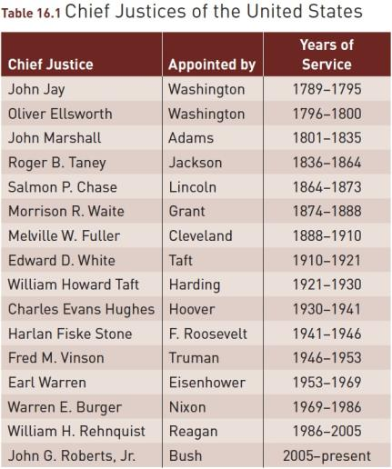
Note: Omitted is John Rutledge, who served for only a few months in 1795 and who was not confirmed by the Senate.

The Development of the Federal Courts
- The Founders’ View
  - Did not expect the federal courts to play a large role in public policy making
  - Hamilton’s thoughts in Federalist No. 78

- National Supremacy
  - Chief Justice John Marshall
  - Marbury v. Madison (1803)
  - McCulloch v. Maryland (1819)

- Slavery
  - President Jackson’s appointment of Chief Justice Roger B. Taney
  - The Dred Scott case (1857)

- Government and the Economy
  - 1860’s–1930’s: When can the economy be regulated by the states and when by the national government?
  - Private property and the 14th Amendment
  - 14th and 15th Amendments and the effect on African-Americans

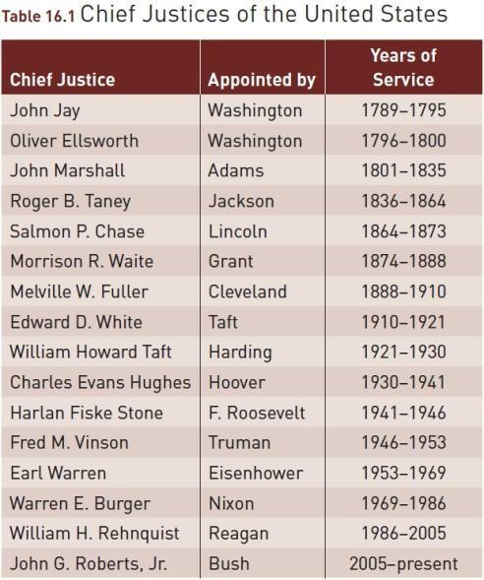

The Development of the Federal Courts
- Government and Political Liberty
  - Supreme Court decisions
  - FDR’s “Court Packing Scheme”
  - The Court’s changing composition
  - Chief Justice Earl Warren

Figure 16.1 Economics and Civil Liberties Laws Overturned by the U.S. Supreme Court, by Decade, 1900–2006
- 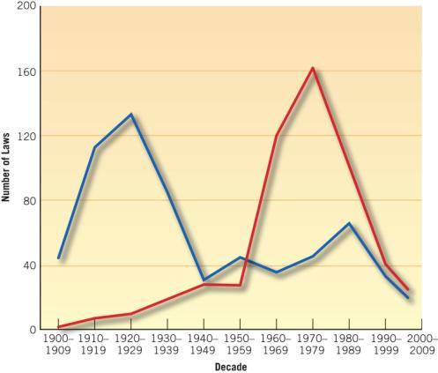

Note: Civil liberties category does not include laws supportive of civil liberties. Laws include
- federal, state, and local.
- Source: Harold W. Stanley and Richard G. Niemi, Vital Statistics on American Politics, 2007–2008,
- 5th ed., p. 302 (Washington, D.C.: CQ Press, 2008). Reprinted by permission of CQ Press; a
- division of Congressional Quarterly, Inc.

The Development of the Federal Courts

- The Revival of State Sovereignty
  - Supreme Court’s movements since the early 1990’s
  - Supreme Court hints
  - Supreme Court’s rendezvous with the new health care plan of 2010

The Structure of the Federal Courts
- Lower Federal Courts
  - Constitutional Courts
    - District courts
    - Courts of appeal
  - Legislative Court
    - Court of Military Appeals & territorial courts

Map 16.1 U.S. District and Appellate Courts
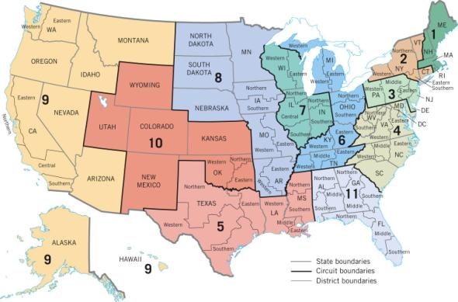

Note: Washington, D.C., is in a separate court. Puerto Rico is in the first circuit; the Virgin Islands are in the third; Guam and the Northern Mariana Islands are in the ninth. The Court of Appeals for the Federal Circuit, located in Washington, D.C., is a Title 3 court that hears appeals regarding patents, trademarks, international trade, government contracts, and from civil servants who claim they were unjustly discharged.
Source: Administrative Office of the United States Courts (January 1983).

The Structure of the Federal Courts

- Selecting Judges
  - Party background
  - Judicial selection surprises
  - Federal judge characteristics
  - Senatorial courtesy
  - The “Litmus Test”

Louis Brandeis, creator of the “Brandeis Brief” that developed court cases based on economic and social more than legal arguments, became the first Jewish Supreme Court justice. He served in the Court from 1916 until 1939.

Figure 16.2 Female and Minority Judicial Appointments, 1963–2004

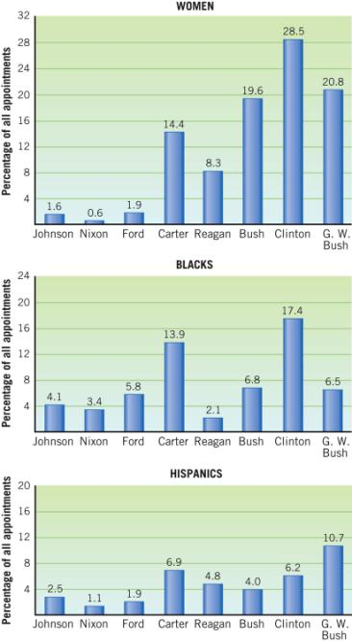
Source: Updated from Harold W. Stanley and Richard G. Niemi, Vital Statistics on American Politics, 2005–2006 (Washington, D.C.: Congressional Quarterly, 2006), Table 7.5.

Figure 16.3 Confirmation Rates for Nominees to the U.S. Court of Appeals (1947–2005)

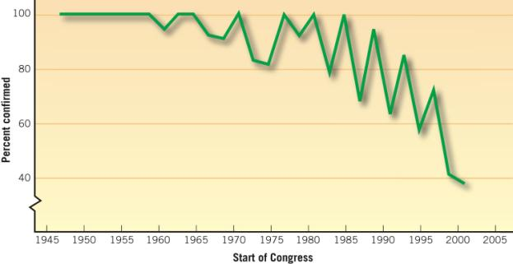
Source: Sarah A. Binder, “The Consequences of Polarization: Congress and the Courts,” in David Brady
and Pietro Nivola, eds., Red and Blue Nation? (Vol. 2) Consequences and Correction of America’s Polarized
Politics (figure 3.3, p. 116). Brookings Institution Press. Reprinted by permission of the author.

The Jurisdiction of the Federal Courts

- Federal-question cases – Cases concerning the Constitution, federal laws, or treaties
- Diversity cases – Cases involving citizens of different states who can bring suit in federal courts
- Writ of certiorari – An order by a higher court directing a lower court to send up a case for review.

Sonia Sotomayor answers questions before the Senate committee considering her nomination to be a Supreme Court justice.

Figure 16.4 The Jurisdiction of the Federal Courts
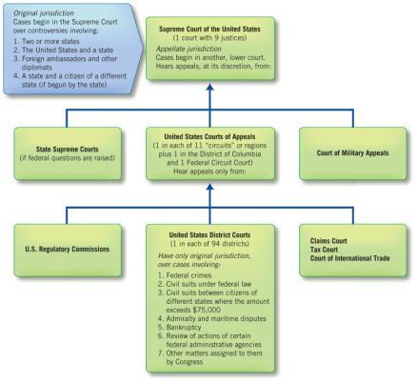
Clarence Earl Gideon studied law books while in prison so that he could write an appeal to the Supreme Court. His handwritten appeal asked that his conviction be set aside because he had not been
provided with an attorney. His appeal was granted.

Getting to Court
- In forma pauperis
- Fee Shifting
- Standing
- Class Action Suits

Linda Brown was refused admission to a white elementary school in Topeka, Kansas. On her behalf, the NAACP brought a class-action suit that resulted in the 1954 landmark Supreme Court decision Brown v. Board of Education, p. 455.

Table 16.2 “Supreme Court Justices in Order of Seniority,” 2011

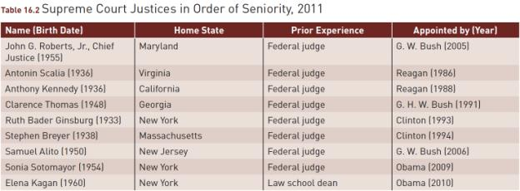

The Supreme Court in Action

- Brief
- Amicus curiae
- Per curiam opinion
- Opinion of the court
- Concurring opinion
- Dissenting opinion

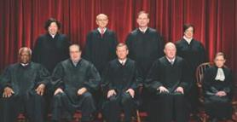

The U.S. Supreme Court Justices in 2010. Front row: Justices
Clarence Thomas and Antonin Scalia, Chief Justice John Roberts, Justices Anthony Kennedy and Ruth Bader Ginsburg; second row: Justices Sonia Sotomayor, Samuel Alito, and Elena Kagan.

The Power of the Federal Courts

- The Power to Make Policy
  - Stare decisis
  - Political question
  - Remedy
- Views of Judicial Activism
- Legislation and the Courts

The activism of federal courts is exemplified by the sweeping orders they have issued to correct such problems as overcrowded prisons, p. 458.

Figure 16.5 Patterns of Public Confidence in the Court, 1974–2006

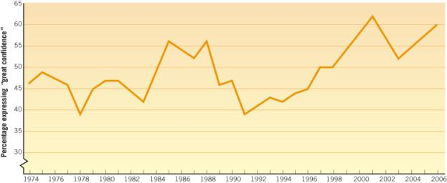

Checks on Judicial Power

- Congress and the Courts
  - Confirmations
  - Impeachment
  - Number of judges
  - Jurisdiction
- Public Opinion and the Courts

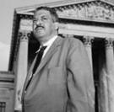

Thurgood Marshall became the first black Supreme Court justice. As chief counsel for the NAACP, Marshall argued the 1954 Brown v. Board of Education case in front of the Supreme Court. He was appointed to the Court in 1967 and served until 1991, p. 463.

WHAT WOULD YOU DO?

M E M O R A N D U M
To: Senator Ann Gilbert
From: Amy Wilson, legislative assistant
The Supreme Court has held that the attorney general cannot use his authority over federally controlled drugs to block the implementation of the Oregon “Death With Dignity” law. Now some of your colleagues want to enact a federal equivalent of that law that would allow physicians to prescribe deadly drugs to patients who request them.

Arguments for:
1. The law respects the people’s rights to choose the time and place of their own death.
2. It is already permissible to post “Do Not Resuscitate” orders on the charts of terminally ill patients.
3. Physicians can be held to high standards in implementing the law.

Arguments against:
1. The law will corrupt the role of doctors as many think has happened in Holland, where a similar law has led some physicians to kill patients prematurely or without justification.
2. Such a law will lead some physicians to neglect or ignore the desires of the patient.
3. This law will undermine the more important goal of helping patients overcome pain and depression.

Your decision:
Support the law?
Oppose the law?

