Chapter 18 – Economic Policy

Overview
Three kinds of economic indicators matter to voters. These are the economic health of the nation, the amount and kinds of government spending, and the level and distribution of taxes. Different kinds of politics influence policies for each of these outcomes.
The politics of inflation, unemployment, and economic growth tends to be majoritarian. The president is held responsible for national conditions, even though there are only imperfect economic theories to direct clumsy government tools controlled by divided political authorities. Still, national economic health has powerful effects on election outcomes, driven as much by people’s perceptions of national conditions as by their worries about personal finances.
When economic ill health occurs in some industries and places but not in others, the politics of economic health is shaped by interest-group politics. Tariff policies are a good illustration of this politics. Firms that import foreign products or sell to foreign nations try to avoid trade restrictions, whereas firms and unions hurt by foreign competition try to have such restrictions imposed.
The amount of government spending is only theoretically determined by the budget. In fact, the president and Congress struggle over particular spending bills, whose amounts often reflect interest-group and client pressures.
The general shape of federal tax legislation is determined by majoritarian politics, but the specific provisions (especially deductions, exemptions, and exclusions) are the result of client and interest-group politics. The Tax Reform Act of 1986 was a remarkable example of the reassertion of majoritarian politics over client and interest-group pressures. It was made possible by policy entrepreneurs and political incentives.

Chapter Outline
I. INTRODUCTION—Reasons for government debt (THEME A: POLITICS AND ECONOMICS)
- Deficit: Spending more than one earns
- Financed by selling government bonds to Americans and foreigners
- National debt: Total amount of all deficits
- Economic reason for debt
- Bonds are always repaid.
- People want to buy U.S. bonds because the dollar is stable and valuable.
- Interest payments must be made each year.
    - In 2006, interest was about 8 percent of all federal expenditures.
    - Third most expensive program (after social welfare and defense)
    - Interest payments equal about 1.7 percent of GDP
    - The recession that began in 2007 and continued through 2009 resulted in business failure, increases in unemployment, and a smaller GNP—the cost of government increases due to increased demand for unemployment while tax revenues are reduced due to slowed economic activity.
- Making interest payments may be more difficult as Social Security and Medicare costs increase with an aging population.
- Substantive argument about debt
- Families borrow to buy long-lasting items, such as a home, car, or college education.
- Government borrows money when it needs it without thought for long-term benefit.
- Political opposition to debt
- Public is opposed to public debt, so politicians are, too.
- Offer contrasting ways to combat it
- Conservatives: Cut spending
- Liberals: Raise taxes
- People do not want cuts in spending, but they also do not want higher taxes; political stalemate usually results.
II. The Politics of Economic Prosperity
- Disputes about economic well-being tend to produce majoritarian politics.
- Voters see connections between nation as a whole and their own situations.
- Low-income voters more likely to worry about employment and vote Democratic.
- High-income voters more likely to worry about inflation and vote Republican.
- Voters respond more to condition of the national economy than of their own personal finances.
- People understand what government can and cannot be held accountable for.
- People see economic conditions having indirect effects on them even when they are doing well.
A. What politicians try to do
- Government officials will sometimes use money to affect elections.
- Patronage
- Veterans’ benefits
- Social Security increases
- Government will not always do whatever is economically necessary to win an election.
- Government does not know how to produce all desirable outcomes.
- Economic pressures are often interrelated.
- Ideology plays large role in shaping policy choices.
- Democrats focus on reducing unemployment.
- Republicans focus on reducing inflation.
III. The Politics of Taxing and Spending
- Majoritarian politics is inconsistent.
- Everyone wants general prosperity.
- Large majorities want more government spending on popular programs.
- Voters want conflicting policies: Lower taxes, less debt, and new programs.
- Lower taxes means less spending or more debt.
- More spending means higher taxes or more debt.
- Key is to raise taxes on “other people.”
- “Other people” are always a minority of voters (cigarette smokers, affluent voters).
- For example, fund new medical research with tax on cigarettes
- What caused the recession?
- Federal Reserve Bank lowered interest rates.
  - Firms developed new methods for selling mortgages.
  - The government reduced credit requirements for lower income families so that they could put a smaller deposit on a mortgage.
  - Cheap money, combined with these new “subprime” mortgage instruments, produced a housing boom.
  - In 1999, Glass-Steagall Act was repealed. Act had separated investment from commercial banking that reduced regulation of banks.
- Investment banks began bundling mortgages together combining secure with subprime, or less secure, mortgages and selling them as “mortgage-backed securities.
  - Stimulated home sales
  - Increased book value of homes
  - Homeowners borrowed against increased value of their homes.
  - Homeowners used this equity to buy goods and services within the economy that stimulated economic growth.
- Debt levels for consumers and banks increased.
  - Banks continued to loan money, increasing their vulnerability to any downturn in the value of the real estate market, which was being used to secure the loans.
  - The economic moved into a recession, in part stimulated by increasing fuel costs. Global production costs increased for goods and services, which led to decreased sales.
  - Many homeowners caught in the economic downturn found the estimated value of their real estate had dropped below the value of their mortgages. Many defaulted on their loans.
  - Banks that held these mortgages were told by federal regulators to revalue their holdings. Investors in the banks withdrew their holdings. Many banks and investment companies that supported them could not afford to maintain payments on these investments, so they failed.
  - Consumers’ and investors’ confidence in global economic markets plummeted. Credit markets froze. This led to reduced economic activity and layoffs, which spiraled into a recession.
- Government policy exacerbated this economic crisis.
  - Two government-backed corporations, Fannie Mae and Freddie Mac, owned $5 trillion in mortgages.
  - They were actually owned by private investors.
  - Widespread belief was that they would be backed by the federal government.
  - They had mandated that banks issue subprime mortgages to poor people. Many of these people were forced to default on their mortgages, which they could not afford.
  - The federal government took over the bankrupt Fannie Mae and Freddie Mac.
- Credit Froze
  - Banks afraid of an economic collapse stopped lending money to preserve their existing capital reserves.
  - Industries that relied on credit to finance purchases of their product, home builders, and automobile companies experienced drastic reduction in sales.
  - The collapse of these two market sectors rippled through the remaining sectors of the economy, resulting in widespread reduction in economic activity.
  - Unemployment rose as firms laid off workers whom they did not need, due to reduced production demands.
  - The stock market, reflecting these economic changes, collapsed.
  - U. S. Securities and Exchange Commission brought charges against investment banks for manipulating subprime mortgages.
  - 2009 Congress passed Wall Street Reform and Consumer Protection Act. This reinstituted regulations that had been removed in 1999.
IV. Economic Theories and Political Needs
- Presidents select economic advisors whose theories reflect the president’s own economic views.
- Conservatives tend to emphasize monetarism and supply-side approaches to economic management.
- Liberals tend to focus on Keynesianism combined with elements of a planned economy.
A. Monetarism
  - Asserts that inflation occurs when there is too much money chasing too few goods (Milton Friedman)
  - Advocates increasing the money supply at a rate about equal to economic growth and then letting the free market operate
  - To combat a recession, monetarist supports cuts in interest rates by the Federal Reserve to stimulate borrowing, which in turn stimulates purchases by consumers, coupled with expansion of business financed by lower interest rates.
B. Keynesianism
- Argues that government should create the right level of demand
- Assumes that the health of the economy depends on what fractions of their incomes people save or spend
- When demand is too low, government should pump money into the economy by spending more than it collects in taxes.
- When demand is too high, government should take money out of the economy by increasing taxes or cutting expenditures.
C. Planning
- Asserts that the free market is too undependable to ensure economic activity
- Government should plan parts of a country’s economic activity.
- Wage-price controls (John Kenneth Galbraith)
- In 2008–2009, the federal government began to invest in failing banks. Some planners asserted that the government should assume control of Bank of America and Citibank in order to recover federal investments.
D. Supply-side tax cuts
- There is a need for less government interference in the market and lower taxes (Arthur Laffer, Paul Craig Roberts).
- Lower taxes would create incentives for work and investment.
- Greater investments lead to more jobs.
- Increase in productivity will produce more tax revenue for the government.
E. Did the federal government end the recession?
- Proponents of the 2009 stimulus law argued:
    - Stimulate consumer activity by giving the public money.
    - Spend more money on state, local, and federal projects to create jobs.
    - Pay for these programs through increased federal borrowing.
- Republicans in Congress opposed these measures.
- It would take two to three years for government projects to stimulate the economy.
- Borrowing this money would increase the federal debt.
- Tax cuts would have the same impact by putting more money into the hands of consumers and businesses.
- Votes on the 2009 stimulus bill reflected deep partisan division. No Republican in the House voted to support the measure. Three Republican senators voted in favor of the measure.
V. The Machinery of Economic Policymaking
- Fragmented policymaking; not under president’s full control
- Within the executive branch, numerous organizations influence economic policy.
- Council of Economic Advisers (CEA): Members are professional economists sympathetic to the president’s view of economics.
- Forecasts economic trends, analyzes issues
- Prepares the annual economic report that the president sends to Congress
- Office of Management and Budget (OMB)
- Prepares estimates of amounts to be spent by federal government agencies; negotiates department budgets
- Ensures that departments’ legislative proposals are compatible with the president’s program
- Secretary of the Treasury reflects the point of view of the financial community.
- Provides estimates of government’s revenues
- Represents the nation in dealings with bankers and other nations
A. The Fed (Federal Reserve Board)
- Members are appointed by the president, confirmed by the Senate; serve a nonrenewable fourteen-year term; removable for cause.
- Chair serves for four years
- Somewhat independent of both the president and Congress
- Regulates the supply and price of money
- Sets monetary policy: The effort to shape the economy by controlling the amount of money and bank deposits and the interest rates charged for money
B. Congress
- Most important part of economic policymaking machine
- Approves all taxes and almost all expenditures
- Consents to wage and price controls
- Can alter/influence Fed policy by threatening to reduce its powers
- But Congress is also internally fragmented, with numerous committees setting economic policy
- Creates fiscal policy when it decides how high taxes should be and how much money the government should spend
- Effects of claims by interest groups
- Supporters of free trade find it easy to sell their goods abroad.
- Supporters of tariffs find it hard to compete with foreign imports.
- NAFTA a victory for free trade, but extension to all Latin American countries was blocked by free-trade opponents.
C. Globalization
- Globalization refers to the growing integration of the economies and societies of the world.
- Supporters favor globalization because it has increased income, literacy, and standard of living of participants; products are also cheaper.
- Opponents object to globalization for a variety of reasons.
- Cheap foreign labor may undercut wages of American workers.
- Selfish corporate interests exploit people in poor countries.
- Local cultures are undermined by global culture.
VI. Spending Money
- Majoritarian, client, or interest-group politics all result from policy debates.
- Sources of conflict are reflected in the inconsistencies in public opinion.
- Politicians have an incentive to make two kinds of appeals:
- Keep spending down and cut deficit
- Support voters’ favorite programs
- Incompatibility of these appeals is evident in the budget.
VII. The Budget (THEME B: THE BUDGET PROCESS)
- Budget: A document that announces how much the government will collect in taxes and spend in revenues and how those expenditures will be allocated among various programs.
- Fiscal year: Time period covered by the budget, running from October 1 to September 30 of the following year.
- Federal budget in practice: Record of expenditures instead of allocation of revenue
- No federal budget before 1921
- No unified presidential budget until the 1930s
- Congressional committees continued to respond independently.
- Congressional Budget Act of 1974: Established procedures to reform past practices
- President submits budget.
- House and Senate budget committees analyze the budget with input from the Congressional Budget Office.
- Each committee proposes to its house a budget resolution that sets a total budget ceiling and ceilings for each of several spending areas.
- Congress is supposed to adopt these resolutions to guide its budget debates.
- Congress considers appropriations bills and sees whether they are congruent with the budget resolution.
- Appropriations bills cannot make big changes in the budget because approximately two-thirds of government spending is on entitlements.
- Nothing requires Congress to make cuts, but the process has made some links between spending and revenues.
- Reagan secured large cuts in 1981 but was unsuccessful in subsequent years.
VIII. Reducing Spending
- Passage of the Gramm-Rudman Balanced Budget Act (1985) placed the first cap on spending.
- Called for automatic cuts from 1986 to 1991, until the federal deficit disappeared
- If there were a lack of agreement between the president and Congress on the total spending level, there would be automatic across-the board cuts (a sequester).
- President and Congress still found ways to increase spending.
- A new budget strategy in 1990
- Congress voted for a tax increase.
- Enacted Budget Enforcement Act that set limits on discretionary spending
- If Congress spends more on one discretionary program, then it must cut spending on another discretionary program or raise taxes.
- Law expired in 2001.
IX. Levying Taxes
- Tax policy reflects blend of majoritarian and client politics.
- “What is a ‘fair’ tax law?” (majoritarian politics)
- “How much is in it for me?” (client politics)
A. The rise of the income tax
- Most revenue was derived from tariffs until ratification of the Sixteenth Amendment (1913).
- Taxes then varied with war (when taxes were high) and peace (when taxes were low).
- Rates were progressive: Wealthiest individuals paid at higher rate than less affluent
- High rates for the rich were offset by many loopholes (political compromise between Republicans and Democrats).
- Constituencies organized around loopholes.
  - Tax bills before 1986 dealt more with tax loopholes (deductions) than with rates.
  - Tax Reform Act of 1986 upset old compromise by changing policy from high rates with big deductions to low rates with smaller deductions.
  - George H. W. Bush and Clinton increased tax rates but kept deductions low.
  - George W. Bush had tax cut plan approved by Congress, but cuts will expire in 2010.
  - December 2010, President Obama extended Bush tax cuts for two years in exchange for additional money for unemployment insurance.

- WHO GOVERNS?
  - Who in the federal government can make our economy strong?
  - Who was responsible for the recession?
- TO WHAT ENDS?
  - Why does the federal government ever have a budget deficit?
  - How do you end a recession?
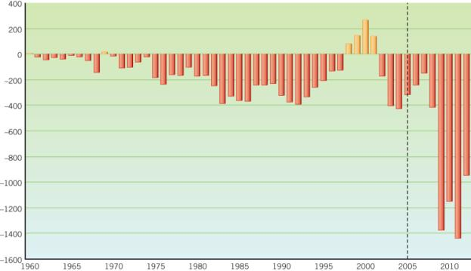
Source: Adapted from Office of Management and Budget (OMB), Historical Tables, February 1, 2010, Table 1.3.

Government Spending is Different
- How do you handle your spending problems?
  - You spend more than you earn
  - You want to buy a car or house
  - You “max out” your credit cards
  - When do you declare bankruptcy?
  - How does the government handle its spending problems?

The Politics of Economic Prosperity
- Majoritarian politics
- Pocketbook Issues
  - National level
  - Individual level
- What Politicians Try to Do
  - Unemployment
  - Inflation
  - Interest rates

The Politics of Taxing and Spending
- Voters want
  - Prosperity
  - Lower taxes
  - Less debt
  - New/continued programs
- Are there inconsistencies?

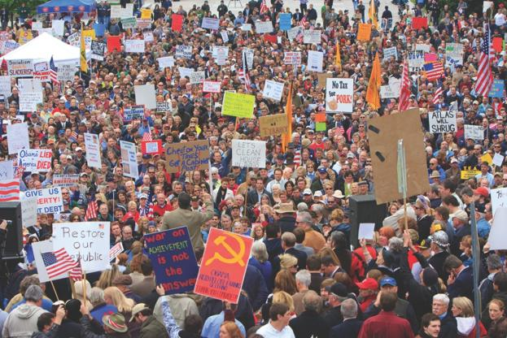
Thousands of Tea Party members gather in Nashville, Tennessee, in early 2009. The movement was named in part after the Boston Tea Party that in 1773 stimulated American resistance to the British. Others have said that “tea” stands for “taxed enough already.”

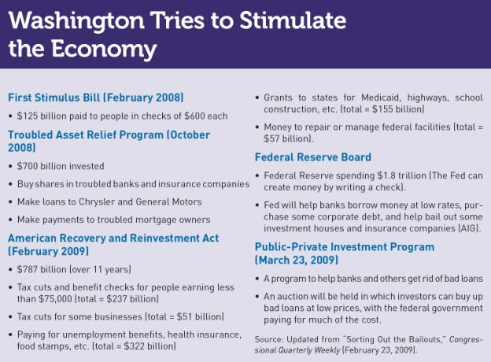
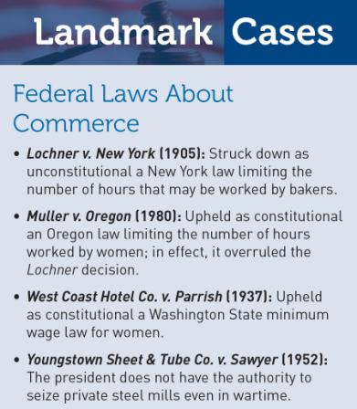

Economic Theories and Political Needs

- Monetarism
- Keynesianism
- Economic Planning
- Supply-Side Tax Cuts
- Did the Federal Government End the Recession?

Milton Friedman
John Kenneth Galbraith
Arthur B. Laffer

The Machinery of Economic Policy Making
- Within the Executive Branch
  - The President
  - The Troika
    - Council of Economic Advisors (CEA)
    - Director of the Office of Management and Budget (OMB)
    - Secretary of the Treasury

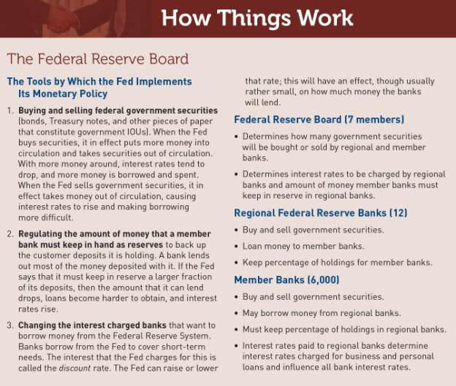
The Machinery of Economic Policy Making
- The Fed
  - Monetary policy – alters the supply of money and interest rates

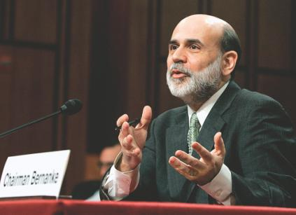

Ben Bernanke, Chairman of the Federal Reserve, speaks to a congressional committee.

- The Congress
  - Approves all taxes
  - Approves almost all expenditures
  - Wage and price controls
  - Ability to alter Federal Reserve Board policies
  - Creates the nation’s fiscal policy

- Globalization
  - How do we experience it?
    - Supporters
      - Increased income, literacy and standards of living in almost every country involved.
      - Makes products cheaper
    - Opponents
      - Undercuts the wages of American workers
      - Exploits people in poor countries
      - Imposes one culture on everyone in ways that hurt the local culture

Spending Money
- Conflicting interests
  - Majoritarian politics
  - Client politics
  - Interest group politics
- Public opinion
- Politicians’ appeals

The Budget
- The U.S. Budget: What is it?
  - In theory
  - In practice
- Before 1921: no federal budget
- Fiscal Year – October 1 through the following September 30 (federal)

- The Congressional Budget Act of 1974
  - The President’s Role
  - The Congressional Budget Committees of the House and Senate
  - Budget resolution – A congressional decision that states the maximum amount of money the government should spend
  - Entitlements - A claim for government funds that cannot be changed without violating the rights of the claimant

Reducing Spending
- Congressional Budget Act of 1974
- Balanced Budget Act of 1985 (Gramm-Rudman Act)
  - Sequester – automatic spending cuts
- Budget Enforcement Act of 1990
  - Limits on discretionary spending

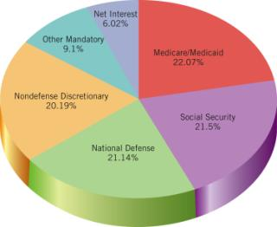
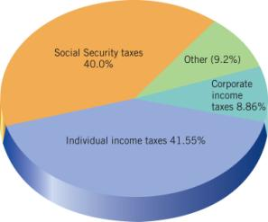

Source: Office of Management and Budget (OMB), Receipts and Outlays, Tables 2.1, 8.5, and 8.7, OMB Review, 2010.

Figure 18.3 Social Security and Medicare Cost as a % of GDP
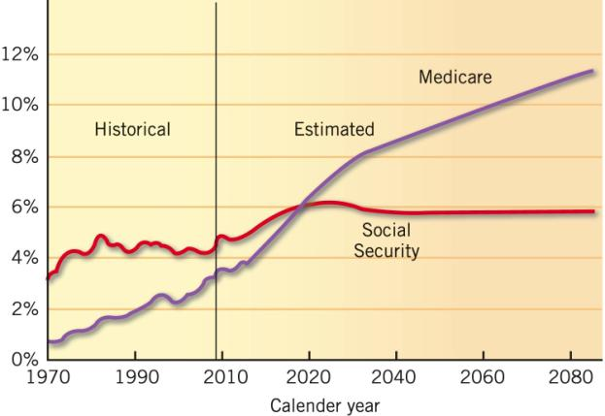

Levying Taxes
- Majoritarian politics
  - Modest tax burden
  - Minimize cheating
- Client politics
  - Loopholes

- Rise in the Income Tax
  - Sixteenth Amendment
  - Tax Reform Act of 1986
  - Tax increase of 1993
  - Tax cuts of 2002
  - Tax cut extension in 2010

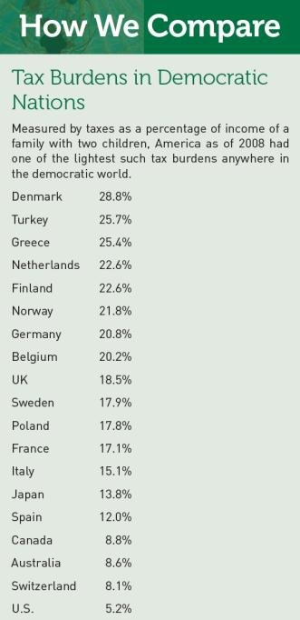
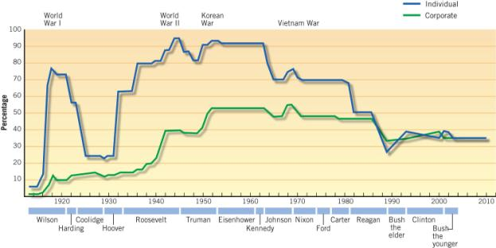
Source: Updated from Congressional Quarterly Weekly Report (various years).

M E M O R A N D U M
To: Elizabeth Gilbert, chairperson, Council of Economics
From: Edward Larson, White House speechwriter
Subject: Flat tax proposal
The President would like your advice on whether to
endorse a flat tax. His likely opponent is pushing this
issue.

Arguments for:
1. A flat tax is fair because it treats all income groups the same. We could leave the lowest income group with no taxes.
2. With a flat tax, we could eliminate almost all deductions and loopholes from the tax code.
3. Countries with a flat tax, such as Lithuania, have achieved great economic prosperity.

Arguments against:
1. A flat tax is unfair because it treats all income groups the same. The rich should be taxed more heavily.
2. Many tax deductions, such as the one for home mortgages, are desirable.
3. We could eliminate undesirable tax loopholes without creating a flat tax.

WHAT WOULD YOU DO?
Your decision:
Support?
Oppose?

