Chapter 19 – Social Welfare

Overview
Welfare policy in the United States can be explained primarily in terms of who benefits, who pays, and citizens’ beliefs about social justice. None of these factors is static. Who will benefit from or pay for a program varies as the society and the economy change. Similarly, beliefs about who deserves what shift with alterations in people’s attitudes toward work, family, and the obligations of government.
The separation of powers and the system of checks and balances mean that greater political effort and more time will be required for the adoption of new welfare policies. The federalist system also guarantees that states will play a large role in determining how welfare programs are designed and administered.
The benefits and costs help explain the popularity of Social Security and Medicare and the controversial nature of the Aid to Families with Dependent Children (AFDC) program. Social Security and Medicare provide widely distributed benefits, imposing widely distributed costs. AFDC provided benefits to some at a cost to many. Further, the wider public increasingly viewed this program’s recipients as “undeserving.” As the controversy escalated, the program lost its political legitimacy and was repealed.

Chapter Outline
- INTRODUCTION
- To promote the general welfare: Framers Madison and Hamilton debated on the meaning of the phrase general welfare which is contained in the preamble to the Constitution.
- Madison favored a more restrictive interpretation arguing Congress should only tax and spend to support specific functions as stated in Article I, Section 8 of the Constitution.
- Hamilton favored a more expansive position arguing that the phrase meant that the government could tax and spend to support any national need.
- The national economic emergency resulting from the Great Depression led to the passage of Social Security Act of 1935.
- In a series of landmark cases the Supreme Court upheld the constitutionality of this act and established the precedent upon which future social welfare programs would be based.
- Helvering v. Davis upheld Congressional provisions designed to aid the general welfare.
- United States v. Butler proclaimed Congress had power to spend for the “general welfare”.
- During the 1960s the federal government established many new programs to address national needs.
- Veteran’s educational benefits
- Medicare and Medicaid
- Children’s lunch programs
- Unemployment benefits
- Head Start
- In 2010 three programs account for over 40 percent of the Federal budget
- Social Security
- Medicare
- Medicaid
- In 2010 the controversial Patient Protection and Affordable Care Act was passed. The cost of the Act was estimated at over 940 billion over the next ten years.
  - Medicare is based on majoritarian politics.
  - “Obamacare” was passed reflecting a combination of client, interest group, and entrepreneurial politic—lacks broad support of Medicare
II. Two Kinds of Social Welfare Programs
- Benefit most citizens, no means test (Social Security and Medicare)
- Represents majoritarian politics
- Questions: Who will pay? How much will they pay?
- Benefit a few citizens, means tested (Medicaid and Food Stamps)
- Represents client politics
- Questions are about legitimacy: Who should benefit? How should they be served?
- Government acts very differently in regard to these programs.
- Majoritarian benefit programs are sacrosanct.
- Politicians look for ways to maintain benefits and hide rising costs.
- Will adopt measures that allow tough decisions to be postponed
- The appeal of client-based, means-tested programs changes with popular opinion.
- Established in 1935, AFDC was seen as a way of helping poor women whose husbands had died in war or been killed in mining accidents.
- By the mid-1960s, perception of AFDC as encouraging out-of-wedlock births and creating social dependency.
- Had lost its political legitimacy and was abolished
III. Social Welfare in the United States (THEME A: United States WELFARE PROGRAMS IN COMPARATIVE PERSPECTIVE)
- Four factors make social welfare policy different in the United States than in other nations.
- Americans generally take a restrictive view of who is entitled to government assistance.
- America has been slower than other nations to embrace the welfare state.
- Americans insist that the states and private enterprise play a large role in administering welfare programs.
- Nongovernmental organizations play a large role.
- Who benefits?
- Public insists that it be only those who cannot help themselves.
- Slow, steady change in popular views, distinguishing between the deserving and the undeserving
- Alternative view: Determine each person’s fair share of national income, and the government redistributes money accordingly
- American public prefers to give services, not money, to help the “deserving poor.”
- Late arrival of welfare policy in the United States, at least at the national level
- Behind twenty-two European nations
- Contrasts between United States and Britain’s 1908 passage of a national system of old-age pensions
- Parliamentary structure and party majority facilitated policy change.
- Unitary government meant programs were nationally run.
- Society was thinking about social classes, accepting an activist government, making welfare a central political issue.
- Contemporary reformers in United States focused on political changes instead of welfare policies.
- States and private enterprises play a role in administering programs in the United States.
- Not until the constitutional reinterpretation of the 1930s was it clear that the national government could enact social policy.
- Political arguments regarding federal involvement:
- Opponents argued against federal involvement, because states were already providing welfare
- But state authorities lobbied for federal involvement to help them
- Nongovernmental organizations administer much of the welfare state.
- Contracts and grants are awarded to national nonprofit organizations, such as Big Brothers, Big Sisters, Jewish Federations, and Catholic Charities.
- Charitable Choice: 1996 provision that allowed religious nonprofit organizations to compete for grants to administer welfare-to-work and related policies
- President George W. Bush expanded role of faith-based organizations in 2001.
- Today, faith-based organizations play prominent roles in urban welfare-to-work programs.
- Fewer than 10 percent give preference in hiring to coreligionists.
- Nearly all accept beneficiaries without regard to religion.
- Public opinion supportive of efforts: 75 percent of Americans believe faith-based organizations are more “caring and compassionate” in providing services.
A. Majoritarian welfare programs: Social Security and Medicare (THEME B: WELFARE POLITICS AND POLICY)
- Social Security Act of 1935
- Great Depression: Private charities and city relief programs were overwhelmed by need.
- Elections of 1932: Democrats, FDR swept into office
- Temporary measures were enacted to provide cash aid to state and local relief agencies and to create public-works jobs.
- Long-term measures would need to adapt to political realities.
- Was direct welfare unconstitutional?
- Would it violate American individualism?
- Fear of more radical movements challenging FDR in the 1936 elections
- Long’s “Share Our Wealth” plan (Louisiana)
- Sinclair’s “End Poverty in California” platform
- Townsend’s old-age pension program
- Cabinet Committee’s plan
- Two kinds of programs:
- Insurance for unemployed and elderly, to which workers contribute and from which they would benefit
- Assistance for dependent children, the blind, and the elderly
- Federally funded, state-administered (except for old-age insurance) programs
- Everybody eligible for insurance programs
- Means test for assistance programs
- Medicare Act of 1965
- Medical benefits omitted in 1935 in order to ensure passage of the Social Security Act.
- For thirty years, policy entrepreneurs sought a national-health care plan that would win a congressional majority.
- Democrats’ big majority in 1964 election altered Ways and Means membership (the chief roadblock to the legislation), and its chair became supportive of the program.
- Proposed bill was designed to avoid objections
- Applied only to the aged, so that costs would be limited
- Only hospitals’, not doctors’, bills were covered so that doctors would not be regulated.
- Actually broadened by Ways and Means to include Medicaid for the poor and to pay doctors’ bills for the elderly.
- Passed both houses with partisan vote; Democrats voted in favor and Republicans voted against.
- Majoritarian welfare program reform needed because costs will soon overwhelm system.
- Problem with Social Security
    - In 2010, 60 million Americans receive Medicaid benefits.
    - 54 million receive Social Security benefits
    - 45 million seniors and 7 million citizens receive disability/Medicare benefits.
- Between 2010–2030 the number of Medicare beneficiaries will rise 50 percent to 78 million. This cost of the program is over 500 billion dollars per year.
- By 2020 there will be fewer than 2 workers to support every retiree.
- By 2017, Medicare is forecast to be insolvent.
- By 2037, Social Security will face a 25 percent shortfall.
- Ryan plan proposed giving Federal money to allow Medicare recipients to purchase a voucher for private health care. Medicare costs outside this insurance coverage would be capped at $6,000.
- Problem with Medicare: Program is costly and inefficient; costs about $500 billion a year.
- Since government pays for doctor or hospital visit, people use medical services unnecessarily.
- Some doctors and hospitals overcharge the government for their services.
- Doctors and hospitals are paid according to government-approved plan that can change whenever government wants to save money.
- Proposed solutions to Medicare problem:
- Eliminate Medicare and have doctors and hospitals work for government.
- Government-run health care may provide fewer benefits.
- May discourage new health care innovation
- Have elderly buy health insurance from private suppliers.
- Health care issues will remain on the political agenda.
- Baby boomer population is aging.
- Government health care expenditures continue to grow.
- The issue is important to powerful interest groups (e.g., AARP).
- Movement toward health-care reform
    - President Obama has proposed comprehensive health care reform.
    - Cut health care costs for businesses
    - End barriers to health-care coverage for persons with preexisting medical conditions.
    - Create a government health-care plan that would compete with private plans.
- In mid-2009, opinion polls indicated that health-care reform was considered “very important” by half of all voters and “somewhat important” by nearly one-third of all voters.
- The plan remains highly controversial.
B. Client welfare programs: Aid to Families with Dependent Children
- Part of Social Security Act (1935)
- Administration shared by federal and state governments
- States should define “need.”
- Washington set rules for how program should work
- Told states how to calculate applicants’ incomes
- Required states to give Medicaid to AFDC recipients
- States had to establish mandatory job-training programs for recipients.
- States had to provide child-care programs for working AFDC parents.
- Women had to identify their children’s fathers.
- Washington also created new programs for which AFDC recipients were eligible.
- Food Stamps
- Earned Income Tax Credit
- Free school meals
- Housing assistance
- AFDC progressively lost political legitimacy over the years.
- States disliked having to conform to burdensome federal regulations.
- Public believed program encouraged out-of-wedlock births by increasing benefits for each new child.
- Public perceived that many recipients were working, too, and thus were undeserving.
- Politicians concerned that healthy parents were choosing to receive government assistance instead of working.
- Changing demographics of recipients
- By 1994, only about one-fourth of AFDC mothers were widowed or divorced; half had never been married at all.
- Two-thirds of women received AFDC for eight years or more.
- AFDC was abolished in 1996; it was replaced by Temporary Assistance to Needy Families (TANF).
    - Block grant program
    - Had strict federal requirements about work, limited how long families can receive federally funded benefits
    - By 2006, welfare caseloads had declined nationally by 62 percent
    - 2007–2009 recession has increased Food Stamp beneficiaries from 27 million to 44 million.
IV. Majoritarian versus Client Politics
1. Majoritarian Politics
- Majoritarian politics: Costs and benefits are widely distributed
- Examples: Social Security Act, Medicare Act
- Question of legitimacy central to debate over Social Security in 1935
- Conservatives argued that nothing in the Constitution authorized the federal government to spend money this way; welfare is a state issue.
- Liberals rejoined that federal government had obligation to elderly citizens; Social Security is insurance program, not government expenditure.
- Similar concerns raised in 1965 debate over Medicare.
- Conservatives argued that medical care was private, not governmental, concern.
- Liberals rejoined that only the government had resources to help elderly.
2. Client Politics
- Client politics: Everybody pays, relatively few people benefit.
- To be politically viable, perceived cost must be low, and client must be “deserving.”
- Original AFDC program thought legitimate because it helped mothers who were single through circumstances beyond their control; replaced with TANF after public rejected aid for those who became single mothers largely by choice.
- Legitimacy of beneficiaries often more important than cost
- For welfare, Americans prefer a service strategy to an income strategy.
- May be willing to bear costs even if high (prescription-drug benefits for seniors) as long as recipients are perceived as legitimate
- WHO GOVERNS? TO WHAT ENDS? Reforming Majoritarian Education Programs
      - President Obama signed the American Recovery and Reinvestment Act. It had about $5 billion for early learning programs, $30 billion for college loans and other support for higher education, and federal grants totaling nearly $50 billion for elementary and secondary schools.
      - In several years after Bush’s No Child Left Behind bill became law, Republicans pulled even with Democrats on public trust with respect to education.
      - By mid-2009, Democrats had regained an edge on the issue.

- WHO GOVERNS?
  - How, if at all, have Americans’ views of government’s responsibility to help the “deserving poor” changed over time?
  - Why are some government social welfare programs politically protected while others are politically imperiled?
- TO WHAT ENDS?
  - What does the Constitution mean by “promote the general Welfare”?
  - Should religious groups be eligible to administer some federal welfare programs?

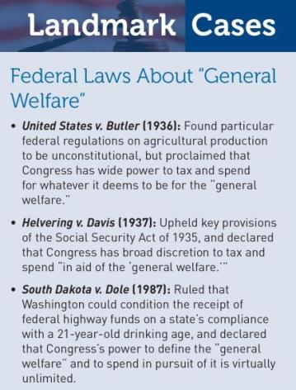

Two Kinds of Social Welfare Programs

- Majoritarian Politics/Programs
  - Examples – Social Security, Medicare
  - No means test
  - Biggest issue – cost
- Client Politics/Programs
  - Examples – Medicaid, Food Stamps
  - Means tested
  - Biggest issue – legitimacy

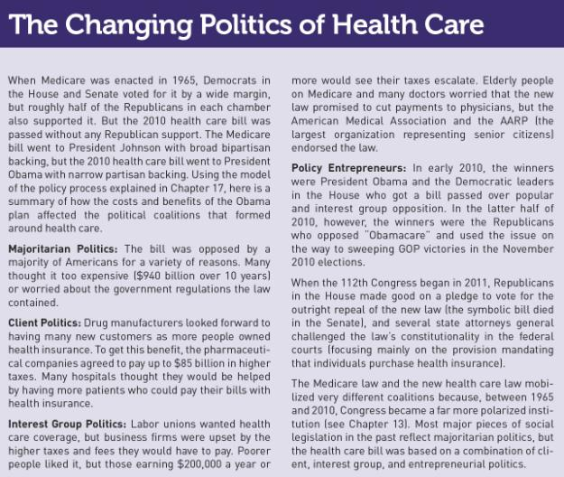

Social Welfare in the United States
United States compared to other nations:
- More restrictive view of who is entitled to governmental assistance
- Slower to embrace the welfare state
- States play a large role
- Nongovernmental organizations play a large role
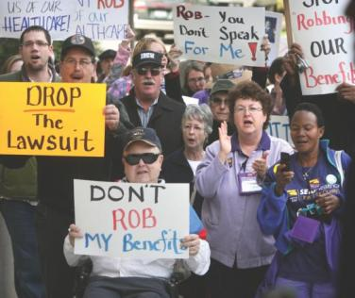

The attorneys general of several states have filed suit challenging the constitutionality of President Obama’s health care law. Here supporters of the law denounce the Washington state attorney general for joining the suit.

Social Welfare in the U. S.

- Who Benefits?
  - Separating the “deserving” from the “undeserving” poor
  - Redistribution to produce fair shares
  - Giving services not money

- Slow to Embrace the Welfare State
  - Social Welfare Examples:
    - U.S. Social Security in 1935
    - 22 European countries, Australia and Japan acted earlier than 1935
    - England contrasted with the U.S.

- Federalism’s Role
  - U. S. Supreme Court’s reinterpretation in the 1930’s
  - Individual states’ experiments with welfare programs

- State Programs’ Double-Edged Effect
  - Opponents of a federal social welfare system would say: “The states are already providing assistance.”
  - Supporters would say: “The states need national legislation to help them out.”

- Nongovernmental Organizations’ Role
  - Grants and Contracts
    - Profit and Nonprofits
    - Examples: Big Brothers, Big Sisters of America
  - Charitable Choice

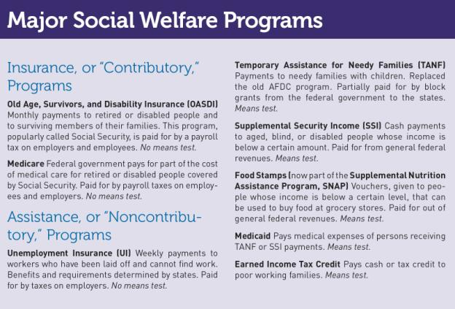

Majoritarian Welfare Programs

- Social Security
  - The Great Depression’s Effect
  - Two Parts
    - Insurance
    - Assistance

In 1932, unemployed workers line up at a soup kitchen during the Great Depression.
Topham/The Image Works

In 1934, Huey Long, the popular governor of Louisiana, claimed that Roosevelt was not doing enough to help the common man. But before he could become a serious threat to Roosevelt in the 1936 election, Long was assassinated in 1935.
Source: Bettmann/CORBIS

Majoritarian Welfare Programs

- Medicare
  - Controversy
    - Not included in the original Social Security bill
    - Actions of the House Ways and Means Committee
    - The 1964 Presidential Election
    - Becomes law with Medicaid attached

President Lyndon Johnson signs the Medicare Act in 1965.

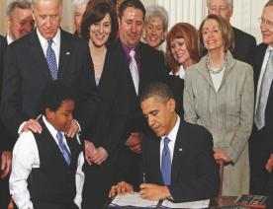

President Barack Obama signs the Affordable Health Care for America Act in 2010.

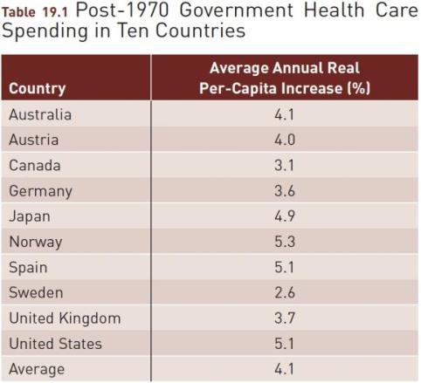
Source: Laurence Kotlilkoff and Christian Hagist, National Bureau of Economic Research, Working paper no. 11833, 2005, reporting OECD data and rounded averages for the period 1970–2002, as
cited in National Center for Policy Analysis, Health Care Spending Trends, 2004, table 1.

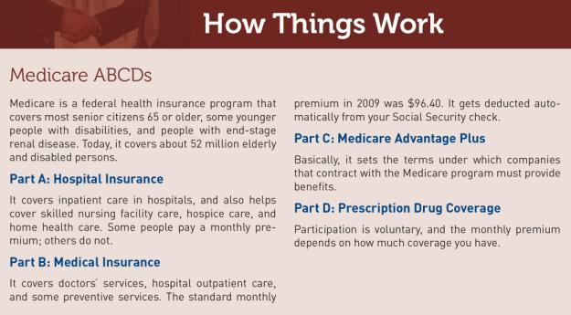

When members of Congress went home in August 2009, they encountered a long line of voters angry over the health care debate.

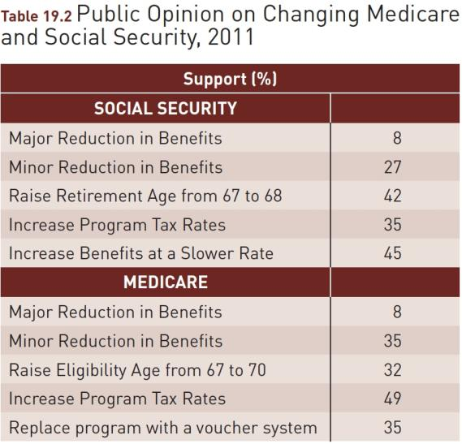

Source: Adapted from ABC News/Washington Post Poll, March 10–13, 2011; Kaiser Family Foundation/Harvard School of Public Health Poll, January 4–14, 2011; and School of Public Policy, University of Maryland and Center on Policy Attitudes, “How Americans Would Deal with the Budget Deficit,” February 3, 2011, p. 49.

An Electronic Benefits Transfer card is like a debit card that allows a person to use food stamps and spend TANF money.

Client Welfare Programs

- Aid to Families with Dependent Children

  - Existing State Programs
  - Federal Government Regulations Governing the Programs
  - Public Opinion Changes
  - Temporary Assistance for Needy Families (TANF)

Majoritarian versus Client Politics

- Majoritarian Politics
- Client Politics
- Service Strategy – A policy providing education and job training to help lift people out of poverty
- Income Strategy - A policy giving money to help lift people out of poverty
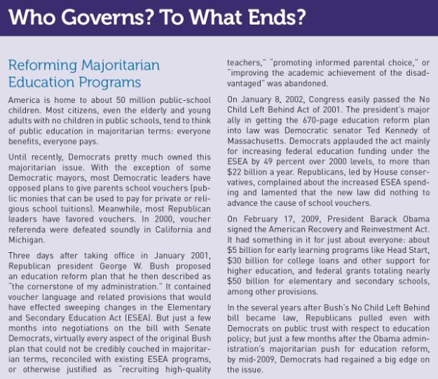

WHAT WOULD YOU DO?

M E M O R A N D U M
To: Ursula Marx, Senate Committee chair
From: Cindy Fried, senior staff member
Subject: Universal Health Care Legislation
You and the committee have two fairly distinct sets of
options on this universal health care package.

Arguments for:
1. With more than 47 million Americans, or one in seven, lacking health care coverage, the government needs to enact far-reaching reform to ensure that everyone receives quality medical care.
2. The soaring cost of health care (which is expected to reach approximately one-fifth of the federal budget in the next decade) can be contained only by a public system that has the power to set prices and control costs.
3. Universal health care is a logical expansion of the Medicare and Medicaid programs created in 1965; nearly half a century later, health care should be a fundamental right guaranteed for everyone who lives in the United States.

Arguments against:
1. Though many people lack health insurance, most of them get health care in hospital emergency rooms and from doctors who donate their services.
2. Medical services in the United States are the best in the world, and government controls on costs will serve only to reduce the quality of care available.
3. In an era of budget deficits and trillions of dollars in national debt, the United States cannot afford to expand social welfare programs.

Your decision:
Support?
Oppose?

