Chapter 20 – Foreign and Military Policy

Overview
The great issues of national diplomacy and military policy are shaped by majoritarian politics. The president is the dominant figure, political ideology is important, and interest groups are central only to those issues—such as free trade or the allocation of military contracts—that engage their interests.
Nevertheless, majority opinion is weakly defined. In general, the public approves of the United States playing an international role, but in particular cases, it would like the United States to stay at home and mind its own business. When there is a crisis or when troops are sent overseas, however, the decisions and the troops are strongly supported.
Elite opinion plays a more powerful role in the decision-making process, but it is divided into four worldviews: isolationist, containment, disengagement, and human rights. The first is less common today than once was the case, but the remaining three are deeply at odds over whether the United States should have stayed in Vietnam, driven Iraqi troops out of Kuwait, given aid to Bosnia, launched an air campaign in Kosovo, or invaded Afghanistan and Iraq.
Unlike in many nations, foreign and military decision making is organized to give civilians control. The president is assisted chiefly by the National Security Council, which includes the secretaries of state and defense. Civilian control of the military is vested in the president, who issues orders through the secretary of defense. The Joint Chiefs of Staff is a planning and advisory body.
When the military budget is developed, it tends to follow the dictates of majoritarian politics, but when it is spent on the services and military contractors, interest-group politics takes precedence.

Chapter Outline
I. INTRODUCTION
- The struggle with terrorism is not a new a recent development.
  - Presidents as far back as Thomas Jefferson have had to deal with terrorists.
      - Barbary Pirates (1801–1805)
      - Ku Klux Klan: First formed in the nineteenth century after the Civil War; replaced with a second Klan in the twentieth century
      - Weather Underground (1960s and 1970s)
      - al Qaeda: Radical Islam Group founded by Osama Bin Laden responsible for attack on U.S. Cole, two American embassies, and World Trade Center on 9/11.
II. Kinds of Foreign Policy (THEME A: FOREIGN POLICY AS MAJORITARIAN POLITICS)
- Majoritarian politics
- Foreign policy is perceived to confer widespread benefits, impose widespread costs.
- Examples
- War
- Military alliances
- Nuclear test ban or strategic arms limitation treaties
- Cuban missile crisis
- Decision to aid Nicaraguan contras
- Diplomatic recognition of People’s Republic of China
- Interest-group politics
- Identifiable groups pitted against one another for costs, benefits
- Example: Tariffs on Japanese steel
- Client politics
- Benefits to identifiable group, without apparent costs to any distinct group
- Examples:
- Arab Americans are pressing government with concerns that differ from those pressing a pro-Israel agenda
- Aid to U.S. corporations doing business abroad
- Who has power?
- Majoritarian politics: President dominates; public opinion supports but does not guide the president
- Interest-group or client politics: Larger congressional role
- Entrepreneurial politics: Congress the central political arena
III. The Constitutional and Legal Context
- Constitution creates an “invitation to struggle” between the president and Congress on war powers.
- President is the commander in chief, but Congress appropriates the money.
- President appoints ambassadors, but Senate confirms them.
- President negotiates treaties, but the Senate must ratify them with a two-thirds vote.
- Only Congress can regulate commerce with other nations and declare war.
- Yet Americans think that the president is in charge, and history confirms that belief.
A. Presidential box score
- Presidents have been relatively strong in foreign affairs.
- More success in Congress on foreign affairs than on domestic affairs
- President may be stronger than the Framers intended regarding military deployment and diplomacy.
      - 1861: Lincoln blockades Southern ports and declares martial law.
      - 1940: FDR sends destroyers to Britain to be used against Germany (United States was technically at peace with Germany).
      - 1950: Truman sends troops to Korea.
      - 1960s: Kennedy and Johnson send advisors and then troops to Vietnam.
      - 1983: Reagan sends troops to Grenada to overthrow a pro-Castro regime.
      - 1989: George H. W. Bush orders the invasion of Panama.
      - 1990: George H. W. Bush sends forces into Saudi Arabia when Iraq invades Kuwait.
      - 1999: Clinton orders attacks against Serbs in Kosovo.
      - 2001: George W. Bush sends troops to Afghanistan.
      - 2003: George W. Bush invades Iraq.
      - 2011: President Obama has indicated support for popular revolts through the Arab world (Arab Spring).
- Yet presidents have been comparatively weak in foreign affairs by standards of other democratic nations.
- Other heads of state find U.S. presidents unable to act.
- Wilson and FDR were unable to ally with Britain before World War I and World War II.
- Wilson was unable to lead United States into League of Nations.
- Ford could not intervene in Angola to support an anti-Marxist regime.
- Reagan was criticized on his commitments to El Salvador and Lebanon.
- Congressional debate on George H. W. Bush’s waging of Gulf War was extended.
- George W. Bush’s decision to invade Iraq was bitterly controversial in the 2004 and 2006 elections.
- Treaties signed by the president are little more than a promise to try to get the Senate to act.
B. Evaluating the power of the president
- Depends on one’s agreement/disagreement with the policies
- Supreme Court has ruled that the federal government has foreign and military policy powers beyond those specifically mentioned in the Constitution.
- Supreme Court is reluctant to intervene in Congress-president disputes about war powers (refused to intervene in Congress’ dispute with Nixon over Vietnam).
- Supreme Court usually upholds use of presidential power. Examples include:
- Lincoln’s extraordinary measures during Civil War
- Carter’s freezing of Iranian assets during the hostage crisis
- FDR’s “relocation” of one hundred thousand Japanese Americans during World War II
- One of few Supreme Court limitations on president’s wartime powers: reversal of Truman’s steel-mill seizure (1952)
C. Checks on presidential power
- Checks on presidential power are chiefly political rather than constitutional.
- Congress: Control of purse strings
- Congress also limits the president’s ability to give military or economic aid to other countries:
- LIMITATIONS ON THE PRESIDENT’S ABILITY TO GIVE MILITARY OR ECONOMIC AID TO OTHER COUNTRIES
- Arms sales to Turkey (1974–78)
- Blocked intervention in Angola (1976)
- Legislative veto (previously) on large arms sales
2. The War Powers Act
- Provisions
- All commitments of troops in hostile situations must be reported within forty-eight hours.
- Only a sixty-day commitment of troops can be made unless there is a declaration of war or a specific statutory authorization.
- Observance
- Every president since the passage of the War Powers Act has sent troops abroad without congressional approval.
- Presidents deny that the War Powers Act is constitutional.
- Supreme Court declared the legislative veto unconstitutional, and this is a crucial element of the War Powers Act.
- Congress is reluctant to cut off appropriations for these missions.
3. Intelligence oversight
- House and Senate intelligence committees must be fully informed, including on covert operations.
- Committees have no authority to disapprove covert action.
- Congress sometimes blocks covert action: Boland Amendment (1982–85) prevented military aid to the contras in Nicaragua for specific periods.
IV. The Machinery of Foreign Policy
- Consequences of major power status for United States following World War II
- President more involved in foreign affairs
- More agencies shape foreign policy.
- Foreign affairs no longer coordinated by Department of State
- Job is too big.
- Many agencies have foreign missions abroad (Defense, CIA, Agriculture, Commerce, Labor, FBI, DEA, and AID).
- Most of these agencies owe no political or bureaucratic loyalty to the secretary of state.
- National Security Council (NSC) was created to coordinate departments and agencies.
- Chaired by president and includes vice president, secretaries of state and defense; usually includes the Director of National Intelligence (DNI), chair of Joint Chiefs of Staff, attorney general
- National security adviser (NSA) heads staff
- Has grown in influence since JFK
- Downgraded by Reagan, but NSC appointees precipitated Iran-contra scandal
- NSA may rival the secretary of state.
- Consequences of multicentered decision-making machinery for policy decisions
- “It’s never over,” due to rivalries within and between executive and legislative branches.
- Agency positions are influenced by agency interests.
V. Foreign Policy and Public Opinion
- Outlines of foreign policy are shaped by public and elite opinion.
- Before World War II, public opposed U.S. involvement in world affairs.
- World War II produced active popular support for an active involvement in international affairs that continued throughout the war.
- Support for active involvement persisted until Vietnam.
- Support for internationalism is highly general and volatile; often dependent on:
- phrasing of poll questions;
- opinions by popular leaders; and
- impact of world events.
A. Backing the president
- Public tends to support the president in crises.
- Strong support (“rally round the flag”) for presidential foreign policy initiatives
- Boost in popularity often occurs immediately after crisis.
- Exceptions: No boost when Clinton sent troops to Bosnia or launched attacks on Iraq.
- Attacks of 9/11 boosted George W. Bush’s favorability rating from 51 percent to 86 percent.
- Military casualties often lead the public to support escalation so that fighting will end more quickly.
- Tradition of opposition
- About 20 percent of Americans opposed invading Iraq, Vietnam, and Korea.
- Opposition is generally highest among Democrats, African Americans, and people with postgraduate degrees.
B. Mass versus elite opinion
- Mass opinion
- Generally poorly informed about foreign policy
- But since World War II, public has generally felt the United States should play an important international role.
- Elite opinion
- Well informed, but opinions are likely to change
- Leaders are more liberal and internationalist than the public.
- Cleavage between mass and elite opinion even wider if elite is restricted only to those involved in making foreign policy
VI. Cleavages Among Foreign Policy Elites (THEME B: THE FOREIGN POLICY ELITE)
- Elite opinion is especially important, because mass opinion is permissive and undefined; but elites are very divided.
- The foreign policy elite:
- Senior officials of the State Department
- Staff of the National Security Council
- Members and staff of the Senate Foreign Relations Committee and the House International Relations Committee
- Members of the Council on Foreign Relations (private organization)
- Editors of Foreign Affairs and Foreign Policy
A. How a worldview shapes foreign policy
- Definition of worldview (or paradigm): Comprehensive mental picture of world issues facing United States and appropriate or inappropriate ways of responding
- Example: Article by “Mr. X” (George Kennan) on containment of USSR
- Not unanimously accepted, but consistent with public’s mood, events, and experience
1. Four worldviews
- Isolationism paradigm (1920s–1930s)
- Opposed getting involved in wars
- Adopted after World War I, because that war accomplished little
- Containment (antiappeasement) paradigm (1940s–1960s)
- Pearl Harbor ended isolationism in United States.
- Reaction to appeasement of Hitler in Munich
- Postwar policy to resist Soviet expansionism
- Disengagement (Vietnam) paradigm (1970s, continuing)
- Reaction to military defeat and political disaster of Vietnam
- Vietnam interpreted in three ways:
- Containment was the correct worldview, but the United States did not try hard enough to win the war.
- Correct worldview but it was applied in wrong place, under wrong circumstances
- Worldview itself was wrong.
- Critics believed the containment worldview was wrong and adopted a new isolationism.
- Human rights
- Prevent genocide: The mass murder of people, usually because of their race or ethnicity
- Applied unevenly and without historical awareness
- New question arose after the 9/11 attacks: Should the United States act unilaterally or only with a broad coalition?
B. Political polarization
- Division in public opinion along partisan lines is new development
- Korea: Divisions in Congress over firing of General MacArthur
- Vietnam: Divisions between elites and general public
- Iraq invasion: Divided along partisan lines
- Democrats strongly opposed it; and
- Republicans strongly favored it
- Public opinion has become more polarized by foreign policy.
VII. The Use of Military Force
- Military power still important, even after end of Cold War
- Functioning of military is affected by politics
- Majoritarian politics
- Everyone is protected, every taxpayer pays.
- President is commander in chief, and Congress has a supportive role.
- Client politics
- Beneficiaries are generals, defense contractors, and members of Congress.
- Military budget reflects lobbying skills of the military-industrial complex.
A. War in Iraq
- Precipitating events
- Saddam Hussein left in power after U.S.-led coalition expelled Iraqi forces from Kuwait.
- Restrictions imposed on Iraq by UN following withdrawal from Kuwait.
- No-fly zone
- Prohibitions against weapons of mass destruction (WMDs)
- Required to allow UN inspectors to search for chemical, biological, or nuclear materials
- Between 1997 and 2003, Hussein violated UN rules.
- UN inspectors found evidence of WMDs in 1997.
- Hussein expelled inspectors from Iraq.
- Gave misleading statements to American and British leaders
- United States response
- Unable to convince UN to support war
- Decided, along with Great Britain and other allies, to act independently
- Launched Operation Iraqi Freedom in March 2003
- Iraqi army defeated in six weeks.
- Inspectors found no evidence of WMDs.
- Helped to organize interim government, new constitution, and regular government, but efforts hampered by terrorist activities of insurgents.
- Eroding political support in United States led to loss of Republican congressional majority in 2006 elections.
- In 2007, President George W. Bush announced new military strategy (“surge”) that improved conditions in Iraq.
VIII. The Defense Budget
A. Total spending
- Small peacetime military until 1950
- No disarmament after Korea due to containment policy
- Military system designed to repel Soviet invasion of Europe and small-scale invasions
- Changes in spending reflect public opinion
- Demise of the USSR generated a debate about the proper direction of U.S. defense strategy.
- Liberals: Sharp defense cuts; United States should collect the peace dividend
- Conservatives: Some cuts, but retain well-funded military since the world was still a dangerous place
- Campaigns in Afghanistan and Iraq highlight need for military force.
B. What do WE GET WITH OUR money?
1. Personnel
- All-volunteer force instituted after Vietnam
- Steady increase in percentage of women in the military
- Presence of homosexual personnel still a source of controversy
2. Big-ticket items
- Cost overruns: The difference between actual costs and estimated costs
- Reasons for cost overruns
- Hard to know in advance what something that has never existed before will actually cost to build
- People have an incentive to underestimate the costs to get the weapon approved
- Pentagon officials want the best money can buy (gold plating)
- Sole sourcing: No competition means no incentive to control costs.
- Congress cuts military budget not by canceling weapons, but by spreading out construction schedule.
3. Readiness
- Client politics makes readiness a low priority (after building equipment and maintaining bases).
- Training and readiness have no specific client constituencies.
4. Bases
- System for locating/maintaining military bases was purely client politics.
- Commission on Base Realignment and Closure created in 1988 to consider recommendations from Secretary of Defense
- Since 1988, there have been five BARC reports. Congress, following these reports, has closed over three hundred fifty bases.
IX. The Structure of Defense Decision Making (THEME C: HOW ARE MILITARY SPENDING DECISIONS MADE?)
- National Security Act of 1947
- Department of Defense
- Secretary of defense is a civilian, as are secretaries of army, navy, air force.
- Joint Chiefs of Staff are military officers.
- Two reasons for separate uniformed services:
- fear that unified military will become too powerful; and
- desire of services to preserve their autonomy
- Defense-reorganization plan of 1986—Goldwater-Nichols Act
- Joint Chiefs of Staff
- Joint Chiefs of Staff (JCS)
- Composed of uniformed head of each service
- JCS chair and vice chair are appointed by president and confirmed by Senate.
- JCS does not have command authority over troops but plays a key role in defense planning.
- Since 1986, JCS chair has been designated the principal military adviser to president, so that the chair may also have greater influence within JCS.
- Joint staff
- Composed of officers from each service assisting the JCS
- Since 1986, the joint staff serves chair; its members are promoted at same rate as those within their service branch
B. The services
- Civilian secretary responsible for purchasing and public affairs
- Senior military officer, who oversees discipline and training, represents service on JCS.
C. The chain of command
- President to secretary of defense to unified and specified commands
- Chair of JCS does not have combat command
- Uncertain whether the 1986 changes will work; 1991 Persian Gulf victory was taken as a positive indication.
X. The New Problem of Terrorism
- Since 9/11, foreign policy has had to focus on terrorism and what to do with nations that have harbored terrorists.
- Superpower status in a unipolar world still leaves United States vulnerable both here and abroad to terrorist attacks.
- “New” view issued by George W. Bush in September 2002: Doctrine of preemption
- America will act against emerging threats before they are fully formed.
- Will identify and destroy terrorist threat before it reaches our borders
- Will not hesitate to act alone
- Debate has divided Congress in a way that is unusual in foreign policy
- Supporters: Hailed it as a positive step to defeat terrorists
- Critics: Justifies preemptive and possibly unjust wars, and abandons the United Nations
- Lack of a common enemy means that party differences and party ideology makes difference in foreign policy.
- United Nations support
- Sought and obtained UN support in regard to Korea and forcing Iraq out of Kuwait.
- Did not seek UN support in regard to Vietnam, Haiti, Bosnia, or Kosovo
- Sought but did not obtain UN support in invading Iraq in 2003
- Rebuilding nations after war
- Previous experience
- Helped Japan and Germany after World War II (successful)
- Tried to help Somalia (1992–94) (failed)
- Tried to install democratically elected president in Haiti (1994–96) (failed)
- Worked to restore order in Bosnia and Kosovo (making progress)
- Now working in Afghanistan and Iraq (making progress)
A. Iraq and Afghanistan
    - Defeated Iraqi army in 2003. However, the United States made mistakes in efforts to both stabilize and democratize the nation.
    - Abolished the army, but this left Iraq without a native defense force. We used American troops to provide stability, but quartered them in secure compounds leaving the Iraqi citizens unprotected.
    - Iran supported terrorist operations in Iraq, which further destabilized the situation.
    - American public opinion soured on the conduct of the war.
    - To address these issues, President Bush increased American force levels within Iraqi.
- He appointed a new military commander, General David Petraeus, to lead operations.
- The “surge” was successful. Deaths of American soldiers and Iraqi civilians dropped dramatically. The Iraqis held new elections in 2009. The nation is more stable. U. S. troops will be removed from Iraq in 2011.
- Afghanistan remains a problem. The nation is very poor and has been unstable for many years with no democratic tradition. Establishment of a stable democratic regime will prove a difficult undertaking.

- WHO GOVERNS?
  - Is American foreign policy set by public wishes or elite views?
  - If only Congress can declare war, why has the president become so powerful in military affairs?
- TO WHAT ENDS?
  - Why do we go to war against some dictatorships and not others?
  - Should our foreign policy be based on American interests or some conception of human rights?

Kinds of Foreign Policy
- Majoritarian Politics
  - Decision to go to war
- Interest Group Politics
  - Decisions regarding tariffs
- Client Politics
  - Aid to American business abroad

The Constitutional and Legal Context
- Presidential Box Score
  - International diplomacy and the use of American troops
  - Historical comparisons that suggest the President’s ability to act decisively often appears modest.

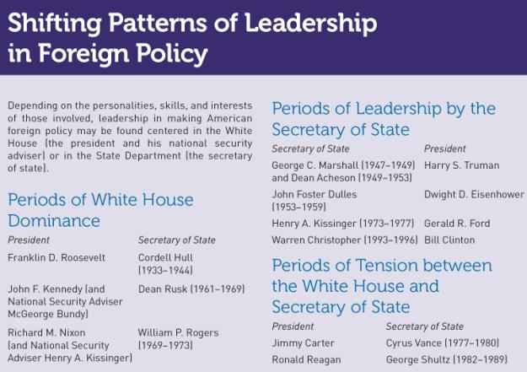

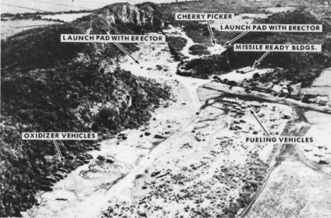

In 1962 President Kennedy forced the Soviet Union to withdraw the missiles it had placed in Cuba after their presence was revealed by aerial photograph.

The Constitutional and Legal Context

- Checks on Presidential Power
  - Limitations on aid
  - The War Powers Act
  - Intelligence oversight
    - House and Senate Intelligence Committees
    - Office of the Director of National Intelligence

The Constitutional and Legal Context

- Evaluating the Power of the President
  - Supreme Court’s Position
  - Extraordinary Measures
    - Lincoln
    - Johnson
    - Nixon
    - Carter
    - FDR and WW II

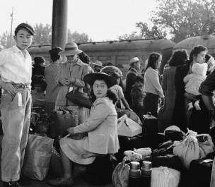
Following the attack on Pearl Harbor, President Roosevelt ordered all Japanese Americans living on the West Coast be interned in prison camps.

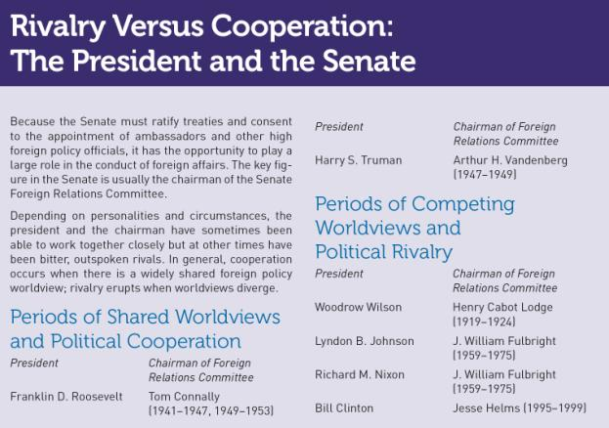

The Machinery of Foreign Policy

- Expansion after WWII
  - The president put foreign policy at top of the agenda
  - Policy was shaped by scores of agencies
- Rivalries within the executive branch intensify rivalries between that branch and Congress
- Interests of the various organizations affect the positions they take

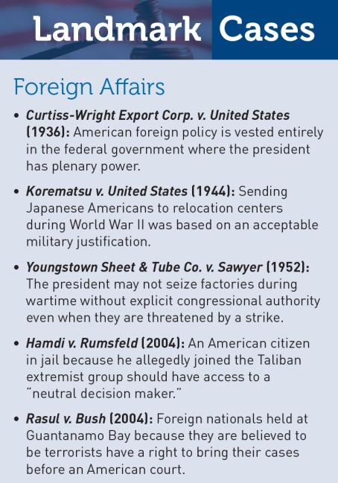

Foreign Policy and Public Opinion

- World War II
- Vietnam
- September 11, 2001
- Backing the President
- Mass versus Elite Opinion

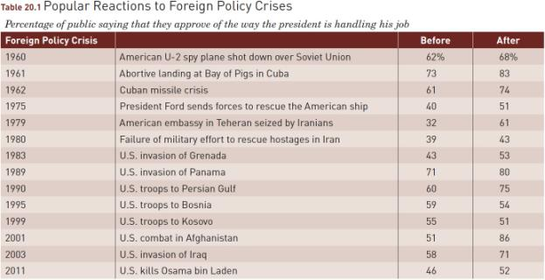
Source: Updated from Theodore J. Lowi, The End of Liberalism (New York: Norton, 1969), 184. Poll data are from Gallup poll. Time lapse between “before” and “after” samplings of opinion was in no case more than one month.

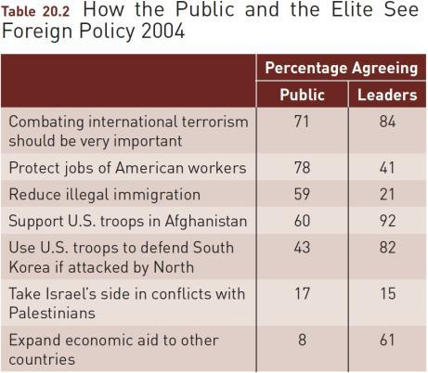
Source: Global Views 2004 (Chicago: Chicago Council on Foreign Relations, 2004).

Cleavages Among Foreign Policy Elites

- How a worldview shapes foreign policy
  - Isolationism
  - Containment
  - Disengagement
  - Human rights
- Political polarization

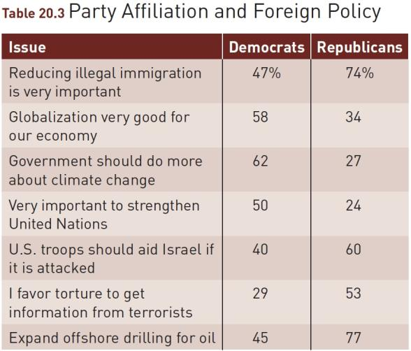

The Use of Military Force

- Two views of the role of the military
  - Majoritarian
  - Client
- Military-industrial complex
- War in Iraq

U.S. Military Intervention in the Middle East

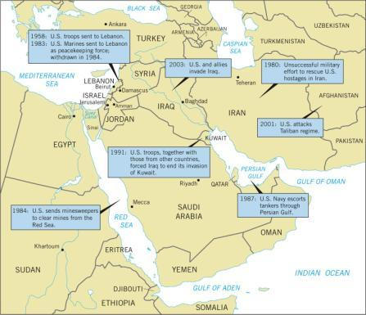

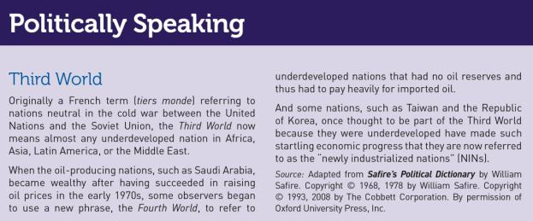

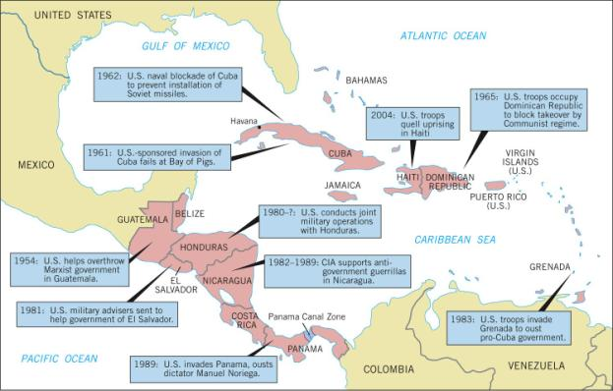

The Defense Budget:
Total Spending

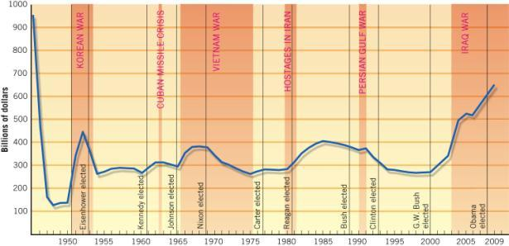

Source: Office of the Under Secretary of Defense (Comptroller), “National Defense Budget
Estimates for FY 2007.”

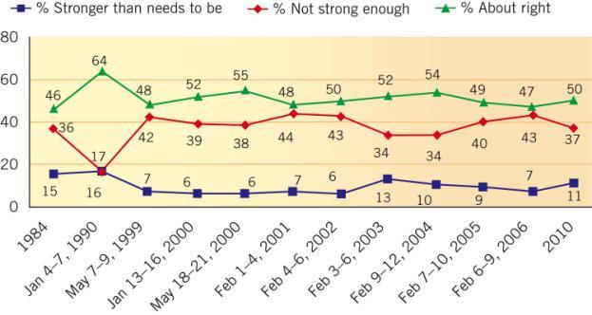

The Defense Budget

- What do we get with our money?
  - Personnel
    - Personnel Issues:
      - Movement to an all-volunteer armed forces
      - Increase in the numbers of women in service
      - Homosexuals in service

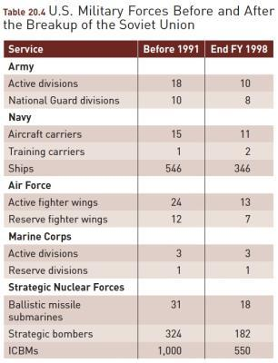

Source: Statistical Abstract of the United States, 1998, 363.

The Defense Budget
- What do we get with our money?
  - Big Ticket Items
    - Cost overruns
    - Remedies

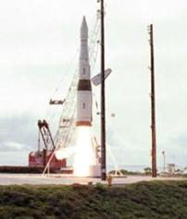

The United States has tried to decide whether to build interceptors like this one to shoot down incoming missiles from enemies.

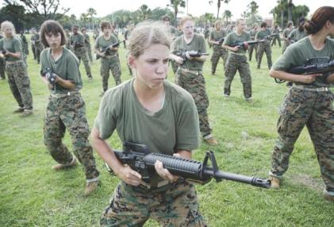

Women Marine recruits go through close combat training.

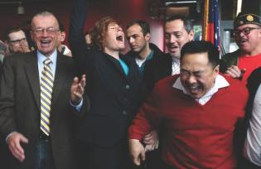

Retired Navy commander Zoe Dunning (2nd from left) and her friends celebrate the end of “Don’t Ask, Don’t Tell” in San Francisco.

The Defense Budget

- What do we get with our money?
  - Readiness
    - Training and readiness issues
  - Bases
    - Keeping bases open
    - 1998 Commission on Base Realignment and Closure

The Structure of Defense Decision Making

- National Security Act of 1947
- Goldwater-Nichols Act of 1986
- Joint Chiefs of Staff
- The Services
- The Chain of Command
  - President – Commander-in-Chief
  - Secretary of Defense

The New Problem of Terrorism

- Bipolar world – A political landscape with two superpowers
- Unipolar world – A political landscape with one superpower
- Doctrine of preemption – attacking a determined enemy before they can attack us or an ally
- Iraq and Afghanistan

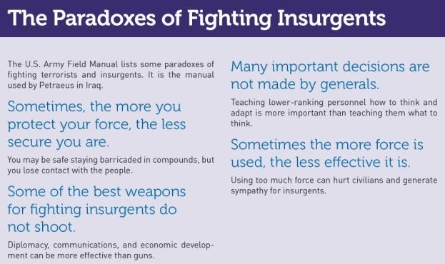

WHAT WOULD YOU DO?

M E M O R A N D U M
To: The President
From: National security adviser
Subject: Hostages
The six Americans held hostage in the Middle East are beginning their second year of captivity. One, a CIA officer, is undergoing torture. It has been the policy of this administration not to negotiate with terrorists. Criticism of this refusal is being heard from hostage families and their sympathizers. The terrorist groups are demanding that we end our support of Israel. A government in the region has secretly indicated that, in exchange for military supplies, it may be able to help win the release of “some” hostages.

Your options:
1. Maintain the “no-negotiations” policy but use quiet diplomacy with friendly nations in the region to see whether they can intercede with the terrorist groups on behalf of the hostages.
Advantages: (a) Our “no-negotiations” policy remains credible, and this will deter other terrorist groups from thinking that they can win concessions by capturing Americans. (b) This policy is consistent with our insistence that U.S. allies not negotiate with terrorists.
Disadvantages: (a) There is no evidence that our traditional policy will get the hostages released. (b) Public sympathy for the hostages may increase, and this will lead to more criticism of this administration for failing to free captive Americans.

Your options:
2. Secretly exchange arms for the release of Americans.
Advantages: (a) Some or all hostages may be released. (b) We may earn the goodwill of more moderate elements in the area and thereby increase our influence there.
Disadvantages: (a) We may deliver arms and no hostages will be released. (b) If secret arms deliveries become public, we will be heavily criticized for abandoning our “no-negotiations” policy.
3. Use military units to find and free the hostages.
Advantage: The hostages may be freed without our having to make any concessions.
Disadvantages: (a) The military is not optimistic that it can find and free the hostages, who are being kept in hidden, scattered sites. (b) The hostages may be killed during the rescue effort.

Your decision:
Option 1 _________________
Option 2 _________________
Option 3 _________________

