Chapter 21 – Environmental Policy

Overview
Environmental issues illustrate all four styles of policymaking.
Entrepreneurial politics: An unorganized public benefits at the expense of a well-organized group. The controversy surrounding global warming and the success of activists seeking to reduce its effects reveal the workings of entrepreneurial politics. Entrepreneurial politics requires mobilizing the media, dramatizing the issue, and convincing members of Congress that their reputations will suffer if they do not cast the right vote. To prevent client groups from directing how the laws will be implemented, the bills must be written so that the courts can be used to force action.
Majoritarian politics: An unorganized public benefits at its own expense. Examples of majoritarian politics include reducing car exhaust emissions, raising gasoline taxes, and requiring environmental impact statements. Interest groups tend not to be decisive players. Whether the proposal wins or loses depends on how the public evaluates the costs. Restrictions on the use of private cars and increased gasoline taxes, for example, are not popular. In recent years, the same has often been true of environmental impact statements.
Interest-group politics: Two organized groups with a material stake in the outcome fight over who will pay and who will benefit. Acid rain is an example of interest-group politics. When confronted with interest-group politics, Congress tends to find workable compromises rather than passing legislation that is more sweeping.
Client politics: An organized group gets a benefit and an unorganized public must pay. Logging in the national forests often generates client politics. Client politics depends on each group having strategically placed allies in Congress and on preempting any effort to generate entrepreneurial politics.
In general, entrepreneurial politics has played the dominant role in most environmental issues. This is because the issues can be portrayed in life-threatening terms; the goals can be related to what most people believe is the good life; and the costs can be minimized, deferred, or placed (seemingly) on small groups. As a result, policy entrepreneurs have been very successful in sensitizing the public to environmental issues, building a momentum into their messages. In addition, a variety of public interest groups have established themselves as political forces to be reckoned with, because each has cultivated close ties to the media, and each has developed the ability to threaten recalcitrant legislators.

Chapter Outline
I. Introduction
- In 2008 presidential race environmental politics a major concern
- Obama—“The planet is in peril.”
- McCain—“We need to restore our planet.”
- The focus has changed. In 2011 the public is not clamoring for stronger environmental policies though two-thirds of the public support the development of clean-energy sources.
- Environmental policy: Why is it so controversial?
- Creates both winners and losers
- Losers may not want to pay the costs.
- Example: Auto emissions control
- Shrouded in scientific uncertainty so problems and solutions are uncertain
- Example: Global warming
- Scientists disagree as to whether it is caused by human activity or natural changes.
- Takes the form of entrepreneurial politics
- Encourages emotional appeals
- May lead to distorted priorities
- Example: The possibility that pesticides may slightly increase cancer risk receives more attention than the problem of polluted runoff from farms and towns.
- Profoundly affects how federal government deals with states and other nations
- States have passed more than three dozen laws to lower emission of various greenhouse gases.
- Government participated in drafting 1997 Kyoto Protocol calling for 5 percent worldwide reduction in greenhouse gases, but the Senate never ratified it.
- Clinton administration never pushed for ratification.
- Treaty allows several countries to keep generating gases, but would have required a 25 percent decrease in energy use in United States by 2012.
- The American context (THEME A: THE POLITICS OF ENVIRONMENTAL PROTECTION)
- Environmental policy is shaped by unique features of U.S. politics.
- In United States, policy has the following characteristics:
- Adversarial political culture
- Rules are often uniform nationally (for instance, auto emissions)
- Many rules, strict deadlines, and expensive technologies required
- Government and business leaders often conflict with one another.
- Example: Clean Air Act took thirteen years to revise in Congress (1977–90).
- In England, policy has the following characteristics:
- Rules are flexible and regional.
- Compliance is voluntary; it does not rely on formal enforcement.
- Government and business leaders cooperate with one another; litigation is rare.
- Policies are effective.
- In the United States, implementing environmental policy depends heavily on states.
- Federal government set standards, but states choose how to achieve them.
- Local politics influences decision making.
- Sewage treatment plants are designed, built, and operated by states.
- States decide where to dispose of radioactive waste.
- Federalism reinforces adversarial politics.
- Separation of powers provides multiple points of access.
II. Entrepreneurial Politics: Global Warming
- Entrepreneurial politics created environmental movement in the 1960s.
- Causes: Santa Barbara oil spill (1969), Earth Day (1970), climate of protest politics
- Numerous legislative successes
- 1970: Environmental Protection Agency established, Clean Air Act toughened, Water Quality Improvement Act passed
- 1972: Clean water legislation passed
- 1973: Endangered Species Act passed
- Global warming is problematic.
  - Hundreds of scientists both in the United States, working through the National Academy of Science and through the Intergovernmental Panel on Climate Change worldwide, have concluded that the earth is getting warmer and that these changes are “very likely” a result of human-made greenhouse gases.
- Is increase in temperature the result of natural climate changes . . .?
- . . . or is it heavily influenced by humans putting greenhouse gases into the air?
- America acting alone will not solve problem; how does the United States get growing nations, such as China and India, to absorb their share of the cost?
- What are the benefits of intervention, and when would they occur?
- Could stop threat posed to coastal communities by rising sea levels
- However, global warming could be beneficial.
- Crops would be easier to grow.
- Heating bills would be lower.
- Ideological conflict among elites
- Activists scare Americans with information about environmental harm.
- Conservatives scare Americans with information about economic pain.
- Because the environment is a popular issue, activists dominate policy discussion.
- Endangered Species Act (ESA) also generates economic problems.
  - Forbids buying or selling any creature or plant that is likely to become extinct unless it receives special protection
  - Regulations also forbid adversely affecting habitats of endangered species.
  - The ESA can add species to the endangered or threatened list.
  - Trafficking in endangered species can lead to criminal penalties.
  - Private lands must be managed to protect an endangered species.
  - Improvement in the numbers of several endangered species has been noted, including bald eagles, gray wolves, sea otters, and grizzly bears.
- Firms and agencies that wish to build anything in an area where an endangered species lives must comply with these regulations, often at a substantial cost.
III. Majoritarian Politics: Pollution from Automobiles (THEME B: TRANSPORTATION AND THE ENVIRONMENT)
- Clean Air Act (1970) imposed tough restrictions
- Public demanded improvements; initially, this was a case of entrepreneurial politics.
- 1975: 90 percent reduction of hydrocarbons and carbon monoxide
- 1976: 90 percent reduction in nitrogen oxides, as well
- Led to a reliance on catalytic converters, because there was not enough time to redesign the engines
- Emergence of majoritarian politics in auto pollution
- States were required to restrict the public use of cars.
- If auto emissions controls were insufficient—L.A., Denver, New York, and elsewhere—then government would mandate use of buses, car pools; ration gas; ban parking.
- Efforts failed: opposition too great
- Congress and EPA backed down, postponing deadlines
- Consumers, auto industry, and unions objected to standards for new cars.
- Cars were now more expensive.
- Catalytic converters caused a loss of horsepower.
- Car industry feared a loss of competitiveness.
- Unions feared a loss of jobs.
- Clean Air Act was weakened in 1977 but revived in 1990 with tougher standards; deadlines were again delayed.
- Most clean air laws passed since 1990 target particular industries (such as construction, agriculture).
- Public will support tough laws:
- when someone else pays; and
- if costs are hidden (for instance, more expensive cars).
- They will not, however, support tough laws if they are forced to change habits (for instance, mandatory car pools).
1. Majoritarian politics when people believe THE costs are low
- Example: National Environmental Policy Act of 1969 (NEPA)
- Requires environmental impact statement (EIS)
- Does not require specific action
- Passed Congress with overwhelming support . . .
. . . but encouraged numerous lawsuits that block or delay projects.
- Popular support remains strong because costs appear low, benefits high.
2. Majoritarian politics when people believe the costs are high
- Example: Increased gasoline taxes:
- Would discourage driving, save fuel, reduce smog
- Most would pay, most would benefit
- But costs come long before benefits . . .
. . . and benefits may not be obvious.
- Easier to raise gas tax if benefits are concrete, such as highways, bridges, a reduction in the federal deficit
- Other approaches include providing tax breaks and incentives to companies that develop alternative energy sources or to car manufacturers who build more fuel efficient cars.
IV. Interest Group Politics: Acid Rain
- Source of acid rain:
- burning of high-sulfur coal in Midwestern factories;
- winds carry sulfuric acid eastward; and
- rains bring acid to earth.
- Effects of acid rain:
- acidification of lakes in East; and
- destruction of forests in East.
- Long-term and some short-term effects are unclear.
- Science is also unclear because acid is also found naturally in environment.
- Regional battle
- East versus Midwest; Canada versus the United States
- Midwestern businesses denied blame and balked at costs.
- Solutions and compromises
- One alternative is to burn low-sulfur coal
- Effective but expensive.
- Low-sulfur coal comes from West; high sulfur is local to Midwest factories.
- Another alternative is to install smokestack scrubbers.
- Costly, not always effective, and leave sludge
- But scrubbers allow the use of cheap, high-sulfur coal.
- Congress voted for scrubbers for all new plants—even those that used low-sulfur coal.
- Political advantages
- Protected jobs of high-sulfur coal miners who had powerful allies in Congress.
- Environmentalists preferred scrubbers as a solution to problem.
- Scrubber manufacturers preferred scrubbers.
- Eastern governors preferred scrubbers because uniform rule made their plants less likely to close and move west.
- Practical disadvantages
- Failed to allow for plants that burn low-sulfur coal
- Scrubbers did not work well.
- Stalemate between interest groups continued for thirteen years.
- Two-step regulation proposed by George H. W. Bush became part of the Clean Air Act of 1990.
- Before 1995: Some plants could choose their approach to reducing emissions by a fixed amount.
- 1995–2000: Sharper reductions for many more plants that require the use of some scrubbers.
- Sulfur dioxide allowances could be bought and sold.
- Interest-group politics permeates many aspects of environmental policymaking (for instance, land-use controls and zoning ordinances).
- The environmentalist movement has had some difficulty maintaining the level of legislative momentum it achieved during the 1970s.
- New interest groups with stake in current policy fight against change.
- Public-interest groups (for instance, Environmental Defense Fund) are now more effective in raising money and public awareness.
- Public opinion historically favors environmentalism, but in 2000s, public favored economic growth.
V. Client Politics: Agricultural Pesticides
- Issue: Use and runoff of pesticides
- Farmers have mostly resisted policy entrepreneurs.
- DDT is the exception.
- EPA efforts to evaluate safety of all pesticides.
- Given mandate by Congress in 1972
- Program has not succeeded.
- Too many pesticides to evaluate
- Many have only long-term effects, which require extended study
- Expensive and time-consuming to evaluate
- Benefits of pesticides may outweigh harm.
- Political complications
- Farmers are well represented in Congress.
- Subsidies often encourage overproduction and that also encourages overuse of pesticides.
- Damage is hard to see and dramatize.
- Farm groups were successful: EPA budget for reviewing pesticides has been kept small.
- Few pesticides have been removed from market.
- Only those receiving heavy media coverage, such as DDT in 1972, which is an example of entrepreneurial politics
- Aided by scientific research that suggests human health effects are minimal
- Timber industry also has client politics
- Issues: Loggers and wood companies want access to U.S. Forest Service timber; environmentalists want further restrictions to prevent clear cutting and harvesting old-growth forests.
- Congress has supported loggers.
- Forest Service has been forced to sell harvesting rights at below-market prices.
- Subsidizes industry
- Endangered species (spotted owl) has become a way for policy entrepreneurs to stop clear cutting.
VI. The Environmental Uncertainties
- Why is a coherent environmental policy so difficult to formulate and put into effect?
- Many environmental problems are not clear cut.
- Goals are often unclear.
- Means of achieving goals (command and control strategies) are complicated.
- Local circumstances
- Technological problems
- Economic costs
- EPA is surrounded by endless political controversies.
1. What is the problem?
- EPA is not left alone to define problem.
- Scandals and congressional demands can shift priorities.
2. What are the costs and benefits?
- People do not distinguish between realistic and unrealistic threats, reasonable and unreasonable costs.
- Difficult to keep policy focused on real risks and not diverted by unfounded popular concerns
3. What are our goals?
- Many are completely unrealistic.
- EPA is forced to ask for extensions and revisions.
- Enforcement agencies, therefore, seem to be caving under industry pressure.
4. How do we achieve our goals?
- Rules have been replaced by incentives.
- Offsets
- Bubble standard
- Pollution allowances (or banks)
- Complaints about command-and-control strategy are now coming from environmental groups and government.
- People are learning from experience.
- Problems that once looked simple are, in fact, part of a complex web that makes policy formation messy.
5. CAP AND TRADE
- In 2009 the House passed the CAP and Trade Bill.
- It called for the creation of a carbon emissions banking system where firms would be capped in the amount of carbon dioxide emissions they would be allowed to produce. If they produced less than their allotment, they could sell the surplus to other firms.
- This followed a plan used in the Kyoto Treaty of 1997. The treaty had been rejected by the Senate because India, China and other growing economies were exempted from it.
- The bill failed to come to a vote in the Senate.
- Failure to pass in part reflects a lack of majoritarian support because of the current economic crisis.
VII. The Results
- Environment has improved since 1970 in some aspects.
- Air quality is better; contains less carbon monoxide, sulfur dioxide, lead
- May be less water pollution, but harder to judge
- Hazardous wastes remain a problem.

- WHO GOVERNS?
  - Why have environmental issues become so important in American politics and policymaking?
  - Does the public get the environmental laws it wants?
- TO WHAT ENDS?
  - If we wish to have cleaner air and water, how far should we go in making them cleaner when the cost of each additional gain goes up?
  - What is the best way for the government to achieve an environmental goal: by issuing orders or offering incentives?

The American Context
- Entrepreneurial Politics
  - Global warming

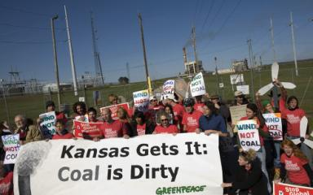

The fight over climate change pits people who use coal with those who oppose burning it.
Source: Robert Nickelsberg/Getty Images

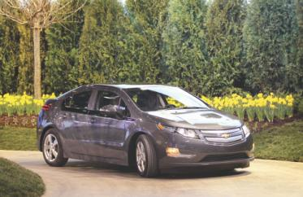
A rider drives the new Chevrolet Volt that, like
the Toyota Prius, combines electric and gasoline
power. The Volt costs over $42,000, but there is a
government subsidy that goes to purchasers.

Entrepreneurial Politics

- Global Warming Questions
  - How much do greenhouse gases cause the earth’s temperature to rise?
  - What would it cost in lost productivity and income to reduce greenhouse gases?
  - How large would be the gains to humankind and when would they occur?

WHAT WOULD YOU DO?

M E M O R A N D U M
To: Senator Diane Gray
From: Keith Mays, legislative assistant
Until recently, you could get a tax credit if you bought a hybrid car. Now that the credit has expired, Congress needs to decide if it will continue supporting the hybrid car market to promote clean energy.

Arguments for incentives:
1. We need to reduce gasoline consumption and our dependence on foreign oil.
2. Hybrid cars consume much less gasoline.
3. A tax break to buyers of hybrid vehicles that rely on both electric and gasoline engines will provide a stable market that will encourage sales.

Arguments against incentives:
1. We can more easily cut fuel consumption by raising taxes on gasoline.
2. Many hybrids get worse gas mileage than several conventional cars.
3. The past tax breaks were essentially a support for domestic car builders who were being beaten in the market by Japanese producers.

Your decision:
Support?
Oppose?

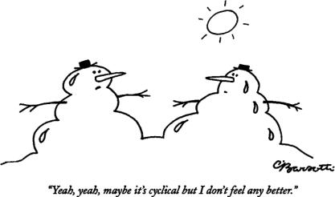

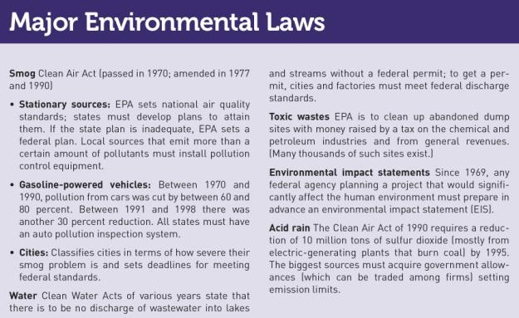
Entrepreneurial Politics
- The Endangered Species Act (ESA)
  - Provisions of the law
  - Lists 600 species of plants and animals
  - Jointly administered by:
    - Fish and Wildlife Service
    - National Oceanic and Atmospheric Administration
  - Construction activity in areas with endangered species must comply with federal regulations

Majoritarian Politics
- Pollution From Automobiles
  - The Clean Air Act of 1970
    - Restricted the amounts of pollutants allowed from automobile tailpipes
    - Required states to develop land use and transportation rules to help reach air quality standards.
  - Opposition to the law

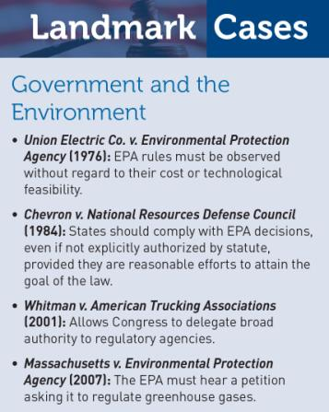

Majoritarian Politics

- If the Public Believes the Costs are Low
  - Example: The National Environmental Policy Act
    - Environment Impact Statement
    - Effects on Planning

- If the Public Believes the Costs are High
  - Example: Raising Gasoline Taxes
    - The Benefits
    - The Opposition
    - Promising Concrete Benefits Now!

Interest Group Politics
- Acid Rain
  - Residents of Canada and New England
vs.
Midwestern businesses, labor unions and politicians
  - Effect of the 1977 Law
  - Clean Air Act of 1990

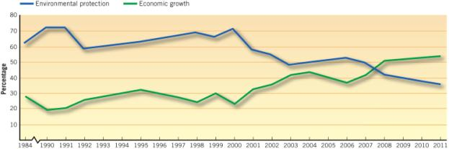

- Client Politics
  - Agricultural pesticides
- Pesticides help grow better crops,
- but some worry they may harm the
- Environment.
- Source: Jack Clark/ The Image Works

Environmentalists have used the protection of endangered species, such as the spotted owl, as a way of reducing timber harvests.
Source: William Campbell/ Corbis

The Environmental Uncertainties
- What is the Problem?
- What Are the Costs and Benefits?
- What Are Our Goals?
- How Do We Achieve Our Goals?
- Cap and Trade

