Chapter 22 – Who Governs? To What Ends?

Overview
There is no single answer to the questions, “Who governs? To what ends?” Everything depends on what policy is being proposed and on the opportunities that proponents and opponents have to mobilize.
As the responsibilities and activities of government have expanded, the structure and the ideals of governance have confronted new challenges. Proposals for improving the government are sometimes sweeping, as when a parliamentary system is recommended in place of the current congressional system. Whatever their scope, however, the reforms will only effect so much change in governmental efficiency. The people of the United States are first concerned that their rights be protected. As a result, they will insist that their government be accountable and responsive—qualities that inevitably limit the speed and coherence of political decision-making processes.

Chapter Outline
I. Introduction
- This chapter covers social problems and the role of government.
II. Restraints on the Growth of Government
- Eisenhower administration: Limited political agenda
- Built interstate highway system
- Admitted Alaska and Hawaii to Union
- Debate over the power of labor unions
- This was about what the Founders had expected.
- For first 150 years, role of federal government was small (Old System)
- Supreme Court restricted federal government to limited role.
- Popular opinion supported a limited governmental role.
- Public did not consider it legitimate for Washington to intervene in economy.
- Racial relations considered a state prerogative, not a federal responsibility
- Half of Americans were skeptical of federal unemployment insurance in 1930s.
- Role of federal government is now large (New System).
- Washington now involved in most political disputes.
- Role expanded in spite of constitutional structure that makes it difficult for federal government to act
III. Relaxing the Restraints
- Constraints on federal action have weakened or disappeared.
- Courts have changed their interpretation of the Constitution.
- Bill of Rights has been extended to the states by the doctrine of incorporation.
- Business is now regulated.
- Broad discretion is granted to administrative agencies.
- Public opinion demanded the expansion of the federal government.
- Great Depression was impetus for original expansion.
- This was followed by demand for federal intervention in other areas, too.
- Debate over federal policy is no longer over legitimacy, but over effectiveness.
- Wide distribution of political resources
- Number of interest groups has grown.
- Easier access to the federal courts
- Technology changes facilitate wide dissemination of information; television coverage of mass protests highlight significance of policy issue.
- Political action committees (PACs) protected by laws and the courts
- More citizens have college education, which encourages political participation.
- Political candidates selected by the public, not party bosses, so must appeal to voters.
IV. The Old System
- Small agenda of political issues
- Limited leadership circle, with movement activists excluded
- Small congressional staffs; stable congressional coalitions that extended across many issues
- Importance of states’ rights was generally accepted.
- Focus of policy debate was domestic.
- Debate was over the legitimacy of new issues.
- Presidency was less powerful, and Congress protected local constituencies.
- Extraordinary powers were exercised only during times of crisis.
V. The New System
- The new system began in the 1930s but did not take present form until the 1970s.
- Large policy agenda
- End of the debate over the legitimacy of government action, except in area of First Amendment.
- Diffusion and decentralization of congressional power
- Multiplication of interest groups
- Debate no longer about whether federal government should act, but how it should act (Social Security, civil rights, budget deficits, Medicare).
- Essential differences between Old and New systems
- Hard to start a new program (Old) versus hard to change existing programs (New)
- Somewhat centralized power (Old) versus decentralized power (new)
- Two periods in U.S. politics changed the political landscape
- Early 1930s: Depression and New Deal
- Mid-1960s: Intellectual and political ferment; LBJ elected in 1964: Great Society and War on Poverty
- The 1960s probably had the greater impact because of the changes in leadership patterns.
- Majority of members of the House came to enjoy safe seats.
- Primary elections supplanted party conventions.
- Interest groups increased in number.
- Television increasingly shaped political agenda and candidate nominations.
VI. Consequences of Activist Government
- More time spent managing consequences of existing programs and less time debating new ideas
- All parts of government have become more bureaucratized to implement rules.
- Businesses have become more bureaucratized to keep up with regulations.
- Increased activity increases appearance of government inconsistency and inefficiency.
- Less susceptible to control by electoral activity
- When federal government did less, outcome of elections more significant
- People have more influence as members of interest groups than they do as voters.
- The recession of 2008–2009 has led to a massive expansion of government activity, the greatest since the 1930s or the mid 1960s.
- In 2009, President Obama proposed a fiscal budget of over $3.55 trillion with a deficit of $1.17 trillion.
- The government has become the majority stockholder in General Motors, increased regulation of financial markets, and proposed to establish a government-regulated health-care system.
- Donald Kettl of the University of Maryland argues that America has gone from debates over privatizing the public sector to bigger steps toward governmentalizing the private sector.
- Government is putting public money into the private economy while establishing more rules on how the private sector will behave.
- This current economic crisis and government’s response to it will establish a new era of government-guaranteed corporate capitalism.
- Public expectations about government’s role in people’s lives will grow. This will lead to growing public disenchantment with government performance, because public expectations about policies will leave some citizens disappointed when government can’t quite meet these increased expectations.
VII. The Influence of Structure
- What if? the Founders had adopted a parliamentary system like the one they had left?
- Political life might have some different features than it currently has, and some things would probably remain the same.
- Quicker adoption of majoritarian policies
- Areas such as social welfare would be affected.
- Popular desires would be translated into national policy sooner when they conformed to the views of party leaders.
- Centralization of bureaucratic authority
- Bureaucracies would be larger and have wider discretionary authority.
- Local authorities would have less autonomy.
- Fewer opportunities for citizens to challenge or block governmental policies
- Courts would no longer be an outlet for challenging policy.
- No state or local arena to challenge policy
- Greater executive control of government
- Similar foreign policy
- Higher and more centralized taxation
- Founders would be amazed at degree of centralization that has developed in the United States.
VIII. The Influence of Ideas (THEME A: THE CITIZENS AND THE GOVERNMENT: RIGHTS AND RESPONSIVENESS)
- Preoccupation with rights
- Assumption that affected groups have a right to participate in policy formation
- Willing to resort to courts
- Effects of rights on government functions:
- Harder to make government decisions
- Harder to manage large institutions
- More red tape—limited government efficiency and effectiveness
- Elite opinion influences which rights are given priority.
- Elites tend to favor freedom of expression over management of property.
- Mass opinion is less committed to the freedom of expression and may view liberty as permissiveness.
- Freedom versus equality: An enduring tension
- Advantages of freedom are remote; costs are obvious.
- Advantages of equality are obvious; costs are remote.
- More recently, this has become a debate about equality of opportunity versus equality of results.
- Ideas influence policy
- More decentralized and fragmented government means that there is more opportunity for ideas to surface through debate.
- New programs become possible when there is popular support for an idea.
- Competing ideas and divided public opinion make change difficult.
- It may be difficult for government to satisfy the public’s expectations.

Justice is the end of government. It is the end of civil society. It ever has been and ever will be pursued until it be obtained, or until liberty be lost in the pursuit.

- Federalist No. 51

Restraints on the Growth of Government

- Old System – The founders felt the federal government should limit itself to war, peace, interstate commerce, establishing a national currency, and delivering the mail.
- New System – Today, federal politics is about practically everything.

The Constitution is filled with arrangements designed to make it hard for the federal government to act.
- Separation of powers
- Federalism
- Division of legislative authority between the House and the Senate

Relaxing the Restraints

- Courts have altered their interpretation of the Constitution in ways that not only permit but require government action at times.
- Public opinion has changed in ways that support an expanded role for the federal government.
- Political resources have become more widely distributed.

The Old System
- Agenda was small
- Was it legitimate for the federal government to take action?
- States’ rights was dominant theme
- Focus of policy debate was domestic affairs
- Crises gave the government reason to take bold action

The New System
- Began in the 1930s; took present form in the 1970s
- Large policy agenda
- End of debate over legitimacy of government action
- Diffusion and decentralization of power in Congress
- Multiplication of interest groups

Food products now contain health
warnings, such as nuts in this package of cookies.

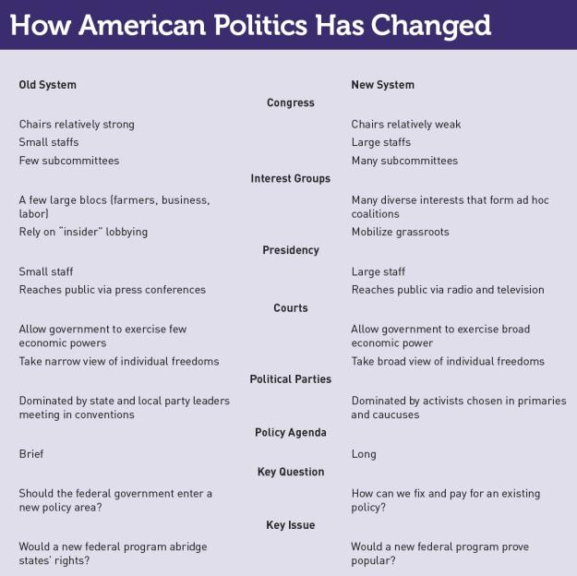

The Ford Motor company did not accept federal support during the recent recession and has begun to show a profit.

A Chevrolet Volt being assembled in Detroit. Federal subsidies go to people who buy one.

Consequences of Activist Government
- More time spent on managing consequences of existing programs
- Inconsistencies more apparent
- Less susceptibility to control by electoral activity
- Rapid increase in number and variety of interest groups
- Greater risk of failure

WHAT WOULD YOU DO?
M E M O R A N D U M
To: President Daniel Gilbert
From: Fowler Brown, legislative liaison
Subject: Replacing Social Security
You face a difficult decision. Despite past reforms, the
program can no longer be funded without large tax
increases. Here are the arguments for and against
allowing workers to invest their taxes in private mutual
funds.

Arguments for:
1. Workers pay 15 percent of their salary to Social Security, with no guarantee that they will get their money back when they retire.
2. There are only two workers for every retired person (in the 1930s, there were 16 for every retiree). People must be encouraged to invest in their own retirement.
3. The federal government spends a quarter of its budget on Social Security, far more than it devotes to national defense.

Arguments against:
1. Workers will have no guarantee that the mutual funds in which they put their tax money will earn them enough.
2. We should raise taxes on all high-income workers to save Social Security.
3. Social Security is more important than national defense.

Your decision:
Approve?
Oppose?

The Influence of Structure
FEATURES OF A PARLIAMENTARY REGIME:
- Quicker adoption of majoritarian policies such as social welfare
- More national planning, less local autonomy
- Fewer opportunities for citizens to challenge or block government policies
- Greater executive control of government
- Similar foreign policy
- Higher and more centralized taxation

The 2009 stimulus bill allowed people to get money if they traded in an old car that burned a lot of gas.

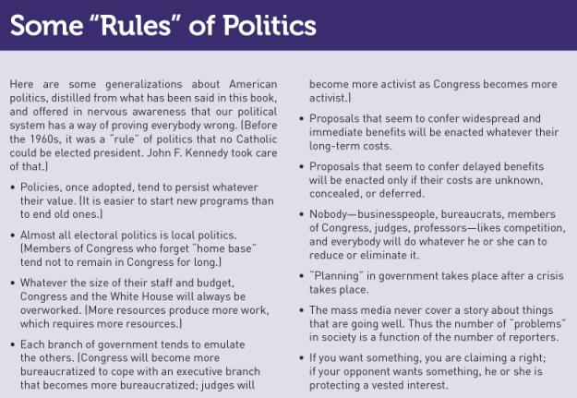

The Influence of Ideas

- Political culture of commitment to rights
- Which rights are most important?
- Freedom of expression versus property freedom
- Tocqueville – Americans are more “attached to equality than to freedom”

