Tourism and art history

Culture touristique et artistique en anglais

I. General introduction into tourism

Perspectives of tourism

4 essentials points:

- the tourist are first involved in tourism:
→ psychic (museum)
→ physical experiences (sports)

- the business
→ providing goods (wine tourism)
→ services (guiding tour)

- the government
→ incomes (money government earns with passport or indirectly with taxes paid by
tourism worker)
→ foreign exchange, receipts (change money: government earns money)
→ tax receipts (company earns money and hav to pay a tax to the government)

- the host community
→ cultural interest
→ employment sector

Tourism could be usefull (benefic) but also armfull (mass tourism)

Definitions

Tourism can be defined as:
→ the processes, activities and outcomes (results €) arising from the relationships and
interactions among tourists, tourist suppliers, host governments, host communities and
the surrounding environments (context of the 4 points) that are involved in the
attracting and hosting of visitors.
(definition created by tourism scientist)

Definition created by the United Nation to Work of Tourism (UNWTO):
→ Tourism comprises the activities of persons traveling to and staying in places outside
the usual environment for not more a consecutive year, for leisure (loisirs), business and
other purposes.

(Diferent terms for persons: tourist, visitor, traveler)

Kinds of travelers

Residents: travelers, visitors → tourism: tourist and Some-Day travelers (= Day-trippers,
Excursionists)

Non Residents: travelers, other travelers

A traveler is a person moving from one country to another or one locality to another
one.
A visitor is a traveler who lives his place for not more than a year
An other traveler is a traveler for work purposes
A Same-Day traveler is someone who does his activities without spendind the night
outside

Kinds of tourism

- Domestic tourism: the residents of a country are travelling into their country, they
don't live.
- Inbound tourism: the visits of a country by non residents
- Outbound tourism: the residents live their country
→ both are international tourism
- Internal tourism: domestic tourism + inbound tourism
- National tourism: domestic tourism + outbound tourism

Purposes of travel

- Leisure
- Visiting Friends and Relatives (VFR)
- Business
- Others: Health ...

Types of tourism

- Ethnic
- Cultural
- Business
- Environmental,(Sustairiable = durable), (Fair tourism)
- Dark tourism (dark chapters of history)
- Medical tourism
- Recreational tourism

Dimensions of tourism

Tourist Natural environment Built environment Operating sector =
tourism industry
- Travel experience

- Landscape
- Climate
- People : . Residents
. Current
and potential tourist
- Culture of residents
- Infrastructure for
the residents
(highway, roads,
suage system (eaux
usées), network ...
- Tourism
superstructure
(hotels, attractions,
restaurants ...)
- High-degree
technology
- Information
("sondage" to get the
project)
- System of
governance
- Transportation
sector (airlines, tran
company ...)
- Accomodation
sector
- Food service sector
- Attraction sector :
* sites
* events
- Travel trade sector:
* retailer (little
agency for private
person)
* wholesaler (big
agency)

PDPCO s (Planning, Development, Promotion and Catalyst Organisation)

They are 2 kinds of PDPCO:

- DMO → Destination, Management Organisation
Stakeholders: Public sector
National level: Maison de la France (State)
Regional level: CRDTA
City level: Tourism office of Clermont Ferrand, (= Convention and visitor bureau)

- DMC → Destination, Management Company
Stakeholders: Private sector
National level: All the tourism industries sector
Regional level: All companies who act for Auvergne tourism
City level: association

→ all the system is often called the 5th dimension

Their tasks:
- define tourism philosofy
- develop a strategy or policy (define the objectifs)
- get a detailed planning
- develop a marketing strategy (product component, price component …)
- control system (watch if the procedure is effective) : negative (ecological factors)
or/and positive (income) impacts on tourism
→ find the tourism philosofy and adapt it.

Tourist attractions

Tourist attractions are the main reason why people travel but the tourist's expenditure
(dépenses) are not high: example, a tourist comes to Paris and visits the Louvre = +- 12€
but hotel, transport … are going to be more expansive.
Planners tourism: combine different attractions to earn more money.

Kinds of attractions:

- cultural
40% of all the tourists who comes to Europe
- natural
- events
- sports / leisure
- attraction parcs

Cultural Tourism

* arts (litterature, painting, music, sculpture)
* architecture
* tradition and history
* cinema / films
* theatre
* language
* beliefs / ideas / religion
* clothing
* work
* gastronomy

How to promot culture, how can we transmit it ?

* exhibitions, museums
* monuments
* performances
* study tours
* library
* schools / universities
* families
* congresses, meetings
* events
- heritage days
- national days
- capitals of culture
- cultural roads (wine road, Alpes road …)

UNESCO (United Nations Educational, Scientific, Cultural Organisation)

Elects some places of cultural or natural outstanding values which need protection.
Their convention is called : Convention concerning the Protection of the World Cultural
and Natural Heritage, it was produced in 1972. They protected a site for the first time in
1978.

They are 189 countries who signed the convention. 981 site in 160 state parties are
actually inscribe at the UNESCO. Among these sites there are natural (193), cultural
(759) and mixt sites (29). Italy has 49 sites listed.

The inscription process

State parties:
- inventory
- tentative list (all the sites that should be protected)
- nomination (submited to the WHC)

UNESCO World Heritage Center (in Paris):
- offer assistance in the preparation process
- they check the nomination document
- transmission to the Advisory Bodies

Advisory Bodies:
- ICOMOS (NGO in Paris): International Consul on Monuments and Sites
- IUCN (NGO in Gland, Suisse): International Union for Conservation of Nature and
Natural ressources
→ both are going to evaluate the transmited files.

- ICCROM (Intergovernmental organisation, Rome: give advice on the protection and
conservation of the sites. They propose training activities to the State parties

When AB accept the files –-> WH Comitee -Intergovernmental (members elected for 6
years)
Once a year they decide for the inscription and if it is too hard to make a decision they
ask the State Parties for further information.
After they will inform the countries and countries have to take protection mesures for
rotected the sites.
Finally countries have to report regularly to the UNESCO about protection mesure and
development of the site.

10 Criteria for the decision:

- Cf photocopie

(II. Travel and holiday companies)

III. Cultural heritage

IV. Periods of art history

Painting in the late XIX century and XX century

 Théodore Rousseau (1812 – 1867): Dans la forêt de Fontainebleau, ?, Kunsthalle,
Hamburg
→ Naturalism (Cf fiche définitions)
Forest all around and a little road in the middle of the picture
→ paint structure of landscape

 Gustave Courbet (1819 – 1877), l'Enterrement à Ornans, 1849 – 1850, Musée
d'Orsay, Paris, (315 cm x 668 cm)
→ Realism
Painting of a normal scene

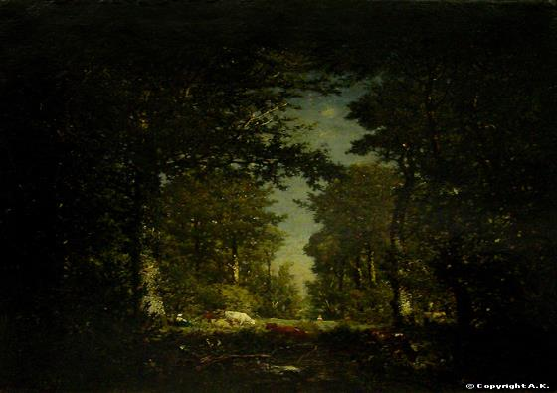
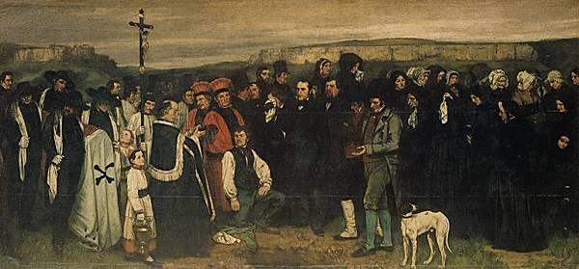

 Claude Monet (1840 – 1926), Nymphéas, vers 1916 – 1921, Musée de l'Orangerie,
Paris
→ Impressionism

 George Seurat (1859 – 1891): Un dimanche à la Grande-Jatte, 1884 – 1886, The Art
Institute, Chicago (208 x 308 cm)
→ Pointillism or divisionism

 Pierre Puvis de Chavannes: Jeunes filles au bord de la mer, 1879, Paris, Musée
d'Orsay
→ Symbolism
Symbol stands for a feeling

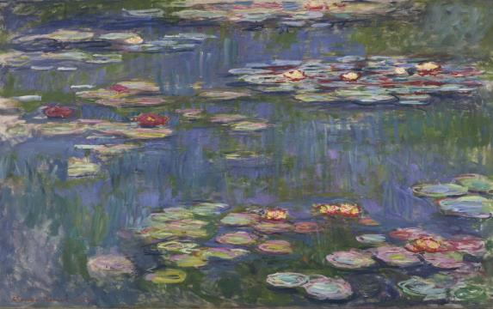
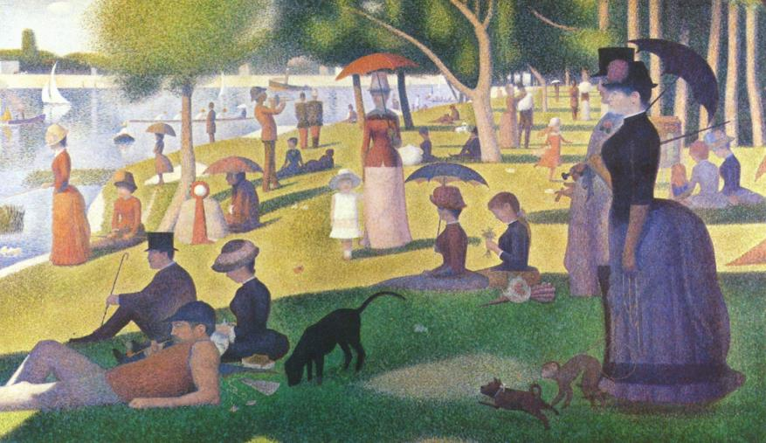
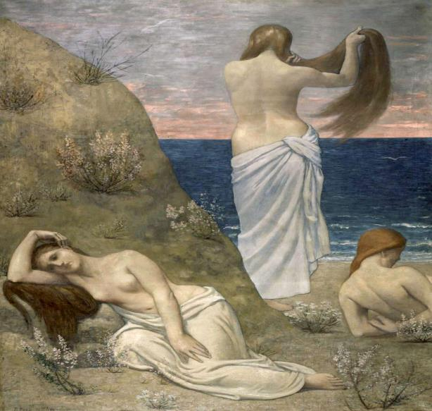

 Alfonso Maria Mucha: Projet d'affiche pour Moët et Chandon, 1899 ; Hector
Guimard: Bouche de Métro, 1900 – 1901, Paris
→ Art Nouveau

 Henri Matisse: Joie de vivre, 1905 – 1906, Merion, Barnes Foundation
→ Fauvism

 Pablo Picasso: Les Demoiselles d'Avignon, 1907, New-York, Museum of Modern Art
→ Cubism

 Robert Delaunay: Formes circulaires, soleil n°1, 1912 – 1913, Ludwigshafen,
Wilhelm-Hack Museum
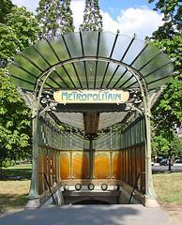
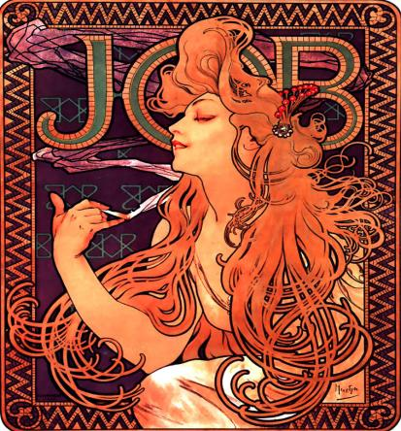
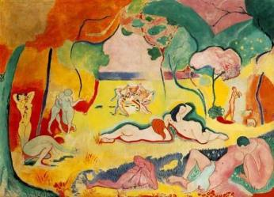
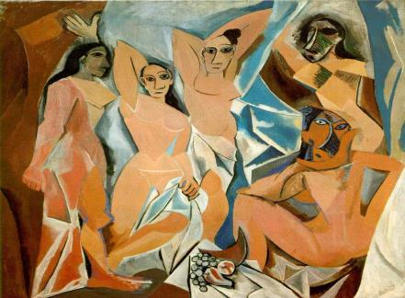

→ Orphism

 Kazimir Malevitch, Carré noir sur fond blanc, 1929, Moscou, Galerie Tretiakov
→ Suprematism

 Marcel Breuer: Chaise, 1925 – 1926 ; Walther Gropius: le Bauhaus à Desseau, 1925
→ Bauhaus

 Hans Arp: La mise au Tombeau des oiseaux et pélicans (Portrait de Tristan Tzara)
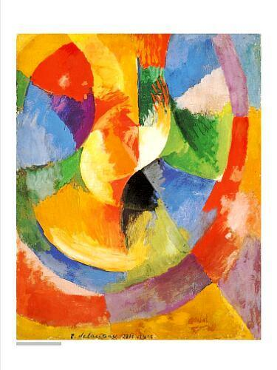

1916, bois peint, Genève, Musée d'Art et d'Histoire
→ Dada, born in Switzerland and Germany

 Juan Miro: Carnaval d'Arlequin, 1924 – 1925, Buffalo, Knox-Art Gallery
→ Surrealism

 Jackson Pollock au travail, 1950; Out of the Web, Number 7, 1949, Stuttgart
→ Abstract expressionism

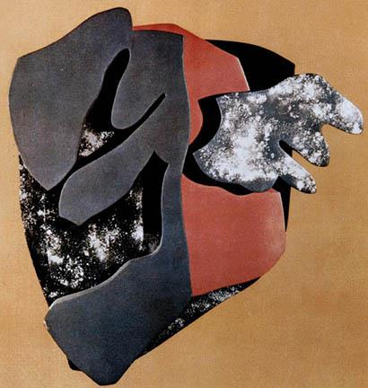
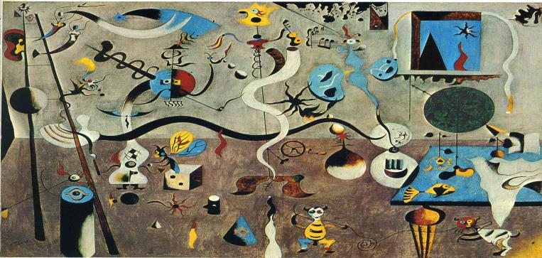
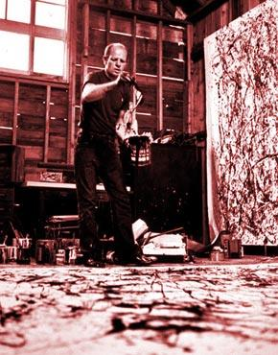
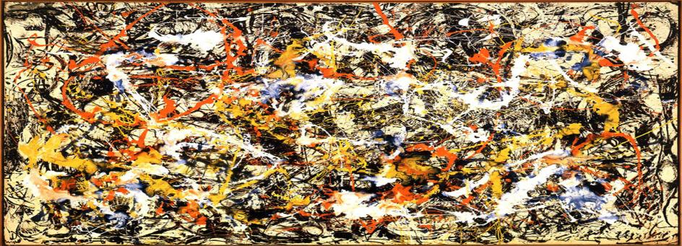

 Mark Rothko: Black, Pink and Yellow over Orange, 1951 – 1952, New-York, William
S Rubin collection
→ Color-Field painting

 Andy Warhol, Marilyn Monroe, 1967, New-York, Metropolitan Museum of Art
→ Pop art

 Richard Estes: Food Shop,
1967, Aachen, Sammlung, Ludwig
→ Photorealism

